Inštitut za hmeljarstvo in pivovarstvo Slovenije
Slovenian Institute of Hop Research and Brewing
Hmeljarski bilten
Hop Bulletin
32 (2025)

Žalec, 2025
Hmeljarski bilten / Hop Bulletin
ISSN za tiskano izdajo 0350-0756
ISSN za spletno izdajo 2536-1988
Izdaja /  Issued by | Inštitut za hmeljarstvo in pivovarstvo Slovenije (IHPS) /  Slovenian Institute of Hop Research and Brewing (IHPS)  Cesta Žalskega tabora 2, 3310 Žalec, Slovenija / Slovenia
Urednika /  Editors | dr. Barbara Čeh in dr. Boštjan Naglič
Uredniški odbor / Editorial board | dr. Barbara Čeh (IHPS), izr. prof. dr. Andreja Čerenak (IHPS), prof. dr. Jernej Jakše (Biotehniška fakulteta Univerze v Ljubljani / University of Ljubljana, Biotechnical Faculty – BF UL), izr. prof. dr. Iztok Jože Košir (IHPS), doc. dr. Rok Mihelič (BF UL), dr. Boštjan Naglič (IHPS), prof. dr. Martin Pavlovič (IHPS in Fakulteta za kmetijstvo in biosistemske vede Univerze v Mariboru / Faculty of Agriculture and Life Sciences University of Maribor – FKBV MB), dr. Sebastjan Radišek (IHPS), dr. Magda Rak Cizej (IHPS), dr. Siniša Srečec (Visoko gospodarsko učilište u Križevcima, Hrvaška / College of Agriculture at Križevci, Croatia), prof. dr. Denis Stajnko (FKBV MB), dr. Igor Šantavec (BF UL), prof. dr. Dominik Vodnik (BF UL)
Naslov uredništva, politika /  Editorial office and policy | Cesta Žalskega tabora 2, SI-3310 Žalec, Slovenija / Slovenia;  e-pošta / e-mail: barbara.ceh@ihps.si  Člani uredniškega odbora so tudi recenzenti prispevkov. Prispevki so najmanj dvojno recenzirani. Za jezikovno pravilnost odgovarjajo avtorji. S poslanim člankom se avtorji strinjajo za spletno objavo revije.  Articles are peer-reviewed and revised. Authors are fully responsible for linguistic structure of the text.
Recenzenti / Reviewers | v tej številki izven uredniškega odbora:  outside the Editorial Board for this number:  dr. Helena Volk (BF UL), prof. dr. Stanislav Trdan (BF UL) in dr. Miha Ocvirk (IHPS)
Tehnično  urejanje /  Technical editing | Žan Trošt in mag. Jolanda Persolja
Domača stran / Home page | IHPS – Hmeljarski bilten (http://www.ihps.si/raziskave-in-razvoj/publikacije/hmeljarski-bilten/)  
Bilten zajemajo /  Indexed and abstracted by | COBISS.SI, CAB Abstracts, EBSCO, DOAJ
Avtorske pravice /  Copyright | © 2025 Inštitut za hmeljarstvo in pivovarstvo Slovenije /  © 2025 Slovenian Institute of Hop Research and Brewing  Izdajo sofinancira Javna agencija za znanstvenoraziskovalno in inovacijsko dejavnost RS. /  The issue was financially supported by the Slovenian Research and Innovation Agency.
VSEBINA / CONTENTS
Matic TACER, Lucija LUSKAR, Andreja ČERENAK, Jernej JAKŠE in Helena VOLK
Optimization of DNA isolation from hop cones and pellets for microsatellite analysis
Optimizacija izolacije DNA iz storžkov in peletov hmelja za analizo mikrosatelitov 4
Barbara ČEH in Ana KARNIČNIK KLANČNIK
Vpliv tehnoloških postopkov na uspešnost kompostiranja hmeljevine
Impact of the implementation on success of hop biomass composting on farms 15
Ksenija OBROVNIK in Monika OSET LUSKAR
Indeks staranja hmelja pri sorti Celeia v času dozorevanja
Hop storage index for Celeia variety at ripening 26
Iztok Jože KOŠIR in Thomas H. SHELLHAMMER
Primerjalna študija postopkov sušenja hmelja (Humulus lupulus L.): Slovenija v primerjavi z Združenimi državami Amerike
Comparative study of hop (Humulus lupulus L.) drying procedures: Slovenia vs. United States 32
Ana Kočevar BALOH, Ksenija OBROVNIK, Miha OCVIRK in Iztok Jože KOŠIR
Možnost ponovne uporabe hmelja po hladnem hmeljenju
Possibility of reusing hops after dry hopping 39
Žan TROŠT in Joško LIVK
Pridelek in kakovost hmelja v Sloveniji v prvem četrtletju tega stoletja
Hops yield and quality in the last 25 years 45
Martin PAVLOVIČ
Production economics estimation on hop farms
Ocena ekonomike pridelave hmelja na kmetijah 55
Marjeta ERŽEN in Marko FLAJŠMAN
Vpliv vršičkanja na pridelek kanabinoidov in morfološke značilnosti industrijske konoplje (Cannabis sativa L.)
Comparison of cannabinoid yield among dioecious and feminized varieties of hemp (Cannabis sativa L.) 60
Tanja GUČEK in Sebastjan RADIŠEK
Izzivi uporabe visoko-pretočnega sekvenciranja (HTS) za rutinsko diagnostiko viroidov
Challenges in the application of high-throughput sequencing for routine diagnostics of viroids 72
Jure FERLIN, Matej KNAPIČ, Vesna ZUPANC in Marjana ZAJC
Uporaba georadarja za neinvazivno določanje globine tal, deleža skeleta in prostorske variabilnosti
Use of ground-penetrating radar for non-invasive determination of soil depth, skeleton content, and spatial variability 85
Primož BUKOVEC, Tanja FATUR in Žan TROŠT
Usmerjeno vzorčenje podtalnih in pitnih voda na aktivne snovi pesticidov in njihovih razgradnih produktov v letu 2024
Targeted sampling of groundwater and drinking water for active substances of pesticides and their degradation products in 2024 93
Octave LACROIX in Sebastjan RADIŠEK
Climate change impacts on plant diseases and crop protection
Vpliv podnebnih sprememb na rastlinske bolezni in varstvo rastlin 101
Tanja GUČEK in Sebastjan RADIŠEK
Corrigendum: Validacija metode duplex RT-qPCR za določanje viroida razpokanosti skorje agrumov (CBCVd) na hmelju z uporabo mRNA1192 interne kontrole
Corrigendum: Validation of the RT-qPCR method for the detection of citrus barkcracking viroid (CBCVd) on hops including mRNA1192 as internal control 111

Ta članek je objavljen pod licenco Creative Commons Priznanje avtorstva-Deljenje pod enakimi pogoji 4.0 Mednarodna.

Optimization of DNA isolation from hop cones and pellets for microsatellite analysis
Matic TACER, Lucija LUSKAR, Andreja ČERENAK, Jernej JAKŠE in Helena VOLK
Article type / Tipologija: Original scientific article / Izvirni znanstveni članek
Arrived / Prispelo: 24. 10. 2025
Accepted / Sprejeto: 1. 11.2025
Published / Objavljeno: December 2025
Abstract
Reliable identification of hop (Humulus lupulus L.) cultivars is important for quality control and authentication in the brewing industry. DNA-based methods provide a powerful tool for this purpose, but isolation of high-quality DNA from processed hop materials such as cones and pellets can be challenging due to the presence of PCR inhibitors, including polyphenols, polysaccharides, and bitter acids. In this study we compared four cetyltrimethylammonium bromide (CTAB)-based DNA extraction protocols for hop cones and pellets, with the aim of improving yield and purity of DNA used for microsatellite genotyping. The tested methods included the standard CTAB protocol, CTAB supplemented with polyvinylpyrrolidone (PVP40), CTAB with PVP40 and activated charcoal, and CTAB with PVP10 and liquid nitrogen grinding. Additionally, a hexane pre-treatment step was evaluated with the aim to reduce the amount of PCR inhibitory compounds. DNA quality was assessed using NanoVue, Qubit, and agarose gel electrophoresis. Agarose gels showed intact high-molecular-weight DNA with minor RNA traces. Microsatellite genotyping confirmed consistent allele profiles across the first three extraction methods, thus confirming the suitability of CTAB-based methods for reliable hop genotyping.
Key words: hop, Humulus lupulus, DNA extraction, CTAB, genotyping
OPTIMIZACIJA IZOLACIJE DNA IZ STORŽKOV IN PELETOV HMELJA ZA ANALIZO MIKROSATELITOV
Izvleček
Možnost zanesljivega določanja sorte hmelja (Humulus lupulus L.) je pomembna za zagotavljanje kakovosti in avtentičnosti v pivovarski industriji. Metode, ki temeljijo na analizi DNA, so za ta namen učinkovito orodje, vendar je izolacija visokokakovostne DNA iz procesiranih oblik hmelja, kot so storžki in peleti, zahtevna zaradi prisotnosti inhibitorjev PCR, med katerimi so polifenoli, polisaharidi ter alfa in beta kisline. V tej raziskavi smo primerjali štiri protokole za izolacijo DNA na osnovi CTAB iz hmeljnih storžkov in peletov. Naš namen je bil izboljšati koncentracijo in čistost DNA, ki jo uporabimo za genotipizacijo hmelja z mikrosateliti. Preizkušene metode so bile: standardni CTAB protokol, CTAB z dodatkom polivinilpirolidona (PVP40), CTAB z dodatkom PVP40 in aktivnega oglja ter CTAB z dodatkom PVP10 in s predhodno homogenizacijo v tekočem dušiku. Poleg tega smo preizkusili tudi predobdelavo s heksanom, katere namen je bil v izolirani DNA zmanjšati količine spojin, ki zavirajo PCR. Kakovost izolirane DNA smo določali z instrumentoma NanoVue in Qubit ter z agarozno gelsko elektroforezo s katero smo pokazali prisotnost nepoškodovane DNA visoke molekulske mase z manjšimi sledovi RNA. Genotipizacija z mikrosateliti je pokazala skladne alelne vzorce pri prvih treh metodah izolacije, kar potrjuje primernost CTAB-protokolov za zanesljivo genotipizacijo hmelja, tako iz storžkov, kot iz peletov.
Ključne besede: hmelj, Humulus lupulus, izolacija DNA, CTAB, genotipizacija

INTRODUCTION
The cultivar of hops (Humulus lupulus L.) plays a major role in their economic value, since different varieties provide unique brewing qualities such as aroma, bitterness, and essential oil content. Because of this, reliable identification of hop cultivars is important for both quality control and preventing mislabeling in the brewing industry. DNA-based methods have the potential to support this process, but authenticating cultivars in processed forms such as cones and pellets is still difficult. This is largely because this type of hop tissue contains high levels of PCR inhibitors, including polyphenols, polysaccharides, and bitter acids, which reduce the success and reliability of DNA amplification. Developing strategies to overcome these obstacles is essential for establishing consistent molecular tools for hop cultivar authentication.
Molecular markers have been widely used in hop genetics, breeding, and germplasm studies over the past decades. Early work with RAPD and microsatellite sequences showed that DNA markers can successfully differentiate hop cultivars (Brady et al., 1996). Later research at the Slovenian Institute of Hop Research and Brewing, Biotechnical faculty University of Ljubljana and partner institutions further developed these methods. Jakše et al. (2001) combined SSR and AFLP markers to study variation and differentiation between hop genotypes, later Jakše et al. (2004) showed large microsatellite diversity in wild and cultivated hops from Europe, Asia and North America with a clear genetic structure related to geographical origin. Murakami et al. (2006) confirmed these results on a larger set of wild hops, showing distinct genetic grouping among continental populations.
The development of new molecular markers further improved the precision of genetic analyses. Hadonou et al. (2004) and Štajner et al. (2005) described new polymorfic microsatellite loci with high information value. Similarly, Čerenak et al. (2004) developed a practical microsatellite-based system for identifying hop cultivars, that is able to separate clones and detect variation among geographically distinct varieties. Later Čerenak et al (2012) used RAPD and microsatellite markers to study the genetic diversity of wild and cultivated hops stored in the Slovenian hop gene bank, confirming their usefulness for evaluating genetic relationships between accessions.
More recent studies expanded the use of molecular tools by combining genetic and chemical analyses. Paquet et al. (2023) used microsatellite genotyping together with metabolomic and chemical profiling of wild hops from northern France, demonstrating strong correlation between genetic structure and chemical composition. Such combined approaches show the importance of molecular markers not only for cultivar identification but also for studying diversity, adaptation and the evolutionary history of hops.
The Slovenian Institute of Hop Research and Brewing uses an internal protocol for hop cultivar genotyping, which is based on the work of Pokorn (2011) where genotyping of H. lupulus cultivars is carried out with fluorescent microsatellite markers. In that study young leaves were used as the source of plant material for DNA isolation by the cetyltrimethylammonium bromide (CTAB)-based method, an extraction method which is commonly used in plant research. However, when this approach was extended to hop cones and pellets, the quality and reliability of genotyping results were lower compared to those obtained from leaves. Therefore, this study focused on optimizing DNA extraction for hop cones and pellets, in order to achieve accurate and consistent genotyping.
Korbecka-Glinka et al. (2016) developed a similar genotyping method of hops using CTAB DNA extraction protocol and six microsatellite loci. DNA of sufficient quality was obtained from leaves and cones, but also from highly processed pellets, with consistent results in the replicates. Most samples matched the declared cultivar, and the method was sensitive enough to detect mixtures as low as 3–5%. Similarly, Krofta and Patzak (2014) showed that DNA can be successfully isolated from both young leaves and dried hop cones of Czech cultivars using a CTAB-based method. With SSR, STS, and EST-SSR markers, they reliably identified all registered cultivars and detected admixtures as low as 5%. They showed that the method is suitable for authenticity and purity control of hop material. Patzak and Henychová (2018) confirmed that the CTAB method enables successful DNA isolation from young leaves, dried cones, and pellets of diverse hop cultivars. The protocols described involve grinding of leaf samples, incubation with CTAB extraction buffer, and several purification steps to remove PCR inhibitors. After extraction, DNA quantity and quality are always checked to confirm that the samples are suitable for molecular analysis. The DNA is then used for PCR amplification with fluorescently labelled microsatellite primers, and the resulting fragments are separated and analyzed by capillary electrophoresis. This provides a reliable identification of hop cultivars and is an effective tool for authentication and diversity studies.
In addition to DNA-based approaches, chemical analysis can also be used to determine hop variety. Ocvirk et al. (2016) used gas chromatography, HPLC, and FTIR spectroscopy combined with chemometric methods to genotype hop samples and achieved nearly 100% correct results for five major Slovenian cultivars (Aurora, Savinjski golding, Bobek and Celeia).
We hypothesized that certain hop varieties may present greater challenges for genotyping due to their higher contents of α-acids, β-acids, and essential oils. Residual traces of these compounds can act as inhibitors and interfere with PCR amplification, thereby reducing the reliability of microsatellite analysis. To address this, our aim in this study was to evaluate several DNA extraction protocols and identify one that provides both reliable and efficient isolation of DNA from hop cones and pellets. We further assumed that a pre-isolation step involving incubation of samples in hexane could remove a substantial portion of these inhibitory compounds and in that way improving DNA purity and facilitating successful PCR and genotyping.

MATERIAL AND METHODS

Plant Material
Five hop varieties were included in this study, represented either as cones or vacuum-packed cones and pellets (Table 1, Picture 1). The selected samples covered a wide range of chemical characteristics, including α-acid, β-acid, and essential oil contents, which are known to influence both brewing quality and the efficiency of DNA isolation due to their potential role as PCR inhibitors. This diversity allowed us to evaluate DNA extraction performance across hop genotypes with different biochemical profiles and processing forms.
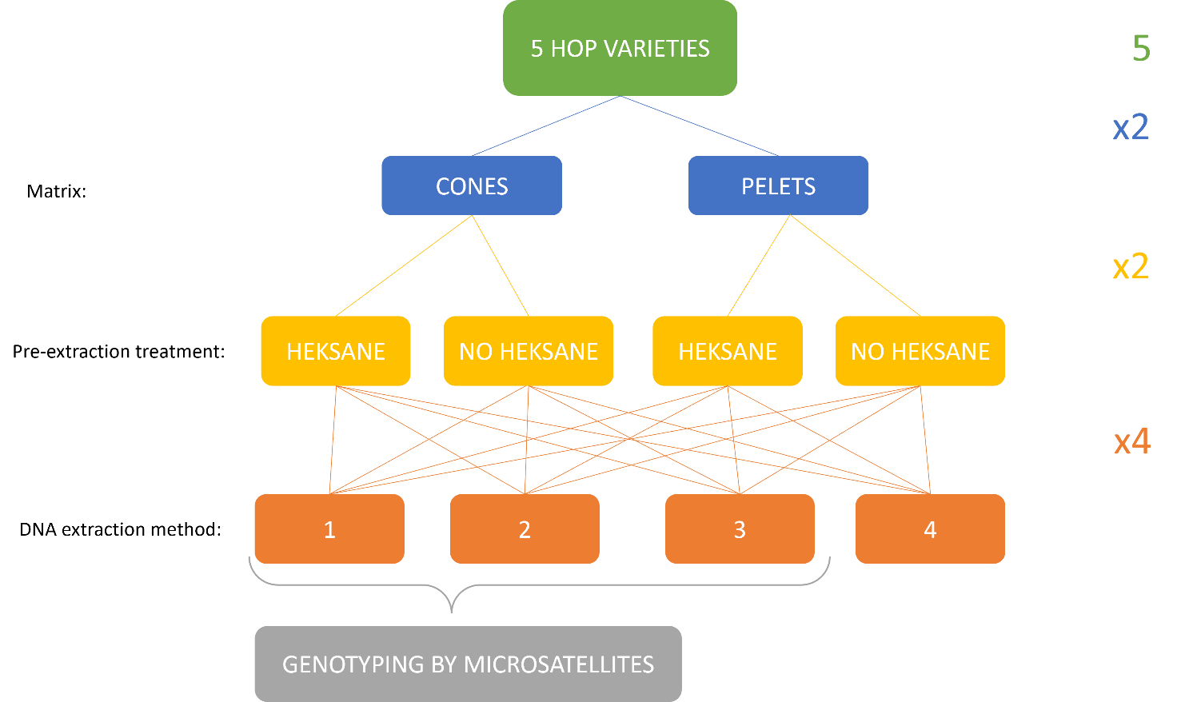
Figure 1: Workflow scheme.
Table 1: Characteristics of hop samples used in the study (Hop variety catalogues, IHPS).
No. | Variety | α-acids  (% w/w) | β-acids  (% w/w) | Essential oils  (ml/100 g hops)
1 | Celeia | 3.0 – 6.5 | 2.0 – 3.3 | 1.5 – 3.6
2 | Aurora | 7.2 – 12.6 | 2.7 – 4.4 | 0.9 – 1.6
3 | Styrian Wolf | 13.5 – 18.5 | 5.0 – 6.0 | 3.0 – 4.5
4 | Styrian Cardinal | 10.0 – 15.0 | 3.2 – 4.6 | 3.0 – 4.0
5 | Styrian Kolibri | 4.0 – 6.0 | 3.8 – 5.4 | 1.0 – 2.0
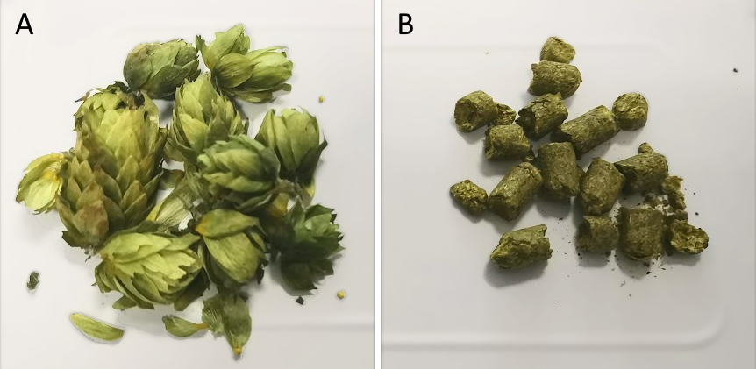
Figure 2: Hop (A) cones and (B) pellets used in this study

Pre-Extraction Treatment with Hexane
For the pre-extraction treatment, 1,3 g of hop cones or pellets were placed in a 100 ml beaker and supplemented with 25 ml of hexane (Merck). The beaker was sealed with parafilm, and the mixture was stirred using a magnetic stirrer for 40 min. Following incubation, cones and hexane were separated using a metal colander and filter paper. The plant material was then left in a fume hood until complete evaporation of residual hexane. Subsequent DNA extractions were carried out using a portion of the pretreated samples.

DNA Extraction Protocols
We compared four CTAB-based DNA extraction protocols for hop cones and pellets performing all extractions both with and without hexane pre-treatment:
(1) Standard CTAB protocol (Kump & Javornik, 1996):
Approximately 50 mg of sample was homogenised in a mortar in 1ml CTAB buffer (2% CTAB, 100 mM Tris-HCl pH 8, 1.4 M NaCl, 20 mM EDTA pH 8, and 0.2% β-mercaptoethanol). 700 µl was transferred to a microcentrifuge tube and incubated at 68 °C for 1.5–2 h. After incubation, an equal volume of chloroform:isoamyl alcohol (24:1) was added, mixed vigorously, and centrifuged (16,000 × g, 15 min, 4 °C). The aqueous phase was transferred to a fresh tube, mixed with 0.1 volume 3 M sodium acetate (pH 5.2) and 1 volume cold isopropanol, and incubated at −20 °C for at least 30 min. DNA was pelleted (16,000 × g, 15 min, 4 °C), washed with 70% ethanol, dried, and resuspended in 100 μl TE buffer.
(2) CTAB with PVP40:
The extraction was performed as described in the above protocol (1), except that 1% (w/v) PVP40 was added to the CTAB buffer to bind phenolic compounds.
(3) CTAB with PVP40 and activated charcoal (modified from Križman et al., 2006):
Approximately 50 mg of plant tissue was homogenised in extraction buffer (100 mM Tris-HCl pH 8, 2.0 M NaCl, 20 mM EDTA pH 8, 2% CTAB, 1% PVP40, and 0.5% activated charcoal). Samples were incubated at 55 °C for 30 min with agitation and centrifuged (16,000 × g, 10 min, room temperature). The supernatant was extracted with chloroform:isoamyl alcohol (24:1) and centrifuged again; this step was repeated until the solution cleared. DNA was precipitated with 0.45 volumes of isopropanol, incubated for 1 h at 25 °C, and pelleted by centrifugation. Pellets were washed with 75% ethanol containing 15 mM ammonium acetate, air-dried, and resuspended in 100 μl TE buffer.
(4) CTAB with PVP10 and liquid nitrogen homogenisation (Patzak, 2025):
When using this protocol, samples were finely ground in liquid nitrogen prior to extraction. The CTAB buffer was added to 50 mg of the powderd samples and contained 1% (w/v) PVP10 in addition to the standard components (2% CTAB, Tris-HCl, NaCl, EDTA, β-mercaptoethanol). DNA isolation was then carried out as in protocol (1).

DNA Quality Assesment
The quality and quantity of the isolated DNA were evaluated using a combination of spectrophotometric, fluorometric, and electrophoretic separation methods.
Spectrophotometric measurements were carried out with a NanoVue instrument (GE Healthcare) to determine purity based on the A260/A280 and A260/A230 absorbance ratios, which provide an indication of protein and polysaccharide/phenolic contamination, respectively.
In parallel, DNA concentrations were quantified more accurately using fluorometry with the Qubit™ 4 Fluorometer and the Qubit™ dsDNA BR Assay Kit (Thermo Fisher Scientific), which is less affected by residual contaminants.
DNA integrity was examined by electrophoresis on 1 % agarose gels stained with ethidium bromide. Electrophoresis was carried out in a Sub-Cell Model 192 system (Bio-Rad Laboratories, Hercules, USA) at 90 V for 1 h. DNA bands were visualised under a UV transilluminator and documented using a G:BOX imaging system (Syngene).

Microsatellite Genotyping
Microsatellite analysis was performed following a protocol adapted from Pokorn (2011). DNA was diluted to a working concentration of 20 ng/µL. PCR reactions were prepared in a final volume of 10 µL, containing 1x PCR buffer, 2 mM MgCl₂, 0.8 mM dNTPs, 0.2 µM of each forward and reverse primer, 0.25 µM fluorescently labeled TAIL primer, 0.025 U Taq DNA polymerase, and 5 µl of template DNA, diluted to 20 ng/µl.
Amplifications were performed on a thermocycler under the following conditions: initial denaturation at 94 °C for 5 min; touchdown phase of 5 cycles with denaturation at 94 °C for 45 s, annealing at 60 °C (decreasing 1 °C per cycle) for 30 s, and elongation at 72 °C for 90 s; followed by 30 cycles at 94 °C for 30 s, 55 °C for 30 s, and 72 °C for 90 s; with a final extension at 72 °C for 8 min. PCR products were checked for successful amplification on agarose gel electrophoresis before submitting the samples for fragment analysis.
Four primer pairs (5-2, GA5-G3-10, 11a59, and GA7-A6-14) were used for genotyping (Table 2). Each forward primer contained a universal TAIL sequence for fluorescent labeling. Fluorescent dyes were assigned to the TAILs in this way: 6-FAM = blue, NED = yellow/black, VIC = green and PET = red.
Table 2: Primers used in this study
Primer name | Sequence (5’ 3’)
5-2_F | TGTAAAACGACGGCCAGTCGAATGGTCCTAGATATCCCC
5-2_R | CAGTAAATGGATGCTTGAAGGC
GA5-G3-10_F | TGTAAAACGACGGCCAGTGCACAACCAGAGCTCCCTTA
GA5-G3-10_R | CTCGAAATCCCAACAACCAC
11a59_F | TGTAAAACGACGGCCAGTGCTTCAACCCTCTAATTTCTGACC
11a59_R | AGAAGGGATACACTCGGTTAATCC
GA7-A6-14_F | TGTAAAACGACGGCCAGTGGCAAGGCTAACCACCATTA
GA7-A6-14_R | CTGTTTCCCGCCAAATTAAA
For fragment analysis, 5 µl of PCR product from four different primer pairs were pooled (total volume 20 µl), centrifuged, and 3 µl of the combined sample was mixed with 0.5 µl GeneScan™ 600 LIZ™ dye size standard (Thermo Fisher Scientific) and 10.6 µL HiDi™ formamide (Applied Biosystems). Capillary electrophoresis was performed using an ABI genetic analyzer, and allele sizes were determined with GeneMapper Software v6.0 (Applied Biosystems). Raw data is available on demand.

RESULTS AND DISCUSSION

DNA Quality Assesment
Firstly, DNA quality was assessed using a NanoVue spectrophotometer, with particular attention to purity ratios. The absorbance ratio A260/A280 provides an estimate of protein contamination in nucleic acid samples. For double-stranded DNA the optimal ratio is approximately 1.8 (ranging from 1.7 to 1.9), lower values indicate protein contamination. In contrast, pure RNA samples typically exhibit higher ratios, around 2.1 (NanoVue, 2007; Koister & Cantor., 2019).
Since CTAB-based extraction protocols, although designed for DNA isolation, also co-extract RNA, the expected A260/A280 ratios for our samples should fall between 1.8 and 2.1. The average A260/A280 ratios obtained for DNA extracted using different CTAB-based protocols are presented in Figure 2. Across all treatments, the measured ratios ranged from 1.579 to 2.049. The optimal purity range for double-stranded DNA (1.7–1.9) is indicated by the green reference line. Most samples extracted with the (1) CTAB, (2) CTAB + PVP40, and (3) CTAB + PVP40 + activated charcoal protocols exhibited A260/A280 ratios close to or slightly above this optimal range, suggesting high DNA purity with minimal protein contamination. In contrast, pellet samples obtained using the (4) CTAB + N₂ method showed lower ratios (1.579), indicating possible protein or phenolic compound contamination. Generally, the addition of PVP40 or activated charcoal slightly improved the purity of extracted DNA, but the addition of liquid nitrogen homogenisation step did not enhance DNA sample quality.

Figure 3: Average A260/A280 ratios indicating protein purity of the DNA samples of hop cones and pellets
Legend: The green line represents the optimal values for pure DNA (1,7-1,7)
The absorbance ratio A260/A230 serves as an indicator of contamination from organic compounds and salts that absorb strongly at 230 nm (e.g., guanidine, EDTA, Triton™ X-100, Tween® 20, phenol, polysaccharides and silica particles) (NanoVue, 2007; Koister & Cantor, 2019). dsDNA typically exhibits A260/A230 ratios between 2.0 and 2.2, while pure RNA samples range from 2.1 to 2.3. The results presented in Figure 3 show that most samples extracted using CTAB-based protocols displayed A260/A230 ratios below these ideal values, suggesting the presence of residual contaminants from the extraction process. Among the tested methods, (2) CTAB + PVP40 and (3) CTAB + PVP40 + activated charcoal yielded the highest ratios (up to 2.191 in cone samples), indicating improved removal of interfering compounds. Samples extracted using (4) CTAB + N₂ consistently exhibited the lowest ratios, with values as low as 0.697 in pellet samples, indicating contamination by salts, phenolic compounds, or polysaccharides.

Figure 4: Average A260/A230 ratios indicating presence of residual contaminants in the DNA samples of hop cones and pellets
Legend: The green line represents the optimal values for pure DNA (2.0-2.2)
DNA concentrations were quantified using a Qubit fluorometer rather than the NanoVue spectrophotometer to avoid overestimation caused by RNA co-extraction when using CTAB-based methods. The results are presented in Figure 4. The average DNA concentrations varied among the extraction protocols, ranging from 13.66 to 173.92 ng/µl. The standard CTAB method consistently yielded the highest or comparable DNA concentrations across most sample types, with values up to 173.92 ng/µl in hexane-treated cone samples. The inclusion of PVP40 or activated charcoal slightly improved DNA recovery in some cases (notably reaching 172.4 ng/µL with (3) CTAB + PVP40 + activated charcoal in pellets), meaning that these additives can enhance extraction efficiency by binding phenolic compounds. In contrast, the (4) CTAB + N₂ protocol resulted in significantly lower DNA yields across all sample types, with concentrations below 45 ng/µL, indicating that the use of liquid nitrogen in this context did not improve extraction performance. Overall, this data demonstrates that the (1) standard CTAB and (3) CTAB + PVP40 + activated charcoal methods are the most effective for obtaining high-quality, high-yield DNA suitable for downstream molecular analyses.

Figure 5: Average DNA concentration of hop cones and pellets in ng/µl

Assessment of DNA Integrity by Agarose Gel Electrophoresis
The quality and integrity of the extracted nucleic acids were further evaluated by agarose gel electrophoresis (Figure 6). Only samples obtained using the (1) CTAB, (2) CTAB + PVP40, and (3) CTAB + PVP40 + activated charcoal protocols were analyzed, as the (4) CTAB + N₂ extractions yielded DNA concentrations too low for visualization. Amongst all three tested methods we can observe clear high-molecular-weight bands that prove successful extraction of intact nucleic acids. However, as the CTAB-based protocols we used lacked a RNAse treatment step, we co-extract both DNA and RNA, therefore several samples demonstrate additional low-molecular-weight bands coming from undegraded ribosomal RNA (18S and 28S rRNA). No evident DNA degradation was detected and we confirmed that all three CTAB-based methods successfully isolated high-quality nucleic acids suitable for downstream molecular applications.
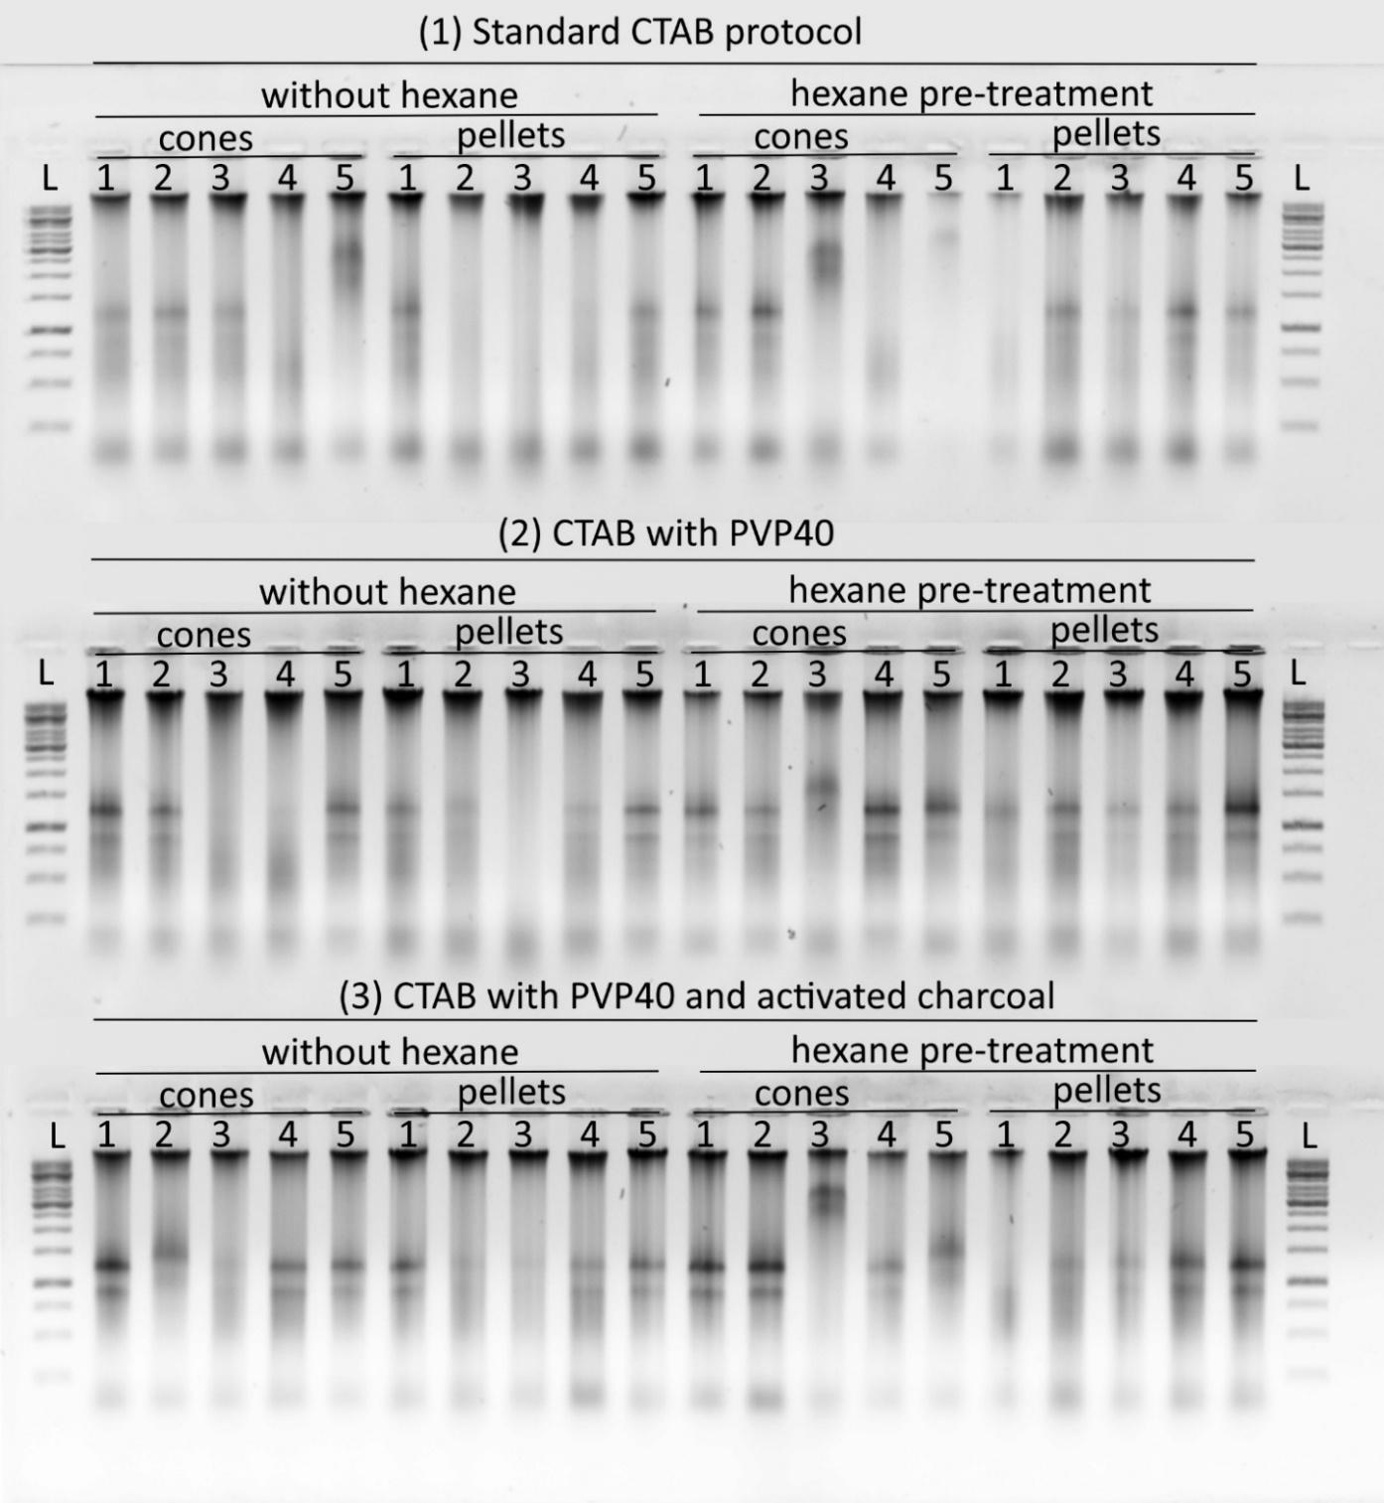
Figure 6: Results of agarose gel electrophoresis for cone and pellet hop DNA samples extracted with CTAB-based extraction methods with different pre-treatments
LEGEND: 1 = Celeia; 2 = Aurora; 3 = Styrian Wolf; 4 = Styrian Cardinal; 5 = Styrian Kolibri; L = GeneRuler 1 kb DNA Ladder (ThermoScientific)

Microsatellite Genotyping
Genotyping with fluorescent microsatellite markers (Pokorn, 2011) showed consistent and well visible allele patterns for DNA extracted using the first three protocols ((1) CTAB, (2) CTAB + PVP40, and (3) CTAB + PVP40 + activated charcoal) (Figure 7). A few samples did not amplify at certain loci, but these failures were random and not connected to any specific extraction method. Interestingly, rare or unexpected alleles were also detected. In the variety Kolibri, the majority of samples showed an additional 181 bp allele at the GA5-G3-10 locus, which has not yet been recorded in the reference database. Subsequent verification confirmed that this additional allele is genuine and represents a previously unreported fragment in Kolibri.
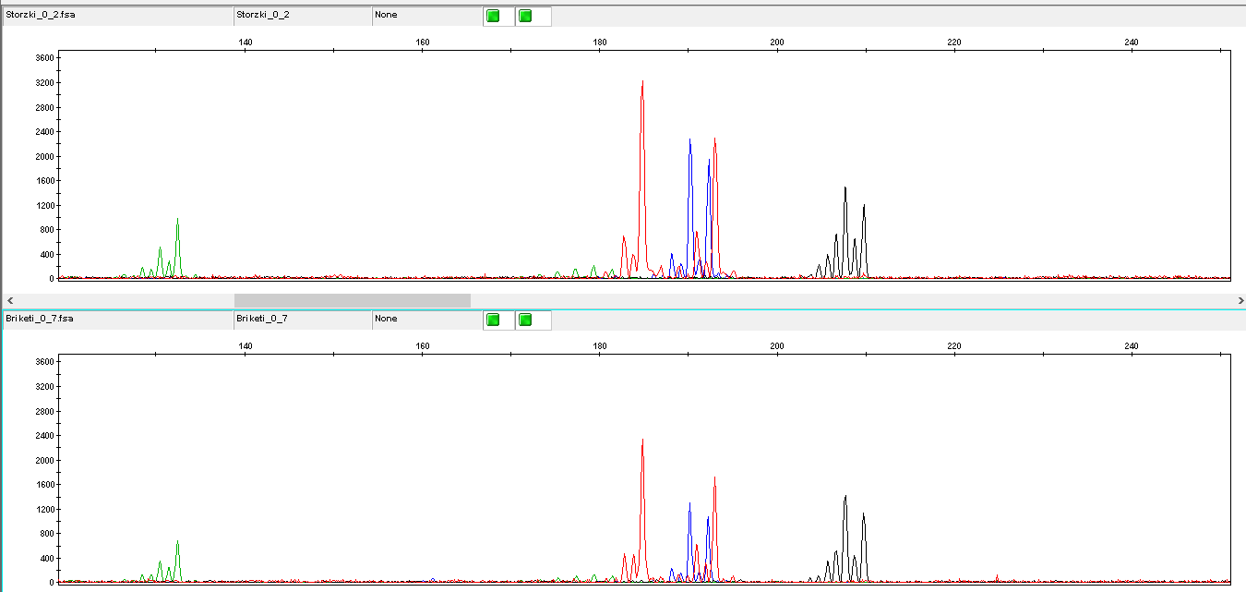
Figure 7: Representative electropherograms of microsatellite analysis from hop DNA samples. Capillary electrophoresis profiles showing microsatellite markers amplified from hop variety 'Aurora' DNA isolated from cones (up, Storzki_0_2) and pellets (down, Briketi_0_7). Both samples were processed using classical CTAB isolation method without hexane pre-incubation. The x-axis represents fragment size in base pairs, and the y-axis shows fluorescence intensity in relative fluorescence units (RFU). Different colours represent different fluorescent dyes used for distinct microsatellite markers.
The effect of different sample preparation methods on microsatellite peak heights was evaluated using normalized data to account for variety-specific variations (Figure 8). After z-score normalization within each variety, Kruskal-Wallis statistical analysis of microsatellite 11a59 peak height (1 allele per variety) revealed that the matrix type significantly influenced peak heights (p = 0.0058), with distinct patterns observed between cone and pellet samples. The DNA isolation method also showed significant effects (p = 0.0266), with the CTAB + PVP40 method demonstrating the most consistent results across varieties. Hexane pre-incubation exhibited a marginal effect (p = 0.0719), suggesting a subtle influence on peak heights that became more apparent after controlling for variety differences.
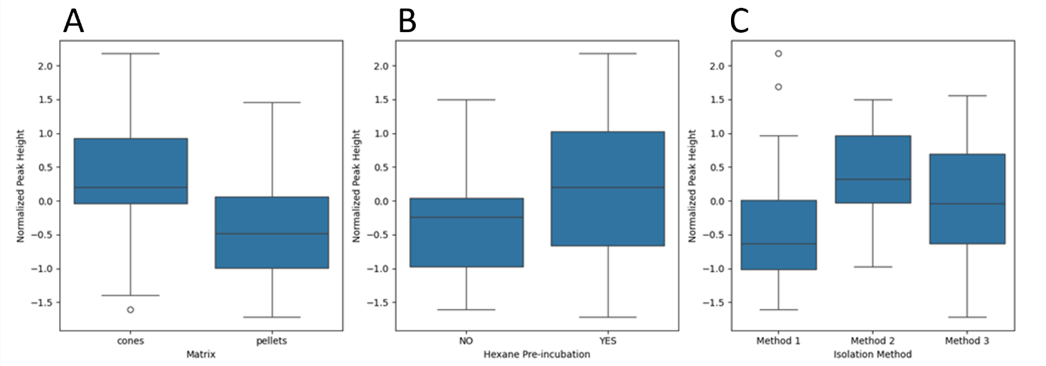
Figure 8: Impact of sample preparation methods on microsatellite peak heights in hop DNA analysis. Normalized peak heights compared across (A) matrix type, (B) hexane pre-incubation treatment, and (C) DNA isolation methods. Data normalized within varieties using z-score transformation.
These results additionally confirm that tested methods produced DNA of sufficient quality for reliable PCR amplification and genotyping with indication for improvement of results by hexane pre-incubation and isolation protocol 3 (classical CTAB with PVP40).

CONCLUSION
The results of this study show that three out of four tested CTAB-based extraction methods produced DNA of acceptable purity and integrity for downstream molecular analyses. The addition of PVP40 and activated charcoal slightly improved DNA purity by reducing contamination from phenolic compounds and polysaccharides, while the use of liquid nitrogen and PVP10 did not provide any benefit. DNA concentrations measured with Qubit ranged from 13.66 to 173.92 ng/µL, with the (1) standard CTAB and (3) CTAB + PVP40 + activated charcoal protocols giving the highest yields. Agarose gel electrophoresis confirmed that the extracted nucleic acids were largely intact, with no visible DNA degradation, although RNA bands were present due to the absence of RNase treatment.
Microsatellite genotyping further confirmed that DNA from the first three extraction protocols had sufficient quality for consistent PCR amplification and allele detection. Statistical evaluation of microsatellite peak heights revealed that both the matrix type and extraction method significantly influenced amplification intensity, while hexane pre-incubation showed a marginal but positive effect on signal strength. DNA from cone samples generally produced higher and more consistent fluorescence peaks than DNA from pellets. Among extraction protocols, the CTAB + PVP40 method demonstrated the most stable performance across varieties, suggesting improved removal of PCR inhibitors. In most cases, allele profiles matched reference data, although a new 181 bp allele was identified in the Kolibri variety, representing a previously unreported variant.
Overall, this study confirms that CTAB-based methods remain reliable for genotyping DNA from hop cones and pellets. These methods yield DNA of high quality and purity suitable for reliable microsatellite genotyping of hop tissues. The inclusion of PVP40 and activated charcoal improves DNA purity, and pre-incubation with hexane may further enhance PCR performance. Despite their reliability, CTAB-based extractions are time-consuming and labour-intensive, typically requiring around three hours. The duration can increase with larger amounts of sample, mainly due to the manual homogenization step. Therefore, future work will focus on developing a faster and more efficient DNA isolation protocol that maintains the quality required for accurate and reproducible hop genotyping.
Acknowledgment
The research was carried out with financial support from the research program ARIS P4-0077 Kmetijske rastline-genetika in sodobne tehnologije.
Data Availability
Data are available from the corresponding author upon reasonable request.

REFERENCES
Brady, J.L., Scott, N.S. & Thomas, M.R. DNA typing of hops (Humulus lupulus) through application of RAPD and microsatellite marker sequences converted to sequence tagged sites (STS). Euphytica 91, 277–284 (1996).
Čerenak, A., Jakše, J., & Javornik, B. (2004). Identification and Differentiation of Hop Varieties Using Simple Sequence Repeat Markers. Journal of the American Society of Brewing Chemists, 62(1), 1–7.
Čerenak, A., Jakše, J., Štajner, N., & Javornik, B. (2012). Vrednotenje genskih virov hmelja z molekulskimi markerji. Acta Agriculturae Slovenica, 99(3), 355–361.
NanoVue. (2007). NanoVue user manual. GE Healthcare. (https://med.fsu.edu/sites/default/files/userFiles/file/NanoVue_Manual.pdf)
Hadonou, A.M., Walden, R. and Darby, P. (2004), Isolation and characterization of polymorphic microsatellites for assessment of genetic variation of hops (Humulus lupulus L.). Molecular Ecology Notes, 4: 280-282.
Jakše, J., Kindlhofer, K., & Javornik, B. (2001). Assessment of genetic variation and differentiation of hop genotypes by microsatellite and AFLP markers. Genome, 44(5), 773–782.
Jakše, J., Šatović, Z., & Javornik, B. (2004). Microsatellite variability among wild and cultivated hops (Humulus lupulus L.). Genome, 47(5), 889–899.
Križman, M., Jakše, J., Baričevič, D., Javornik, B., & Prošek, M. (2006). A robust CTAB-activated charcoal protocol for plant DNA extraction. Acta Agriculturae Slovenica, 87(2), 429–433.
Koister, G., & Cantor, E. (2019). A Practical Guide to Analyzing Nucleic Acid Concentration and Purity with Microvolume Spectrophotometers [Technical note]. New England Biolabs. (https://www.neb.com/en/-/media/nebus/files/application-notes/technote_mvs_analysis_of_nucleic_acid_concentration_and_purity.pdf)
Korbecka-Glinka, G., Skomra, U., & Olszak-Przybys, H. (2016). Cultivar identification in dry hop cones and pellets using microsatellite loci. European Food Research and Technology, 242(9), 1599–1605.
Krofta, K., & Patzak, J. (2014). Zjišťování autenticity českých odrůd chmele pomocí chemických a molekulárně-genetických analýz [Investigation of Czech hop varieties authenticity by means of chemical and genetic analyses]. Chmelařský institut s. r. o., Žatec, Czech Republic.
Kump, B., & Javornik, B. (1996). Evaluation of genetic variability among common buckwheat (Fagopyrum esculentum Moench) populations by RAPD markers. Plant Science, 114(2), 149–158.
Murakami, A., Darby, P., Javornik, B. et al. Microsatellite DNA Analysis of Wild Hops, Humulus lupulus L. Genet Resour Crop Evol 53, 1553–1562 (2006).
Ocvirk, M., Grdadolnik, J., & Košir, I. J. (2016). Determination of the botanical origin of hops (Humulus lupulus L.) using different analytical techniques in combination with statistical methods. Journal of the Institute of Brewing, 122(4), 580–587.
Paquet, A.-S., Siah, A., Lefèvre, G., Moureu, S., Cadalen, T., Samaillie, J., Michels, F., Deracinois, B., Flahaut, C., Alves Dos Santos, H., Etienne-Debaecker, A., Rambaud, C., Chollet, S., Molinié, R., Fontaine, J.-X., Waterlot, C., Fauconnier, M.-L., Sahpaz, S., & Rivière, C. (2023). Multivariate analysis of chemical and genetic diversity of wild Humulus lupulus L. (hop) collected in situ in northern France. Phytochemistry, 205, 113508.
Patzak, J. (2025, June 30). Personal communication at STC Meeting, Spalt, Germany.
Patzak, J., & Henychová, A. (2018). Evaluation of genetic variability within actual hop (Humulus lupulus L.) cultivars by an enlarged set of molecular markers. Czech Journal of Genetics and Plant Breeding, 54(2), 86–91.
Pokorn, T. (2011). Genotyping of Humulus lupulus [Master’s thesis, University of Ljubljana]. University of Ljubljana Repository.
Slovenian Institute of Hop Research and Brewing web page. Hop varieties catalogue. (https://www.ihps.si/en/research-and-development/publications/hop-variety-catalogues/)
Štajner, N., Jakše, J., Kozjak, P., & Javornik, B. (2005). The isolation and characterisation of microsatellites in hop (Humulus lupulus L.). Plant Science, 168(1), 213–221.

Ta članek je objavljen pod licenco Creative Commons Priznanje avtorstva-Deljenje pod enakimi pogoji 4.0 Mednarodna.

Vpliv tehnoloških postopkov na uspešnost kompostiranja hmeljevine
Barbara ČEH in Ana KARNIČNIK KLANČNIK
Tipologija / Article type: Strokovni članek / Professional article
Prispelo / Arrived: 22. 10. 2025
Sprejeto / Accepted: 2. 12. 2025
Objavljeno / Published: December 2025
Izvleček
V prispevku predstavljamo rezultate kompostiranja hmeljevine (listi in stebla hmelja, ki ostanejo po obiranju storžkov) na šestih hmeljarskih kmetijah. Kompostne kupe so postavili po obiranju hmelja (začetek septembra) v letih 2023 (štiri kmetije) in 2024 (šest kmetij). Kompostiranje naj bi potekalo po smernicah za kompostiranje hmeljevine, a so imeli na kmetijah med izvajanjem postopka različne težave. Le-te smo popisali in ocenili njihov vpliv na kakovost pridelanega komposta. Kompost smo vzorčili v aprilu v letih 2024 in 2025 in ugotovili, da je imel v vseh primerih temperaturo na nivoju okoliške in bil prijetnega vonja po zemlji. Največji negativen vpliv je imelo nezadostno mešanje – v primeru, ko je bil kup jeseni premešan le dvakrat, ni bila dosežena temperatura za higienizacijo (55 oC), material je bil slabo razgrajen, vsebnost hranil v kompostu je bila srednja, razmerje C:N pa neugodno. In le na teh vzorcih je bioindikatorski test kalivosti semen kitajskega kapusa pokazal možno fitotoksičnost komposta. Slabši rezultat je bil tudi v primeru, ko je bila za postavitev kupa uporabljena premajhna gmota biomase (le 7 ton) in je bila le-ta hkrati nekoliko presuha, ter v primeru, ko so kup prekrili s polprepustno ponjavo šele v sredini decembra namesto v novembru. Mešanje kupa v času dežja v primeru presuhe biomase jeseni je pozitivno vplivalo na parametre kakovosti komposta. Kompost z najboljšimi parametri je nastal v primeru, ko so izvajali kompostiranje dosledno po smernicah - pri rednem mešanju glede na meritve temperature, uporabljeni dovolj veliki gmoti hmeljevine (15 ton) in pravočasnem pokrivanju kupov. V tem primeru je bil test kalivosti 94 % (odličen kompost, ki vzpodbuja kalitev).
Ključne besede: hmeljevina, hmelj, Humulus lupulus L., kompost, organsko gnojilo
IMPACT OF THE IMPLEMENTATION ON SUCCESS OF HOP BIOMASS COMPOSTING ON FARMS
Abstract
This paper presents the results of composting hop waste biomass (leaves and stems remaining after cone harvesting) on six hop farms. Compost piles were established right after harvest (early September) in 2023 (at four farms) and 2024 (at six farms). Although composting was intended to follow the established guidelines for waste hop biomass composting, farmers encountered various difficulties during the process. These issues were documented and their impact on the quality of the final compost was assessed. Compost samples were collected in April 2024 and 2025. In all cases, the compost temperature matched the ambient temperature and had a pleasant earthy smell. The most severe negative impact was caused by insufficient turning—specifically, when the pile was turned only twice in autumn. This compost did not reach the sanitisation temperature (55 °C), showed poor biomass decomposition, had moderate nutrient content, an unfavourable C:N ratio, and the germination test with Chinese cabbage indicated potential phytotoxicity. Other suboptimal results were observed when the initial biomass amount was too small (only 7 t), when the biomass was too dry and not moistened, and when the pile was covered with a semi-permeable membrane only in mid-December instead of in November. Conversely, turning the pile during rainfall proved beneficial in cases of overly dry biomass. The highest-quality compost was obtained when farmer followed the guidelines consistently—regular turning based on temperature measurements, using a sufficiently large amount of biomass (15 t), and timely covering of the pile. In this case, the germination test reached 94%, indicating excellent compost that promotes seed germination.
Key words: hop waste biomass, hop, Humulus lupulus L., compost, organic fertilizer

UVOD
Proces kompostiranja je nadzorovana aerobna biološka razgradnja organske snovi, pri čemer nastane stabilna, humusu podobna snov, imenovana kompost. Ta metoda posnema naravno razgradnjo, vendar je le-ta okrepljena, pospešena in nadzorovana, da se čim bolj spodbuja razvoj mikroorganizmov (USDA 1999). S tem pristopom k ravnanju z rastlinskimi odpadki pretvarjamo rastlinske odpadke v dragoceno, reciklirano organsko gnojilo iz higienizirane in stabilizirane organske snovi. Pri pravilnem postopku kompostiranja se uničijo semena plevelov in morebitni prisotni patogeni (Pan in sod., 2023). S kompostom se vnaša v tla organska snov in hranila, s čimer se povečuje rodovitnost tal, izboljšajo se aktivnosti in s tem funkcije talnega mikrobioma (Jahangir in sod., 2021).
V preteklih letih smo na področju kompostiranja hmeljevine, ki se izvaja na kmetijah, izvedli vrsto poskusov in na tej podlagi napisali Smernice za ravnanje s hmeljevino in njeno predelavo v kompost na kmetijskem gospodarstvu, ki se ukvarja s hmeljarstvom (Čeh in sod., 2022) ter pridobili podatke o kakovostnih parametrih komposta, ki se lahko pridela na kmetijah pri skrbni izvedbi postopka (Čeh in sod., 2025).
V tem prispevku predstavljamo rezultate kompostiranja hmeljevine na šestih hmeljarskih kmetijskih gospodarstvih, ki začenjajo s kompostiranjem na svojih kmetijah.

MATERIAL IN METODE

Postavitev poskusov
Poskus smo izvedli na šestih hmeljarskih kmetijah v Spodnji Savinjski dolini in na Koroškem (na štirih v sezoni kompostiranja hmeljevine 2023/2024 in na dodatnih dveh v sezoni 2024/2025). Hmeljevina se praviloma začne kompostirati takoj po obiranju (konec avgusta do sredina septembra, odvisno od časa obiranja glede na sorto hmelja) in po šestih do sedmih mesecih dobimo zrel in stabilen kompost (Čeh in sod., 2025).
Po obiranju hmelja septembra 2023 in 2024 smo iz hmeljevine (stebla in listi) s približno enega hektarja (to je okrog 15 t hmeljevine, z dvema izjemama (preglednica 1) na vsaki kmetiji naredili kompostne kupe trapezoidne oblike, visoke 2 m. Obravnavanja so se razlikovala glede na začetno velikost delcev, saj obiralni stroji režejo stebla na različno dolžino, odvisno od tipa stroja, ter glede na to, ali obiralni stroj meče na kup istočasno trto in liste ali ločeno, zaradi česar je bilo treba material pred kompostiranjem pomešati.
V jeseni 2024 je bila hmeljevina nekoliko presuha. Na eni lokaciji (KG Z 2024) se je navlažila z enkratnim mešanjem v času deževja.
Za merjenje temperature na globinah 50 in 100 cm na vseh štirih straneh kupa smo uporabili prilagojeno sondo TFA® digitalnega vbodnega termometra. Kupi bi morali biti premešani takrat, ko je sredica kupa presegla 60 °C, vendar se to na vseh kmetijah, zaradi težav pri določanju pravega termina za mešanje ali v enem primeru okvare traktorja, ni vedno dosledno izvajalo (preglednica 1).
Ob koncu termofilne faze, ko so temperature v kupu padle pod 45 °C, kar je bilo v preučevanih sezonah v drugi polovici novembra, smo z obračanjem kupov zaključili in kupe do spomladi prekrili s polprepustno ponjavo TenCate Toptex. To je zračno prepustna, kemijsko obstojna tkanina, izdelana iz neprekinjenih 100 % polipropilenskih vlaken.
Septembra 2024 smo na eni lokaciji stehtali začetno mase hmeljevine in v začetku maja 2025 stehtali iz nje nastali kompost, da smo pridobili podatek o količini komposta (organskega gnojila), ki se pridela iz določene količine hmeljevine.

Vzorčenje in analiza komposta
V aprilu 2024 in 2025 smo izvedeli vzorčenje nastalega komposta. Najprej smo naredili vizualno oceno, ki je vključevala oceno barve, vonja, strukture, prisotnosti nerazgrajenih delcev in prisotnosti neželenih primesi. Vsebnost vlage smo določili s stiskanjem komposta v roki (Cornell Waste Management Institute, 1996). Primeren kompost mora biti vlažen, a ne moker; ko ga stisnemo v pesti, se ne sme drobiti (presuh) oziroma iz njega se ne sme pocediti voda (premoker).
Potem smo iz vsakega kupa odvzeli tri vzorce za kemijsko analizo, pri čemer je bil vsak vzorec komposta odvzet z roko na 12 različnih točkah iz globine 30–50 cm.
V svežih vzorcih smo analizirali pH in amonijski dušik N (NH4-N; SIST ISO 14255:1999), medtem ko smo v posušenih vzorcih analizirali vsebnost organskega ogljika in humusa (metoda SIST ISO 14235:1999), nitratnega dušika (NO3-N; SIST ISO 14255:1999), skupnega dušika (SIST ISO 11261:1996), fosforja (SIST ISO 6491:1999, prirejeno), kalija (SIST EN ISO 6869:2001, prirejeno) ter železa in cinka (sežig in meritev na atomskem absorpcijskem spektrometru; Hodnik, 1998). Vsebnost vlage je bila določena po najmanj 24-ih urah sušenja pri 60 °C - ko je bila dosežena konstantna masa vzorca.
Za oceno primernosti komposta smo uporabili tudi bioindikatorski test kalivosti s hitro kaljivim semenom kitajskega kapusa (Yuan in sod., 2018). Aprila 2025 smo dali kompost z vsake lokacije v tri vrtnarske lončke. V vsak lonček smo posejali po pet semen kitajskega kapusa in po 14 dneh prešteli vznikle rastlinice.
Rezultate smo obdelali v programih Excel in Statgraphics Plus, za zaznavanje razlik med obravnavanji smo uporabili Duncanov test (p=0,05).
Preglednica 1: Podatki po poskusnih lokacijah; odebeljeno so označene napake v postopku
KG in leto vzorčenja | Masa hmelje-vine  (t sveže snovi) | Listi in stebla pomešani že na obiralnem stroju | Velikost  delcev (cm) | Vodilo za oporo na njivi | Št. me-šanj | Dosežena tempera-tura za  higieniza-cijo | Datum pokrivanja kupa | Pokrito od nov. do apr.
KG Z 2024 | 15 | da | 5–50 | PP | 6 | da | 28. 11. 2023 | da
KG O 2024 | 15 | ne | 10-15 | žica | 4 | da | 28. 11. 2023 | da
KG S 2024 | 15 | ne | 5-10 | žica | 6 | da | 28. 11. 2023 | da
KG I 2024 | 7 | ne | 4-5 | PLA | 3 | ne | 28. 11. 2023 | da
KG Z 2025 | 15 | da | 5-50 | PLA | 2 | ne | Zadnji teden nov. | Le od nov. do jan.
KG O 2025 | 15 | ne | 10-15 | žica | 4 | da | Zadnji teden nov. | da
KG S 2025 | 15 | ne | 5-10 | PLA | 4 | da | Sredina dec. | Le od dec. do apr.
KG I 2025 | 7,5 | ne | 4-5 | PLA | 8 | da | Zadnji teden nov. | da
KG N 2025 | 15 | da | 2,5-5 | PLA | 5 | da | Zadnji teden nov. | da
KG K 2025 | 15 | da | 2,5-5 | PP + žica | 9 | da | Zadnji teden nov. | Le od nov. do jan.

Vremenske razmere v času kompostiranja 2023/2024 in 2024/2025
Povprečna temperatura septembra 2023 je bila za 3,0 °C višja od dolgoletnega povprečja, kar ga uvršča med enega najtoplejših od leta 1950. Oktobra je bila povprečna dnevna temperatura 15 °C (za 4,9 °C več kot je dolgoletno povprečje). Morebiti je to vplivalo tudi na to, da je bila hmeljevina jeseni 2023 nekoliko presuha za kompostiranje. V obdobju oktober – december 2023 je bilo 429 mm padavin (143 mm več kot je dolgoletno povprečje), od tega v oktobru 179 mm. Zima 2024 je bila nadpovprečno topla. Bila sta samo dva ledena dneva v januarju, ko se je maksimalna dnevna temperatura spustila pod ledišče; mrzli dnevi, ko se minimalna temperatura spusti pod -10 °C, pa so bili le štirje. Tudi april in maj 2024 sta bila toplejša od dolgoletnega povprečja; april za 2,7 °C in maj za 1,4 °C (Agrometeorološki …, 2024).
Padavine v septembru 2024, v času, ko kupi še niso bili pokriti, so bile zelo obilne, padlo je kar 264 mm dežja. V oktobru in decembru je bila povprečna temperatura zraka nad dolgoletnim povprečjem, v novembru na nivoju dolgoletnega povprečja. Največ dežja je padlo v oktobru (159 mm), v zadnjih dveh mesecih leta pa smo zabeležili malo padavin; novembra 60 mm in decembra 29 mm. Januar in februar 2025 sta bila nadpovprečno topla; v prvi in tretji dekadi januarja je bila povprečna temperatura kar za 6,5 in 6,8 °C višja od dolgoletnega povprečja. V prvih treh mesecih leta 2025 je bilo več padavin kot v dolgoletnem povprečju, sploh v marcu (Agrometeorološki …., 2025), kar pa naj ne bi vplivalo na postopek kompostiranja v pokritih kupih, morebiti pa bi bil lahko negativen vpliv le-teh na izpiranje hranil iz kupov, ki jih je januarja odkril veter.

Slika 1: Primerjava desetdnevnih povprečnih temperatur (T) in količine padavin (P) v letih 2023/2024 in 2024/2025 od septembra do aprila s 30. letnim povprečjem (1981‒2010) na postaji Medlog pri Celju (vir podatkov: ARSO) z referenčno postajo Spodnje Savinjske doline (Latkova vas)

REZULTATI IN RAZPRAVA

Vizualna ocena komposta
V preglednici 2 so navedeni rezultati vizualne ocene komposta glede na preučevano leto in kmetijsko gospodarstvo (KG).
Dober kompost ima prijeten, zemeljski vonj, medtem ko vonj po amonijaku, gnitju ali kislosti nakazuje na nepopolno kompostiranje. Če je temperatura komposta, enaka ali podobna zunanji pomeni, da je proces kompostiranja končan. Ta dva parametra sta bila dosežena v vseh primerih.
Temno rjava do skoraj črna barva komposta kažeta na dobro razgrajen organski material. To so dosegli vsi vzorci, razen enega (KG Z 2025), ki je bil svetlo rjave barve.
Struktura je pokazatelj razgrajenosti, pri čemer je dober znak, če je kompost drobljiv, homogeno zrnast, brez večjih ne-razgrajenih delcev. V dobrem kompostu ni prepoznavnih delov prvotnega materiala, kot so vidna prisotnost vejic, stebel in listov, kar nakazuje na slabšo razgradnjo. V prvem letu (2024) je bil samo kompost s KG Z zelo dobro razgrajen - na kmetiji so izvajali mešanje kupa enkrat v dežju, pri čemer se je kup navlažil. V nobenem od ostalih treh kupov se sicer kompost ob stisku v pest ni razdrobil, pri vseh se je obdržala oblika, vendar pa so bili vzorci na otip nekoliko suhi in so kazali krhkost na površini, kar pomeni, da bi bila za optimalno mikrobiološko aktivnost in lažjo razgradnjo organske snovi boljša nekoliko višja vlažnost. Po smernicah za kompostiranje (Čeh in sod., 2022) naj bi biomasa ob stisku v pest obdržala obliko, a bila hkrati rahlo vlažna na otip, kar torej pri ostalih treh kupih ni bilo povsem doseženo.
V drugem letu (2025) je bila stopnja razgradnje komposta slabša od drugih kupov na KG O in KG Z. Na KG O je bil vzrok morebiti ta, da so morali na začetku pomešati listje in trto (ker ti dve frakciji njihov obiralni stroj ločuje) in morebiti mešanica ni bila dovolj homogena. Na KG Z pa je bil kup premešan le dvakrat, ker se je potem pokvaril traktor. Mešanje biomase pozitivno vpliva na povečanje zračnosti, preprečuje nastanek anaerobnih con (brez kisika), kjer bi se začele razvijati gnilobne bakterije, da ne nastaja neprijeten vonj, na hitrost razgradnje, pomaga pri uravnavanju vlage – suhi in mokri deli se izenačijo, uravnavanju temperature (vroči deli v notranjosti in hladnejši v zunanjem deli se premešajo), bolj enakomerne razmere za mikroorganizme, rahlja se material in olajša dostop kisika. Z mešanjem se aktivne cone razgradnje širijo na celoten volumen kupa.
V kompostu je nezaželena prisotnost primesi, kot so plastika, kovine ali drugi odpadki (Lobnik, 2007). Kakor je razvidno iz preglednice 2, so to dosegli le kupi, ki so v hmeljevini vsebovali biorazgradljivo vrvico.
Kompost mora biti rahlo vlažen, a ne premoker ali izsušen (Lobnik, 2007). Vsi razen enega kupa so to dosegli; kup na KG Z 2025 je namreč imel zelo vlažen obod in relativno suho sredico. Ta kup je poleg ostalih že navedenih težav tudi odkril veter že v januarju in je bil nepokrit do vzorčenja v aprilu. Sicer je kup odkril veter tudi na KG K v tej sezoni, vendar pa je bil kljub temu v tem primeru kompost lepo enakomerno vlažen.
Preglednica 2: Opažanja pri vizualni oceni komposta glede na kmetijo in leto vzorčenja; odebeljeno so zapisane negativno izstopajoče lastnosti posameznega komposta.
Leto vzor-čenja | KG | Barva | Vonj | Struktura | Prisotnost nerazgraje-nih delcev | Prisotnost neželenih primesi | Vlaga
2024 | KG I | temno rjava | po zemlji | slabo razgrajeno, veliko nerazgrajenih stebel | da | žica (trda, oksidirana), polipropilenska vrvica | ustrezna
2024 | KG Z | temno rjava | po zemlji | dobro razgrajen | ne | žica (trda, oksidirana), polipropilenska vrvica | ustrezna
2024 | KG O | temno rjava | po zemlji | delno razgrajen, vidijo se še stebla hmeljevine | da | polipropilenska vrvica (nacefrana) | ustrezna
2024 | KG S | temno rjava | po zemlji | nerazgrajen | da | biorazgradljiva vrvica nerazgrajena) | ustrezna
2025 | KG O | temno rjava | po zemlji | delno razgrajen, vidijo se še stebla od hmeljevine, dokaj nerazgrajena | da | žica (trda, oksidirana), polipropilenska vrvica | ustrezna
2025 | KG K | temno rjava | po zemlji | homogena, dobro razgrajena | ne | polipropilenska vrvica | ustrezna
2025 | KG Z | svetlo rjava | po zemlji | delno razgrajen, vidijo se še dokaj nerazgrajena stebla hmeljevine | da | kosi nerazgrajene biorazgradljive vrvice | zelo vlažno v zunanjem sloju kupa, dokaj suho v sredini
2025 | KG S | temno rjava | po zemlji | homogen kompost, dobro razgrajena biomasa | ne | samo na površini še vidno nekaj biorazgradljive vrvice, sicer ne | ustrezna
2025 | KG N | temno rjava | po zemlji | homogen kompost, dobro razgrajena biomasa | ne | polipropilenska vrvica | ustrezna
2025 | KG I | temno rjava | po zemlji | homogen kompost, dobro razgrajena biomasa | ne | biorazgradljiva vrvica (sicer zelo razpadla, a še nekoliko vidna) | ustrezna

Razmerje med hmeljevino in maso pridelanega komposta
S tehtanjem začetne hmeljevine (15 t hmeljevine, to je z okrog 1 ha hmeljišča) v septembru 2024 in tehtanjem iz nje nastalega komposta v aprilu 2025 smo ugotovili, da smo iz 15 t hmeljevine (vsebnost vlage 70 %, torej 4,5 t suhe snovi) dobili 11,5 t komposta z 61 % vlage, torej 4,5 t suhe snovi komposta. Suha snov se je med kompostiranjem torej praktično ohranila, izgube so bile očitno minimalne, čeprav bi pričakovali nekaj izgub zaradi biološke razgradnje organskih snovi, pri kateri mikroorganizmi porabljajo ogljik kot vir energije in se večji del ogljika sprosti v obliki CO₂.

Vlaga
Oshins in sod. (2022) in Cornell Waste Management Institute (1996) priporočajo vlažnost komposta med 45–60 %, po navedbah McFarlanda (2001) naj bi imela začetna kompostna mešanica vsebnost vlage med 50–70 %. Za kompost iz hmeljevine pa je po navedbah Luskar in sod. (2022) primerna vlaga 60–70 %. V naših vzorcih je bila glede na lokacijo aprila 2024 vlaga v kompostih 51–61 %, v aprilu 2025 pa med 60–78 % (preglednica 3). Komposta na KG I in KG S nista dosegla te zahteve. V prvem primeru je bil vzrok morebitna premajhna količina vstopne biomasa oz. premajhna gmota kompostnega kupa, zato proces ni nemoteno potekal, v jeseni pa je bila biomasa nekoliko presuha. V drugem vzorcu pa morebiti vstopna biomasa ni bila homogeno pomešana, zato proces ni nemoteno stekel.
V aprilu 2025 je bil kompost vseh kupov primerne vlažnosti.
V obeh letih se je vlaga v kompostu značilno razlikovala med lokacijami. V aprilu 2024 je bila značilno manjša na KG I in KG S v primerjavi s KG Z in KG O, v aprilu 2025 pa značilno manjša na KG I, KG O in KG S v primerjavi s KG K, KG Z in KG N. V poskusih Luskar in sod. (2022) je bila vlaga komposta iz hmeljevine okoli 70 % (kupi v njihovem poskusu niso bili pokriti čez zimo in pomlad), medtem ko so imeli čez zimo in pomlad pokriti kompostni kupi hmeljevine v poskusu Čeh in sod. (2025) v aprilu vlago 60–71 %.
Preglednica 3: Vsebnost hranil v kompostu glede na kmetijsko gospodarstvo (KG) v aprilu 2024 in aprilu 2025 (po sedmih mesecih kompostiranja; v suhi snovi - s.s.) v primerjavi s hlevskim gnojem in odličnim kompostom iz hmeljevine
Leto vzor-čenja | KG | Vse-bnost vlage (%) | Celok. P (% v s.s.) | Celok. K (% v s.s.) | N (org. + NH4-N + NO3-N)  (% v s.s.) | Organski C  (% v s.s.) | Zn  (mg/kg s.s.) | Raz-merje  C : N | Fe (mg/g s.s.)
2024 | KG I | 51 a* | 0,2 a | 0,3 a | 1,5 a | 27 ab | 80 a | 12 : 1 c | 1,7 ab
2024 | KG Z | 61 c | 0,3 a | 0,7 a | 3,0 c | 34 bc | 70 a | 8 : 1 ab | 0,8 a
2024 | KG O | 60 bc | 0,3 a | 0,9 a | 2,4 bc | 37 c | 40 a | 10 : 1 bc | 3,4 c
2024 | KG S | 52 ab | 0,2 a | 0,5 a | 1,7 ab | 21 a | 85 a | 8 : 1 a | 2,9 bc
2025 | KG O | 67 a | 0,3 b | 1,4 c | 3,5 c | 21 b | 47 a | 7 : 1 a | 2,2 b
2025 | KG K | 78 b | 0,3 b | 1,6 c | 3,6 c | 28 c | 43 a | 9 : 1 a | 0,4 a
2025 | KG Z | 78 b | 0,4 b | 1,0 b | 4,6 d | 27 c | 45 a | 7 : 1 a | 0,03 a
2025 | KG S | 60 a | 0,2 a | 0,4 a | 1,5 a | 12 a | 60 a | 9 : 1 a | 0,9 a
2025 | KG N | 75 b | 0,4 b | 1,8 c | 4,8 d | 29 c | 104 b | 8 : 1 a | 0,04 a
2025 | KG I | 66 a | 0,3 b | 0,9 b | 2,3 b | 19 b | 73 ab | 8 : 1 a | 0,3 a
- | Hlevski gnoj** | 75–80 | 0,5 | 2,2 | 2,2 | 40–45 | - | 15–25 : 1 | -
- | Ciljna vrednost za kompost iz hmeljevine*** | 65 | 0,5 | 2,1 | 3,5 | 33 | 50 | 9–10 : 1 | -
*Enaka črka v stolpcu določenega parametra in znotraj istega leta (2024 in 2025) pomeni, da med vrednostma ni značilne razlike.
**Podatki iz Mihelič in sod. (2010), Smernice za strokovno utemeljeno gnojenje (dostopno na: https://skp.si/download/smernice_za_strokovno_utemeljeno_gnojenje-pdf), preračunano na suho snov (s.s.)
***Podatki iz članka Čeh in sod. (2025) kot povprečje treh kupov komposta iz hmeljevine s strokovno dosledno izvedenim postopkom kompostiranja.

pH komposta
V začetni fazi kompostiranja se sproščajo organske kisline, ki jih v termofilni fazi mikroorganizmi razgradijo, kasneje med stabilizacijo pa se sprošča amonij, ki tvori bazično reakcijo (NH4OH), kar običajno vodi v dvig pH od 7,5 do 8,5. Slabo zračenje lahko povzroči anaerobne razmere, pri čemer nastajajo organske kisline, kar se odrazi v nižjem pH, lahko pa na razliko vpliva tudi različna mikrobna aktivnost. Hachicha in sod. (2009) in Rynk in sod. (1992) navajajo, da je pH območje zrelega komposta 6,0–8,5.
V našem poskusu se je pH komposta v obeh letih značilno razlikoval med lokacijami, je pa bil v vseh primerih v okviru pričakovanega razpona za zrel kompost. V aprilu 2024 je bil značilno manjši na lokaciji KG I (8,0) kot na ostalih lokacijah, na lokaciji KG S je bil značilno najvišji (8,4) (preglednica 3). V aprilu 2025 je bil pH nekoliko nižji kot v letu prej, bil je 7,7–8,1 glede na lokacijo. Na KG Z, KG N in KG I je bil značilno najnižji, značilno najvišji pa na KG K. V poskusih Luskar in sod. (2022) je bil pH komposta iz hmeljevine 7,6–8,1.

C:N razmerje
O zrelem kompostu govorimo, ko je C:N razmerje 10–20 : 1, saj je takrat večina lahko razgradljive organske snovi že predelana in mikroorganizmi več ne porabljajo presežka dušika in kompost ne povzroča dušične depresije v tleh. Glede na to sta imela kupa KG Z in KG S v aprilu 2024 preozko C:N razmerje (8 : 1), ostala dva komposta sta dosegla to zahtevo. Vendar je tudi kompost iz poskusa Čeh in sod. (2025), ki je bil proizveden pod skrbnim spremljanjem temperature in obračanjem/mešanjem natančno po strokovnih navodilih, dosegel C:N razmerje 9–10 : 1.
V aprilu 2025 je bilo C:N razmerje v kompostu od 7 : 1 do 9 : 1 in med lokacijami statistično značilno primerljivo. Najožje C:N razmerje je bilo na KG Z (7 : 1), kar je preozko za zrel kompost. Na KG Z se torej pozna tudi na tem parametru, da se kup ni dovolj obračal (samo dvakrat zaradi okvare na traktorju).
Za primerjavo - svež hlevski gnoj ima C:N razmerje 15–25 : 1 (odvisno od stelje in skladiščenja), pri starejšem/kompostiranem gnoju pa je bližje 15 : 1 - bolj podobno dobremu zrelemu kompostu (Rynk in sod., 1992).

Vsebnost organskega ogljika
V aprilu 2024 je bila vsebnost organskega ogljika v suhi snovi vzorcev komposta 21–37 %, kar je primerljivo z rezultati poskusa Čeh in sod. (2025), v katerih je kompost iz hmeljevine vseboval 23–38 % organskega ogljika. Značilno največja vsebnost organskega ogljika je bila v kompostu na KG O in KG Z ter značilno najmanjša v kompostu s KG S.
Tudi v aprilu 2025 se je vsebnost organskega ogljika med lokacijami značilno razlikovala, vendar so bile vrednosti nižje kot v letu prej. Značilno najmanjša je bila na KG S (12 %), značilno največja pa na KG N (29 %), KG Z in KG K. Morebiti je bila relativno majhna vsebnost ogljika v kompostu na KG S posledica nehote primešane zemlje (npr. z nakladalno žlico traktorja pri mešanju, z drsanjem le-te po tleh …). Zemlja namreč vsebuje le 1–3 % organskega ogljika (FAO, 2017), zato že manjša primes razredči delež ogljika v gmoti. To bi bilo možno, saj je ta kompost vseboval tudi značilno najmanj fosforja, kalija in skupnega dušika (preglednica 3).
Rezultati potrjujejo, da ima način izvedbe kompostiranja velik vpliv na končno vsebnost organskega ogljika. Kompost z višjo vrednostjo (npr. KG O, KG Z, KG N) je praviloma bolj stabilen, hranila se sproščajo počasneje, kar je koristno za dolgoročno izboljšanje organske snovi v tleh in rodovitnosti tal. Tak kompost je še posebej primeren za zboljšanje tal, saj prispeva k povečanju vsebnosti humusa v tleh in dolgoročni stabilnosti strukture tal.

Celokupni fosfor in celokupni kalij
Čeprav je bila kompostirajoča masa septembra in v začetku oktobra 2023 zaradi suhega vremena (slika 1) nekoliko presuha, kmetje kupov niso navlaževali. Razlog, ki so ga navedli, je bil predvsem v tem, da se prvi mesec kompostiranja časovno prekriva z obiranjem drugih sort hmelja, ta agrotehnični ukrep pa ni del njihove rutine na posestvu, zato so bili zaposleni z drugimi opravili. Na nekaterih kmetijah je bila težava, da obiralni stroj ločuje trto in listje in se mora vse to pred kompostiranjem premešati, kar se lahko odrazi v nehomogeni mešanici in se del kupa, kjer je veliko stebel, hitreje osušuje. Te napake so se (med drugim) verjetno odrazile v slabši hranilni vrednosti komposta aprila 2024, kot bi jo sicer lahko dosegli (preglednica 2) in kot so jo na kmetijah dosegli v naslednji sezoni kompostiranja. Skupna vsebnost fosforja (P) in kalija (K) se med lokacijami aprila 2024 sicer ni značilno razlikovala, a v kupih KG Z in KG O so bile vrednosti nekoliko višje. V teh dveh kupih je bila značilno višja tudi vsebnost dušika (N) kot v preostalih dveh. Ta dva komposta sta vsebovala slabše razgrajen material.
Aprila 2025 so se med lokacijami pokazale značilne razlike v vsebnosti celokupnega P in K v kompostu. Značilno najmanj ju je bilo v kupu KG S, ki so ga pokrili dva tedna kasneje kot drugod. Na slabši rezultat na tej lokaciji je morda vplival tudi način priprave kupa, saj so morali stebla in liste hmeljevine, ki jih je stroj ločil, premešati, kar je verjetno povzročilo manj homogeno zmes, kot če bi stroj že sproti mešal liste in delce stebel. Lahko pa je v času zamika v pokrivanju prišlo do dodatne izgube/izpiranja hranil s padavinami.
Če primerjamo vsebnosti P in K v našem poskusu z vzorčnim kompostom iz hmeljevine, ki dosega primerljivo vsebnost P in K kot hlevski gnoj (Čeh in sod., 2025; preglednica 2), vidimo, da bi se z bolj skrbnim postopkom kompostiranja lahko pridelal kompost z višjo vsebnostjo P in K. V poskusih Čeh in sod. (2025) je dal najboljše rezultate in je imel tudi najmanj izcednih vod in najnižje izgube hranil kup hmeljevine, ki je bil postavljen takoj po obiranju hmelja, začetni delci hmeljevine so merili 2–10 cm, kup so petkrat obrnili na podlagi rednih meritev temperature in ga prekrili s polprepustno ponjavo novembru. Ta rezultat lahko vzamemo kot referenčni primer glede hranilne vrednosti komposta iz hmeljevine v naših razmerah (preglednica 2). Za primerjavo - kompost iz oljčnih tropin v poskusih Chowdhury in sod. (2013) je vseboval 0,1–3 % P in 0,12–4,4 % K.

Vsebnost dušika
Vsebnost nitratnega dušika (NO3-N) je bila v aprilu 2024 značilno največja v kompostu KG Z (6,0 g/kg), sledil je kompost KG O (slika 2), medtem ko sta imela komposta KG I in KG S značilno najmanjšo vsebnost NO3-N (1,3 oziroma 1,4 g/kg). V aprilu 2025 je bila vsebnost NO3-N značilno največja na KG N (11 g/kg s.s.), značilno najmanjša na KG S (0,3 g/kg s.s.) in KG I (0,6 g/kg s.s.), kar je primerljivo s komposti poskusa Čeh in sod. (2025), ki so po strokovno dosledno izvedenem kompostiranju hmeljevine imeli vsebnost NO3-N 0,7 do 1,6 g/kg.
Po navedbah Zucconi in de Bertoldi (1987) bi morala biti vsebnost amonijske oblike N (NH4-N) v zrelem kompostu manjša od 0,4 g/kg; komposti v našem poskusu so v 2024 izpolnjevali to zahtevo, na meji je bil le KG Z. V 2025 pa sta le dva vzorca dosegla to zahtevo, in sicer vzorca s KG O in KG S. Najbolj je vrednost presegel vzorec s KG Z (1,0 mg/kg s.s.), kjer ni bila dosežena termofilna faza in ni bilo ustreznega mešanja.
Kot so poročali v poskusu Čeh in sod. (2025), je višja vsebnost NO3-N ob nižji vsebnosti NH4-N posledica bolj celovitega procesa nitrifikacije in bolj zrelega komposta, omogočenega s pokritjem kupov skozi celotno fazo zorenja v primerjavi s kupi v poskusih, kjer kupi niso bili pokriti. V naših vzorcih iz obeh let (2024 in 2025) je bilo to razmerje zelo ozko le pri KG I in KG S v 2025, ostali vzorci so imeli dosti večjo vsebnost nitratne (NO3-N) kot amonijske oblike N (NH4-N). Samo v dveh primerih (na KG I in KG S v 2025) je nitrifikacija potekala manj intenzivno.

Slika 2: Vsebnost različnih oblik dušika v kompostu različnih kmetij (KG) aprila 2024 in aprila 2025

Vsebnost cinka in železa
Med vzorci komposta v aprilu 2024 ni bilo značilnih razlik v vsebnosti cinka, v aprilu 2025 pa se je med lokacijami vsebnost značilno razlikovala med lokacijami, in sicer je bila značilno največja v kupu na KG I, sledil je kup na KG N. Kljub temu so glede na vsebnost cinka vsi komposti v obeh preučevanih letih dosegli zahtevo za 1. razred (manj kot 0,4 g Zn/kg suhe snovi). S cinkom je bil problem v kompostu iz hmeljevine v naših poskusih sicer le enkrat v preteklih letih, ko so hmeljevini pred začetkom kompostiranja primešali kurjeke.
Vsebnost železa (Fe) sta imela v aprilu 2024 komposta KG S in KG O (oba kupa iz hmeljevine, ki je vsebovala žico kot vodilo) značilno višjo kot druga dva komposta (KG I in KG Z), ki sta imela kot vodilo primešano plastično oziroma biorazgradljivo vrvico iz polimlečne kisline (PLA) (preglednica 3). V aprilu 2025 pa je bila vsebnost Fe v kompostu na KG O, ki je imel edini žico kot vodilo v celotnem poskusu, značilno večja kot v vseh ostalih vzorcih.
Določene mejne vrednosti za vsebnost železa v kompostu ni, so pa rezultati raziskav pokazali, da se vsebnost med komposti iz različnih organskih odpadkov močno razlikuje (Gao in sod., 2023) glede na izvor materiala, sestavo vhodnih snovi in postopke kompostiranja. V poskusu Ceylan (2014), v katerih so začetne mešanice biomase pripravili z mešanjem govejega gnoja, piščančjega gnoja, lupin lešnikov, odpadkov obrezovanja lešnikov, zelenjavnih in sadnih odpadkov ter suhih listov, nato pa so jih kompostirali 180 dni, je bila vsebnost Fe v končnem kompostu 4025 mg/kg, 8879 mg/kg, 3889 mg/kg oz. 1775 mg/kg.

Bioindikatorski test kalivosti
V kolikor je vznik posejanih rastlin nad 90 %, se šteje, da je kompost odličen, v kolikor je med 80–90 % dober, v kolikor je vznik pod 80 %, pa se šteje, da je takšen kompost sicer sprejemljiv, a je možna blaga fitotoksičnost (Evanylo, 2020). Skrbna in ustrezna priprava materiala ter nadzor procesa kompostiranja omogočata, da dobimo kakovostnejši kompost, kar posledično vpliva tudi na boljši vznik rastlin. Nasprotno pa lahko manj natančna tehnologija privede do manj kakovostnega komposta in slabših rezultatov pri vzniku. V našem poskusu je bil najvišji vznik kitajskega kapusa zabeležen pri kompostu s KG N 2025, in sicer 94 %, najnižji pa je bil pri kompostu s KG Z 2025, in sicer pod 80 % (slika 3). V ostalih vzorcih komposta je bil vznik 86 %.
Rezultati tega testa potrjujejo rezultate predhodnih meritev, da brez ustreznega mešanja razgradnja ni enakomerna in lahko v gmoti ostanejo fitotoksične snovi (npr. amonijak, hlapne organske kisline), ki zavirajo vznik. Zaradi nepopolne termofilne faze v primerih, ko kompost ne doseže 55–65°C več dni zapored, se ne uničijo patogeni in škodljive bakterije, kompost pa lahko vsebuje organizme, ki ovirajo kalitev ali razvoj rastlin. Če kompost ni dozorel, lahko v njem še vedno poteka razgradnja, pri čemer se porablja kisik in se ustvarjajo plini, kar negativno vpliva na rast rastlin.
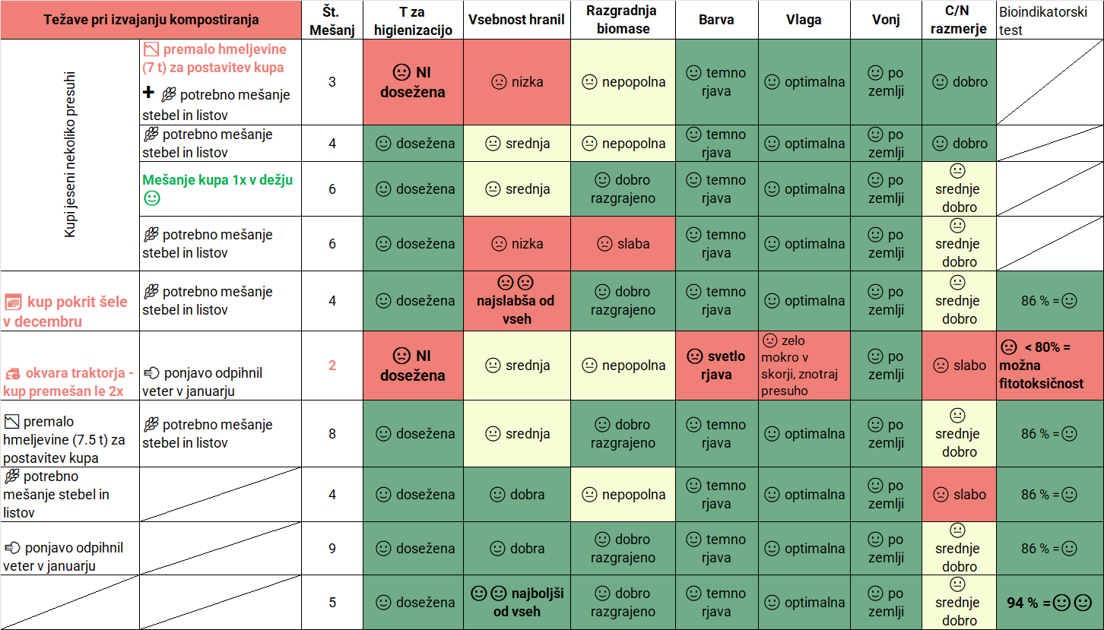
Slika 3: Shematsko prikazani rezultati kompostiranja na kmetijah glede na vrsto težave pri izvajanju kompostiranja (zelena barva – parameter ustrezen, rumena barva – parameter srednje dober, rdeča barva – slaba ocena za dotičen parameter)

ZAKLJUČKI
Pravilno izvedeno kompostiranje hmeljevine na kmetiji predstavlja učinkovit proces za pridobitev kakovostnega in varnega organskega gnojila – s skrbnim postopkom kompostiranja lahko pridelamo kompost, ki je v vsebnosti P in K primerljiv hlevskemu gnoju, v vsebnosti N pa ga celo prekaša – vendar je treba dosledno slediti priporočenim smernicam. Kmetije v naši raziskavi so pridelale kompost z nekoliko manjšo vsebnostjo hranil od pričakovane, nekatere so imele tudi slabše razgrajen in celo nehigieniziran kompost. Razlogi so bili kombinacija različnih nedoslednosti: v enem primeru se je kup premešal le dvakrat, v drugem se je pokril relativno pozno – šele v sredini decembra, vhodna biomasa hmeljevine je bila pol manjša od priporočene, biomasa je bila jeseni presuha, ipd.
Največji negativen vpliv na kakovost komposta je povzročila okvara traktorja, zaradi katere je bil kup premešan le dvakrat (KG Z 2025). Ta kompost je imel najslabše parametre in ni izpolnil varnostnih kriterijev - bioindikatorski test kalivosti je pokazal manj kot 80 % kalitev semen kitajskega kapusa, kar nakazuje morebitno fitotoksičnost komposta. Težava se je nakazala že jeseni, ko kup ni dosegel temperature za higienizacijo, ki znaša vsaj 55 °C. Prav tako je bil to edini kompost svetlo rjave barve, medtem ko so vsi ostali razvili značilno temno rjav odtenek. Vsebnost hranil je bila srednja, razgradnja vhodnega materiala pa nepopolna - v kompostu je bilo še veliko nerazgrajenih stebel. Razmerje C:N je bilo neugodno, kar dodatno potrjuje nizko zrelost in slabo kakovost komposta.
Drugi najslabši postopek je bil na KG I 2024 - jeseni presuha biomasa hmeljevine v kombinaciji s premajhno vhodno količino biomase (le 7 ton namesto priporočenih najmanj 15 ton). Ta kup ni dosegel temperature, potrebne za higienizacijo, razgradnja materiala je bila nepopolna, vsebnost hranil v kompostu pa majhna.
Čeprav je bila količina začetne biomase na KG I v naslednjem letu prav tako nezadostna (7,5 t), se ta pomanjkljivost ni odrazila v toliko slabši kakovosti komposta, saj je bil kup jeseni premešan kar osemkrat in ni bil presuh.
Težavo prenizke vlažnosti v kupu jeseni se je dalo rešiti že s tem, da je kmet kup enkrat premešal med dežjem – primer KG Z 2024. Med vsemi kupi, ki so bili jeseni 2023 nekoliko presuhi, je imel ta ukrep izrazito pozitiven vpliv na kakovost komposta. Vsebnost hranil sicer ni bila najvišja, se pa je biomasa dobro razgradila.
Najslabše rezultate glede vsebnosti hranil med vsemi preučevanimi kompostnimi kupi je pokazal kup KG S 2025. Kot možen vzrok navajamo zamik pri prekrivanju kupa, saj je bil ta pokrit šele sredi decembra namesto konec novembra, zaradi česar je v vmesnem obdobju verjetno prišlo do povečanega izpiranja hranil. Zato je pravočasno pokrivanje kompostnega kupa, takoj po termofilni fazi, izjemnega pomena. Poleg tega obstaja možnost, da stebla in listi hmeljevine na začetku niso bili enakomerno premešani ali pa se je med mešanjem v kup primešala zemlja, kar sklepamo na podlagi nizke vsebnosti organskega ogljika, ugotovljene prav v tem kompostu.
Po vsebnost cinka so vsi komposti dosegli zahtevo za 1. kakovostni razred, vsebnost železa pa je bila značilno večja v primeru komposta, nastalega iz hmeljevine s primešano žico, ki je tekom rastne sezone služila kot opora hmelju.
Najboljše rezultate je dosegel kompost na KG N 2025, kjer je kmet dosledno upošteval smernice za kompostiranje hmeljevine na kmetiji.
Iz 15 t hmeljevine, ki predstavlja maso hmeljevine z enega hektarja hmeljišč, s približno 70 % vlago (4,5 t suhe snovi) smo v pridobili 11,5 t komposta z 61 % vlage, torej 4,5 t suhe snovi komposta.
Zahvala
Delo je nastalo v sklopu After LIFE programa EU LIFE projekta BioTHOP, rezultati pridobljeni v okviru projekta EIP EKOHMELJ in prispevek spisan v okviru strokovne naloge Tehnologija pridelave in predelave hmelja. Financerjem se zahvaljujemo za financiranje in zaupanje.
Dostopnost raziskovalnih podatkov
Podatki so na voljo pri avtoricah na utemeljeno zahtevo.

VIRI
Agrometeorološki portal. 2025. Dostopno na: https://agromet.mkgp.gov.si/APP2/sl/Home/Index
Chowdhury A.K.M.M.B., Akratos C.S., Vayenas D.V., Pavlou S. (2013): Olive mill waste composting: a review. International Biodeterioration and Biodegradation, 85: 108–119.
Cornell Waste Management Institute (1996). Available at: https://compost.css.cornell.edu/physics.html?utm_source=chatgpt.com
Čeh, B., Flis, J., Luskar, L., Polanšek, J., Trošt, Ž. 2022. Smernice za ravnanje s hmeljevino in njeno predelavo v kompost na kmetijskem gospodarstvu, ki se ukvarja s hmeljarstvom. Dostopno na: https://life-biothop.eu/wp-content/uploads/2022/08/Smernice_hmeljevina-AVGUST-2022_FINAL-VERZIJA-1.pdf
Čeh, B., Polanšek, J., Trošt, Ž., Karničnik Klančnik, A. 2025. On-site composting of waste hop biomass: the impact of covering piles on leachate quantity and compost quality. Plant Soil Environ., 2025, 71(2):109-122 | DOI: 10.17221/197/2024-PSE
Evanylo, G. 2020. Compost Standards and Quality. Available at: https://www.clemson.edu/extension/camm/manuals/proceedings/camm_2020/07_compost_quality_and_standards_camm_jan_2020.pdf?utm_source=chatgpt.com
FAO 2017. Soil Organic Carbon: the hidden potential. Food and Agriculture Organization of the United Nations Rome, Italy.
Gao, Y., Wang, S., Tan, W., Xi, B. 2023. Front. Sustain. Food Syst., 01.06.2023. Sec. Waste Management in Agroecosystems, Volume 7. Dostopno na: https://doi.org/10.3389/fsufs.2023.1181392
Hodnik, A. 1998. Kemične analize talnih vzorcev, rastlinskih vzorcev in odcednih vod. Univerza v Ljubljani, Katedra za pedologijo, prehrano rastlin in ekologijo, Ljubljana (interni vir).
Jahangir, M.M.R., Islam, S., Nitu, T.T., Uddin, S., Kabir, A.K.M.A., Meah, M.B., Islam, R. 2021. Bio-compost-based integrated soil fertility management improves postharvest soil structural and elemental quality in a two-year conservation agriculture practice. Agronomy, 11: 11. DOI: 10.3390/agronomy11112101
Lobnik, F. 2007. Kompostiranje biološko razgradljivih odpadkov – Priročnik. Agencija Republike Slovenije za okolje.
Pan, C., Zhao, Y., Chen, X., Zhang, G., Xie, L., Wei, Z., Song, C. 2023. Improved carbon sequestration by utilization of ferrous ions during different organic wastes composting. Journal of Environmental Management, 347: 119188. https://doi.org/10.1016/j.jenvman.2023.119188.
Plants Database. 1999. Natural Resources Conservation Service, United States Department of Agriculture. Dostopno na: http://plants.usda.gov (pridobljeno 2022).
Yuan L., Jie L., Guangming Z., Ming C., Dan M., Guoxue L., Difang Z. (2018). Seed germination test for toxicity evaluation of compost: Its roles, problems and prospects. Waste management, volume 71, p. 109-114. Dostopno na: https://www.sciencedirect.com/science/article/abs/pii/S0956053X17306918?utm_source=chatgpt.com

Ta članek je objavljen pod licenco Creative Commons Priznanje avtorstva-Deljenje pod enakimi pogoji 4.0 Mednarodna.

Indeks staranja hmelja pri sorti Celeia v času dozorevanja
Ksenija OBROVNIK in Monika OSET LUSKAR
Tipologija / Article type: Strokovni članek / Professional article
Prispelo / Arrived: 20. 10. 2025
Sprejeto / Accepted: 8. 12. 2025
Objavljeno / Published: December 2025
Izvleček
Sorta Celeia je ena vodilnih slovenskih aromatskih sort hmelja, znana po prefinjeni aromi in harmonični grenčici, dobri skladiščni obstojnosti in ustreznih lastnostih za strojno spravilo. Kljub temu v zadnjih letih opažamo relativno visoko začetno vrednost indeksa staranja hmelja (HSI - ključni kazalnik kakovosti in svežine hmelja, ki odraža razmerje med oksidacijskimi produkti alfa- in beta-kislin ter celotno vsebnostjo alfa- in beta-kislin) že ob začetku predelave v brikete. Zato smo izvedli dvoletno raziskavo spremljanja HSI pri sorti Celeia v času dozorevanja do optimalne tehnološke zrelosti na petih pridelovalnih lokacijah. Vzorčenje storžkov je potekalo v hmeljiščih z ročnim obiranjem v več zaporednih terminih v času od zadnjega tedna avgusta do obiranja v sredini septembra. V času obiranja smo pridobili še t.i. realne vzorce – vzorce storžkov, ki so prešli celoten strojni postopek obiranja in sušenja. Rezultati so pokazali, da je HSI do dosežene tehnološke zrelosti večinoma nizek (≤ 0,30), kar označuje visoko kakovost pridelka. Nekoliko povišano vrednost HSI smo opazili le v enem primeru, kjer je bila le-ta verjetno posledica neustreznega ravnanja s pridelkom v času spravila (v času od obiranja do konca sušenja, na primer predolgo stanje na prikolici, neustrezna temperatura ali čas sušenja ipd.). Po dveh mesecih skladiščenja pri 4 °C oziroma 20 °C (ob dostopu kisika) so rezultati pokazali, da je sorta Celeia pri ustreznih razmerah skladiščenja (4 °C) ohranila nizko vrednost HSI, pri skladiščenju pri 20 °C pa se je vrednost HSI povečala do 0,55, kar pa v pivovarskem pogledu ne predstavlja več optimalne kakovosti hmelja. Raziskava poudarja pomen natančnega določanja časa obiranja, doslednega izvajanja tehnoloških postopkov v času obiranja in sušenja ter pomembnost ustreznega skladiščenja.
Ključne besede: Celeia, slovenski hmelj, HSI, tehnološka zrelost, kakovost hmelja
HOP STORAGE INDEX FOR CELEIA VARIETY AT RIPENING
Abstract
The Slovenian aroma hop variety Celeia is recognized for its refined aroma profile, balanced bitterness, and good storage stability; however, in recent years a relatively high initial Hop Storage Index (HSI)—a key indicator of hop quality and freshness reflecting the ratio of oxidation products of alpha- and beta-acids to their total content—has been observed at the onset of pellet production. To investigate this, a two-year study was conducted at the Slovenian Institute of Hop Research and Brewing, monitoring HSI dynamics in Celeia during technological maturity at five growing locations. Cones were sampled manually in multiple consecutive intervals, and additional “real samples” representing cones that had undergone the full picking and drying process were collected at harvest. Results showed that HSI remained predominantly low (≤ 0.30) up to technological maturity, indicating high crop quality, with only one instance of elevated HSI likely attributable to technological factors during harvest, such as delays between picking and drying or suboptimal drying conditions. After two months of storage at 4 °C and 20 °C under oxygen exposure, Celeia retained low HSI values when stored at 4 °C, whereas storage at 20 °C resulted in HSI levels reaching up to 0.55, which is considered too high for brewing applications. The study underscores the importance of precise harvest timing, strict adherence to processing procedures, and maintenance of appropriate storage conditions to preserve hop quality.
Key words: Celeia, Slovenian hops, HSI, technological maturity, hop quality

UVOD
Sorta Celeia spada med vodilne slovenske sorte hmelja in se odlikuje po prefinjenem aromatičnem profilu ter uravnoteženi, harmonični grenčici. V Sloveniji predstavlja drugo najbolj razširjeno sorto hmelja (547 ha od 1603 ha površin (Livk in sod., 2025)) in je cenjena tudi zaradi dobrih lastnosti, ki omogočajo učinkovito strojno spravilo pridelka. Sorta Celeia je prepoznana kot sorta z dobro skladiščno obstojnostjo, kar pomeni, da med šestmesečnim skladiščenjem pri 20 °C padec alfa-kislin ne preseže 40 %, kar ustreza indeksu staranja hmelja (HSI) pod 0,6 (Čerenak in Košir, 2016).
Indeks staranja hmelja (HSI) predstavlja ključni kazalnik kakovosti in svežine hmelja, saj odraža razmerje med oksidacijskimi produkti alfa- in beta-kislin ter celotno vsebnostjo alfa- in beta-kislin (Nickerson in Likends, 1979). Dinamika povečevanja vrednosti HSI je odvisna od številnih dejavnikov, ne le od starosti hmelja. Na vrednost vplivajo različni dejavniki – agrotehnični ukrepi tekom vegetacije na njivi, vključno z obiranjem, v času predelave (na primer briketiranje) in med skladiščenjem. Vrednosti HSI pod 0,30 nakazujejo svež, pravilno pridelan in ustrezno predelan hmelj, vrednosti med 0,4 in 0,5 so še sprejemljive v pivovarski praksi, višje vrednosti pa že negativno vplivajo na kakovost piva. Pri sorti Celeia se pri tradicionalnem hmeljenju vpliv povišanega HSI na aromo in okus piva začne zaznavati pri HSI nad 0,5, medtem ko pri hladnem hmeljenju že vrednosti nad 0,4 vplivajo na končni senzorni profil (Rutnik in sod., 2022; Rutnik in sod., 2023a). Kljub dobri skladiščni obstojnosti lahko sorta Celeia relativno hitro doseže HSI, ki omejuje njeno uporabo v pivovarstvu (Rutnik in sod., 2023b).
V zadnjih letih je opažena relativno visoka vrednost HSI že ob začetku predelave hmelja v brikete, zaradi česar lahko v le mesecu dni HSI preseže vrednost 0,4. Za razjasnitev vzrokov te povišane začetne vrednosti smo na Inštitutu za hmeljarstvo in pivovarstvo Slovenije izvedli dvoletno raziskavo spremljanja HSI pri sorti Celeia v času dozorevanja do tehnološke zrelosti na štirih oziroma petih pridelovalnih lokacijah – torej ko so bile rastline še v hmeljišču, jo nadaljevali v času po sušenju hmelja in po dveh mesecih skladiščenja pri različnih razmerah. Sistematično spremljanje HSI v obdobju dozorevanja je omogočilo vpogled v dinamiko oksidacijskih sprememb alfa-kislin glede na stopnjo zrelosti storžkov, analiza HSI v teh vzorcih po dveh mesecih skladiščenja pa je pokazala vpliv temperature skladiščenja na ta parameter.

MATERIAL IN METODE

Opis lokacij in načina vzorčenja
V času dozorevanja sorte Celeia (22. 08. 2024 do 16. 09. 2024 in 25. 08. 2025 do 11. 09. 2025) smo ročno vzorčili storžke v več zaporednih terminih na štirih (2024) oz. petih (2025) lokacijah, izbranih v treh različnih hmeljarskih območjih Slovenije (Savinjska dolina, Koroška in ptujsko območje) (preglednica 1).
Preglednica 1: Podatki o lokacijah vzorčenja hmelja sorte Celeia in datumi obiranja – pridobitve realnih vzorcev
Leto | Lokacija A | Lokacija B | Lokacija C | Lokacija D | Lokacija E
Območje | Savinjska dolina | Savinjska dolina | Savinjska dolina | Koroška | Ptujsko območje
Obiranje v letu 2024 | 05. 09. 2024 | 05. 09. 2024 | 03. 09. 2024 | 10. do 11. 09. 2024 | /
Obiranje v letu 2025 | 05. do 06. 09. 2025 | 03. do 06. 09. 2025 | 09. 09. 2024 | 10. do 11. 09. 2025 | 03. do 05. 09. 2025
Vzorčenje smo izvajali dvakrat tedensko, običajno ob ponedeljkih in četrtkih, z začetkom v zadnjem tednu avgusta. V primeru dežja je bilo vzorčenje zamaknjeno na prvi naslednji dan brez padavin. Vzorčenje smo izvajali v notranjosti nasada v dolžini od 30 m naprej, z rastlin najmanj v širini 4 ali 5 vrst. Lokacija vzorčenja v nasadu je bila označena, tako da je do obiranja potekalo na istem območju nasada. Po obiranju nasadov so pridelovalci v nasadu pustili za naša vzorčenja pet rastlin. Vzorce storžkov smo vsakič nabrali v plastično vrečko v enaki količini s spodnje, srednje in zgornje tretjine z več naključno izbranih rastlin, tako smo pridobili povprečen vzorec volumna 1,5 do 2 litra. Sveže vzorce storžkov smo sušili v kondenzacijski sušilni omari pri 55 °C okrog 12 h.
Z vsake lokacije smo pridobili tudi realni vzorec – vzorec, ki je prešel celotno tehnologijo strojnega obiranja in sušenja na hmeljarski kmetiji. Datumi obiranja – pridobitve realnih vzorcev so podani v preglednici 1. Na vseh lokacijah, z izjemo ene (Lokacija C v letu 2025) je obiranje potekalo v optimalnem času – v času tehnološke zrelosti. Na lokaciji C v letu 2025 je obiranje potekalo ob izteku tehnološke zrelosti.

Vremenske razmere v preučevanih letih
Na sliki 1 je prikazan graf vremenskih razmer v letih 2024 in 2025. Vegetacijsko obdobje leta 2024 se je zaradi nadpovprečno toplega marca začelo zelo zgodaj. Spomladanski del, predvsem april in maj, je bil topel in izrazito namočen, kar je spodbujalo bujno rast hmelja, hkrati pa povečalo tveganje za pojav bolezni. Poletje je bilo ekstremno vroče, z več vročinskimi valovi, kar je vplivalo na rast, razvoj storžkov in oblikovanje hmeljnih smol. Avgust 2024, ko hmelj dozoreva, je bil posebej topel, predvsem zadnja dekada, ko je bil vročinski val in je pospešil zorenje, kar je lahko vplivalo na aromatični profil. Jesenski del, predvsem september, je prinesel zelo veliko padavin, kar je oteževalo spravilo in vplivalo na kakovost pridelka, predvsem v primerih, kjer je v sklopu pridelave večji obseg pridelave sorte Celeia.

Slika 1: Vremenske razmere v letih 2024 in 2025 – dekadne povprečne temperature in vsota padavin na referenčni lokaciji Latkova vas (Savinjska dolina) (Agrometeorološki portal (https://agromet.mkgp.gov.si/APP2/Home/Index ))
V letu 2025 se je vegetacija prav tako začela zgodaj, saj je bil marec ponovno nadpovprečno topel, vendar je bila pomlad v primerjavi z letom 2024 bolj uravnotežena. April je bil topel, maj pa temperaturno blizu dolgoletnega povprečja, pri čemer je bila količina padavin zmerna in manj obremenjujoča za rast kot leto prej. Konec junija in v začetku julija se je pojavil prvi izrazit vročinski val, ki je vplival na rast in cvetenje zgodnejših sort. Avgust 2025 je prav tako prinesel visoke temperature, vendar so bile razmere z vidika razpoložljive vlage manj ekstremne kot v letu 2024. September je bil ponovno topel in namočen, kar je podobno kot leto prej vplivalo na razmere ob spravilu.

Analize
Vsebnost alfa-kislin smo določali po metodi Analytica -EBC 7.4 (Analytica EBC, 2019). V šotovko smo natehtali 5 g hmelja, dodali 50 mL toluena in stresali 45 min. Po ekstrakciji smo s filtracijo odstranili hmelj, nastali raztopini pa smo dodali raztopino etanola in dimetil sulfoksida. Nato smo izvedli konduktometrično titracijo ekstrakta s svinčevim acetatom, pri čemer smo merili spremembo električne prevodnosti. Končna točka titracije označuje količino α-kislin, ki reagirajo s svinčevimi ioni, rezultat pa se izrazi kot vrednost LCV (% m/m), ki ustreza vsebnosti α-kislin v hmelju.
Poleg parametrov tehnološke zrelosti smo vsakem vzorcu določili v skladu z metodo Analytica-EBC 7.13 (Analytica EBC, 2007) še vrednost HSI. Zmletemu hmelju (2,5 g) smo dodali 25 mL toluena in stresali 45 min. Po ekstrakciji smo s filtracijo odstranili hmelj, filtrirano raztopino pa smo uporabili za nadaljnjo analizo. 2 mL filtrata smo raztopili v metanolu (do 50 mL). Nastalo raztopino smo nato še dodatno redčili z bazičnim metanolom v razmerju 1:24 (v/v). Tej raztopini smo nato izmerili absorbanco pri valovnih dolžinah 275 nm in 325 nm s spektrofotometrom Shimadzu UV-1900 (Shimadzu, Kyoto, Japonska). V slepo raztopino smo namesto filtrata dodali toluen. Absorbanca pri 275 nm predstavlja vsebnost oksidacijskih produktov alfa- in beta-kislin, absorbanca pri 325 nm pa vsebnost alfa- in beta-kislin. Razmerje med absorbanco pri 275 nm in 325 nm da vrednost HSI.

REZULTATI IN RAZPRAVA

Parametri tehnološke zrelosti
Spremljanje masnega deleža alfa-kislin v storžkih je ključno za določanje tehnološke zrelosti hmelja, saj se vsebnost alfa-kislin v storžkih v obdobju zorenja praviloma povečuje, v času tehnološke zrelosti doseže največjo vrednost, nato pa začne upadati (Oset Luskar in sod., 2021). Rezultati meritev za leti 2024 in 2025, prikazani v preglednici 2, kažejo dinamiko zorenja na vseh petih lokacijah s povečevanjem vsebnosti alfa-kislin – le-ta se je povečevala in v prvi dekadi septembra ustalila. Malenkostna odstopanja od tega trenda so zato, ker storžki najprej zrastejo in se potem polnijo in če vzorčimo ravno v vmesnem času potem zaznamo z analizo razredčitveni učinek.
Preglednica 2: Masni delež alfa-kislin v storžkih v ut % na suho snov glede na lokacijo in termin vzorčenja
Leto | Datum | Lokacija A | Lokacija B | Lokacija C | Lokacija D | Lokacija E
2024 | 26. 08. 2024 | 3,9 | 4,0 | 3,8 | 5,5 | -
2024 | 29. 08. 2024 | 3,3 | 3,6 | 3,2 | 5,7 | -
2024 | 5. 09. 2024 | 3,4 | 4,1 | 4,4 | 5,5 | -
2024 | 10. 09. 2024 | 3,4 | 3,4 | 3,8 | 6,6 | -
2024 | 16. 09. 2024 | 3,8 | 3,8 | 4,3 | - | -
2025 | 25. 08. 2025 | 3,7 | 3,4 | 4 | 5,7 | 4,2
2025 | 28. 08. 2025 | 3,8 | 5,7 | 4,9 | 6,9 | 4,9
2025 | 1. 09. 2025 | 4,4 | 3,8 | 3,8 | 6,7 | 5,2
2025 | 4. 09. 2025 | 4,2 | 5,1 | 3,9 | 6,4 | 7,9
2025 | 8. 09. 2025 | 5,0 | 4,2 | 3,9 | 6,1 | 4,1
2025 | 11. 09. 2025 | 3,9 | 4,6 | - | 7,4 | -
2025 | Realni vzorec | 4,9 | 4,2 | 3,5 | 6,6 | 4,5
2025 | Realni vzorec po dveh mesecih (4 °C) | 4,6 | 3,9 | 3,4 | 5,6 | 3,8
2025 | Realni vzorec po dveh mesecih (20 °C) | 3,7 | 2,7 | 2,8 | 4,8 | 3,8
Sorta Celeia glede na opisno sortno listo (Oset Luskar in sod., 2021) dosega vsebnost alfa-kislin v pričakovanem razponu med 3,4 in 7,0 %. Na vseh treh lokacijah v Savinjski dolini (Lokacije A, B in C) je bila izmerjena zmerno visoka vsebnost alfa-kislin, večinoma v razponu 3,2–4,9 %, kar je značilno za rastna okolja s prodno-peščeno podlago in toplejšimi mikroklimatskimi razmerami (Livk in sod., 2025). V obeh letih se je vsebnost alfa-kislin proti začetku septembra stabilizirala ali dosegla vrh, kar ustreza pričakovanemu terminu tehnološke zrelosti pri sorti Celeia, ki je med 1.9.in 7.9. (Oset Luskar in sod., 2021).
Lokacija na Koroškem (lokacija D) je dosledno izkazovala najvišjo vsebnost alfa-kislin, v razponu 5,5–7,4 %, kar potrjuje, da kombinacija hladnejšega podnebja, višje nadmorske višine in počasnejšega zorenja ugodno vpliva na akumulacijo lupulina pri tej sorti.
Na ptujskem območju (lokacija E) je vsebnost alfa-kislin v letu 2025 dosegla širok razpon 4,1–7,9 %, pri čemer je izrazitejši porast v posameznih terminih povezan z dinamiko zorenja in časom odvzema vzorcev. Opazni skok vsebnosti lahko odraža naravno variabilnost v sintezi lupulina v obdobju hitrega tehnološkega dozorevanja, prav tako pa ga je mogoče delno pripisati tudi vplivu vzorčenja, saj lahko pride do razlike v terminu, položaju ali homogenosti storžkov v vzorcu, kar povzroči zaznavna odstopanja v izmerjeni vsebnosti alfa-kislin.
Povprečja po letih kažejo, da je bila sezona 2025 nekoliko bolj ugodna za sintezo alfa-kislin, saj je bila vsebnost v tem letu na več lokacijah višja kot v letu 2024. Ne glede na lokacijo rezultati potrjujejo, da je optimalna tehnološka zrelost dosežena v prvi polovici septembra, ko vsebnost alfa-kislin doseže svoje najvišje ali stabilne vrednosti.

Vrednost HSI v času tehnološke zrelosti – vzorčenje na njivi
V preglednici 3 so podani rezultati za vrednost HSI za posamezno lokacijo v letu 2024, v preglednici 4 pa za leto 2025.
Preglednica 3: Rezultati za vrednost HSI za leto 2024
Datum vzorčenja | Lokacija A | Lokacija B | Lokacija C | Lokacija D
26. 08. 2024 | 0,61 | 0,31 | 0,65 | 0,37
29. 08. 2024 | 0,28 | 0,28 | 0,29 | 0,24
5. 09. 2024 | 0,27 | 0,28 | 0,27 | 0,26
10. 09. 2024 | 0,28 | 0,28 | 0,27 | 0,26
16. 09. 2024 | 0,28 | 0,29 | 0,27 | /
Realni vzorec | 0,32 | 0,29 | 0,24 | 0,29
Preglednica 4: Rezultati za vrednost HSI za leto 2025
Datum vzorčenja | Lokacija A | Lokacija B | Lokacija C | Lokacija D | Lokacija E
25. 8. 2025 | 0,27 | 0,29 | 0,25 | 0,26 | 0,29
28. 8. 2025 | 0,27 | 0,24 | 0,24 | 0,25 | 0,25
1. 9. 2025 | 0,25 | 0,25 | 0,26 | 0,23 | 0,25
4. 9. 2025 | 0,27 | 0,25 | 0,25 | 0,25 | 0,27
8. 9. 2025 | 0,29 | 0,29 | 0,28 | 0,26 | 0,28
11. 9. 2025 | 0,31 | 0,27 | 0,27 | 0,25 | 0,28
Realni vzorec | 0,27 | 0,27 | 0,30 | 0,25 | 0,29
Realni vzorec po 2 mesecih (4 °C) | 0,24 | 0,27 | 0,28 | 0,24 | 0,28
Realni vzorec po 2 mesecih (20 °C) | 0,42 | 0,55 | 0,50 | 0,44 | 0,44
V letu 2024 so bile vrednosti HSI na začetku vzorčenja izjemno visoke, kar nakazuje na neuravnoteženost med oksidacijskimi produkti kislin in kislinami v času dozorevanja storžkov. V letu 2025 so se ta razmerja do pričetka vzorčenja že stabilizirala, k čemer so verjetno pripomogle nekoliko nižje temperature in občutno manjša količina padavin. Na podlagi sprememb v izgledu, strukturi in vonju storžkov smo ugotovili, da je tehnološka zrelost v obeh letih nastopila okoli 4.–5. septembra, na lokaciji D (Koroška) pa približno 4 dni kasneje, kar je tudi sicer značilno za to lokacijo.
V času tehnološke zrelosti je bila vrednost HSI na vseh analiziranih lokacijah v obeh letih nizka – pod 0,30, kar v praksi odraža visoko pivovarsko vrednost hmelja. Poleg nizkega HSI pa so v obdobju tehnološke zrelosti optimalni tudi ostali parametri, kot so npr. vsebnost alfa-kislin, kompaktnost storžkov, masa storžkov ter aroma. Čeprav HSI ostaja nizek še nekaj dni po doseženi tehnološki zrelosti, je mogoče zaznati trend njegovega postopnega povečevanja. Prezrel hmelj bolj kot visoka vrednost HSI določajo spremembe v senzoričnih, fizikalnih in mehanskih spremembah – pojav vonja po česnu, porjavitev storžkov in povečana krhkost storžkov.
Z izjemo enega vzorca so imeli vsi realni vzorci HSI ≤ 0,30, kar kaže na to, da Celeia ni problematična sorta z vidika visokega začetnega HSI. Pri vzorcu s HSI nekoliko nad 0,30 (2024, lokacija A) sklepamo, da je prišlo do nepravilnosti v fazi sušenja, saj je bil HSI v času tehnološke zrelosti in v času obiranja še nizek. Pri primerjavi vzorcev v letu 2025 je moč zaznati rahlo odstopanje realnega vzorca na lokaciji C (HSI = 0,30), kar pa še vedno nakazuje na svež hmelj.
Ponovno analizo smo izvedli čez 2 meseca, in sicer pri vseh vzorcih, ki smo jih v tem času skladiščili pri različnih temperaturah. Vrednost HSI pri vzorcih, skladiščenih na 4 °C, ni izkazovala statističnih razlik v primerjavi z vzorci takoj po obiranju, medtem ko se je vzorcem, skladiščenim pri 20 °C, vrednost HSI v tem času povečala nad 0,4, in sicer na med 0,42 in 0,55.
Če primerjamo vzorce, skladiščene dva meseca, med seboj, lahko opazimo odstopanje vzorcev z lokacij B in C. Vzorec C je bil v primerjavi z ostalimi obiran nekaj dni kasneje, kar lahko nakazuje na pomembnost izbire optimalnega časa obiranja pri sorti Celeia. Pri vzorcu z lokacije B je verjetno prišlo do nepravilnosti v tehnoloških postopkih spravila, vendar zaradi pomanjkanja podatkov o ključnih dejavnikih (npr. temperatura sušenja, čas čakanja na kupu, trajanje sušenja) vpliva posameznih dejavnikov ni mogoče zanesljivo opredeliti.
Iz rezultatov obeh let sklepamo, da je visok začetni HSI pri sorti Celeia posledica nepravilnosti pri tehnologiji spravila pridelka in skladiščenja in ne lastnosti same sorte, saj je bila vrednost tega parametra na njivi ustrezna. Med takšne nepravilnosti lahko spada prepozno obiranje, čas čakanja hmelja v kupu do sušenja, nepravilna temperatura sušenja, neoptimalen čas sušenja, neustrezna vlažnost hmelja in neprimerno skladiščenje po sušenju.

ZAKLJUČKI
Dvoletno spremljanje indeksa staranja hmelja (HSI) pri sorti Celeia je pokazalo, da sorta v času tehnološke zrelosti na njivi ohranja nizke vrednosti HSI, kar nakazuje na stabilnost alfa-kislin in visoko pivovarsko kakovost. Problemi so se pojavili zaradi očitnih napak v času spravila in sušenja ter nepravilnega skladiščenja. Povišane vrednosti HSI so bile zabeležene v primeru skladiščenja pri 20 °C, kar nakazuje, da visoki HSI v praksi verjetno izhaja iz tehnoloških dejavnikov spravila in skladiščenja hmelja.
Rezultati raziskave poudarjajo, da je za ohranjanje optimalne pivovarske vrednosti sorte Celeia ključnega pomena dosledno izvajanje strokovno svetovanih tehnoloških postopkov v času spravila in ustrezno skladiščenje, kar zmanjšuje tveganje za pospešeno oksidacijo in povišan HSI.
Zahvala
Poskus je bil izveden v sklopu izvajanja Javne službe v hmeljarstvu, strokovne naloge Tehnologije pridelave in predelave hmelja, ki jo financira MKGP.
Dostopnost raziskovalnih podatkov
Podatki so na voljo pri odgovornem avtorju na utemeljeno zahtevo.

VIRI
EBC Analytica, 7.13 (2007). Hop Storage Index of Hops and Hop Pellets. The brewers of Europe
Čerenak, A. in Košir, I. J. (2016). Skladiščna obstojnost slovenskih dišavnih sort hmelja. Hmeljarski Bilten, 23.
Livk, J., Trošt, Ž., Košir, I. J., in Ocvirk, M. (2025). Strokovna naloga ocena letnika hmelja
Nickerson, G. B. in Likens, S. T. (1979). Hop Storage Index. Journal of the American Society of Brewing Chemists, 37(4), 184–187. https://doi.org/10.1094/ASBCJ-37-0184
Oset Luskar, M., Čerenak, A., Radišek, S., Košir, I. J. in Čeh, B. (2021). Opisna sorta lista za hmelj, Opisna sortna lista Republike Slovenije, Republika Slovenija, Ministrstvo za kmetijstvo, gozdarstvo in prehrano in Inštitut za hmeljarstvo in pivovarstvo Slovenije
Rutnik, K., Ocvirk, M., & Košir, I. J. (2022). Impact of Hop Freshness on Dry Hopped Beer Quality, 1310, 11(9), https://doi.org/10.3390/FOODS11091310
Rutnik, K., Ocvirk, M., & Košir, I. J. (2023a). The Impact of Hop Freshness on Kettle-Hopped Beers. Foods, 12(23), 4353. https://doi.org/10.3390/foods12234353
Rutnik, K., Ocvirk, M., & Košir, I. J. (2023b). The Stability of Hop (Humulus lupulus L.) Resins during Long-Period Storage. Plants, 12(4), 936. https://doi.org/10.3390/PLANTS12040936/S1

Ta članek je objavljen pod licenco Creative Commons Priznanje avtorstva-Deljenje pod enakimi pogoji 4.0 Mednarodna.

Primerjalna študija postopkov sušenja hmelja (Humulus lupulus L.): Slovenija v primerjavi z Združenimi državami Amerike
Iztok Jože KOŠIR in Thomas H. SHELLHAMMER
Tipologija / Article type: Strokovni članek / Professional article
Prispelo / Arrived: 24. 10. 2025
Sprejeto / Accepted: 25. 11. 2025
Objavljeno / Published: December 2025
Izvleček
Sušenje hmelja po obiranju je zadnji, a ključni korak v pridelavi hmelja. Vpliva na vsebnost vlage, kemično sestavo (vsebnost alfa-kislin in eteričnega olja), stabilnost pri skladiščenju in na kakovost piva. V članku primerjamo tipične postopke sušenja, ki se uporabljajo v Sloveniji in Združenih državah Amerike, s poudarkom na izvedbenih rešitvah, integraciji sušenja v nadaljnje pakiranje/skladiščenje ter kakovostnih vidikih. Manjši slovenski hmeljarji poudarjajo nežno sušenje za ohranjanje arome, medtem ko velika ameriška podjetja poleg tega poudarjajo produktivnost, doslednost in integracijo s peletiranjem ter logistiko hladne verige. Na podlagi literature in prakse v industriji članek ponuja priporočila za optimalne protokole sušenja in predstavi točke, ki bi jih bilo mogoče izboljšati.
Ključne besede: hmelj, sušenje, kakovost, ZDA, Slovenija
COMPARATIVE STUDY OF HOP (HUMULUS LUPULUS L.) DRYING PROCEDURES: SLOVENIA VS. UNITED STATES
Abstract
The post-harvest drying (kilning) of hops is a critical process step in hop production, influencing moisture content, chemical composition (alpha-acids, essential oils), storage stability and ultimately beer quality. This paper compares the typical drying procedures employed in Slovenia and the United States, with an emphasis on process solutions and integration into packaging/storage together with quality considerations. The comparison highlights how smaller hop growers in Slovenia emphasise gentle drying for aroma preservation, while large-scale U.S. operations beside that emphasise throughput, consistency and integration with pelletising and cold-chain logistics. Based on literature and industry practice, the paper offers recommendations for optimal drying protocols and points that could be improved.
Key words: hops, kilning, product quality, USA, Slovenia

UVOD
Hmelj (Humulus lupulus L.) je ena ključnih surovin v pivovarstvu, saj prispeva k grenčici, aromi in mikrobiološki stabilnosti piva. Njegova vrednost na trgu ni odvisna zgolj od pridelka, temveč predvsem od kakovosti, ki jo določajo vsebnost alfa-kislin, eteričnih olj in polifenolov. Te snovi so občutljive na temperaturo, kisik in svetlobo, zato je sušenje hmelja eden najpomembnejših tehnoloških korakov po obiranju. Namen sušenja je zmanjšati vsebnost vlage s približno 75–80 %, kot jo ima svež hmelj, na 8–11 %, s čimer se prepreči mikrobiološka aktivnost, zmanjša masa za transport in omogoči stabilno skladiščenje ter nadaljnja obdelava (npr. stiskanje, peletiranje).
Tehnološki postopki sušenja so se v zadnjih desetletjih bistveno razvili, vendar ostajajo razlike med regijami zaradi različne velikosti kmetij, klimatskih razmer, sortne strukture in tržnih zahtev. V Sloveniji, kjer prevladujejo manjše kmetije s povprečno površino 14 ha (Barthhaas, 2023), je pridelava hmelja pogosto usmerjena v kakovost in aromo, kar pomeni poudarek na nižjih temperaturah in ohranjanju senzoričnih lastnosti. Nasprotno pa v Združenih državah Amerike – zlasti v zveznih državah Washington, Oregon in Idaho – obsežna hmeljarska posestva, pogosto večja od 160 ha, poleg skrbi za kvalitetno aromo uporabljajo visoko zmogljive, avtomatizirane sušilne sisteme, prilagojene veliko večjim serijam in izvozni usmerjenosti.
Pomembna razlika med obema državama je tudi v organizaciji verige vrednosti. V ZDA obstaja močna integracija med pridelovalci, predelovalnimi obrati in pivovarskimi koncerni, kar omogoča centralizirano upravljanje kakovosti, optimizacijo energije in uvedbo digitalnih orodij za nadzor procesov. V Sloveniji je struktura hmeljišč bolj razpršena; manjši pridelovalci pogosto sodelujejo z lokalnimi zadrugami ali nastopajo sami, kar povečuje potrebo po tehnološki prilagodljivosti in upravljanju posameznih serij.
S stališča kmetijskega inženirstva je proces sušenja kompleksen sistem prenosov toplote in mase, kjer je potrebno uravnotežiti hitrost odstranjevanja vode ob hkratnem ohranjanju kemične stabilnosti in senzorične kakovosti. Ključni parametri so:
- temperatura zraka za sušenje,
- njegova vlažnost,
- pretok,
- višina nasipa hmelja in
- čas trajanja posameznih faz sušenja.
Ustrezna izbira teh parametrov bistveno vpliva na kakovost lupulina, barvo in aromatični profil končnega produkta.
Z vedno večjo pozornostjo do energetske učinkovitosti in trajnostne pridelave postaja sušenje tudi pomemben dejavnik v okoljskem smislu. Po ocenah Rybka in sod. (2017) proces sušenja predstavlja do 35 % celotne energetske porabe pri pridelavi hmelja, zato je prehod na energetsko učinkovite sušilnice z rekuperacijo toplote ali sistemi z digitalnim nadzorom parametrov ključnega pomena za zmanjšanje ogljičnega odtisa in dolgoročno konkurenčnost panoge.
Pri sušenju hmelja se izgubi precejšnja količina eteričnega olja, nekatere študije poročajo o izgubah od 10 % do več kot 60 %, odvisno od razmer pri sušenju in sorte hmelja (Rybka in sod., 2018). Zaradi visoke hlapnosti eteričnih olj, ki so odgovorna za aromo hmelja, lahko komponente intenzivneje izhlapevajo ali se razgradijo pod vplivom visokih temperatur in pretoka zraka v sušilnici.
Študiji iz let 2018 in 2021 (Rybka in sod., 2018; Rybka in sod., 2021) sta pokazali, da sušenje žateškega hmelja pri 55–60°C povzroči 36-odstotno izgubo olja, medtem ko sušenje pri nižjih temperaturah (40°C) izgubo zmanjša na 15–25 % (za žateški hmelj: ~33 % manjše izgube). Vendar se v tem primeru zelo podaljša čas sušenja (za 25-30 %). V primeru slovenskih sort smo, v okviru tehnoloških poskusov ugotavljanja optimalnih parametrov sušenja na IHPS pri sortah Styrian gold, Dana in Styrian Eureka, pridobili primerljive podatke. Ti podatki so izredno pomembni, saj je eterično olje aromatičnih sort njihova največja dodana vrednost.
V Sloveniji tako kot drugod v Evropi prevladujejo manjše kmetije, ki pridelujejo aromatične sorte hmelja, ki se pogosto dostavljajo kupcem v obliki storžkov, pakiranih v RB60 kocke. Približno 95 % pridelanega hmelja v Sloveniji se izvozi. V ZDA pa je hmeljarska proizvodnja močno usmerjena v velike integrirane sisteme s peletiranjem, vakuumskim pakiranjem in izvozom. Razumevanje razlik v tehnologiji sušenja med Slovenijo in ZDA ni pomembno le za primerjalno analizo, temveč tudi za razvoj prilagojenih pristopov optimizacije procesa, ki upoštevajo lokalne razmere, sortno sestavo in razpoložljive vire.
Cilj tega prispevka je primerjati postopke sušenja, tehnične parametre in tržne kontekste v obeh državah, analizirati njihove inženirske prednosti in slabosti ter opredeliti priložnosti za izboljšave v smeri večje učinkovitosti, kakovosti in trajnosti pridelave.

MATERIAL IN METODE
Primerjalna analiza postopkov sušenja hmelja v Sloveniji in ZDA je bila izvedena s kombinacijo pregleda strokovne literature, analize sekundarnih podatkov, terenskih informacij iz dostopnih poročil in tehničnih virov ter opazovanja procesov v praksi.
Podatki za Združene države Amerike temeljijo na poročilih United States Department of Agriculture National Agricultural Statistics Service (USDA NASS, 2024) in panožnih združenj, predvsem Hop Growers of America (HGA, 2024) in poročilih International Hop Growers Convention (IHGC, 2024) ter poročilih BarthHaas Group (BarthHaas, 2023). Ti viri so zagotavljali podatke o povprečnih velikostih hmeljišč, pridelkih, tehnologijah sušenja in njihovi energetski učinkovitosti. Dodatno smo upoštevali rezultate študij s področja sušenja rastlinskih materialov (Rybka in sod., 2017, 2018 in 2021).
Podatki za Slovenijo izhajajo iz Statističnega urada Republike Slovenije (SURS, 2023), Inštituta za hmeljarstvo in pivovarstvo Slovenije (IHPS, 2025) ter tehničnih poročil in opisov delovanja sušilnic v Sloveniji Inštituta za hmeljarstvo in pivovarstvo Slovenije (IHPS, 2012). Poleg tega smo uporabili povzetke terenskih opažanj in praktičnih izkušenj hmeljarskih gospodarstev v letih 2020–2025 (ustni viri in neobjavljen arhiv oddelka za agrokemijo in pivovarstvo).
Analiza je vključevala primerjavo povprečne velikosti hmeljišč, pregled uporabljenih tipov sušilnic in tehnoloških parametrov, analizo procesnih kompromisov (temperatura–čas–kakovost), oceno energetske učinkovitosti in stopnje avtomatizacije, sintezo vpliva tržne usmerjenosti (lokalno tržišče nasproti izvoznemu) na tehnološke izbire.
Podatki so bili obdelani deskriptivno in interpretirani kvalitativno s ciljem osvetlitve inženirskih razlik in razvojnih usmeritev obeh regij.

REZULTATI IN RAZPRAVA
Primerjava kaže, da so osnovni cilji sušenja hmelja – doseganje ustrezne vlažnosti, ohranjanje ključnih spojin v hmelju in zagotavljanje stabilnosti med skladiščenjem – univerzalni, vendar se načini izvedbe med državama bistveno razlikujejo.

Slovenija
V slovenski pridelavi hmelja poleg pridelovalcev hmeljarjev močno sodelujejo raziskovalne in svetovalne inštitucije, in sicer Inštitut za hmeljarstvo in pivovarstvo Slovenije (IHPS) s sedežem v Žalcu ter svetovalna služba pri Kmetijsko gozdarski zbornici Slovenije, ki podpirata pridelovalce pri posredovanju informacij in svetovanju na področju pridelave.
V Sloveniji je veliko hmeljarskih kmetij majhnih do srednje velikih. Povprečna površina nasadov hmelja na hmeljarsko posestvo je 14 ha, s skupno površino nasadov hmelja 1716 ha v letu 2024 (Livk in sod, 2025; SURS, 2023; IHGC, 2024). Pogosto se osredotočajo na aromatične sorte (npr. Savinjski golding, Celeia, Aurora, Bobek). Večina hmelja se še vedno proda v obliki storžkov. Zaradi tega sta kvaliteta storžkov in njihov izgled še posebej pomembna. Sušenje poteka znotraj kmetije, kjer se hmelj pridela. Tipičen postopek je obiranje hmelja na njivi v času tehnološke zrelost, ko vsebuje 70–80 % vlage (svež hmelj), ki se pripelje neposredno s polja v obrat za obiranje (obiralni stroj) in sušenje. Temu sledi navlaževanje v navlaževalnih komorah in baliranje, običajno v RB60 vreče s 50 do 60 kg.
V Sloveniji uporabljamo večinoma trietažne sušilnice z zeleno, srednjo in spodnjo suho etažo, na katerih je višina nanosa povprečno med 25 in 40 cm. Približno na dve uri se hmelj spusti eno etažo nižje, s čimer se dosega izpovprečenost suhosti/vlažnosti po celotni višini nasipa. Pri temperaturah med 50 in 60°C in primernem pretoku sušilnega zraka med 1100 in 1300 m3/m2h, odvisno od sorte, je pričakovani čas sušenja okoli 6 h. Raziskave porabe energije so pokazale, da je ta način sušenja, zaradi nizke produktivnosti, energetsko najbolj potraten (Rubottom in Shellhammer, 2023). Za 100 kg suhega hmelja je poraba goriva (ekvivalent) povprečno 44 L, medtem ko je pri ameriškem načinu sušenja z višjim nasipom ta povprečno 29,4 L (Peacock in sod., 2018).
Svež hmelj vsebuje okoli 75 % vlage. Približno dve tretjini vode je v lističih (brakteje in brakteole), ostala pa je v vretencu. Med procesom sušenja je prenos vlage iz lističev v sušilni zrak sorazmerno hiter, v primeru vretenca pa je zaradi čvrstosti in pokritosti vretenca z lističi ta proces precej otežen. Po približno šestih urah, ko naj bi bil hmelj tehnično suh, vsebujejo lističi približno 5 % vlage, vretenca pa približno 14 %. Skupaj to pomeni hmelj s povprečno vsebnostjo vlage med 8 in 9 %. V Evropi in Sloveniji velja prepričanje, da je hmelj primerno posušen, ko je suho tudi vretence storžka. Tako je pri povprečni vlažnosti 8 % po sušenju zunanji del storžka presuh in zato zelo drobljiv, storžki pa so odprti. Posledica tega je, da so lupulinska zrna, ki vsebujejo hmeljne smole in eterično olje, izpostavljena zraku, kar pospešuje oksidacijo in izhlapevanje komponent olja in hmeljnih smol, poleg tega pa tudi fizično izgubo lupulina med transportiranjem na trakovih. Zaradi prenizke povprečne vlažnosti in posledične krhkosti storžkov je zato po sušenju nujno potreben dodaten ukrep – navlaževanje. To običajno poteka v navlaževalnih komorah, ki so lahko povsem manualne, v modernejših primerih pa so to tako imenovani »klima boksi«. Namen navlaževanja je povrniti storžku vlago do povprečne vrednosti med 10 in 11 % in mu s tem povrniti primerno elastičnost, da preprečimo drobljenje.
Glavni problem pri takšnem načinu je, da se sušenje v vsaj 30 % primerov (empiričen podatek na osnovi podatkov iz certificiranja pridelka hmelja, zdrobljenosti in razmerja med deli trte in listja ter odpada v reprezentativnih vzorcih za certificiranje) ne zaključi pri vlažnosti 8 %, temveč se nadaljuje do povprečne vlažnosti pod 7 %. Tako posušen hmelj pa izgubi sposobnost ponovne vezave vode in ostane krhek. Tudi če je povprečna vlažnost takega hmelja po končanem navlaževanju 10 %, so storžki še vedno drobljivi, saj je vlaga kondenzirana na zunanji strani storžka in ni absorbirana v samo tkivo, ker je to zaradi presušenosti izgubilo sposobnost ponovne vezave vode.
Iz energetskega vidika je način sušenja v Sloveniji precej potraten, saj v prvi fazi sušenja hmelj presušimo na stopnjo vlažnosti pod priporočenim deležem vlage (okoli 8 % ali celo nižje), čemur sledi navlaževanje v komorah, ki tudi zahteva določeno energijo in čas ter človeško delovno silo. Poleg omenjenega pa predvsem zadostne kapacitete navlaževalnih komor, vključno z vso pripadajočo instrumentalno opremo, kar predstavlja velik finančni vložek v infrastrukturo, ki je letno uporabljana zelo kratek čas, samo v času obiranja. Izven teh terminov je praktično neuporabna za druge namene.

ZDA
Velikost hmeljišč v Združenih državah Amerike se močno razlikuje glede na regijo, proizvodno usmeritev in stopnjo mehanizacije. Glavnina komercialne pridelave hmelja je skoncentrirana na pacifiškem severozahodu (Pacific Northwest, PNW) – predvsem v zveznih državah Washington, Oregon in Idaho – ki skupaj predstavljajo okoli 98 % vseh ameriških površin s hmeljem. Po podatkih industrijskih poročil (BarthHaas, 2023) znaša povprečna velikost hmeljišča na pacifiškem severozahodu približno 350 hektarjev (≈ 870 juter).
Skupna površina hmeljišč v ZDA v letu 2024 je bila približno 18.140 ha (IHGC, 2024; HGA, 2024; USDA NASS, 2024), skoraj v celoti v regiji PNW. Visoka stopnja mehanizacije in koncentracija proizvodnje v tej regiji pojasnjujeta precej večjo povprečno velikost hmeljišč v primerjavi z novimi pridelovalnimi območji drugod po državi. Pridelavo v tej regiji obvladujejo večja in visoko specializirana kmetijska posestva.
Zunaj območja PNW so hmeljišča bistveno manjša. Novi in razpršeni pridelovalci hmelja na srednjem zahodu, na severovzhodu in jugovzhodu države običajno obdelujejo površine, manjše od 10 hektarjev, le redke večje kmetije pa dosegajo velikosti med 100 in 150 hektarji hmeljišč (BarthHaas, 2023). Takšne manjše in srednje velike kmetije so večinoma usmerjene v dobavo lokalnim malim pivovarnam ter v pridelavo posebnih sort hmelja, namenjenih nišnim trgom. V ZDA, zlasti v PNW, se hmelj obira in predeluje v veliko večjem obsegu kot v Sloveniji.
Raziskave sušenja ameriških sort (Amarillo®, Simcoe®) so pokazale, da je sušenje v širokem temperaturnem območju (49–82 °C v pilotnem merilu, 49–71 °C v komercialnem merilu), ob primernem pretoku sušilnega zraka, povzročilo le majhne razlike v kemiji hmelja in senzorični kakovosti, kar omogoča fleksibilnost pri temperaturi sušenja za visokozmogljive operacije (Rubottom in sod., 2022). Tipične temperature v praksi so med 51–57 °C za aromatične in med 54–63 °C za grenčične sorte. Čas sušenja je 5–14 ur, odvisno od sorte, temperature, višine nasipa in pretoka zraka.
Raziskava Rubottom (Rubottom in sod., 2022) je eksperimentalno potrdila, da temperature nad 60 °C povzročijo opazno izgubo monoterpenov in spremembo oksidacijskega profila smol, medtem ko sušenje pri 50–55 °C ohranja ravnotežje med učinkovitostjo in kakovostjo. Te ugotovitve se ujemajo tudi s slovenskimi izkušnjami, kjer pridelovalci zaznavajo optimalno razmerje med ohranitvijo arome in trajanjem procesa pri podobnih temperaturah. Tehnološki poskusi optimiranja temperature sušenja, pri istih pretokih zraka, so na primeru sorte Styrian Eureka, ob uporabljenih temperaturah 55 in 60 °C pokazali 8 % višje izgube eteričnih olj pri 60 kot pri 55 °C. Vsebnost alfa-kislin je bila v obeh primerih primerljiva. V primeru sorte Styrian gold so poskusi pri enakih temperaturah pokazali 6 % razliko v izgubi eteričnih olj in kar 18,9 % višjo izgubo alfa-kislin pri uporabljeni temperaturi 60 °C. Čas sušenja pri 55 °C je bil v obeh primerih 6 ur, medtem ko je bil čas sušenja pri 60 °C 4,5 ure (neobjavljeni rezultati). Končna vsebnost vlage je bila v vseh primerih primerljiva okoli 8 %.
V ameriških operacijah sta hitrost in produktivnost ključnega pomena, zato hmelj običajno prispe v sušilnice v kratkem času po obiranju. Oprema vključuje velike sušilnice (tipično 9,3 x 9,3 m) z višjim nasipom (60–80 cm, 76 cm je standard) (slika 1) (Rubottom in Shellhammer, 2023), ki so v nadaljevanju pogosto integrirane s peletiranjem, primernim pakiranjem in skladiščenjem v hladilnicah (0–2 °C), tako da je zagotovljena celotna hladna veriga od pridelovalca do potrošnika. Vendar se je potrebno zavedati, da višina nasipa vpliva na končno izgubo eteričnih olj, predvsem njihovih lahko hlapnih komponent, kot je mircen, kar so potrdili v tej raziskavi Raut in sod. na primeru sorte Hallertauer Tradition. Zato je potrebno poiskati optimalne razmere za vsako posamezno sorto (Raut in sod., 2020).
Ključna razlika pri sušenju je spremljanje vlage oziroma določitev konca sušenja. Določanje vlažnosti je izvedeno preko vgrajenih senzorjev za merjenje vlage in temperature (slika 2) in dodatno s premičnimi merilci vlage. Zanimivo je tudi spremljanje in določanje pretoka zraka in temperature preko spremljanja nasipne mase hmelja na dnu sušilnice. V tem primeru je v dno sušilnice vgrajena tehtnica, velikosti približno 1 m x 1 m (slika 3). Ob predhodnem podatku o vsebnosti vlage v svežem hmelju in nasipni masi svežega hmelja se določi tarčna, končna nasipna masa ob predpostavki povprečne končne vsebnosti vlage 10 %. Na ta način določena vlažnost tako ni toliko odvisna od relativno problematičnega merjenja vlage z različnimi sondami, ki je odvisno tudi od vsebnosti lupulina (sortna značilnost) in nasipne gostote, temveč od zanesljivosti tehtanja. V vsakem primeru je pred samim zaključkom sušenja potrebna potrditev pravilnosti dosežene vlažnosti z ustreznim merilcem vlage, ki je sposoben podati verodostojne rezultate v realnem času. Za pridobitev in uravnavanje ustreznih procesnih parametrov je potrebna digitalna povezava vseh merjenih parametrov in ustrezna programska oprema, ki omogočata sprotno izračunavanje in spreminjanje temperature in pretoka zraka za doseganje željenega poteka sušenja.
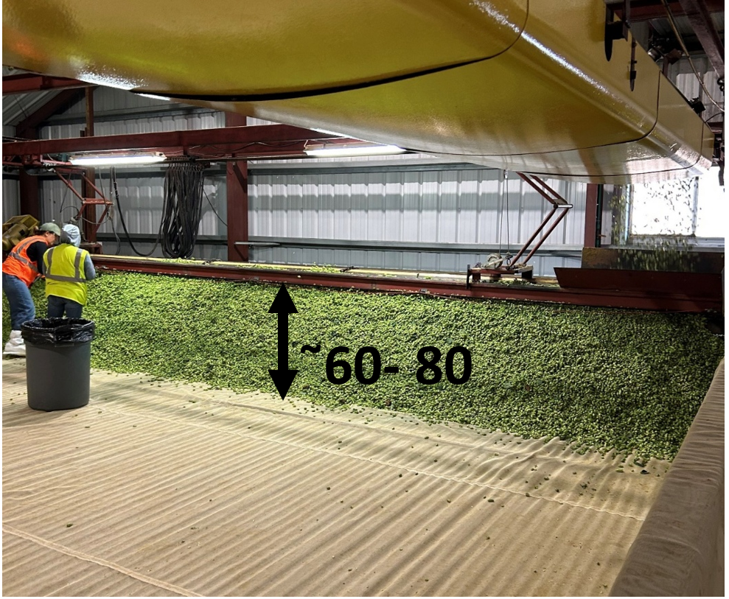
Slika 1: Višina nasipa svežega hmelja na sušilnici (Foto: I. J. Košir)
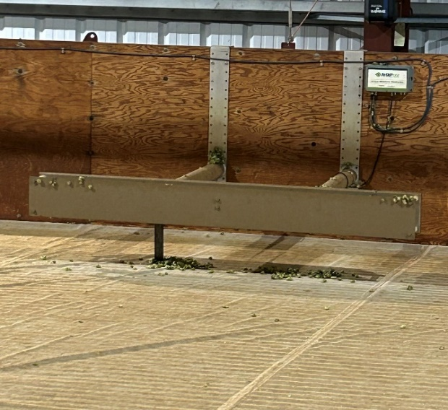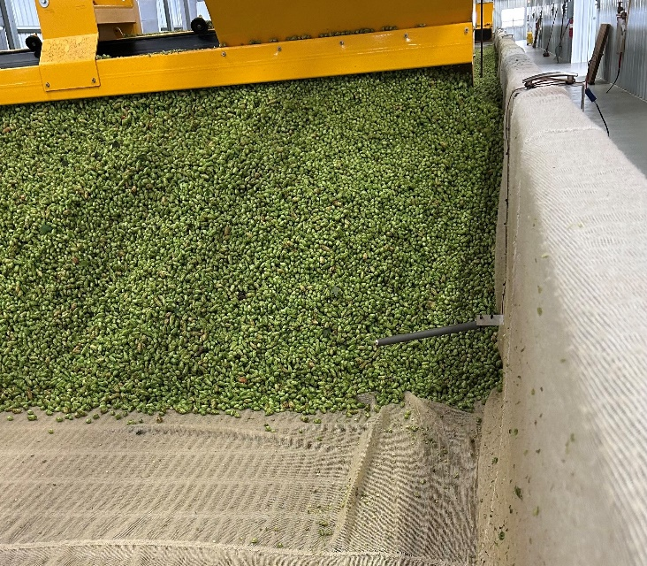
A
B
Slika 2: Merilne sonde za merjenje vlage v hmelju in temperature sušenja (Foto: I. J. Košir)
Bistvena razlika pri procesu sušenja je, da se hmelj na ta način posuši na ciljano povprečno vlažnost približno 10 %, s čimer se izognejo presušenosti in posledično drobljivosti storžkov. Maksimalno je zmanjšana odprtost storžkov in s tem je manjše tveganje za fizično izgubo lupulina med transportiranjem ter izpostavljenost lupulina zraku in s tem oksidacijske procese ter izhlapevanje komponent eteričnega olja.
Hmelj se po fazi sušenja odloži v kupe za približno 24 ur, da se izpovpreči vlaga v šarži. Po tej fazi se hmelj balira v kocke 200 funtov (≈90 kg) pod znatno višjim tlakom kot v Evropi. Zaradi sušenja na končno vlažnost 10 % v drugem koraku ni potrebna faza navlaževanja. Na ta način tudi ni potrebe po inštalaciji navlaževalnih komor in spremljajoče opreme za izvedbo navlaževanja. Po baliranju je običajno hmelj takoj transportiran v hladilnico in s tem v začetek hladne verige. Peletiranje oziroma nadaljnja predelava se izvede v čim krajšem času po obiranju, s čemer se zagotovi maksimalno ohranjanje kakovosti.
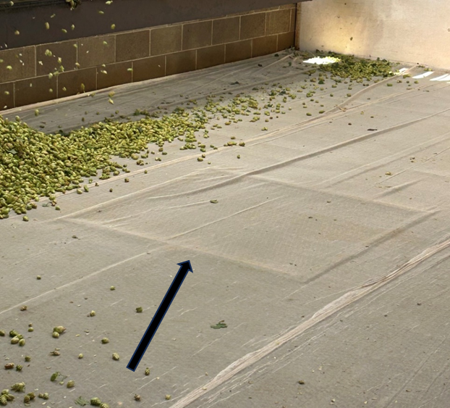
Slika 3: Merilno mesto na dnu sušilnice, preko katerega je možno spremljanje pretoka zraka, v odvisnosti od suhosti hmelja (Foto: I. J. Košir)

ZAKLJUČKI
Primerjalna analiza postopkov sušenja hmelja v Sloveniji in Združenih državah Amerike potrjuje, da se kljub enakim ciljem – doseči primerno končno vlažnost in ohraniti kakovostne aromatične ter grenčične spojine – tehnološke prakse pomembno razlikujejo zaradi različnih pridelovalnih razmer, obsega pridelave in tržnih usmeritev.
Slovenski sistem temelji na majhnih, specializiranih hmeljarskih kmetijah, kjer se ohranja tradicionalno sušenje v tanjših slojih na večetažnih sušilnicah in pri nižjih temperaturah (50–60 °C). Tak pristop omogoča ohranjanje eteričnih olj in senzorične kompleksnosti, kar je bistveno za kakovost aromatičnih sort. Po drugi strani ameriški pridelovalci uporabljajo sodobne, globokoslojne sušilnice (deep bed dryers) z večstopenjskim nadzorom primerljivih temperatur in vlage ter avtomatiziranimi procesi, ki ravno tako zagotavljajo kakovost arome, poleg tega pa omogočajo visoko pretočnost, standardizacijo postopkov ter manjšo variabilnost med serijami.
Za sorte, občutljive na izgubo arome, je v Sloveniji potrebno razmisliti o nižjih temperaturah sušenja (pod 50 °C) in podaljšanju časa sušenj s ciljem maksimalne ohranitve kompleksne sestave eteričnih olj, ki predstavljajo dodano vrednost aromatičnih sort hmelja.
Napredne senzorske tehnologije, kot sta hiperspektralno slikanje in termografija, omogočajo spremljanje vlage in kemijskih sprememb v realnem času. V praksi se njihova uporaba šele uveljavlja, vendar napoveduje prihod digitalno podprtih, pametnih sušilnic z avtomatsko regulacijo pretoka sušilnega zraka in temperature. V prihodnje lahko pričakujemo spremljanje procesa preko temperature, pretoka zraka, vlažnosti in kinetike odstranjevanja vlage v realnem času, namesto zgolj fiksnih nastavitev sušilnic na »pravilo palca«.
V vsakem primeru se je potrebno izogibati prekomernemu sušenju (na manj kot 8 % vlage), ki lahko povzroči krhkost storžev in kemijsko ter fizično izgubo lupulina oziroma aktivnih snovi v njem.
Energetska analiza kaže, da so slovenski sistemi sicer energetsko bolj zahtevni, izkazujejo pa večjo trajnostno fleksibilnost, saj pogosto uporabljajo obnovljive vire toplote (biomasa), medtem ko ameriški sistemi izstopajo po učinkovitosti izrabe energije in možnosti rekuperacije toplote.
Tako Slovenija kot ZDA kažeta, da je prihodnost hmeljarstva odvisna od optimalnega razmerja med tehnološko učinkovitostjo, ohranitvijo kakovosti storžkov in trajnostno rabo energije.
Sklepno lahko povzamemo, da bo prihodnji razvoj tehnologije sušenja hmelja temeljil na integraciji senzorjev za nadzor vlage, pretoka zraka in temperature v realnem času, avtomatiziranih algoritmih sušenja, prilagojenih posameznim sortam in namenu uporabe hmelja, analizi življenjskega cikla infrastrukture za zmanjšanje ogljičnega odtisa in povezovanju postopkov sušenja, peletiranja, pakiranja in skladiščenja v energetsko optimizirane verige.
Zahvala
Primerjalna študija je bila izvedena v okviru štipendije Bureau of Educational and Cultural Affairs, United States Department of State in Institute of International Eduation, program Fulbright, št. PS00383572.
Dostopnost raziskovalnih podatkov
Podatki so na voljo pri prvem avtorju na utemeljeno zahtevo.

VIRI
Annual Statistical Report on Hop Acreage and Production, V 2024 Hop Industry Annual Report, Hop Growers of America (HGA), Yakima, WA, 2024, str. 5.
BarthHaas Report 2022/23 General, Urednik: Heinrich Meier Georgensgmuend, BarthHaas GmbH & Co. KG, Nuremberg, 2023, str. 19-24.
Ferant, N., Košir, I.J., Sušenje hmelja, V Hmelj od sadike do storžkov, Urednica: Čeh B., Inštitut za hmeljarstvo in pivovarstvo Slovenije, Žalec, 2012, str. 113-121, ISBN:978-961-93322-0-7.
IHGC - Economic Commission Summary Reports, IHGC, 2024, Nuremberg.
Kmetijska rastlinska pridelava, Površine poljščin, V Statistični pregled leta 2023, Statistični urad Republike Slovenije (SURS), 2023, Ljubljana, str. 20.
Livk,J., Košir, I.J.K., Trošt, Ž., Strokovna naloga ocena letnika hmelja, Javna služba v hmeljarstvu, Končno poročilo, Inštitut za hmeljarstvo in pivovarstvo Slovenije, Žalec, 2025, str.7.
National Hop Report, United States Department of Agriculture, National Agricultural Statistics Service (USDA NASS), 2024, Washington, D.C., ISSN:2158-7825.
Peacock, V., Arendt, B., Thiel, R., Gura, M., Chadwick, L., A comparison of hop drying with unheated, dehumidified air versus traditional drying with heated air, Master Brewers Association of the Americas TQ, 2018, 55, str. 63-66, doi: 10.1094/TQ-55-3-1108-01
Raut, S., von Gersdorff, G.J.E., Münsterer, J., Kammhuber, K., Hensel, O. & Sturm, B., Impact of Process Parameters and Bulk Properties on Quality of Dried Hops, Processes, 2020, 11(8), str.1507, doi:10.3390/pr8111507
Rubottom, L.N., Lafontaine, S.R., Shellhammer, T.H., Evaluating the impact of kilning temperature on hop quality in American deep bed dryers, BrewingScience, 2022, 75(11/12), str. 98-108, doi:10.23763/BrSc22-15rubottom
Rubottom, L.N., Shellhammer, T.H., A review of hop drying technologies and room for improvement, Master Brewers Association of the Americas TQ, 2023, 60, str. 52-56, doi: 10.1094/TQ-60-3-0621-01​
Rybka, A., Heřmánek, P., Honzík, I., Krofta, K., Parameters of the drying medium and dried hops in belt dryer, Research in Agricultural Engineering, 2017, 63(10), str. S24-S32, doi:10.17221/35/2017-RAE
Rybka, A., Heřmánek, P., Honzík, I., Krofta, K., Effect of drying temperature on the content and composition of hop oils, Plant Soil Environ., 2018, 64(10), str. 512-516, doi:10.17221/482/2018-PSE
Rybka, A., Heřmánek, P., Honzík, I., Effect of drying temperature in hop dryer on hop quality, Research in Agricultural Engineering, 2021, 67(1), str. 1-7, doi:10.17221/61/2020-RAE

Ta članek je objavljen pod licenco Creative Commons Priznanje avtorstva-Deljenje pod enakimi pogoji 4.0 Mednarodna.

Možnost ponovne uporabe hmelja po hladnem hmeljenju
Ana Kočevar BALOH, Ksenija OBROVNIK, Miha OCVIRK in Iztok Jože KOŠIR
Tipologija / Article type: Strokovni članek / Professional article
Prispelo / Arrived: 22. 10. 2025
Sprejeto / Accepted: 11. 12. 2025
Objavljeno / Published: December 2025
Izvleček
Študija preučuje možnost ponovne uporabe hmelja po uporabi v postopku hladnega hmeljenja (dry hopping), kjer zaradi nizkih temperatur ne pride do znatne izomerizacije alfa-kislin. Namen raziskave je bil oceniti, ali tak hmelj po sušenju ohrani zadostno vsebnost grenčičnih spojin za učinkovito ponovno uporabo pri klasičnem vretju pivine. V raziskavi so bili uporabljeni briketi sort hmelja Styrian Dragon in Aurora, ki so bili vključeni v tri- oziroma petdnevno hladno hmeljenje, nato posušeni in ponovno uporabljeni pri varjenju piva. Grenčico v pivu smo določali spektrofotometrično (IBU) in s tekočinsko kromatografijo visoke ločljivosti (HPLC). Rezultati so pokazali, da se je po hladnem hmeljenju vsebnost alfa-kislin v hmelju zmanjšala za 29 % pri sorti Aurora in za 36 % pri sorti Styrian Dragon. Kljub temu je ponovno uporabljen hmelj omogočil tvorbo primerljivih ali celo višjih koncentracij izo-alfa-kislin v pivu kot svež hmelj, zlasti pri 60-minutnem vretju. Najvišje izmerjene vrednosti grenčice so presegale 90 IBU, kar potrjuje, da hmelj po hladnem hmeljenju ohrani zadosten grenčični potencial. Rezultati potrjujejo, da je ponovna uporaba hmelja po hladnem hmeljenju tehnološko izvedljiva in predstavlja trajnostno možnost za zmanjšanje odpadkov in stroškov surovin v pivovarski industriji.
Ključne besede: hmelj, hladno hmeljenje, ponovna uporaba, grenčica, izo-alfa-kisline
POSSIBILITY OF REUSING HOPS AFTER DRY HOPPING
Abstract
This study investigates the potential for reusing hops after the use in dry hopping process, during which low temperatures prevent the extend isomerization of alpha-acids. The aim was to evaluate whether such hops, once dried, retain sufficient quantity of bitter compounds for effective reuse in conventional kettle hopping. Two hop varieties, Styrian Dragon and Aurora, were used in three- and five-day dry hopping treatments, then dried and reused in kettle hopping. Bitterness was determined spectrophotometrically (IBU) and by high-performance liquid chromatography (HPLC). The results showed that alpha-acid content decreased by 29% in Aurora and by 36% in Styrian Dragon after dry hopping. Nevertheless, reused hops produced comparable or even higher concentrations of iso-alpha-acids than fresh hops, particularly after 60 minutes of wort boiling. The highest measured bitterness values exceeded 90 IBU, confirming that hops retain a sufficient bitterness potential after dry hopping. These findings demonstrate that reusing hops after dry hopping is technologically feasible and represents a sustainable approach to reducing waste and raw material costs in the brewing industry.
Key words: hops, dry hopping, reuse, bitterness, iso-alpha-acids

UVOD
Hmelj (Humulus lupulus L.) je nepogrešljiva surovina v pivovarstvu, saj pomembno prispeva k značilni grenčici, aromi in stabilnosti piva. Glavni povzročitelji grenkobe v pivu so tako imenovane izo-alfa-kisline, ki nastanejo z izomerizacijo alfa-kislin iz hmelja med vrenjem pivine. To vrenje običajno poteka pri približno 102 °C in traja 60–90 minut. V tem koraku se hmelj doda v pivino, njegove alfa-kisline pa se ekstrahirajo in izomerizirajo, s čimer se pivu doda grenkoba (Calado in sod., 2019). Žleze lupulina na ženskih storžkih hmelja vsebujejo mehke smole in sicer alfa-kisline (predvsem kohumulon, humulon, adhumulon) ter beta-kisline (predvsem kolupulon, lupulon, adlupulon). Te kisline med toplotno izomerizacijo izomerizirajo v izo-alfa-kisline, ki predstavljajo glavne grenčične spojine v pivu. Pri izomerizaciji se vsak izomer izo-alfa-kislin pojavlja kot trans- in cis-stereoizomera v razmerju približno 3:7 pri običajno hmeljenih pivih (Oladokun in sod., 2016).
Grenčico hmelja je mogoče prilagajati tudi z neposrednim dodajanjem komercialnih hidrogeniranih izo-alfa-kislin v pivino. Poleg grenčice pa izo-alfa-kisline prispevajo še k stabilnosti pene in predvsem beta-kisline imajo še antibakterijske lastnosti. Raziskave celo kažejo, da uživanje izo-alfa-kislin lahko preprečuje demenco in kognitivni upad, povezan z debelostjo (Calado in sod., 2019).
Poleg klasičnega hmeljenja med vrenjem se v sodobnem pivovarstvu vse pogosteje uporablja tudi »dry hopping« ali hladno hmeljenje. Gre za postopek, pri katerem se hmelj dodaja ohlajenemu pivu, običajno med fermentacijo ali zorenjem, s čimer se v pivo prenese predvsem aromatični del eteričnih olj, medtem ko alfa-kisline ostanejo neizomerizirane in zelo slabo topne (Kirkpatrick in Shellhammer, 2018). Tak pristop omogoča bogatejši aromatični profil, vendar pomeni, da po končanem postopku v ostanku hmelja ostane znatna količina neizkoriščenih grenčičnih spojin.
Zaradi velike količine odpadkov v pivovarski industriji in trenda trajnostnega krožnega gospodarstva se pojavlja vprašanje, ali bi bilo mogoče tak hmelj po hladnem hmeljenju ponovno uporabiti. Če morebiti hmelj po ponovnem sušenju ohrani zadostno vsebnost alfa-kislin, bi ga bilo mogoče ponovno uporabiti kot sekundarni vir grenčice pri klasičnem kuhanju piva. Tak pristop bi lahko zmanjšal količino odpadkov, stroške surovin in bi to pomembno vplivalo na obremenjevanje okolja.
Hmelj je ena glavnih sestavin pri proizvodnji piva in poleg dodajanja okusa ter arome. Njegova glavna vloga v končnem pivu izhaja iz grenčice, ki nastane pri dodajanju pri visokih temperaturah. Danes obstaja veliko sort hmelja z zelo raznoliko sposobnostjo tvorjenja grenčice, ki je povezana s koncentracijo in sestavo alfa- in beta-kislin. Celo pri isti sorti se lahko vsebnost alfa-kislin razlikuje zaradi različnih pedoklimatskih razmer, kar je značilno za naravne proizvode. Zato mora pivovar natančno prilagoditi količino dodanega hmelja, da zagotovi enakomerno grenčico med različnimi serijami istega piva. Posledično je merjenje grenčice piva ključno za proizvodnjo kakovostnih piv.
Namen tega dela je bil preučiti možnost ponovne uporabe hmelja po hladnem hmeljenju kot vira grenčičnih spojin. Analizirali smo, ali tak hmelj še vsebuje dovolj alfa-kislin, da ob klasičnem vretju omogoči zadostno tvorbo izo-alfa-kislin in razvoj ustrezne grenčice v pivu. S tem želimo prispevati k boljšemu razumevanju potenciala ponovne uporabe hmelja v pivovarskem procesu ter k razvoju bolj trajnostnih praks v industriji.

MATERIAL IN METODE

Material in zasnova poskusa
V raziskavi smo uporabili sveže in že rabljene brikete hmelja sort Styrian Dragon in Aurora.
Hladno hmeljenje je potekalo v dveh paralelkah 3 in 5 dni pri 20 °C, v odmerku 500 g/hl. Po končanem postopku smo hmelj ločili od piva s filtracijo, ga iztisnili in posušili pri temperaturi do 40 °C, da bi preprečili izgubo hlapnih komponent in razgradnjo grenčičnih spojin. Posušen hmelj smo nato uporabili za pripravo novih piv po klasičnem postopku vretja.
Za preverjanje potenciala ponovne uporabe hmelja smo iz posušenega hmelja, pridobljenega po hladnem hmeljenju, pripravili dvanajst različnih vzorcev piva, ki so se razlikovali po sorti, času hladnega hmeljenja in času kuhanja:
- Aurora, 0 dni hladnega hmeljenja,10 minut kuhanja;
- Aurora, 0 dni hladnega hmeljenja, 60 minut kuhanja;
- Aurora, 3 dni hladnega hmeljenja, 10 minut kuhanja;
- Aurora, 3 dni hladnega hmeljenja, 60 minut kuhanja;
- Aurora, 5 dni hladnega hmeljenja, 10 minut kuhanja;
- Aurora, 5 dni hladnega hmeljenja, 60 minut kuhanja;
- Styrian Dragon, 0 dni hladnega hmeljenja, 10 minut kuhanja;
- Styrian Dragon, 0 dni hladnega hmeljenja, 60 minut kuhanja;
- Styrian Dragon, 3 dni hladnega hmeljenja, 10 minut kuhanja;
- Styrian Dragon, 3 dni hladnega hmeljenja, 60 minut kuhanja;
- Styrian Dragon, 5 dni hladnega hmeljenja, 10 minut kuhanja;
- Styrian Dragon, 5 dni hladnega hmeljenja, 60 minut kuhanja.
V vseh primerih je bil dodatek hmelja preračunan tako, da je bil odmerek alfa-kislin v pivini enak, torej 250 mg alfa-kislin na liter piva. Pivina je bila kuhana pri 100 °C, nato ohlajena, inokulirana s pivskim kvasom vrste Saccharomyces cerevisiae (US-05, Fermentis by Lesaffre, Belgija) in fermentirana pri standardnih pogojih za ale piva pri 20 °C. Po končanem postopku fermentacije so bili vzorci piva pripravljena za nadaljnje analize.
Hkrati smo analizirali še štiri vzorce piva, ki smo jih dobili po hladnem hmeljenju s svežimi briketi hmelja:
- sorta Aurora, 3 dni namakanja;
- sorta Aurora, 5 dni namakanja;
- sorta Dragon, 3 dni namakanja;
- sorta Dragon, 5 dni namakanja.

Določanje grenčice spektofotometrično
Grenčico piva smo določali po standardni metodi Analytica-EBC 9.8 (EBC Analytica, 2020). Iz vzorcev piva smo z izooktanom (CARLO ERBA Reagents S.A.S., Francija) ekstrahirali grenke spojine, pri čemer se v organsko fazo prenesejo predvsem izo-alfa-kisline. Absorbanca izooktanskega ekstrakta je bila izmerjena pri 270 nm z UV–Vis spektrofotometrom (UV-1900, Shimadzu, Japonska). Vrednost grenčice je bila izražena v enotah grenčice (IBU) po enačbi:
$$IBU=A_{270}×50$$kjer je $A_{270}$absorbanca pri 270 nm.

Določanje izo-alfa-kislin s HPLC
Koncentracijo izo-alfa-kislin smo določili z metodo tekočinske kromatografije visoke ločljivosti (HPLC) po metodi Analytica-EBC 9.47 (EBC Analytica, 2018). Analize smo izvedli na sistemu Agilent 1260 Infinity II (Agilent Technology, ZDA) z detektorjem UV–Vis pri 270 nm. Uporabili smo kolono Nucleodur® 5–100 C18 (125 × 4 mm; Macherey-Nagel, Düren, Nemčija), temperaturo kolone 40 °C in pretok 1 mL/min. Mobilna faza je bila sestavljena iz metanola (J. T. Baker, Norveška), vode in fosforjeve kisline (CARLO ERBA Reagents S.A.S., Francija) (v razmerju 775:210:9; v/v/v). Identifikacija izo-humulona, izo-kohumulona in izo-adhumulona je temeljila na primerjavi retencijskih časov z raztopinami standardov (ICE4, LaborVeritas, Švica), kvantifikacija pa na osnovi kalibracijskih krivulj.

Izračuni in obdelava podatkov
Vrednosti koncentracij izo-alfa-kislin, izražene v mg/L, smo primerjali med vzorci, da bi ovrednotili vpliv sorte in časa vretja na količino izo-alfa-kislin ter na intenzivnost grenčice. Za izračune in grafično predstavitev rezultatov smo uporabili programski paket Microsoft Excel 365.

REZULTATI IN RAZPRAVA
Oba vzorca svežih briketov hmelja smo najprej analizirali in s tem pridobili naše izhodiščne podatke. Za tem smo jih uporabili pri postopku hladnega hmeljenja v pivu tipa lager (Zlatorog, Pivovarna Laško Union d.o.o.), s sledečo kakovostjo: vsebnost alkohola 5,22 vol.%, ekstrakt v osnovni sladici je bil 11,11 %, grenčica 18,8 IBU, vsebnost izo-alfa-kislin pa 16,3 mg/L.
Styrian Dragon je sorta hmelja, ki je zaradi dobrih pridelovalnih lastnosti in odpornosti na bolezni dobro sprejeta pri hmeljarjih. Ker ima sveže citrusne arome, jo uporabljajo zlasti za posebne tipe piva. Tipično vsebuje med 6,0 in 11,0 ut. % alfa-kislin ter med 1,5–2,1 mL eteričnega olja / 100 g hmelja (IHPS, 2016). Naš vzorec (briketi hmelja sorte Styrian Dragon) je imel na začetku poskusa 7,0 ut.% alfa-kislin in 0,5 mL eteričnega olja / 100 g (preglednica 1).
Sorta Aurora je prepoznavna po prijetni hmeljni aromi in grenčici, ki se odražata v zelo dobri pivovarski vrednosti. Tipično vsebuje med 7,2 in 12,6 ut. % alfa-kislin ter med 0,9 in 1,6 mL eteričnega olja / 100 g hmelja, kar je opazno manj kot sorta Styrian Dragon. Zato se manj uporablja pri postopkih hladnega hmeljenja (IHPS, 2016). Naš vzorec briketov je imel na začetku 10,0 ut. % alfa-kislin in 0,9 mL eteričnega olja / 100 g hmelja (preglednica 1). Oba vzorca hmelja smo pridobili pri Hmezad export-import d.o.o..
Rezultati analize vsebnosti alfa- in beta-kislin v hmelju sort Aurora in Styrian Dragon so prikazani v preglednici 1. Rezultati določanja grenčice sprektrofotometrično in določanje izo-alfa-kislin s HPLC v pivu so podani v preglednici 2.
Preglednica 1: Vsebnost alfa- in beta-kislin ter razmerje alfa/beta v briketih hmelja sort Aurora in Styrian Dragon pred in po postopku 3- oziroma 5-dnevnega hladnega hmeljenja
SORTA | Čas hladnega hmeljenja (v dneh) | Alfa-kisline ut.% (s.s.) | Beta-kisline ut.% (s.s.) | Alfa/beta
Aurora | 0 | 10,0 | 4,5 | 2,2
Aurora | 3 | 7,6 | 2,7 | 2,8
Aurora | 5 | 7,1 | 2,5 | 2,8
Styrian Dragon | 0 | 7,0 | 6,2 | 1,1
Styrian Dragon | 3 | 6,6 | 5,8 | 1,1
Styrian Dragon | 5 | 4,5 | 3,3 | 1,4
Preglednica 2: Grenčica piva, določena spektrofotometrično (IBU), in koncentracije skupnih izo-alfa-kislin, določene s HPLC, pri pivih, pripravljenih iz svežega in ponovno uporabljenega hmelja sort Aurora in Styrian Dragon
SORTA | Čas hladnega hmeljenja (v dneh) | Čas kuhanja sladice (min) | Povprečna grenčica – spektofotometrično (IBU) | Povprečje skupnih izo-alfa kislin – HPLC (mg/L)
Aurora | 0 | 10 | 38,2985 | 10,75
Aurora | 5 | 0 | 43,6005 | 9,60
Aurora | 3 | 0 | 47,8980 | 9,90
Aurora | 0 | 60 | 61,1220 | 26,95
Aurora | 3 | 10 | 62,9680 | 14,75
Aurora | 5 | 10 | 64,8060 | 8,55
Aurora | 3 | 60 | 72,7445 | 17,45
Aurora | 5 | 60 | 85,8510 | 35,40
Styrian Dragon | 3 | 0 | 34,7260 | 20,85
Styrian Dragon | 0 | 10 | 37,4835 | 6,00
Styrian Dragon | 5 | 0 | 43,6485 | 12,30
Styrian Dragon | 3 | 10 | 61,7560 | 16,20
Styrian Dragon | 0 | 60 | 68,0545 | 23,05
Styrian Dragon | 3 | 60 | 69,0665 | 57,00
Styrian Dragon | 5 | 60 | 94,7935 | 50,35
Styrian Dragon | 5 | 10 | 97,8200 | 12,35

Spremembe vsebnosti grenčičnih kislin v hmelju po hladnem hmeljenju
Po postopku hladnega hmeljenja se je vsebnost alfa-kislin v uporabljenem hmelju obeh sort izrazito zmanjšala, pri čemer je bil upad izrazitejši pri sorti Styrian Dragon. V hmelju sorte Aurora se je koncentracija alfa-kislin znižala z začetnih 10,0 ut.% na 7,6 ut.% po treh in 7,1 ut.% po petih dneh hmeljenja, kar predstavlja približno 29-odstotno zmanjšanje. Pri sorti Styrian Dragon pa se je vsebnost alfa-kislin znižala s 7,0 ut.% na 6,6 ut.% po treh in 4,5 ut.% po petih dneh, kar pomeni zmanjšanje za približno 36 %.
Zmanjšanje alfa-kislin med hladnim hmeljenjem je mogoče pripisati ekstrakciji v pivo in oksidaciji med podaljšanim stikom z alkoholnim medijem in zrakom pri nizkih temperaturah. Medtem ko se pri sortah z višjo začetno vsebnostjo alfa-kislin (npr. sorta Aurora) del teh spojin ohrani tudi po večdnevnem stiku, so sorte z nižjim deležem (npr. sorta Styrian Dragon) bolj podvržene razgradnji in oksidaciji.
Vsebnost beta-kislin je pri pivih iz obeh sort prav tako upadla, pri čemer je bila izguba nekoliko večja pri sorti Styrian Dragon (s 6,2 na 3,3 ut.%). Posledično se je razmerje alfa/beta pri sorti Aurora celo nekoliko povečalo (z 2,2 na 2,8), kar kaže na selektivno izgubo beta-kislin, medtem ko je pri sorti Styrian Dragon razmerje ostalo nizko (1,1–1,4). To nakazuje različne kemijske stabilnosti obeh sort in potencialno večjo odpornost kislin v hmelju sorte Aurora na oksidativne procese med hladnim hmeljenjem.

Grenčica piva in vsebnost izo-alfa-kislin
Rezultati spektrofotometričnega določanja grenčice (IBU) in koncentracij izo-alfa-kislin, določenih s HPLC, so predstavljeni v preglednici 2. Pri obeh sortah je bilo pričakovano zaznano povečanje grenčice z daljšim časom kuhanja, kar je posledica učinkovitejše izomerizacije alfa-kislin. Pri pivu, pripravljenem iz še nerabljenih briketov hmelja sorte Aurora, je grenčica znašala 38,3 IBU po 10 minutah in 61,1 IBU po 60 minutah kuhanja, kar pomeni povečanje za približno 60 %. Podobno se je v pivu z uporabljenim hmeljem sorte Styrian Dragon vrednost IBU povečala s 34,7 na 68,0 IBU. V pivu, pripravljenem iz ponovno uporabljenih briketov po petih dneh hladnega hmeljenja, so bile vrednosti IBU celo višje – do 85,9 IBU v pivu iz sorte Aurora in 94,8 IBU v pivu sorte Styrian Dragon, kar kaže, da je kljub predhodni uporabi hmelj ohranil zadostno količino prekurzorjev za tvorbo izo-alfa-kislin.
Kvantitativna analiza s HPLC je potrdila podobne trende. Koncentracije skupnih izo-alfa-kislin so bile v pivu iz sorte Aurora med 8,55 in 35,40 mg/L, v pivu iz sorte Styrian Dragon pa med 6,00 in 57,00 mg/L. Vrednosti so bile v splošnem višje pri vzorcih, kuhanih 60 minut, kar potrjuje pričakovano odvisnost izomerizacije od časa vretja.
Zanimivo je, da je pri sorti Styrian Dragon po petih dneh hladnega hmeljenja in 60 minutah vretja koncentracija izo-alfa-kislin dosegla 50,35 mg/L, kar presega vrednosti pri svežem hmelju. Ta pojav bi lahko bil posledica lažje topnosti delno oksidiranih hmeljnih smol ali prisotnosti humulinonov, ki prispevajo k grenkobi in se zaradi nizke specifičnosti metode deloma zaznajo tudi v spektrofotometrični metodi, predstavljeni zgoraj.
Spektrofotometrično določene vrednosti IBU so bile večinoma nekoliko višje od koncentracij izo-alfa-kislin, kar je skladno s pričakovanji, saj metoda meri tudi oksidirane produkte in druge grenke spojine. Kljub temu pa je bila med obema metodama opažena jasna korelacija, kar potrjuje zanesljivost rezultatov.

Vpliv sorte in časa obdelave na potencial ponovne uporabe hmelja
Rezultati kažejo, da ima hmelj po hladnem hmeljenju, kljub zmanjšani vsebnosti alfa-kislin, še vedno zadosten grenčični potencial za ponovno uporabo v klasičnem varjenju piva.
Briketi iz hmelja sorte Aurora so ohranili večji delež aktivnih grenčičnih spojin, kar se je odrazilo v postopnem, a enakomernem povečanju grenkobe z daljšim časom kuhanja. Sorta Styrian Dragon je izkazovala večje razlike med posameznimi vzorci, ki so bili različno dolgo izpostavljeni hladnemu hmeljenju, kar nakazuje neenakomerno ekstrakcijo in večjo občutljivost kislin za razgradnjo med kasnejšim sušenjem in ponovnim vretjem.

ZAKLJUČKI
Rezultati raziskave so pokazali, da ima hmelj po postopku hladnega hmeljenja še vedno pomemben potencial za ponovno uporabo v pivovarskem procesu. Kljub delni izgubi alfa-kislin med hladnim hmeljenjem so briketi sort Aurora in Styrian Dragon po sušenju vsebovali dovolj aktivnih spojin, da je bila omogočena učinkovita izomerizacija in tvorba izo-alfa-kislin med klasičnim vretjem pivine.
Vrednosti grenkobe, izražene v IBU, in koncentracije izo-alfa-kislin so bile pri pivu, pripravljenem iz recikliranega hmelja, primerljive ali celo višje kot pri pivu iz svežega hmelja, zlasti pri daljšem času vretja (60 min). To potrjuje, da ponovno uporabljen hmelj lahko prispeva k ustrezni stopnji grenčice v pivu.
Na splošno lahko zaključimo, da ima ponovna uporaba hmelja po hladnem hmeljenju potencial, saj omogoča doseganje primerljivih ali celo višjih vrednosti grenčice kot pri svežem hmelju, kar so pokazali tudi rezultati našega poskusa. Vendar je treba upoštevati, da se z vsakim ciklom uporabe spreminja kemijska sestava hmeljnih smol in s tem potencialno tudi senzorični profil okusa piva.
Za optimalno uporabo recikliranega hmelja v pivovarstvu bi bilo zato priporočljivo določiti standardizirane pogoje sušenja, shranjevanja in dodajanja, ki bi zagotovili stabilnost in ponovljivost rezultatov.
Ugotovitve kažejo, da je ponovna uporaba briketov hmelja po hladnem hmeljenju možna in tehnološko smiselna možnost za delno nadomestitev svežega hmelja. Tak pristop bi lahko prispeval k zmanjšanju količine odpadkov hmelja, nižjim stroškom surovin in večji trajnosti proizvodnje.
Nadaljnje raziskave bi morale vključiti senzorično oceno piva, podrobnejšo karakterizacijo oksidacijskih produktov in preučitev možnosti večkratne ponovne uporabe hmelja v različnih slogih piva.
Zahvala
Avtorji prispevka se zahvaljujejo podjetju Hmezad export-import d.o.o. za vzorce hmelja, uporabljene v raziskavi.
Dostopnost raziskovalnih podatkov
Podatki so na voljo pri zadnjem avtorju na utemeljeno zahtevo.

VIRI
Calado, L. S., Lacerda, A. L. F., Fiaux, S. B., Sphaier, L. A., Silva, V. N. H., & Peixoto, F. C., Low-cost fluorescence-based method for beer bitterness measurement, Journal of Food Engineering, 2019, 262, 9-12, https://doi.org/10.1016/j.jfoodeng.2019.05.015
EBC Analytica, 9.47 – Iso-α-acids and reduced iso-α-acids (Rho, Tetra, Hexa) in beer by HPLC, 2010, 23. oktober 2018, dostop 19. oktober 2025, https://brewup.eu/ebc-analytica/beer/iso-acids-and-reduced-iso-acids-rho-tetra-hexa-in-beer-by-hplc/9.47
EBC Analytica, 9.8 - Bitterness units (BU) of beer (IM), 2020, 23. november 2020, dostop 19. oktober 2025, https://brewup.eu/ebc-analytica/beer/bitterness-of-beer-im/9.8
Inštitut za hmeljarstvo in pivovarstvo Slovenije, Legenda žlahtne arome, 2016
https://view.publitas.com/ihps-sihrb/the-legend-of-noble-aroma/page/1
Inštitut za hmeljarstvo in pivovarstvo Slovenije, Val dišavnega hmelja s Štajerske, 2018. https://www.ihps.si/wp-content/uploads/2016/10/Katalog-disavnih-sort-IHPS-web-zakl.pdf
Kirkpatrick, K. R., & Shellhammer, T. H., Evidence of dextrin hydrolyzing enzymes in Cascade hops (Humulus lupulus), Journal of Agricultural and Food Chemistry, 2018, 66(34), 9121-9126,
Kirkpatrick, K. R., & Shellhammer, T. H., Evidence of dextrin hydrolyzing enzymes in Cascade hops (Humulus lupulus), Journal of Agricultural and Food Chemistry, 2018, 66(34), 9121-9126, https://doi.org/10.1021/acs.jafc.8b03563
Oladokun, O., Tarrega, A., James, S., Smart, K., Hort, J., & Cook, D., The impact of hop bitter acid and polyphenol profiles on the perceived bitterness of beer, Food chemistry, 2016, 205, 212-220, https://doi.org/10.1016/j.foodchem.2016.03.023

Ta članek je objavljen pod licenco Creative Commons Priznanje avtorstva-Deljenje pod enakimi pogoji 4.0 Mednarodna.

Pridelek in kakovost hmelja v Sloveniji v prvem četrtletju tega stoletja
Žan TROŠT in Joško LIVK
Tipologija / Article type: Strokovni članek / Professional article
Prispelo / Arrived: 25. 10. 2025
Sprejeto / Accepted: 4. 12. 2025
Objavljeno / Published: December 2025
Izvleček
V začetku 21. stoletja je bilo v Sloveniji s hmeljem posajenih okoli 1800 ha hmelja, hmelj je pridelovalo več kot 200 hmeljarjev, povprečna površina hmeljišč na hmeljarski kmetiji pa je bila okoli 9 ha. Prevladovala je sorta Aurora, ki je bila zasajena v skoraj dveh tretjinah vseh hmeljišč. V letu 2012 je bilo s hmeljem posajenih nekaj manj kot 1200 ha, potem pa se je površina zopet začela povečevati in je trenutno okoli 1600 ha. Aktivnih hmeljarjev je v zadnjih letih okoli 120, povprečna velikost hmeljarske kmetije pa se je povečala na 14 ha. Z leti se je površina, posajena s sorto Aurora, zmanjševala, vse bolj pa se je uveljavljala sorta Celeia. Površina, posajena s sorto Bobek, je v zadnjih 25 letih na približno enaki ravni, to je 100 - 200 ha, delež površine s sorto Savinjski golding pa se počasi, a vztrajno zmanjšuje in je trenutno okrog 8 %. Podobno velja tudi za pridelek teh sort. Glede na pregled vremenskih razmer v pridelovalnih letih lahko sklepamo, da suša in vročina negativno vplivata tako na pridelek kot na kakovost hmelja (vsebnost alfa-kislin). Najmanjša vsebnost alfa-kislin je bila v izrazito vročih in sušnih letih 2003 in 2013. Vsebnost alfa-kislin pri sorti Aurora se v zadnjih 25 letih počasi, a vztrajno povečuje, medtem ko se nekatere druge sorte slabše prilagajajo vremenskim spremembam. To je najbolj opazno pri najstarejši sorti v naših hmeljiščih – sorti Savinjski golding, ki v zadnjih letih ne dosega minimalnih referenčnih vrednosti za vsebnost alfa-kislin. Kakovost hmelja je v veliki meri povezana tudi s sušenjem; bolj kot je hmelj presušen, več odpada vsebuje. Vsebnost listov in pecljev v hmelju se je v zadnjih 25 letih znižala za polovico, zahvaljujoč posodobitvi obiralnih strojev.
Ključne besede: hmeljarstvo, pridelek hmelja, kakovost hmelja, Humulus lupulus, vsebnost alfa-kislin
HOPS YIELD AND QUALITY IN THE LAST 25 YEARS
Abstract
At the beginning of the 21st century, around 1,800 ha of hops were planted in Slovenia, with more than 200 hop growers producing hops, and the size of hop acreage on hop farm was around 9 ha. The Aurora variety dominated, planted in almost two-thirds of all hop fields. In 2012, less than 1,200 ha were planted with hops, but the areas started to grow again soon and are now around 1,600 ha. There have been around 120 active hop growers in recent years, and the size of the hop farm is increased at 14 ha. Over the years, the areas planted with Aurora have decreased, while the Celeia variety has become increasingly popular. The areas planted with the Bobek variety have been stable in the last 25 years, while the share of the Savinjski golding area is slowly but steadily decreasing. A similar picture applies to the yield of these varieties. Based on the review of weather conditions in the growing years, we can conclude that dry and hot conditions negatively affect both the yield and the quality of hops (alpha acids). The lowest alpha acid contents were achieved in the extremely hot and dry years of 2003 and 2013. The alpha acid contents of the Aurora variety have been increasing slightly in the last 25 years, while some other varieties are less able to adapt to weather changes. This is most noticeable in the old variety Savinjski golding, which has not reached the minimum reference values for alpha acid content in recent years. The quality of hops is also largely related to drying, the more dried the hops are, the more hop waste they contain, so drying has a major impact on the final quality of the crop. The content of leaves and stalks in hops has decreased for half over the last 25 years, thanks to the modernization of harvesting machines.
Key words: hop growing, hop yield, hop quality, alpha-acids

UVOD
Pri pridelavi hmelja imata količina in kakovost pridelka ključno vlogo pri ohranjanju konkurenčnosti tako slovenskih sort kot celotne hmeljarske panoge. Pridelek hmelja se med leti pomembno razlikuje, in sicer zaradi vremenskih razmer, agrotehničnih ukrepov ter pritiska bolezni in škodljivcev. Kakovost, izražena predvsem skozi vsebnost alfa- in beta-kislin ter aromatični profil, je neposredno povezana s sortimentom, tehnologijo pridelave in razmerami v času rasti hmelja. Zadnja leta se hmeljarstvo sooča z velikimi izzivi, povezanimi s podnebnimi spremembami, okoljsko trajnostjo in zahtevami pivovarn po specifičnih kakovostnih parametrih. Površina pod hmeljem pa se spreminja v glavnem zaradi stanja na trgu – odvisnost od stanja na trgu.
Namen članka je predstaviti trende pridelka in kakovosti hmelja v Sloveniji v prvem četrtletju tega stoletja ter poudariti ključne dejavnike, ki vplivajo na variabilnost med leti in med sortami. Predstavljena je površina teh sort v prvih 25 letih tega stoletja in količina njihovega pridelka, ter njihovi kakovostni parametri, in sicer vsebnost alfa-kislin, vlaga ter prisotnost primesi v pridelku (listi in odpad).

MATERIAL IN METODE
Članek se osredotoča na glavne štiri sorte hmelja, ki se v Sloveniji pridelujejo na največji površini, to so sorte Aurora, Celeia, Bobek in Savinjski golding. Podatki o površinah in količinah pridelanega hmelja so prevzeti iz poročil o certificiranju hmelja, ki jih letno izda Inštitut za hmeljarstvo in pivovarstvo Slovenije. Tudi kakovostni parametri so prevzeti iz baze podatkov o certificiranju hmelja, kjer se vsaka pošiljka hmelja v okviru certificiranja vzorči in analizira na vlago, vsebnost semena, listov in pecljev ter odpada. Odpad predstavljajo majhni delci, ki nastanejo pri strojnem obiranju in so različnih barv med temno zeleno in črno ter običajno niso del storžka (Delegirana uredba Komisije (EU) 2024/602).
Vsebnost vlage se analizira po akreditirani gravimetrični metodi po Analytici-EBC, 1998, 7.2., vsebnost semena po akreditirani sejalno prebiralni metodi po Analytici-EBC, 1998, 7.3., ter vsebnost listov in pecljev ter odpada po akreditirani sejalno prebiralni metodi po Izvedbeni uredbi Komisije (EU) 2024/601, Priloga IV, Metoda C. Za ta namen se iz tovorkov hmelja vzame najmanj 300 g vzorca.
V okviru Javne službe v hmeljarstvu izvajamo tudi strokovno nalogo Ocena letnika hmelja, kjer se letno določa kakovost hmelja, med drugim tudi vsebnost alfa-kislin. Letno na hmeljarskih kmetijah odvzamemo okoli 120 vzorcev različnih sort hmelja. Vzorci se odvzamejo iz tovorkov hmelja ali iz zračno suhega hmelja, običajno že pred pakiranjem. Analiza alfa-kislin se opravi po akreditirani metodi Konduktometrična vrednost hmelja s toluensko ekstrakcijo, standardizirana metoda po Analytici-EBC 2000, 7.4. Iz rezultatov te naloge potem ocenimo kakovost posameznega letnika hmelja (Livk in sod., 2024).

REZULTATI IN RAZPRAVA

Površine in pridelek hmelja
Do leta 1876 o pridelavi hmelja na Slovenskem ni veliko znanega. Po tem letu pa se je pričela intenzivnejša in načrtna pridelava hmelja, ko so aklimatizirali angleško sorto hmelja Fuggle in pričeli pridelovati sorto Savinjski golding (IHPS, 2025). Pridelava hmelja se je pozneje intenzivno razširila in do pričetka prve svetovne vojne, leta 1914, ko je dosegla okoli 1800 ha. Ta površina se je med vojno zmanjšala na približno 600 ha. Kasneje se je površina začela počasi povečevati in leta 1929 dosegla rekordnih 2835 ha s pridelkom okrog 3300 ton.
V zgodovini pridelave hmelja v Sloveniji je imela odločilno vlogo na površino hmeljišč cena hmelja. Višja kot je bila cena, bolj se je hmelj sadil in obratno. Število hmeljarjev se je do druge svetovne vojne povzpelo na 4000. Bili so združeni v enotni Hmeljarski zadrugi, ki je zastopala vse hmeljarje in tako tudi nastopala na trgu (interni podatki IHPS ter Majer in sod., 2002). V času druge svetovne vojne je bila slika glede pridelovalnih površin hmelja podobna kot med prvo svetovno vojno, po vojni pa se je površina zopet začela povečevati, povečevali pa so se tudi hektarski pridelki. Tako se je leta 1960 na 2439 ha pridelalo več kot 4000 ton hmelja. Površina hmelja je bila po letu 1960 med 2000 in 2600 ha, v letih po osamosvojitvi Slovenije pa se je zmanjševala - tako je bilo leta 2012 v Sloveniji s hmeljem posajenih le še 1160 ha površin. Kasneje se je površina zopet začela povečevati, predvidoma zaradi boljših tržnih razmer in obnov nasadov po izkrčenju zaradi bolezni ter leta 2023 dosegla 1676 ha. Ves ta čas se je število hmeljarjev zmanjševalo; v začetku 90-ih let jih je bilo več kot 500, leta 2000 več kot 200, trenutno pa je v Sloveniji okoli 120 aktivnih hmeljarjev (Interni podatki IHPS). Trenutno je Slovenija na petem mestu po površinah hmelja na svetu, kar predstavlja 3 % vseh površin hmelja na svetu (IHGC, 2025). Namen članka je predstaviti gibanje površin, pridelka in kakovost le tega v zadnjih 25 letih.
V zadnjih 25 letih se je povprečna velikost hmeljišč na hmeljarski kmetiji povečala z okoli 9 ha na približno 14 ha (slika 1). Povečevanje površine s hmeljem na kmetijo je predvsem posledica zmanjšanja števila hmeljarjev, katerih površine so nato povečini prevzeli preostali hmeljarji. Razlogi za opuščanje pridelave hmelja so v največji meri povezani z ekonomiko - cena hmelja skozi leta precej variira, dolgoročna neekonomičnost pridelave pa vodi v opuščanje hmeljarstva (Pavlovič, 2014). Leta 2001 je bil aktiven 201 hmeljar, medtem ko je bilo leta 2025 samo še 117 hmeljarjev. Najmanj hmeljarjev je bilo leta 2014, in sicer 110, medtem ko v zadnjih letih število hmeljarjev ne upada več (slika 2).
Skupna površina pod glavnimi štirimi sortami (Aurora, Celeia, Savinjski golding in Bobek) v zadnjih 25 letih predstavlja 89–96 % od celotne površine hmelja v Sloveniji, podobno tudi skupna količina pridelanega hmelja (88–97 % vse pridelane količine hmelja v Sloveniji).

Slika 1: Povprečna površina hmeljišč na hmeljarski kmetiji v obdobju 2001-2025 (ha)

Slika 2: Število aktivnih hmeljarjev v obdobju 2001-2025

Slika 3: Površina nasadov hmelja v Sloveniji v zadnjih 2025 letih (podatki na vsakih 5 let) v ha
Na sliki 3 je predstavljena skupna površina nasadov hmelja v času 2001–2025 , podatki so prikazani za vsako peto leto. V začetku 21. stoletja je bilo v Sloveniji s hmeljem zasajenih okoli 1800 ha hmelja. V tem času je na nekaterih območjih prišlo do popolne opustitve hmeljarstva (Brežice, Kozje, Rače, Radmirje) (Joško Livk, ustni vir). V začetku je prevladovala sorta Aurora, ki je bila zasajena v skoraj dveh tretjinah vseh hmeljišč. Z leti se je površina, zasajena s sorto Aurora, zmanjševala, vse bolj pa se je uveljavljala sorta Celeia. V določenem obdobju je po površini celo prehitela sorto Aurora, trenutno pa si delita skoraj enak delež površin v Sloveniji (Aurora predstavlja 39 % vseh površin s hmeljem, Celeia pa 34 % vseh površin). Površina, zasajena s sorto Bobek, je v zadnjih 25 letih stabilna, delež površine s sorto Savinjski golding pa se počasi, a vztrajno zmanjšuje, tako zaradi manjšega zanimanja za to sorto na trgu kot zaradi slabših pridelkov in kakovosti v zadnjih letih.
Količina pridelanega hmelja po sortah se je gibala podobno kot površina s hmeljem (slika 4 in preglednica 1). Od leta 2001 do leta 2015 se je letno pridelalo največ sorte Aurora, po letu 2015 pa je letna količina pridelanega hmelja sort Aurora in Celeia precej podobna (med 700 in 1300 t letno). V obdobju 2001–2025 je bil največji letni pridelek ene sorte, to je bila sorta Aurora, v letu 2005 (1.678 kg). Glede na 25-letno povprečje je pridelava Aurore v upadu, medtem ko se pridelava Celeie povečuje (preglednica 1). Vseh 25 let je količina pridelanega hmelja sort Bobek in Savinjski golding podobna in stabilna, v povprečju okoli 200 ton letno, čeprav se je pridelava sorte Savinjski golding v zadnjih letih zmanjšala pod 200 ton letno, pridelava sorte Bobek pa je večinoma nad 200 tonami letno. Na sliki 5 so predstavljene površine nasadov v letu 2025. Tudi tu vidimo, da prevladujejo štiri sorte, ki so predstavljene v tem članku.

Slika 4: Količina pridelanega hmelja po sortah v obdobju 2001-2025 (kg)
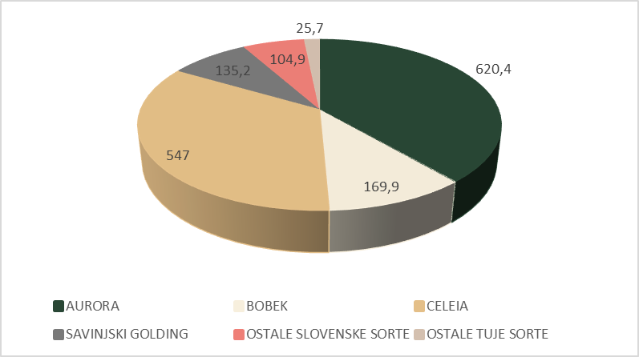
Slika 5: Površina nasadov hmelja (ha) v letu 2025 glede na sorto
Preglednica 1: Certificiran pridelek hmelja (t) v obdobju 2001-2025
Leto | Aurora (t) | Bobek (t) | Celeia (t) | Savinjski golding (t) | Skupaj (te štiri sorte) (t)
2001 | 1376,18 | 299,59 | 69,69 | 265,40 | 2010,85
2002 | 1448,66 | 324,77 | 96,24 | 187,74 | 2057,41
2003 | 820,99 | 136,32 | 126,35 | 92,90 | 1176,56
2004 | 1571,23 | 260,57 | 151,89 | 291,17 | 2274,86
2005 | 1677,55 | 294,36 | 218,41 | 227,16 | 2417,48
2006 | 1147,72 | 255,20 | 213,83 | 183,73 | 1800,47
2007 | 1205,08 | 246,50 | 246,87 | 178,82 | 1877,27
2008 | 1423,52 | 288,11 | 275,86 | 239,09 | 2226,58
2009 | 1581,91 | 333,05 | 265,57 | 198,89 | 2379,42
2010 | 1516,67 | 244,43 | 355,56 | 232,15 | 2348,81
2011 | 1558,15 | 216,94 | 402,84 | 182,70 | 2360,63
2012 | 901,11 | 133,43 | 336,60 | 133,15 | 1504,29
2013 | 650,00 | 111,91 | 369,21 | 123,15 | 1254,28
2014 | 1175,57 | 182,03 | 683,46 | 196,69 | 2237,75
2015 | 622,74 | 142,67 | 720,28 | 113,63 | 1599,31
2016 | 813,12 | 272,92 | 1006,17 | 211,26 | 2303,48
2017 | 903,25 | 267,48 | 1153,39 | 201,65 | 2525,77
2018 | 1058,02 | 340,71 | 1220,82 | 184,21 | 2803,76
2019 | 827,29 | 257,62 | 980,02 | 203,04 | 2267,97
2020 | 1114,30 | 260,59 | 891,40 | 208,49 | 2474,78
2021 | 811,23 | 210,93 | 762,03 | 143,88 | 1928,07
2022 | 956,37 | 236,91 | 714,48 | 129,61 | 2037,37
2023 | 1282,23 | 250,63 | 799,21 | 166,17 | 2498,24
2024 | 954,52 | 186,90 | 761,03 | 146,14 | 2048,59
2025 | 864,14 | 227,40 | 935,68 | 127,10 | 2154,31
SKUPAJ 2001 - 2025 | 28261,55 | 5981,94 | 13756,91 | 4567,91 | 52568,31
SKUPAJ 2016 - 2025 | 9584,47 | 2512,09 | 9224,24 | 1721,55 | 23042,34
Če pogledamo skupni pridelek v zadnjih 25 letih, vidimo, da je skupna količina pridelane sorte Aurora (28262 t) večja od pridelka ostalih treh sort skupaj (24307 t). V zadnjih 10 letih pa je dejstvo drugačno; hmelja pridelanih sort Aurora in Celeia je skoraj enaka količina (9584 t in 9224 ton).
Najmanjši skupni pridelek teh štirih sort je bil v letih 2003 in 2013, 1177 t oz. 1255 t. Leta 2003 je huda suša prizadela večino Slovenije, pomanjkanje vode je spremljala še zelo visoka temperatura (Sušnik, 2004), leto 2013 pa je bilo prav tako izrazito neugodno za pridelavo hmelja, saj je bilo poletje zelo sušno ter nadpovprečno vroče, poleg tega pa je v maju klestila še toča, ki je poškodovala 750 ha hmeljišč (Čeh in sod., 2013). Največji skupni pridelek je bil v letu 2018, in sicer 2804 t. V ostalih letih je pridelek precej variiral, v večini let pa je presegel 2000 t.

Vsebnost alfa-kislin v pridelku hmelja
Vsebnost alfa-kislin glede na leto in sorto je predstavljena v preglednici 2. Sorta Aurora je v zadnjih 25 letih dosegala vsebnost alfa-kislin med 5,7 % in 11,4 %, povprečna vsebnost alfa-kislin v obdobju 2000-2025 je bila 8,1 %, medtem ko je bila v zadnjih 10 letih malo višja, in sicer 8,4 %.
Pri sorti Bobek je bila vsebnost alfa-kislin med 2,1 % in 6,3 %, povprečje 2000-2025 je bilo 4,6 %, podobno kot pri desetletnem povprečju (4,5 %). Sorta Celeia je dosegala vsebnost alfa-kislin od 2,2 % do 4,6 %, povprečje 25 let (3,6 %) je bilo višje kot povprečje zadnjih 10 let (3,3 %). Sorta Savinjski golding je dosegala vsebnost alfa-kislin od 2 % do 4,5 %, povprečje zadnjih 25 let je 3 %, medtem ko je povprečje zadnjih 10 let 2,8 %. Najnižja vsebnost alfa-kislin je bila v letih 2003 ter 2013, kar sovpada tudi z nizkimi pridelki v teh letih, posledice vročine in pomanjkanje vode v teh dveh letih.
Preglednica 2: Povprečna vsebnost alfa-kislin (%), preračunano na 11 % vlage v hmelju, po sortah v letih 2000-2025
Leto | Aurora | Bobek | Celeia | Savinjski golding
2000 | 8,6 | 5,7 | 4,5 | 3,7
2001 | 7,8 | 4,6 | 3,7 | 3,6
2002 | 7,3 | 4,3 | 3,9 | 3
2003 | 5,9 | 2,6 | 2,2 | 2
2004 | 8,8 | 5,6 | 4,1 | 4,2
2005 | 8,8 | 5,5 | 4,4 | 3,9
2006 | 6,3 | 4,2 | 3,5 | 2,5
2007 | 7,4 | 4,7 | 4,1 | 2,6
2008 | 8,8 | 5,5 | 4,2 | 3,4
2009 | 8,4 | 4,9 | 4,2 | 4
2010 | 8,3 | 4,7 | 4 | 2,7
2011 | 9,1 | 5,9 | 4,1 | 3,8
2012 | 8,2 | 4 | 3,2 | 2,6
2013 | 5,7 | 2,1 | 2,2 | 2,1
2014 | 10,2 | 6,3 | 4,6 | 3,9
2015 | 8,5 | 4,9 | 3,2 | 2
2016 | 8,6 | 4,4 | 3,2 | 3,4
2017 | 7,4 | 3,5 | 3,2 | 2,2
2018 | 8,9 | 4,3 | 3 | 3,3
2019 | 7,8 | 4,9 | 3,4 | 3,1
2020 | 11,4 | 5,9 | 4,1 | 4,5
2021 | 6,7 | 3,9 | 3,3 | 2,2
2022 | 7 | 3,2 | 2,6 | 2,4
2023 | 9,6 | 5,8 | 4,1 | 3
2024 | 7,6 | 3,7 | 3 | 2,2
2025 | 8,1 | 4,5 | 3,8 | 2,1
Povprečje 2000 - 2025 | 8,1 | 4,6 | 3,6 | 3
Desetletno povprečje (2016 – 2025) | 8,4 | 4,5 | 3,3 | 2,8
Kot vidimo na sliki 6, v 25-letnem obdobju povprečna vsebnost alfa-kislin pri sorti Aurora ostaja stabilna oz. se celo rahlo povečuje. Pri sorti Bobek (slika 7) pa je glede na 25-letno povprečje vsebnost alfa-kislin skoraj enaka oz. se rahlo zmanjšuje.
Pri sorti Celeia (slika 8) se vsebnost alfa-kislin v zadnjih 25 letih zmanjšuje očitneje kot pri sorti Bobek, kar nakazuje, da se slabše prilagaja na spremenljive vremenske razmere, predvsem višje temperature in sušni stres, ki jih je v zadnjih letih vse več.
Tudi pri sorti Celeia vidimo, da je bila najnižja povprečna vsebnost alfa-kislin v letih 2003 in 2013, medtem ko je najvišjo vsebnost alfa-kislin dosegla leto kasneje, 2014, ko je bilo leto precej deževno in brez temperaturnih ekstremov (Čeh in sod., 2014).

Slika 6: Povprečna vsebnost alfa-kislin v hmelju sorte Aurora (pri 11 % vlage)

Slika 7: Povprečne vrednosti alfa-kislin sorte Bobek (pri 11 % vlage)

Slika 8: Povprečna vsebnost alfa-kislin pri sorti Celeia (pri 11 % vlage)
Tako kot pri sorti Celeia, tudi pri sorti Savinjski golding beležimo padec povprečne vsebnosti alfa-kislin v zadnjih 25 letih (slika 9). Opisna sortna lista za hmelj sicer navaja, da Savinjski golding dosega 2,8 % do 6,1 % alfa-kislin (v suhi snovi) oz. 2,5 % do 5,4 % alfa-kislin (pri 11% vlagi) (Oset Luskar in sod., 2021), vendar v zadnjih letih vidimo, da z izjemo leta 2020, vsebnost alfa-kislin le redko preseže 3 % (pri 11 % vlagi), pogosto pa ne doseže niti spodnje vrednosti z opisne sortne liste. Za razliko od ostalih sort, pri katerih je vsebnost alfa-kislin izrazito padla le v res vremensko neugodnih letih 2003 in 2013, pri sorti Savinjski golding vidimo, da je imela nizko vsebnost alfa-kislin tudi v večini drugih let, kar nakazuje, da se najslabše odziva na sedanje vremenske razmere, saj gre za staro sorto, ki se je razvila iz angleške sorte Fuggle, ki so jo k nam prinesli v 19. stoletju, ko so bile vremenske razmere drugačne od današnjih (IHPS, 2025). Nadpovprečno visoko vsebnost alfa-kislin je sorta Savinjski golding dosegla v letu 2020 (4,5 % pri 11% vlagi); takrat je bilo poletje bogato s padavinami, ni pa bilo vročinskih valov in ekstremno visokih temperatur (Ferlež Rus in Naglič, 2020), kar je ugodno vplivalo na rast in razvoj vseh sort, predvsem pa sorte Savinjski golding.

Slika 9: Povprečna vsebnost alfa-kislin pri sorte Savinjski golding glede na leto (pri 11 % vlage)

Vlaga in vsebnost primesi v certificiranem hmelju
V zadnjih desetih letih se je v povprečju vlaga v certificiranem pridelku hmelju zmanjševala, predvsem zaradi zahtev trgovcev, da naj bo vlaga pridelka čim nižja. Nižjo vlago so hmeljarji dosegali z daljšim časom sušenja ali višjo temperaturo zraka za sušenje. To včasih vodi v presušenost hmelja, ki ima za posledico previsok delež zdrobljenih storžkov. Presušen hmelj izgubi sposobnost vezave vlage med navlaževanjem, s tem postanejo storžki krhki in drobljivi. Pri pakiranju takšni storžki razpadejo in se zdrobijo (Vrhovnik in Košir, 2024). Ta povezava se jasno odraža na sliki 10, saj vidimo, da se je vlaga v zadnjih desetih letih zniževala, medtem ko se je vsebnost odpada povečevala. Zdrobljenost storžkov vpliva tako na vizualno ter tudi kemijsko kakovost, saj se z njo povečuje HSI (Indeks staranja hmelja), ki neposredno vpliva na vsebnost alfa-kislin (Vrhovnik in Košir, 2024).

Slika 10: Povprečna letna vsebnost vlage in odpada v certificiranem hmelju (%)
Odstotek listov in pecljev v hmelju (slika 11) se je od leta 2007 naprej zniževal in se v zadnjih letih ustalil pri okrog 1 %, medtem ko je po zakonodaji dovoljeno do 6 % listov in pecljev (Delegirana uredba Komisije (EU) 2024/602). To gre pripisati tudi dejstvu, da se je število hmeljarjev zmanjševalo (157 hmeljarjev v letu 2007, 117 v letu 2025), manjši hmeljarji s starejšimi obiralnimi stroji so zaključili s pridelavo hmelja, medtem ko je veliko aktivnih hmeljarjev posodobilo obiralne stroje.

Slika 11: Listi in peclji v certificiranem hmelju (%)

ZAKLJUČKI
V zadnjih 25 letih je opazen trend zmanjševanja števila hmeljarjev ter povečevanje povprečne površine nasadov hmelja na obstoječih hmeljarskih kmetijah. Kljub večjemu številu novih sort hmelja v Sloveniji še vedno prevladujejo starejše sorte, ki so zajete v tem članku (Aurora, Celeia, Bobek in Savinjski golding). Na podlagi podatkov o površinah s hmeljem, količini pridelka in vsebnosti alfa-kislinah lahko ugotovimo, da se nekatere od teh sort bolje prilagajajo spremenljivim vremenskim razmeram kot druge, v bolj ekstremnih letih (vročina in suša) pa sta bila pri vseh sortah količina in kakovost pridelka manjša.
Spremenjene vremenske razmere z več ekstremnimi dogodki najbolj negativno vplivajo na pridelek in kakovost sorte Savinjski golding, katere površina najbrž prav zaradi te njene nestanovitnosti v količini pridelka v zadnjih letih upada. Tudi med trgovci postaja manj zaželena, saj kakovosti pridelka med leti zelo niha.
V zadnjih letih opažamo trend zmanjševanja vlage v certificiranem hmelju, kar pogosto vodi v zdrobljenost hmelja, posledično pa to vodi tudi v večji delež odpada v hmelju, zato bo sušenju hmelja v prihodnje potrebno posvetiti več pozornosti. Po drugi strani pa opažamo znižanje vsebnosti listov in pecljev v pridelku hmelja, kar nakazuje na to, da se je v tem pogledu kakovost hmelja zvišala.
Dostopnost raziskovalnih podatkov
Podatki so na voljo pri odgovornem avtorju na utemeljeno zahtevo.

VIRI
Čeh B., Oset Luskar M., Leskošek G. in Ferlež Rus A. 2013. Vpliv rastnih razmer na rast in razvoj hmelja v letu 2013. Hmeljar, 75: 16-17
Čeh B., Ferlež Rus A., Oset Luskar M. in Naglič B. 2014. Vpliv vremena na rast in razvoj hmelja v deževnem letu 2014. Hmeljar, 76: 22-23
Delegirana uredba Komisije (EU) 2024/602. Delegirana uredba Komisije (EU) 2024/602 z dne 14. decembra 2023 o dopolnitvi Uredbe (EU) št. 1308/2013 Evropskega parlamenta in Sveta glede tržnih standardov v sektorju hmelja ter razveljavitvi Uredbe Komisije (ES) št. 1850/2006 (https://eur-lex.europa.eu/legal-content/SL/TXT/?uri=CELEX%3A32024R0602). Dostopano: 24.11.2025
Ferlež Rus A. in Naglič B. 2020. Vremenske razmere v letu 2020 in potreba po namakanju hmelja. Hmeljar, 82: 48-49
IHGC. 2025. IHGC - Economic Commission Summary Reports - Video-Call - November 24, 2025. (https://www.ihgc.org/wp-content/uploads/2025_11_IHGC_CountryReports.pdf). Dostopano: 1.12.2025
IHPS. Savinjski golding. (https://www.ihps.si/prodaja/sadike-hmelja/savinjski-golding/) Dostopano: 26.11.2025
Livk J., Košir I.J. in Trošt Ž. 2024. Ocena letnika hmelja. Končno poročilo – 2024 (https://www.ihps.si/wp-content/uploads/2016/08/Ocena-letnika-hmelja-2024-koncno-poro%C4%8Dilo.pdf) Dostopano:22.10.2025
Majer D., Virant M., in Pavlovič M. 2002. Priročnik za hmeljarje. Inštitut za hmeljarstvo in pivovarstvo Žalec. 248 str.
Oset Luskar, M., Čerenak, A., Radišek, S., Košir, I. J. in Čeh, B. 2021. Opisna sortna lista za hmelj 2021. Republika Slovenija, Ministrstvo za kmetijstvo, gozdarstvo in prehrano in Inštitut za hmeljarstvo in pivovarstvo.
Pavlovič M. 2014. Analiza globalnega povpraševanja po hmelju v letih 1980-2012. Hmeljarski bilten, 21: 38-48
Sušnik, A., & Kurnik, B. (2004). Katastrofalna kmetijska suša leta 2003. Ujma, (17-18), 54-60.
Vrhovnik D. in Košir I.J. 2024. Identifikacija napak pri ravnanju s hmeljem v času obiranja in po obiranju glede vpliva na HSI (https://www.ihps.si/wp-content/uploads/2025/04/Identifikacija-napak-pri-ravnanju-s-hmeljem_IJK_final-za-splet.pdf) Dostopano:17.10.2025

Ta članek je objavljen pod licenco Creative Commons Priznanje avtorstva-Deljenje pod enakimi pogoji 4.0 Mednarodna.

Production economics estimation on hop farms
Martin PAVLOVIČ
Article type / Tipologija: Professional article / Strokovni članek
Arrived / Prispelo: 15. 10. 2025
Accepted / Sprejeto: 7. 11. 2025
Published / Objavljeno: December 2025
Abstract
Hops are international trading commodity in agricultural markets. As per acreage of hops - Slovenia is positioned in 2025 as the 5th country on a global hop market. Farmers may acquire accurate estimate of production costs and gross margin (EUR/ha) by participating on workshops for benchmarking of economics at farm level. On workshops in 2025 input data about cultivation technology and production costs as well as revenues related to production and marketing of hops were analyzed from 10 farms for the 2024 growing season. In the paper we illustrate the three key economic parameters related to competitive value of hop farms analyzed. The average group revenue amounted 10,463 EUR/ha, the average group variable costs were assessed as 6,476 EUR/ha and the average gross margin was calculated as 4,169 EUR/ha. The included farmers acknowledged benefits and have thus accepted for the fourth time (since 2021) the presented method of a group assessment of hop production economics at farms level.
Key words: hop industry, farms, costs analysis, gross margin, model PKH
OCENA EKONOMIKE PRIDELAVE HMELJA NA KMETIJAH
Izvleček
Hmelj je mednarodno blago na kmetijskih trgih. V letu 2025 uvrščamo Slovenijo na peto mesto v svetovnem obsegu površin hmeljišč. Hmeljarji lahko za lastno kmetijo pridobijo natančno oceno proizvodnih stroškov in pokritja (EUR/ha) z udeležbo na delavnicah panožnega krožka v hmeljarstvu (PKH). Na dveh delavnicah v letu 2025 smo za rastno sezono 2024 analizirali podatke o tehnologiji pridelave in proizvodnih stroških ter prihodkih, povezanih s proizvodnjo in trženjem hmelja, za 10 kmetij. V prispevku predstavljamo tri ključne ekonomske parametre v povprečnih vrednostih za skupino. Povprečni prihodek skupine je znašal 10.463 EUR/ha, povprečni variabilni stroški skupine so bili ocenjeni na 6.476 EUR/ha, povprečje pokritja pa 4.169 EUR/ha. Sodelujoči hmeljarji že četrto leto (od leta 2021) ocenjujejo udeležbo v panožnem krožku kot koristno za iskanje možnosti boljše organizacije dela na kmetijah.
Ključne besede: hmeljarstvo, kmetije, analiza stroškov, pokritje, model PKH

Introduction
Monitoring and verification of business performance is essential for effective management and planning of farm development. Existing reference sources in the field of model assessment of agricultural production economics include a wide variety of agricultural policies. The latest printed copy of the Catalogue of Calculations for Planning Farm Management in Slovenia was produced by agricultural consultants and specialists in agricultural economics at the Chamber of Agriculture and Forestry of Slovenia in 2011. It includes model calculations of a gross margin for the purpose of applications for public tenders within the framework of the Rural Development Program 2014-2020. The catalogue was later upgraded with the online application of the agricultural production planning program Farm Manager. The economic efficiency of agricultural production is determined by (a) the yield, (b) the price achieved and (c) payments from CAP measures/subsidies on the revenue side, and (d) production costs on the expenditure side.
As per supply of hops - Slovenia is positioned as the 5th on a global hop market (IHGC, 2025; Pavlovič, 2025). For hop growing, where hops are international trading commodity, a capital and labor-intensive industry, the model calculation method of total production costs is more appropriate than the calculation method of gross margin (Pavlovič, 2014). For a more comprehensive overview of the economic competitiveness of hop farms, it is necessary to consider also farms’ other economic activities, which is not the subject of this paper.
A farm can obtain accurate estimate of the revenues and costs of a sector production by participating on the so-called workshops for benchmarking of production economics at farm level. These workshops represent a form of group advisory work in agriculture (Žgajnar et al., 2023). Market-oriented farms, ready to cooperate and exchange their own experiences, can voluntarily join the industry circle. Agricultural economists from research and advisory institutions participate in managing the work at benchmarking workshops and processing the data. Such benchmarking workshops in dairy farming have the longest tradition in Slovenia. In 2021, so called “sector/industry groups/circles” (panožni krožki) in fruit growing and hop growing were also introduced. We economically evaluated the hop production technology using the model - by analyzing farms’ revenue, variable costs and a gross margin (Figure 1).

Figure 1: Manual for Benchmarking workshops for farmers, analyzing their economic parameters at farm level (https://www.kgzs-ms.si/wp-content/uploads/2023/09/Prirocnik-za-izvajanje-panoznih-krozkov.pdf)

MATERIALS AND METHODS
During workshops with farmers, we used the economic analysis model of hop production from the so-called hop industry circle (PKH). We compared the technological and economic data of the 10 hop farms with the data of the calculated group average from PKH. For the participating Slovenian farms, we used data for the 2024 growing seasons from two workshops, which took place in February 2025.

Model PKH for assessment of hop economics at farm level
The model is based on the revenue inputs, analysis of variable production costs and the calculation of the gross margin (EUR/ha) of hop production (Figure 2). The model PKH offers pre-prepared standard input data for material, machine and energy costs - to be updated by farmers if needed, while the remaining data is completed by the hop growers themselves based on their notes and estimates (Pavlovič et al., 2024). The model has six worksheets.
- To enter basic data about the hop production farm, year of data processing, agricultural land in use, hop field areas, variety structure and number of employees on the farm.
- To input data of variable costs (costs of materials, hired labor and energy in hop production).
- To input revenues from (i) hop sales, (ii) potential insurance compensation for natural disasters and (iii) CAP (Common Agricultural Policy) subsidies related to a hop industry at farm level.
- To calculate the variable costs of using machines and attachments in hop production.
- The model PKH offers a calculation of the costs of hop production for the farm in the production year analyzed. The entire calculation with revenues, variable costs and gross margin is shown, which illustrates the economics of production. This calculation is then the basis for reviewing the data in the second, workshop with the same participating farmers.
- To link data between different farms participating in workshops. The data is arranged in columns, where each farm obtains a code (CE1... CE10), which hop growers then use to identify themselves when interpreting the results of the model analysis of the participating farms.
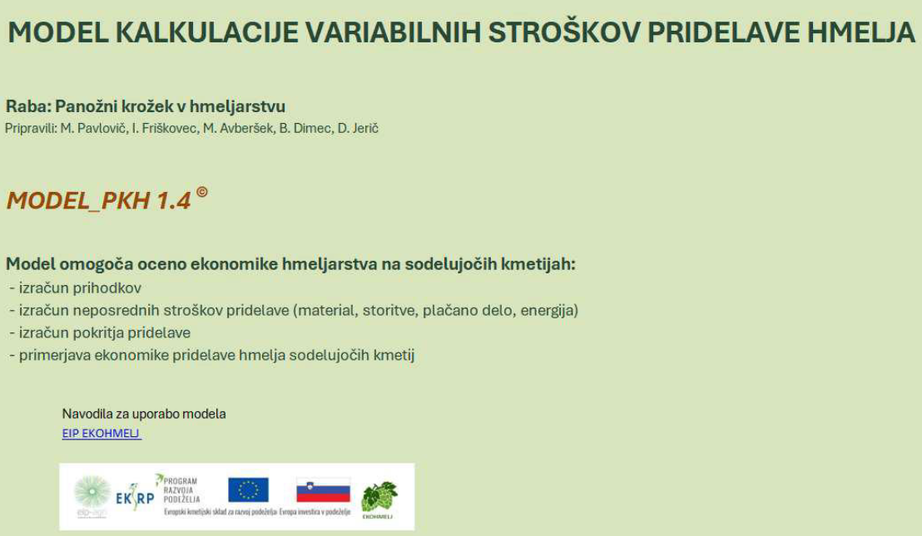
Figure 2: Model PKH for assessment of hop industry economics at farm level (https://www.ihps.si/wp-content/uploads/2023/08/Model-PKH-2025.xlsx)

Structure and location of farms
Slovenian hop farms that participated in benchmarking workshops in 2025 are multi-generational family farms with a long tradition of hop production. The farms are located in the Styrian growing region. The specific combination of the subalpine climate and soil enables the production of aromatic hop varieties with a worldwide reputation with the PGI 'Styrian hops' designation. The farms are highly specialized in high-quality hop production. The average number of full-time workers is 1.83, and family members often help with farm work.
The participating members grow various varieties of hops on their farms at their own choice, but Slovenian varieties predominate, which are: Aurora, Bobek, Celeia, Savinjski golding, Styrian Wolf. Most of the hop fields are irrigated or have the possibility of irrigation. Hop growers have their own harvesting halls for harvesting the crop. All participating farms have a long tradition, as they are led by the fourth or fifth generation. The members use modern machines, tools and mechanization in their work and thus strive to develop their farms. It is characteristic of hop farms that, in addition to hop growing, they also engage in livestock farming or some other agricultural branch, which also applies to the majority of the participating farms in the hop industry circle.

Workshops and processing of input data
A group of 10 hop growers participated in the research at the workshops held in 2025. At the first workshop, each hop grower had his own computer with a pre-prepared file with a model PKH for entering data from his own farm (Figure 3). Together, the farmers had entered their own technological and economic data on the revenues and expenses of hop production into the model in a guided manner (Pavlovič et al., 2025).
The workshop was followed by the analyzing of all data from the files of individual farms. The correctness of the data was checked and the farms were coded (CE1...CE10). This was followed by a comparative analysis of the input data with an illustration of the cumulatively calculated average values according to the selected model items. In case of excessive deviation, the data were excluded from the calculation of the average.
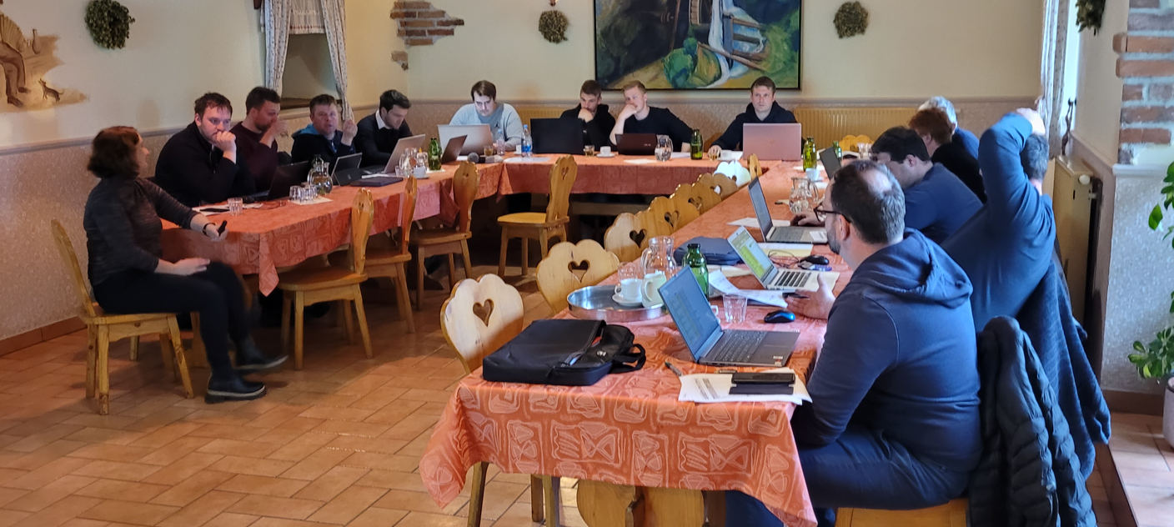
Figure 3: A benchmarking workshop with farmers who shared their hop production input data and model results
The second workshop was intended primarily for the presentation of data from individual farms - in comparison with the average values of the group and a discussion of the results obtained. This was followed by an exchange of opinions and a group debate. Participating hop growers looked for reasons for both poor and good results. They shared their experiences on how to improve practices on other farms.
The analyses also include a comparison of data from previous years (Figure 4). Experts in hop industry and economics play a key role in data analyses and in a debate with intention to improve economics of farms.

RESULTS AND DISCUSSION
In a results discussion we summarize and point out the following three group average economic parameters related to competitive value of hop farms analyzed for the growing seasons 2024:
- The average group revenue amounted 10,463 EUR/ha,
- the average group variable costs were assessed as 6,476 EUR/ha and
- the average gross margin was calculated as 4,169 EUR/ha.
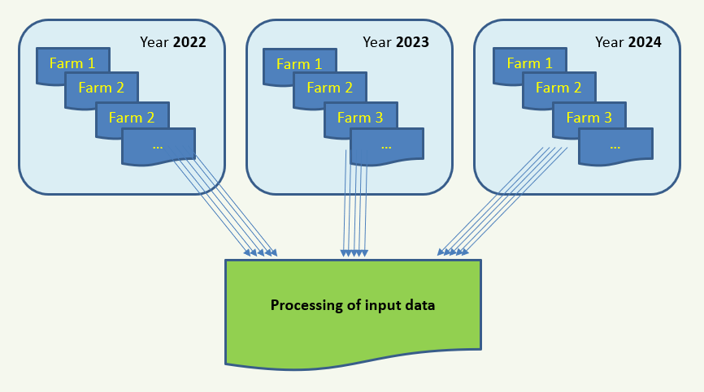
Figure 4: System links of Excel files for economic analyses of hop farms on workshops PKH
Summarized from the group costs analysis, the model PKH illustrated average output data on acreage (15 ha), hop yield (1,553 kg/ha) and hop price (6.04 EUR/kg) as well as major hop production variable cost groups such as stringing material (249 EUR/ha), manure and fertilizers (631 EUR/ha), energy for drying hops (751 EUR/ha), plant protection material (813 EU/ha), hired seasonal labor (1,718 EUR/ha) and mechanization (955 EUR/ha) related to farms analyzed within the benchmarking workshop evaluation (Pavlovič and Trpin Švikart, 2025).
The tables with workshops benchmarking results in detail (not included in this paper) are useful to determine whether the reason for the above-average successful farm in terms of gross margin (EUR/ha) is the highest yield and the highest selling price of hops. If we compare the data of all farms analyzed, we see that one farm may have the highest gross margin as the sum of average variable costs, above-average hop yield and slightly above-average selling price of hops. We may find out that the farm that is most successful in terms of gross margin may not necessarily have the highest yield per hectare and the highest selling price of hops. The level of variable costs counts and plays a key role, as well.
The included farmers acknowledged benefits and have thus accepted for the fourth time (since 2021) the presented methodological approach of a group assessment of hop production economics at farms level.

CONCLUSIONS
The benefits of the camaraderie and freedom to participate in workshops and to discuss the issues of the production technique and economics in a hop industry, whatever they may be, far outweigh the costs and limitations of such workshop activities. The workshop participants approved benefits and have thus accepted for the fourth time (since 2021) the method of a group assessment of hop production economics at farms level – in original Slovenian called as “panožni krožek v hmeljarstvu”.
In fact, the greater the understanding by workshop members about their economic situation in the global market creates a more cohesive national sector industry. Furthermore, it increases awareness of members regarding the global market situation of the day (macro-economic) as well as at their farm level (micro-economic) providing information to which they may not otherwise have access so they may act and respond should they so choose.
Acknowledgment
The author appreciates the project EIP FARM MANAGER and the project EIP EKOHMELJ team members from the Chamber of Agriculture and Forestry in Slovenia: mag. Darija Trpin Švikart, Irena Friškovec, Marjana Avberšek, Blaž Dimec and Damijan Jerič.
Data Availability
Data are available from the corresponding author upon a reasonable request.

REFERENCES
IHGC. (2025). International Hop Growers Convention, IHGC. https://www.ihgc.org/wp-content/uploads/2025_05_IHGC_Country Reports.pdf (accessed May 27, 2025).
MacKinnon, D., Pavlovič, M. (2019). Global hop market analysis within the International Hop Growers' Convention. Slovenian Institute of Hop Research and Brewing. Hop Bulletin, 26: 99-108.
Pavlovič, M. (2014). Hop Industry - Quality Management, Decision Support Modelling. Verlag Dr. Kovač, Hamburg, ISBN 978-3-8300-7537-0, 103 p.
Pavlovič, M. (2025). Prodaja pridelka pod lastno ceno ogroža projekte in finančne naložbe v sektorju. Hmeljarske informacije. [Spletna izd.]. 17. 10. 2025, vol. 42, nr. 17, pp. 5-7, https://www.ihps.si/wp-content/uploads/2025/06/HMI-7-2025.pdf.
Pavlovič, M., Trpin Švikart, D., Avberšek, M., Dimec, B., Jerič, D. (2024). Model PKH for assessment of hop industry economics at farm level. https://www.ihps.si/wp-content/uploads/2023/08/Model-PKH-2025.xlsx (accessed October 17, 2025).
Pavlovič, M, Avberšek, M., Dimec, B., Jerič, D. (2025). Ocena stroškov pridelave hmelja kmetij v panožnem krožku. Hmeljarske informacije, vol. 42, nr. 2, pp. 6-7. ISSN 2536-2062. https://www.ihps.si/wp-content/uploads/2025/04/HMI-2-2025.pdf (accessed September 15, 2025).
Pavlovič, M., Trpin Švikart, D., Vrednotenje gospodarnosti pridelave na kmetijah. Hmeljarske informacije. [Spletna izd.]. 26. avgust 2025, vol. 42, nr. 14, pp. 2-4. ISSN 2536-2062. https://www.ihps.si/ns_obvestila/hmeljarske-informacije-42-14/ (accessed September 15, 2025).
Žgajnar, J., Tomšič, M., Kavčič, S., Pavlovič, M., Jerič, D., Čop, T. (2023). Priročnik za izvajanje empirično podprtih panožnih krožkov. Ljubljana: Biotehniška fakulteta. https://www.kgzs-ms.si/wp-content/uploads/2023/09/Prirocnik-za-izvajanje-panoznih-krozkov.pdf (accessed August 25, 2025).

Ta članek je objavljen pod licenco Creative Commons Priznanje avtorstva-Deljenje pod enakimi pogoji 4.0 Mednarodna.

Vpliv vršičkanja na pridelek kanabinoidov in morfološke značilnosti industrijske konoplje (Cannabis sativa L.)
Marjeta ERŽEN in Marko FLAJŠMAN
Tipologija / Article type: Izvirni znanstveni članek / Original scientific article
Prispelo / Arrived: 25. 10. 2025
Sprejeto / Accepted: 10. 12. 2025
Objavljeno / Published: December 2025
Izvleček
Za boljši pridelek socvetja in bujnejšo rast konoplje se izvajajo različne tehnike pridelave. Ena od tehnik je rez vrhov ali vršičkanje, s katerim spodbudimo rast lateralnih poganjkov in omogočimo višji pridelek socvetja na rastlino. V raziskavo smo vključili pet dvodomnih sort in pet feminiziranih sort / žlahtniteljskih linij industrijske konoplje (Cannabis sativa L.), pri katerih smo preučevali vpliv vršičkanja v vegetativni fazi na vsebnost kanabinoidov, maso socvetja, višino rastlin in maso stebel. Vpliv vršičkanja na vsebnost kanabinoidov ni bil univerzalen, prav tako ni bilo statistično značilnih razlik med dvodomnimi in feminiziranimi sortami v tem parametru. Najvišja celokupna vsebnost CBD in najvišji povprečni pridelek CBD/rastlino je bil pri vršičkanih rastlinah sorte Midwest (14,3 % in 42,5 g/rastlino), najvišja celokupna vsebnost CBG in najvišji povprečni pridelek CBG/rastlino je bil pri vršičkanih rastlinah sorte Berry Blossom (8,3 % in 41,3 g/rastlino), najvišja celokupna vsebnost THC in najvišji pridelek THC/rastlino je bil pri vršičkanih rastlinah sorte Tiborszallasi (0,8 % in 1,8 g/rastlino). Vršičkane rastline so bile v povprečju za 6 cm nižje od nevršičkanih rastlin. Najvišje rastline so bile nevršičkane rastlina sorte Fibranova (357 cm), najnižje pa vršičkane rastline sorte Midwest (152 cm). Feminizirane sorte so bile za 129 cm nižje od dvodomnih. Pridelek suhega socvetja je bil pri večini sort večji pri vršičkanih rastlinah, pri katerih je najvišji pridelek dosegla feminizirana sorta Enectaliana (227 g). Med feminiziranimi sortami/linijami in dvodomnimi sortami v pridelku suhega socvetja ni bilo razlike. Razmerje med maso suhih socvetij in maso suhih stebel je pokazalo, da je v večini primerov masa suhih socvetij večja od mase suhih stebel. Izjema je bila pri sorti Northwest, pri kateri je bila masa stebla višja. Z raziskavo smo potrdili, da ima vršičkanje kot ukrep pomembno vlogo pri morfologiji konoplje, pri čemer je lahko močno odvisen od sorte.
Ključne besede: Cannabis sativa L., kanabinoidi, konoplja, pridelek, vršičkanje
COMPARISON OF CANNABINOID YIELD AMONG DIOECIOUS AND FEMINIZED VARIETIES OF HEMP (CANNABIS SATIVA L.)
Abstract
Various techniques are used to improve the yield and vigor of hemp plants. One such technique is topping, which promotes the growth of lateral branches and increases yield per plant. In this study, we used ten industrial hemp (Cannabis sativa L.) varieties to investigate the effect of topping on cannabinoid content, inflorescence mass, plant height, and stem mass. The experiment included five dioecious and five feminized varieties. The highest total CBD content was observed in topped plants of the variety Midwest (14.3% and 42.5 g/plant), the highest total CBG content in topped plants of Berry Blossom (8.3% and 41.3 g/plant), and the highest total THC content in Tiborszallasi (0.8% and 1.8 g/plant). Topped plants were generally shorter for 6 cm than non-topped plants. The tallest plants were non-topped Fibranova (357 cm), while the shortest were topped Midwest (152 cm). Feminized varieties were for 129 cm shorter than dioecious ones. The yield of dry inflorescences was, in most varieties, higher in topped plants (e.g., Enectaliana, 226,9 g). There was no significant difference in inflorescence yield between feminized and dioecious varieties. The ratio between dry inflorescence mass and dry stem mass showed that, in most cases, the mass of dry inflorescences exceeded that of dry stems. An exception was the variety Northwest, where stem mass was higher. This study confirmed that topping plays an important role in hemp morphology, although its effect can be highly dependent on the variety.
Key words: Cannabis sativa L., cannabinoids, hemp, yield, topping

UVOD
Konoplja vsebuje različne sekundarne metabolite, med katerimi so najpomembnejši kanabinoidi in terpeni, prav tako pa tudi flavonoidi, alkaloidi, steroidi in lignani (Janatová in sod., 2018). Kanabinoidi so terpenofenolne snovi, ki jih pri konoplji najdemo v žleznih trihomih, cvetovih, listih in steblih, medtem ko jih v semenih in koreninah ni. Največ kanabinoidov se nahaja v žleznih trihomih neoplojenih cvetov (do 60 %) (Russo in Marcu, 2017). Med najbolj znane kanabinoide uvrščamo tetrahidrokanabinol (THC), kanabidiol (CBD), kanabikromen (CBC), kanabigerol (CBG) in njihove karboksilirane oblike, kot so tetrahidrokanabinolna kislina (THC-A), kanabidiolna kislina (CBD-A), kanabikromenska kislina (CBC-A) in kanabigerolna kislina (CBG-A). Kanabinoidi so večinoma biosintetizirani v kislinski obliki, s pomočjo toplote pa se pretvarjajo v dekarboksilirano obliko (Namdar in sod., 2018).
Najpogostejša delitev konoplje glede na vsebnost kanabinoidov je na marihuano oz. indijsko konopljo (v Evropi to označuje, da ima vsebnost THC višjo od 0,3 %) in industrijsko konopljo (vsebnost THC je nižja od 0,3 %) (Bakel in sod., 2011). Glede na vsebnost kanabinoidov pa jo lahko klasificiramo tudi glede na kemotip; kemotip I (vsebnost THC > 0,3 % in CBD < 0,5 %), kemotip II (vsebnost THC in CBD je približno enaka), kemotip III (THC < 0,3 % in CBD > 0,5 %) (Meijer in sod., 2003), kemotip IV (vsebnost CBG > 0,3 % in CBD > 0,5 %) in kemotip V, kjer ima večina kanabinoidov zanemarljive vrednosti (Pacifico in sod., 2008).
Zaradi psihoaktivne lastnosti kanabinoida THC je bila konoplja skozi zgodovino precej osovražena rastlina. V začetku 20. stoletja so uporabo konoplje v Ameriki in Evropi prepovedali. V Ameriki je tako med leti 1943 in 1950 pridelava konoplje postopoma ugašala in leta 1950 ni bilo zabeležene nobene pridelave konoplje več. Nato pa so leta 1970 v Ameriki vpeljali pojem marihuana ter tako konopljo z višjo vsebnosti THC uvrstili na seznam prepovedanih drog. Z boljšim poznavanjem biokemičnih in biomolekularnih lastnosti konoplje je bilo mogoče razumeti mehanizem delovanja in sinteze kanabinoidov. Tako je bila Kanada ena prvih držav, ki je leta 1998 obudila pridelavo industrijske konoplje, katera je vsebovala manj kot 0,3 % THC. V Evropi pa se je ponovna pridelava industrijske konoplje vzpostavila šele leta 2013, pri čemer THC ni smel presegati 0,2 % (Farinon in sod., 2020).
Za konopljo je značilna dvodomnost. Največ kanabinoidov se nahaja na socvetjih ženskih rastlin, zato se za pridelavo kanabinoidov uporabljajo izključno ženske rastline. Moške in hermafroditne rastline v pridelavi kanabinoidov niso zaželene, saj opraševanje in nato tvorba semena znižujeta vsebnost kanabinoidov v ženskih socvetjih (Janatová in sod., 2018). Zato se za pridelavo kanabinoidov vse več uporabljajo feminizirane sorte. To so sorte, katerih seme daje v celoti rastline ženskega spola in so zato bolj primerne od enodomnih ali dvodomnih sort.
Namen naše raziskave je bil ugotoviti, kakšen vpliv ima ukrep vršičkanja na pridelek kanabinoidov dvodomnih in feminiziranih sort/linij konoplje. Ena od tehnik, s katero lahko spremenimo morfologijo rastlin, je namreč tudi odstranjevanje glavnega poganjka oz. vršičkanje v vegetativni fazi, ki je pogosta praksa pri pridelavi konoplje za socvetje, saj omogoča spremembe v rastlinski arhitekturi, biomasi, pridelku socvetja in kanabinoidov na rastlino (Roussis in sod., 2022). Drugi del raziskave je bil primerjati vpliv vršičkanja in sorte na višino rastlin, maso socvetja, maso stebel in na razmerje med maso socvetij in stebel.

MATERIAL IN METODE

Vzorčenje rastlin, meritve in priprava vzorcev
Spravilo rastlin v fazi zrelih socvetij je potekalo konec septembra in v začetku oktobra leta 2023, odvisno od sorte in zrelosti socvetij. Rastlinam smo izmerili višino, jih ločili na stebla in socvetja z listi, sušili v sušilniku 7 dni na 40 °C, da smo dobili zračno suhe vzorce ter stehtali maso stebel in pridelek socvetij z listi vsake posamezne rastline. Določili smo razmerje med maso suhih socvetij z listi in maso suhih stebel, saj je za pridelavo kanabinoidov pomembno, da imajo rastline čim več socvetij in čim manj stebel, saj kanabinoidov v steblih skoraj da ni. Na koncu smo vzorce socvetij z listi združili po sortah ter ločili na vršičkane in nevršičkane; tako smo dobili 20 vzorcev v katerih smo izmerili vsebnost kanabinoidov in izračunali njihov pridelek. Za natančno določanje vsebnosti kanabinoidov smo iz socvetij odstranili seme, če je bilo prisotno, večje liste in stebla ter vzorce zmleli s kavnim mlinčkom. Iz podatkov o vsebnosti CBD in pridelka socvetij z listi smo izračunali pridelek CBD na rastlino.

Določanje vsebnosti kanabinoidov
Kanabinoide smo določali s tekočinsko kromatografijo visoke ločljivosti (HPLC) (angl. High-performance liquid chromatography) po protokolu, opisanem v članku Bitežnik in sod. (2024). Za ekstrakcijo smo v centrifugirko v dveh serijah zatehtali med 75 mg in 85 mg homogeniziranega vzorca, dodali 10 mL topila MeOH : kloroform (Honeywell, Kanada) v razmerju 9:1 ter vzorce postavili v ultrazvočno kopel za 10 min. Nato smo odpipetirali po 1 mL vzorca ter preko Chromafi®CA (LLG, Nemčija) prefiltrirali v viale in izmerili vsebnost kanabinoidov. Celokupno vsebnost kanabinoidov smo izračunali po naslednjih enačbah (Glivar in sod., 2020):
1) % celokupnega Δ9-THC = % Δ9-THC + (% Δ9-THC-A x 0,877),
2) % celokupnega CBD = % CBD + (% CBD-A x 0,877),
3) % celokupnega CBG = % CBG + (% CBG-A x 0,878).

Zasnova poskusa, preučevane sorte in statistična analiza rezultatov
V poskus je bilo vključenih pet dvodomnih sort: Tiborszallasi, Kompolti, Dioica 88, Carmagnola in Fibranova ter pet feminiziranih sort Berry Bloosom (BB), CBGo (žlahtniteljska linija), Midwest, Northwest in Enectaliana. Seme posameznih sort/linij smo v začetku maja posejali v plastične platoje, pred tem smo seme 12 h namakali v vodi v hladilniku.
Sorta Berry Bloosom je feminizirana sorta z višjo vsebnostjo CBD. Sorta izvira iz križanja med sortama Cherry Kandahar S1 in Chardonay in je dvodomna sorta. Vegetativni cikel traja od 100 do 140 dni in zraste v višino od 1,5 do 2,5 m. Polno svetenje doseže v mesecu septembru. Vsebnost THC je nižja od 0,5 % medtem ko je vsebnost CBD lahko med 8 do 12 % (Cannapuglia, 2025a).
Sorta Carmagnola je italijanska sorta, ki se goji že vrsto let. Najprej so jo gojili zaradi vlaken sedaj pa tudi zaradi vsebnosti CBD. Je dvodomna sorta s 160 do 180 dnevnim vegetativnim ciklom. V višino zraste od 2,5 do 6,5 m. Pridelek semena znaša od 400 do 600 kg/ha. Vsebnost THC je nižja od 0,2 % medtem ko vsebnost CBD lahko doseže med 3 in 10 % (Canapuglia, 2025b).
Žlahtniteljska linija CBGo je križanec med sorto Matterhorn in sorto Fenopure z visoko vsebnostjo kanabinoida CBG. Požlahtnili so jo na Biotehniški fakulteti pod vodstvom doc. dr. Marka Flajšmana.
Sorta Dioica 88 je francoska dvodomna sorta visoke rasti. Vegetativni cikel traja od 140 do 160 dni, polno cvetenje doseže v avgustu. Poprečen pridelek socvetja je 600 do 1000 kg/ha. Vsebnost THC je nižja od 0,2 %, vsebnost CBD pa nižja od 8 % (Canapuglia, 2025c).
Enectaliana je enodomna sorta, ki izvira iz Italije. Je prva sorta z visoko vsebnostjo CBD, ki je registrirana v Evropski sortni listi. Cveti 75 do 80 dni in zraste do 2,5 m visoko. Vsebnost THC je nižja od 0,2 %, vsebnost CBD pa lahko doseže od 5 do 6 % (Enecta.farm, 2025).
Fibranova je dvodomna italijanska sorta in je križanec med sortama Eletta Campana in Carmagnola. Sprva je bila namenjena za pridelavo stebel, sedaj pa jo uporabljajo tudi za pridelavo CBD. Vegetativni cikel traja od 160 d 180 dni, v višino zraste od 2,5 do 6,5 m. Pridelek socvetja lahko doseže od 600 do 1000 kg/ha. Vsebnost THC je nižja od 0,2 % medtem ko je vsebnost CBD lahko od 3 do 10 % (Cannapuglia, 2025d).
Kompolti je madžarska dvodomna sorta. Sprva je bila namenjena za pridelavo vlaken, sedaj pa jo uporabljajo za pridelavo socvetij in CBD. Vegetativni cikel traja od 140 do 160 dni, v višino pa lahko zraste od 2,5 do 3,5 m. V povprečju se lahko pridela 600 do 1500 kg/ha socvetij. Vsebnost THC je nižja od 0,2 %, vsebnost CBD pa lahko doseže od 2 do 10 % (Cannapuglia 2025e).
Midwest dvodmna sorta, ki izvira iz Amerike. Je CBD sorta, ki lahko doseže od 5 do 16 % CBD, medtem ko je vsebnost THC nižja od 0,2 %. V višino zraste od 1 do 2 m. Vegetativni cikel traja od 4 do 5 mesecev. V povprečju lahko doseže od 2500 do 3000 kg/ha biomase pridelka. Sorta Northwest ima podobne lastnosti kot Midwest s tem da ima krajši vegetativni cikel in sicer od 3 do 4 mesece (Cannapuglia, 2025f).
Tiborszallasi je madžarska dvodomna sorta. Sprva so jo pridelovali za vlakna sedaj pa jo uporabljajo tudi za pridobivanje kanabinoida CBD. Vegetativni cikel traja od 140 do 160 dni, v višino pa zraste od 2,5 do 4,5 m. Pridelek socvetja lahko v povprečju znaša od 600 do 1500 kg/ha. Vsebnost THC je pod 0,2 %, vsebnost CBD pa je v povprečju lahko od 2 do 10 % (Cannapuglia 2025g).
Rastline smo po vzniku (junija) 2023 posadili na njivo v okolici Krškega, kjer so tla srednje težka z 3,4 % organske snovi in 6,8 pH, vsebnosti fosforja in kalija v leh sta bili v C razredu. Feminizirane sorte (po 30 rastlin na sorto) smo sadili vsako v svojo vrsto dolžine 30 m. Medvrstna razdalja je bila 1 m. Dvodomne sorte smo posadili na razdaljo 50 cm v vrsti po 60 rastlin vsake sorte, saj smo predvidevali, da bo polovica rastlin moških rastlin, ki smo jih med rastno dobo odstranjevali; tako smo v času vrednotenja imeli prav tako okoli 30 rastlin teh sort (preglednica 1). Zaradi slabega vznika smo na njivo presadili le 10 rastlin sorte Midwest, in po 20 rastlin sort Northwest in Enectaliana.

Preglednica 1: Število analiziranih rastlin po posameznih sortah/linijah
Vršičkanje/sorta | BB | CBGo | MW | NW | ENE | FIB | KOM | CAR | DIO | TIB
NE-VR | 11 | 12 | 4 | 10 | 8 | 9 | 12 | 10 | 16 | 14
VR | 11 | 4 | 4 | 10 | 3 | 9 | 10 | 17 | 13 | 18
Feminizirane sorte: BB-Berry Blossom, , CBGo – Žlahtniteljska linija CBG, ENE – Enectaliana, MW – Midwest, NW – Northwest, Dvodomne sorte: CAR – Carmagnola, DIO – Dioica 88, FIB – Fibranova, KOM – Kompolti, NE-VR – nevršičkano, VR – vršičkano
Po dveh tednih rasti na njivi (razvitih med 6 in 8 členkov) smo pri polovici rastlin vsake sorte (prva polovica vrste) izvedli vršičkanje, kar pomeni, da smo odrezali glavni poganjek.
Poskus je bil zasnovan kot poskus z dvema obravnavanjema (sorta in vršičkanje) z do 15 ponovitvami (rastlinami) na obravnavanje. Podatke smo obdelali v programu R 4.5.1. (R Core Team, 2021) kjer smo za analizo uporabili dvosmerno ANOVA analizo s post hoc Duncanovim testom, ki smo jo izvedli z uporabo paketa »agricolae«. Z dvosmerno ANOVA analizo smo preverjali vpliv obeh faktorjev (sorta in vršičkanje) na pridelek kanabinoidov na rastlino. Grafe smo narisali v programu R 4.5.1.

Vremenske razmere
Na sliki 1 je prikazan graf s povprečnimi mesečnimi temperaturami in količino padavin v času poskusa v obdobju od junija do oktobra leta 2023 na vremenski postaji na letališču Cerklje ob Krki (6,6 km zračne razdalje od lokacije poskusa). Z grafa je mogoče razbrati, da je bila temperatura v času rasti konoplje ugodna, brez večjih vročinskih stresov, medtem ko je bila količina padavin nekoliko problematična konec julija in v začetku avgusta (poplave). Povečana količina padavin namreč lahko povzroči poleganje rastlin, zastajanje vode v tleh in propad rastlin. Prav tako lahko pride do nastajanja plesni.

Slika 1: Povprečne mesečne (junij-oktober) temperature (°C) in količina padavin (mm) v letu 2023 za postajo letališče Cerklje ob Krki (ARSO, 2025)

REZULTATI IN RAZPRAVA

Celokupna vsebnost kanabinoidov
Pri vsaki sorti smo določili celokupno vsebnost treh kanabinoidov (CBD, CBG in THC). Najvišjo vsebnost CBD so dosegle vršičkane rastline sorte Midwest (14,3 %), sledile so nevršičkane rastline sorte BB (10,4 %). Najnižja vsebnost CBD pa je bila pri vršičkanih rastlinah linije CBGo (0,5 %). Največja razlika pri vsebnosti CBD med vršičkanimi in nevršičkanimi rastlinami znotraj iste sorte je bila pri sorti BB, kjer je bil količnik razmerja 12,0. Pri sortah Enectaliana, Kompolti, Tiborszallasi, BB in CBGo so imele nevršičkane rastline višjo vsebnost CBD od vršičkanih, medtem ko je bilo pri sortah, Fibranova, Dioica 88, Carmagnola, Midwest in Northwest obratno.
Najvišja vsebnost kanabinoida CBG je bila pri vršičkanih rastlinah BB (8,3 %). Zanimivo, tako vršičkane kot nevršičkane rastline sorte CBGo so bile šele na drugem mestu (6,6 % in 6,9 %), saj bi pričakovali da bo, glede na to, da je to linija z višjo vsebnostjo CBG, imela najvišjo vsebnost kanabinoida CBG. Nevršičkane rastline BB pa so dosegle 4,1 %. Pri ostalih sortah je bila vsebnost CBG pod 1 %. Največja razlika v razmerju vsebnosti CBG med vršičkanimi in nevršičkanimi rastlinami iste sorte je bila pri sorti Fibranova (količnik 1,3). Sorti Fibranova in Tiborszallasi sta imeli pri nevršičkanih rastlinah višjo vsebnost CBG, medtem ko je bilo pri ostalih sortah obratno.
Preglednica 2: Celokupna vsebnost kanabinoidov CBD, CBG in THC (%) ter njihov pridelek na rastlino (g) v socvetjih z listi glede na sorto in vršičkanje.
Sorta | Vršičkanje | CBD (%) | Povprečen pridelek CBD (g) | CBG (%) | Povprečen pridelek CBG (g) | THC (%) | Povprečen pridelek THC (g)
KOM | Ne-vr | 5,9 | 10,9 defgh | 0,1 | 0,2 e | 0,1 | 0,2 gh
KOM | Vr | 5,6 | 15,74 bcdefg | 0,2 | 0,6 e | 0,1 | 0,3 fgh
FIB | Ne-vr | 7,4 | 16,6 bcdefg | 0,2 | 0,4 e | 0,2 | 0,4 efgh
FIB | Vr | 7,5 | 19,9 bcde | 0,1 | 0,3 e | 0,2 | 0,6 defg
DIO | Ne-vr | 4,9 | 9,2 efgh | 0,1 | 0,2 e | 0,1 | 0,2 h
DIO | Vr | 8,1 | 20,4 bcd | 0,2 | 0,6 e | 0,2 | 0,5 defgh
TIB | Ne-vr | 6,7 | 14,2 cdefg | 0,1 | 0,3 e | 0,3 | 0,7 cde
TIB | Vr | 5,6 | 13 cdefg | 0,1 | 0,2 e | 0,8 | 1,8 a
CAR | Ne-vr | 5,2 | 8,0 gh | 0,1 | 0,1 e | 0,7 | 1,0 bc
CAR | Vr | 5,7 | 8,4 fgh | 0,5 | 0,8 e | 0,1 | 0,2 h
Skupna vsebnost kanabinoidov (% ali g) |  | 6,3 | 13,6 | 0,2 | 0,4 | 0,3 | 0,6
BB | Ne-vr | 10,4 | 35,2 a | 4,1 | 13,9 d | 0,3 | 1,2 b
BB | Vr | 2,8 | 14,1 cdefg | 8,3 | 41,3 a | 0,1 | 0,5 defgh
MW | Ne-vr | 8,4 | 19,5 bcde | 0,3 | 0,7 e | 0,3 | 0,6 defgh
MW | Vr | 14,3 | 42,5 a | 0,4 | 1,2 e | 0,5 | 1,4 b
NW | Ne-vr | 8,5 | 22,9 bc | 0,2 | 0,6 e | 0,3 | 0,7 def
NW | Vr | 9,2 | 25,9 b | 0,2 | 0,6 e | 0,3 | 0,8 cd
CBGo | Ne-vr | 5,7 | 18,8 bcdef | 6,6 | 21,6 c | 0,2 | 0,5 defgh
CBGo | Vr | 0,5 | 2,2 h | 6,9 | 32,0 b | 0,0 | 0,2 h
ENE | Ne-vr | 9,2 | 21,2 bcd | 0,1 | 0,3 e | 0,2 | 0,4 defgh
ENE | Vr | 6,5 | 13,8 cdefg | 0,2 | 0,4 e | 0,1 | 0,3 fgh
Skupna vsebnost kanabinoidov (% ali g) |  | 7,56 | 21,6 | 2,7 | 11,2 | 0,2 | 0,7
Feminizirane sorte: BB-Berry Blossom, , CBGo – Žlahtniteljska linija CBG, ENE – Enectaliana, MW – Midwest, NW – Northwest, Dvodomne sorte: CAR – Carmagnola, DIO – Dioica 88, FIB – Fibranova, KOM – Kompolti, Ne-vr – nevršičkano,. Vr – vršičkano
Vsebnost THC je bila pri vršičkanih rastlinah sorte Tiborszallasi (0,8 %), nevršičkanih rastlinah sorte Carmagnola (0,7 %), vršičkanih rastlinah sorte Midwest (0,5 %) ter pri nevršičkanih rastlinah rastlin Tiborszallasi in nevršičkanih rastlinah sorte BB (0,3 %) višja od zakonsko določene meje 0,3 % THC. Najnižja vsebnost THC pa je bila pri vršičkanih rastlinah linije CBGo. Največje razmerje pri vsebnosti THC med vršičkanimi in nevršičkanimi rastlinami znotraj sorte je bilo pri sorti Carmagnola, kjer je bil količnik 5,4. Pri sortah Enectaliana, Kompolti, Carmagnola, BB in CBGo je bila vsebnost THC višja pri nevršičkanih rastlinah kot pri vršičkanih, medtem ko je bilo pri ostalih sortah obratno.
Pri vsebnosti kanabinoidov med feminiziranimi sortami in dvodomnimi sortami nismo opazili značilne razlike. Feminizirane sorte so imele v povprečju za 1,3 % višjo vsebnost CBD. Največja razlika je bila pri vsebnosti CBG, saj so feminizirane sorte imele 2,6 % višjo vsebnost CBG, kar je pričakovano, saj smo med feminiziranimi sortami imeli CBG linijo. Pri vsebnosti THC med feminiziranimi in dvodomnimi sortami ni bilo razlike.
Vršičkanje oz. odstranitev apikalnega meristema se izvaja predvsem zato, ker s tem povečamo pridelek socvetij na rastlino. Ko odstranimo apikalni meristem, v rastlini spremenimo hormonsko ravnovesje avksinov in citokininov in s tem spodbudimo rast stranskih poganjkov (Trancoso in sod., 2022). Folina in sod. (2020) so preučevali vpliv vršičkanja na vsebnost kanabinoidov in ugotovili višjo vsebnost kanabinoida CBD pri vršičkanih rastlinah sort Fedora 23 in Futura 75, vendar pa vsebnost celokupnega CBD ni bila statistično značilno različna. Prav tako so ugotovili višji pridelek in biomaso socvetij. Statistično značilno višjo vsebnost CBD so pri vršičkanih rastlinah v primerjavi z nevršičkanimi rastlinami sort Fedora 17 in Felina potrdili tudi Roussis in sod. (2022).

Pridelek kanabinoidov
Najvišji pridelek kanabinoida CBD je bil pri vršičkanih rastlinah sorte Midwest (42,5 g/rastlino), sledile so nevršičkane rastline sorte BB s 35,2 g/rastlino, najnižji pridelek CBD pa je bil pri vršičkanih rastlinah sorte CBGo, in sicer 2,2 g/rastlino (preglednica 2 in slika 2). Feminizirane sorte so imele v povprečju višji pridelek CBD kot dvodomne. Pri sortah Dioica 88, Fibranova, Kompolti, Midwest in Northwest so imele vršičkane rastline višji pridelek CBD od nevršičkanih, medtem ko je bilo pri ostalih sortah obratno.
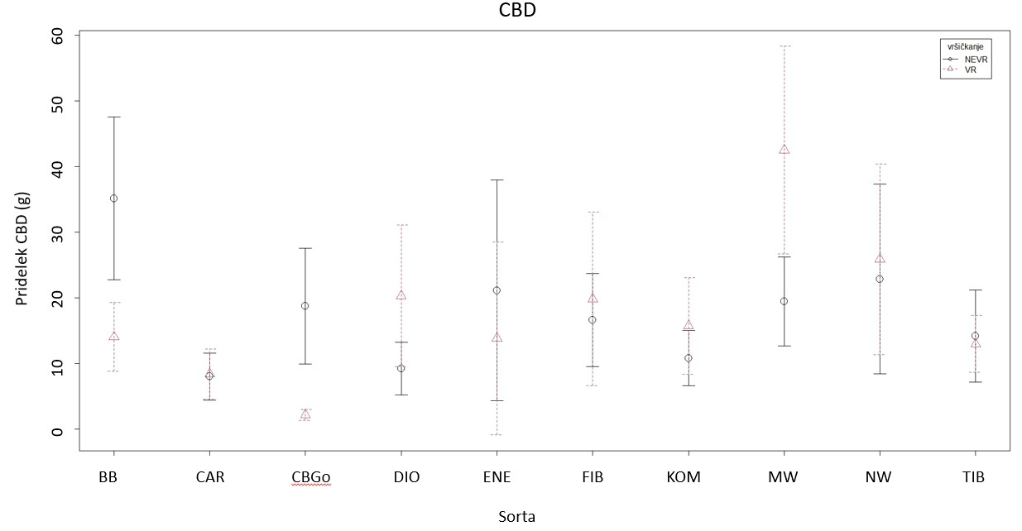
Slika 2: Povprečen pridelek CBD (g) na rastlino s standardnim odklonom.
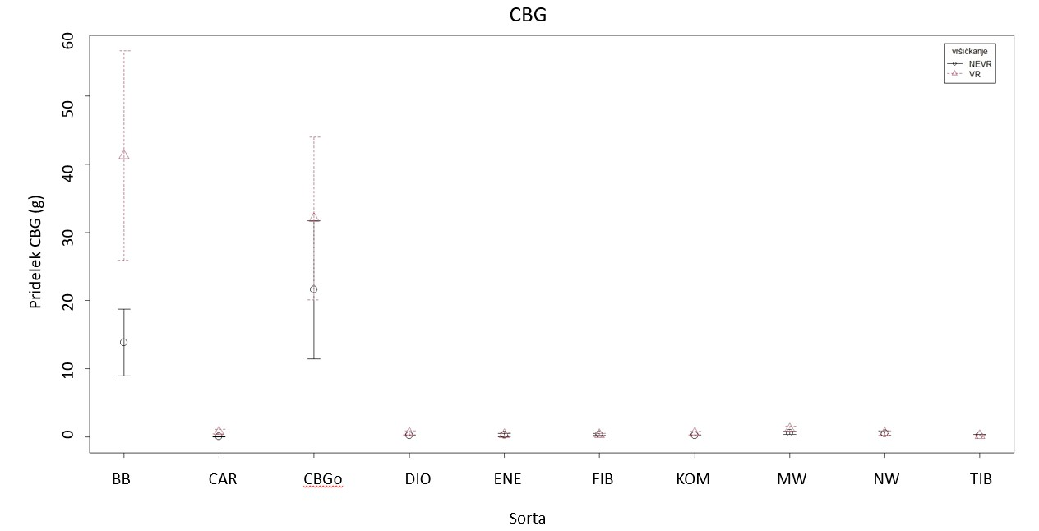
Slika 3: Povprečen pridelek CBG (g) na rastlino s standardnim odklonom.
Z dvosmerno ANOVA analizo smo preverjali vpliv obeh faktorjev (sorta in vršičkanje) na pridelek CBD/rastlino. Ugotovili smo, da vršičkanje nima statistično značilnega vpliva na pridelek CBD (p=0,911), medtem ko se pridelek CBD razlikuje med sortami (p < 0,001). Interakcija med vršičkanjem in sorto je bila prav tako statistično značilna (p < 0,001). Duncanov test mnogoterih primerjav je pokazal, da so se znotraj sorte po pridelku CBD/rastlino razlikovale vršičkane in nevršičkane rastline sorte Midwest, rastline sorte BB in rastline žlahtniteljske linije CBGo (preglednica 2).
Najvišji pridelek CBG/rastlino je bil pri vršičkanih rastlinah sorte BB (41,3 g/rastlino), sledile so vršičkane rastline žlahtniteljske linije CBGo s pridelkom 32,0 g/rastlino. Najnižji pridelek CBG pa je bil pri nevršičkanih rastlinah sorte Carmagnola (0,1 g/rastlino). Prav tako so imele vse sorte, razen sorta BB in žlahtniteljska linija CBGo pridelek CBG nižji od 1,2 g/rastlino. Feminizirane sorte so imele višji skupni pridelek CBG/rastlino od dvodomnih rastlin (preglednica 2 in slika 3).
Tako sorta, vršičkanje, kot tudi interakcija med sorto in vršičkanjem so statistično značilno vplivali na pridelek CBG (p < 0,001). Glede na Duncanov test so se po pridelku CBG/rastlino razlikovale vršičkane in nevršičkane rastline sorte BB in rastline žlahtniteljske linije CBGo, med ostalimi sortami ni bilo razlike (preglednica 2).
Najvišji pridelek THC/rastlino je bil pri vršičkanih rastlinah sorte Tiborszallasi (1,8 g/rastlino), sledile so vršičkane rastline sorte Midwest (1,4 g/rastlino), najnižji pridelek THC pa je bil pri vršičkanih rastlinah sorte Carmagnola (0,2 g/rastlino). Skupni pridelek THC/rastlino je bil med dvodomnimi in feminiziranimi rastlinami enak (preglednica 2 in slika 4).
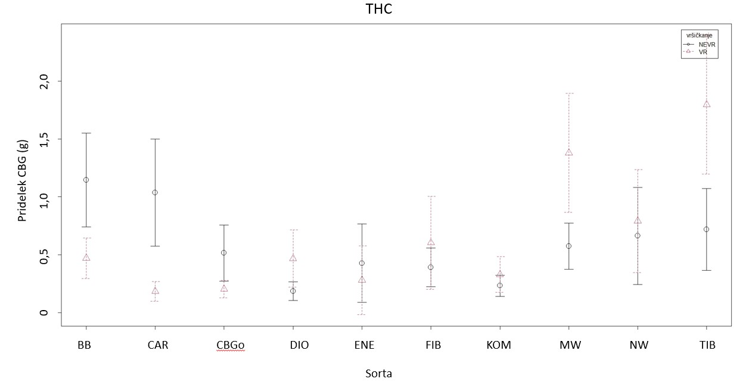
Slika 4: Povprečen pridelek THC (g) na rastlino s standardnim odklonom.
Dvosmerna ANOVA je pokazala, da sorta močno vpliva na pridelek THC/rastlino (p < 0,001), medtem ko vršičkanje ni imelo statistično značilnega vpliva (p=0,0923). Interakcija med sorto in vršičkanjem pa je prav tako pokazala statistično značilno razliko (p < 0,001). Znotraj sorte je bila glede na Duncanov test mnogoterih primerjav razlika med vršičkanimi in nevršičkanimi rastlinami sort Tiborszallasi, Midwest, BB in Carmagnola.

Višina rastlin
Najvišjo višino so dosegle nevršičkane rastline sorte Fibranova, ki so v povprečju merile 357 cm. Najnižje pa so bile nevršičkane rastline sorte Northwest (152 cm) in vršičkane rastline sorte Midwest (povprečno 152 cm) (slika 5). Kot lahko vidimo na sliki 5, so bile feminizirane sorte za 129 cm nižje od dvodomnih sort, pri čemer so feminizirane sorte v povprečju merile 191 cm, dvodomne pa 320 cm. Vršičkane rastline so bile v povprečju za 6 cm nižje od nevršičkanih.
Vršičkanje pomembno vpliva na višino rastline (p=0,00147), prav tako se višina rastlin konoplje razlikuje med sortami (p < 0,001). Interakcija med vršičkanjem in sorto ni bila statistično značilna. Duncanov test mnogoterih primerjav je pokazal, da med vršičkanimi in nevršičkanimi rastlinami ni razlike v višini, medtem ko se feminizirane sorte po višini razlikujejo od dvodomnih sort (preglednica 3). V povprečju nobena od feminiziranih sort ni presegla višine 230 cm, medtem ko so bile dvodomne sorte v povprečju višje od 280 cm (preglednica 3), kar je pričakovano, saj je žlahtniteljski cilj feminiziranih sort najpogosteje pridelek kanabinoidov, zato so feminizirane rastline bolj grmičaste in nižje, s krajšimi internodiji. Prav tako pa sam proces feminizacije lahko vpliva na manjšo rast rastlin (Timoteo Junior in Oswald, 2024).
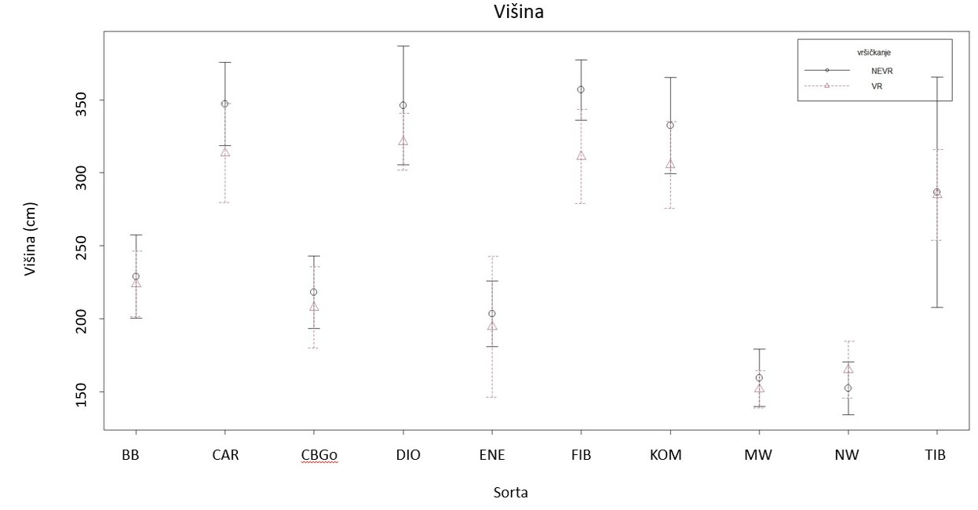
Slika 5: Povprečne višine (cm) vršičkanih in nevršičkanih rastlin glede na sorto s standardnim odklonom.

Masa suhega socvetja
Na sliki 6 vidimo, kako se masa suhega socvetja z listi spreminja glede na sorto in vršičkanje. Iz preglednice 3 je razvidno, da so vršičkane sorte BB, CBGo, Dioica 88, Enectaliana, Fibranova, Kompolti in Midwest imele v povprečju višji pridelek suhega socvetja od nevršičkanih rastlin, medtem ko je bil pridelek suhih socvetij z listi pri sortah Carmagnola, Northwest in Tiborszallasi višji pri nevršičkanih rastlinah. Med vsemi sortami je imela najvišji pridelek sorta Enectaliana pri vršičkanih rastlinah (227 g), sledila ji je sorta BB prav tako pri vršičkanih rastlinah (185 g). Najnižji pridelek suhega socvetja z listi pa so imele vršičkane rastline sorte Carmagnola.
Na povprečno maso suhih socvetij z listi sta tako sorta (p < 0,001) kot vršičkanje (p=0,00234) imela statistično značilen vpliv, interakcije pa ni bilo. Najvišji pridelek suhih socvetij z listi je dosegla sorta BB (418 g), najnižjega pa sorta Carmagnola (151 g). Vršičkane rastline so dosegle skoraj 40 g višji pridelek od nevršičkanih (preglednica 3).
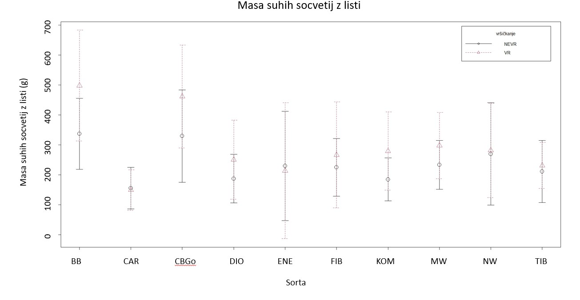
Slika 6: Povprečna masa suhega socvetja z listi (g) pri vršičkanih in nevršičkanih rastlinah glede na sorto s standardnim odklonom

Preglednica 3: Primerjava višine konopljinih rastlin glede na sorto in vršičkanje. Enaka črka znotraj istega stolpca pomeni, da med obravnavanji ni statistično značilne razlike.
Dejavnik |  | Povprečna višina (cm) | Masa suhega socvetja z listi (g)
Sorta | DIO | 335 a | 215 bc
Sorta | FIB | 334 a | 245 bc
Sorta | CAR | 326 a | 151 c
Sorta | KOM | 320 a | 227 bc
Sorta | TIB | 285 b | 222 bc
Sorta | BB | 226 c | 417 a
Sorta | CBGo | 215 cd | 362 a
Sorta | ENE | 200 d | 225 bc
Sorta | NW | 158 e | 275 b
Sorta | MW | 155 e | 265 b
Vršičkanje | Ne-vr | 274 a | 273 a
Vršičkanje | Vr | 268 a | 234 b
BB-Berry Blossom, CAR – Carmagnola, CBGo – Žlahtniteljska linija CBG, DIO – Dioica 88, ENE – Enectaliana, FIB – Fibranova, KOM – Kompolti, MW – Midwest, NW – Northwest, Ne-vr – nevršičkano, Vr - vršičkano

Masa suhih stebel in razmerje med maso suhih socvetij ter maso suhih stebel
Na sliki 7 in v preglednici 4 je prikazana povprečna masa suhih stebel glede na sorto in vršičkanje. Vršičkane sorte BB, CBGo, Enectaliana, Kompolti in Northwest so imele večjo maso suhih stebel od nevršičkanih rastlin, medtem ko so imele nevršičkane rastline sort Carmagnola, Dioica 88, Fibranova, Midwest in Tiborszallasi večjo maso suhih stebel od vršičkanih. Največjo maso suhih stebel so imele vršičkane rastline linije CBGo (691 g), sledile so vršičkane rastline sorte BB (625 g), najmanjša masa suhih stebel pa je bila pri nevršičkanih rastlinah sorte Enectaliana (230 g). V primeru, da gojimo konopljo za namen pridelave socvetij in kanabinoidov si želimo imeti čim več socvetij in čim manj stebel, saj se v socvetjih oz. trihomih na socvetjih tvori največ kanabinoidov, medtem ko je vsebnost kanabinoidov v steblih zanemarljiva (Russo in Marcu, 2017).
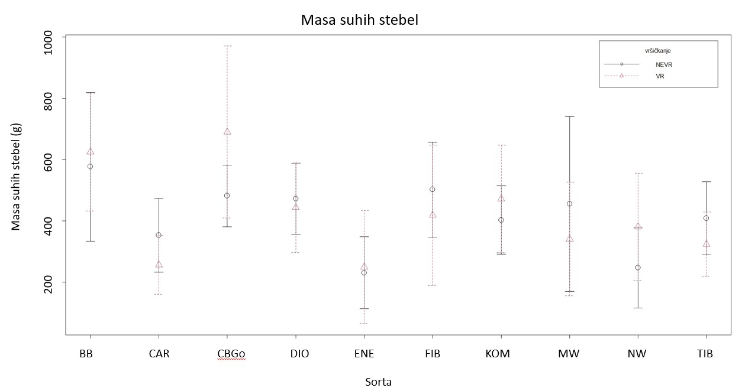
Slika 7: Povprečna masa suhih stebel (g) vršičkanih in nevršičkanih rastlin glede na sorto s standardnim odklonom
Izračunali smo razmerje med maso socvetja z listi in maso stebel (preglednica 4). Pri vseh sortah bodisi vršičkanih ali nevršičkanih rastlin je bila masa suhih socvetij z listi večja od mase suhih stebel, razen pri nevršičkanih rastlinah sorte Northwest, kjer je bila masa suhih stebel večja od mase suhih socvetij (razmerje 1,1), kar ni ravno v prid pridelavi konoplje za kanabinoide.
Rezultat dvosmerne ANOVA analize je pokazal, da sorta statistično značilno vpliva na maso suhih stebel (p < 0,001), medtem ko vršičkanje ni imelo statistično značilnega vpliva. Interakcija med sorto in vršičkanjem je pokazala statistično značilen vpliv (p=0,0364). Med rastlinami linije CBGo pa je razlika le med vršičkanimi in nevršičkanimi rastlinami (preglednica 4, slika 8).
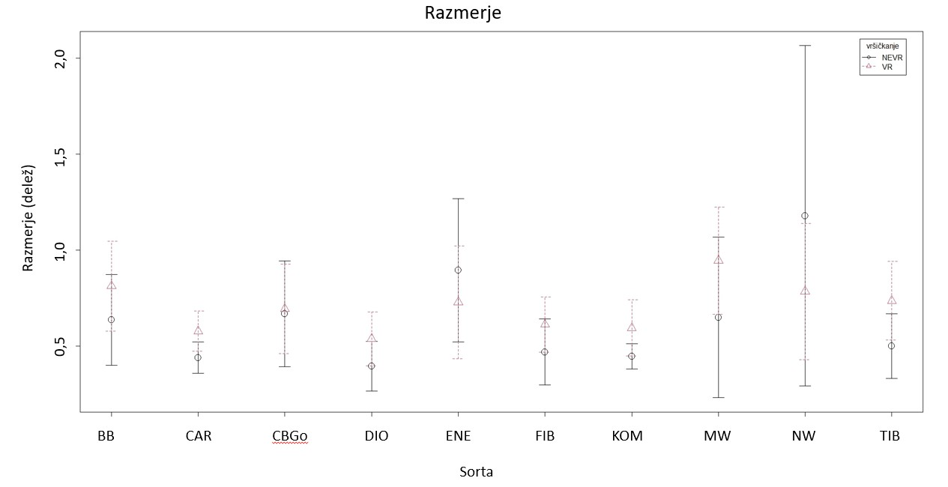
Slika 8: Razmerje med povprečno maso suhih socvetij z listi in povprečno maso suhih stebel (g) za vršičkane in nevršičkane rastline glede na sorto s standardnim odklonom
Preglednica 4: Kombinacija sorte in vršičkanja ter njen vpliv na povprečno maso suhih stebel (g) in razmerje med maso suhih socvetij z listi in maso suhih. Enaka črka znotraj istega stolpca pomeni, da med obravnavanji ni statistično značilne razlike.
Obravnavanje | Povprečna masa suhih stebel (g) | Razmerje med maso suhih socvetij z listi in maso suhih stebel
CBGo-vr | 690 a | 0,7 bcdefg
BB-vr | 624 ab | 0,8 bcd
BB-Ne-vr | 576 abc | 0,6 bcdefg
CAR-Ne-vr | 352 def | 0,4 fg
CAR-Vr | 255 ef | 0,5 cdefg
CBGo-Ne-vr | 481 bcd | 0,6 bcdefg
DIO-Ne-vr | 471 bcd | 0,3 g
DIO-Vr | 443 cd | 0,5 defg
ENE-Ne-vr | 230 f | 0,8 abc
ENE-Vr | 248 ef | 0,7 bcdefg
FIB-Ne-vr | 501 bcd | 0,4 efg
FIB-Vr | 418 cde | 0,6 cdefg
KOM-Ne-vr | 402 cdef | 0,4 efg
KOM-Vr | 471 bcd | 0,6 cdefg
MW-Ne-vr | 455 bcd | 0,6 bcdefg
MW-Vr | 340 def | 0,9 ab
NW-Ne-vr | 247 ef | 1,1 a
NW-Vr | 380 def | 0,7 bcde
TIB-Ne-vr | 408 cdef | 0,5 defg
TIB-Vr | 323 def | 0,7 bcdef
BB-Berry Blossom, CAR – Carmagnola, CBGo – Žlahtniteljska linija CBG, DIO – Dioica 88, ENE – Enectaliana, FIB – Fibranova, KOM – Kompolti, MW – Midwest, NW – Northwest, Ne-vr – nevršičkano, Vr - vršičkano
Vpliv sorte na razmerje med suhim socvetjem z listi in suhimi stebli je bil statistično značilen (p < 0,001), prav tako pa sta bila statistično značilna vpliva vršičkanja na razmerje (p=0,0235), kot tudi interakcija med sorto in vršičkanjem (p=0,0149). Znotraj sorte je bila razlika le med vršičkanimi in nevršičkanimi rastlinami pri sorti Northwest (preglednica 4). Razlika v masi suhih stebel ni bila značilna med feminiziranimi sortami in dvodomnimi, prav tako ni bilo značilne razlike v razmerju med maso suhih socvetij in maso suhih stebel med feminiziranimi in dvodomnimi sortami.
Vpliv vršičkanja na različne parametre so preučevali tudi drugi avtorji (Bajić in sod., 2022; Folina in sod., 2020; Roussis in sod., 2022). Bajić in sod. (2022) poročajo, da so bile nevršičkane rastline višje od vršičkanih rastlin. O takšnih rezultatih poročajo tudi Roussis in sod. (2022). Vršičkanje je imelo statistično značilen vpliv tudi na maso suhe snovi na rastlino in na število socvetij na rastlino in maso suhih socvetij v korist vršičkanih rastlin (Roussis in sod., 2022). Bajić in sod. (2022) so pri vršičkanih rastlinah ugotovili statistično značilno nižji pridelek stebel rastlin, kar pomeni, da vršičkanje ni priporočljivo, če pridelujemo konopljo za pridelek stebel ali vlaken. Crispim Massuela in sod. (2022) so ugotovili, da so vršičkane rastline razvile več stranskih poganjkov, medtem ko na vsebnost kanabinoida CBD ta ukrep ni imel značilnega vpliva. Prav tako značilnega vpliva vršičkanja na vsebnost kanabinoidov niso ugotovili v raziskavi pri Danziger in Bernstein (2021).

ZAKLJUČKI
V našem enoletnem poskusu z desetimi izbranimi sortami/linijami se je pokazalo, da pridelek kanabinoidov na rastlino ni odvisen od vršičkanja. Se je pa pokazalo, da so imele izbrane feminizirane sorte (Berry Blossom, CBGo, Midwest, Northwest, Enectaliana) v povprečju višji pridelek CBD kot izbrane dvodomne sorte (Fibranova, Kompolti, Carmagnola, Dioica 88, Tiborszallasi).
Vršičkanje je v povprečju zmanjšalo višino rastlin, kar je z vidika pridelave konoplje za kanabinoide dobro, saj so rastline namesto rasti v višino bolj razvejale stebla, s čimer smo dobili več socvetij. Prav tako so bile feminizirane rastline nižje od dvodomnih.
Vršičkanje je v povprečju vplivalo značilno tudi na pridelek suhega socvetja, saj so imele vršičkane rastline višji pridelek od nevršičkanih. Ni pa imelo vršičkanje vpliva na maso suhih stebel. Razmerje med maso suhih stebel in maso suhih socvetij je bilo pri večini sort v prid mase suhih socvetij kot masi suhih stebel z izjemo nekaterih sort.
Vršičkanje se je izkazalo kot pomemben agronomski ukrep, ki vpliva tako na morfologijo rastlin konoplje kot v nekaterih primerih tudi na pridelek proučevanih kanabinoidov (CBG, CBD in THC). Učinek vršičkanja je bil značilno odvisen od sorte.
Za natančnejšo razlago rezultatov pri nekaterih sortah bi bilo potrebno imeti večletni poskus, ki bi preučeval tudi mehanizem vpliva rezi, saj bi le na ta način lahko ugotovili zakaj pri nekaterih sortah prihaja do drugačnih rezultatov. S trenutnimi rezultati pa lahko podamo samo opažanja, ki smo jih ugotovili tekom poskusa.
Zahvala
Zahvaljujemo se Mihi Vengarju, ki je uporabljene podatke zbral v svoji diplomski nalogi, ter dr. Romanu Štuklju za opravljene HPLC analize.
Dostopnost raziskovalnih podatkov
Podatki so na voljo pri odgovornem avtorju na utemeljeno zahtevo.

VIRI
ARSO, 2023. https://meteo.arso.gov.si/met/sl/app/webmet/#webmet==8Sdwx2bhR2cv0WZ0V2bvEGcw9ydlJWblR3LwVnaz9SYtVmYh9iclFGbt9SaulGdugXbsx3cs9mdl5WahxXYyNGapZXZ8tHZv1WYp5mOnMHbvZXZulWYnwCchJXYtVGdlJnOn0UQQdSf
Bajić, I., Pejić, B., Sikora, V., Kostić, M., Ivanovska, A., Pejić, B., & Vojnov, B. (2022). The Effects of Irrigation, Topping, and Interrow Spacing on the Yield and Quality of Hemp (Cannabis sativa L.) Fibers in Temperate Climatic Conditions. Agriculture, 12(11), 1923. https://doi.org/10.3390/agriculture12111923
Bakel, H. van, Stout, J. M., Cote, A. G., Tallon, C. M., Sharpe, A. G., Hughes, T. R., & Page, J. E. (2011). The draft genome and transcriptome of Cannabis sativa. Genome Biology, 12(10). https://doi.org/10.1186/gb-2011-12-10-r102
Bitežnik, L., Štukelj, R., & Flajšman, M. (2024). The Efficiency of CBD Production Using Grafted Cannabis sativa L. Plants Is Highly Dependent on the Type of Rootstock: A Study. Plants, 13(8), 1117. https://doi.org/10.3390/plants13081117
Cannapuglia, 2025a. https://canapuglia.it/en/products/berry-blossom-cbd-femminizzata?_pos=2&_sid=fe20308a3&_ss=r
Cannapuglia, 2025b. https://canapuglia.it/en/products/carmagnola?_pos=1&_sid=3598cf6ab&_ss=r
Cannapuglia, 2025c. https://canapuglia.it/products/dioica-88?srsltid=AfmBOor2kwNfMJjKeARB27aoslHk3sDIR9QmSnQ8oGZGnpFjyf_dcLdB
Cannapuglia, 2025d. https://canapuglia.it/products/fibranova?srsltid=AfmBOopiDEzV4-HPxfMpV1_dm7AuL0t-4sQBHdbrznGxvzwpHXMA2U8L
Cannapuglia, 2025e. https://canapuglia.it/en/products/kompolti?srsltid=AfmBOoruBf3e7p2gVgEcfSjoTqmQfZjKHL1Gfl2-Egt6WU1fPtLBpAHA
Cannapuglia, 2025f. https://canapuglia.it/en/products/semi-midwest-cbd-femminilizzati?srsltid=AfmBOor5i7X2UQCRJAcf9Ue4Z-04aZjYmychKZ8doIvXNEB-sUckoSBy
Cannapuglia, 2025g. https://canapuglia.it/en/products/tiborszallasi?srsltid=AfmBOoqvdxEgeQHivxkrQd6dUZEqvt84OYsI_7i-np7pp2E_TKLiVVXn
Crispim Massuela, D., Hartung, J., Munz, S., Erpenbach, F., & Graeff-Hönninger, S. (2022). Impact of Harvest Time and Pruning Technique on Total CBD Concentration and Yield of Medicinal Cannabis. Plants, 11(1), 140. https://doi.org/10.3390/plants11010140
Danziger, N., & Bernstein, N. (2021). Shape Matters: Plant Architecture Affects Chemical Uniformity in Large-Size Medical Cannabis Plants. Plants, 10(9), 1834. https://doi.org/10.3390/plants10091834
Enecta.farm, 2025. https://enecta.farm/blogs/news/hemp-seeds-for-planting-discover-enectaliana?_pos=1&_sid=917b5522d&_ss=r
Farinon, B., Molinari, R., Costantini, L., & Merendino, N. (2020, julij). The seed of industrial hemp (Cannabis sativa l.): Nutritional quality and potential functionality for human health and nutrition. V Nutrients (Let. 12, Številka 7, str. 1–60). MDPI AG. https://doi.org/10.3390/nu12071935
Folina, A., Kakabouki, I., Tourkochoriti, E., Roussis, I., Pateroulakis, H., & Bilalis, D. (2020). Evaluation of the Effect of Topping on Cannabidiol (CBD) Content in Two Industrial Hemp (Cannabis sativa L.) Cultivars. Bulletin of University of Agricultural Sciences and Veterinary Medicine Cluj-Napoca. Horticulture, 77(1), 46–52. https://doi.org/10.15835/buasvmcn-hort:2019.0021
Glivar, T., Eržen, J., Kreft, S., Zagožen, M., Čerenak, A., Čeh, B., & Benković, E. T. (2020). Cannabinoid content in industrial hemp (Cannabis sativa L.) varieties grown in Slovenia. Industrial Crops and Products, 145(August 2019). https://doi.org/10.1016/j.indcrop.2019.112082
Hillig, K. W. (2005). Genetic evidence for speciation in Cannabis (Cannabaceae). Genetic Resources and Crop Evolution, 52(2), 161–180. https://doi.org/10.1007/s10722-003-4452-y
Janatová, A., Fraňková, A., Tlustoš, P., Hamouz, K., Božik, M., & Klouček, P. (2018). Yield and cannabinoids contents in different cannabis (Cannabis sativa L.) genotypes for medical use. Industrial Crops and Products, 112(October 2017), 363–367. https://doi.org/10.1016/j.indcrop.2017.12.006
Meijer, E. D., Bagatta, M., Carboni, A., Crucitti, P., Moliterni, V. M. C., Ranalli, P., & Mandolino, G. (2003). The Inheritance of Chemical Phenotype in Cannabis sativa L.. Genetics, 163(1), 335–346. https://doi.org/10.1093/genetics/163.1.335
Namdar, D., Mazuz, M., Ion, A., & Koltai, H. (2018). Variation in the compositions of cannabinoid and terpenoids in Cannabis sativa derived from inflorescence position along the stem and extraction methods. Industrial Crops and Products, 113(November 2017), 376–382. https://doi.org/10.1016/j.indcrop.2018.01.060
Pacifico, D., Miselli, F., Carboni, A., Moschella, A., & Mandolino, G. (2008). Time course of cannabinoid accumulation and chemotype development during the growth of Cannabis sativa L. Euphytica, 160(2), 231–240. https://doi.org/10.1007/s10681-007-9543-y
R Core Team (2021). R: A language and environment for statistical computing. R Foundation for Statistical Computing, Vienna, Austria. https://www.R-project.org/
Roussis, I., Bilalis, D., Papastylianou, P., Kakabouki, I., Mavroeidis, A., & Stavropoulos, P. (2022). Effect of Topping on Growth Development and CBD Content of Hemp (Cannabis sativa L.) in Pot Culture. Bulletin of University of Agricultural Sciences and Veterinary Medicine Cluj-Napoca. Horticulture, 79(2), 78–82. https://doi.org/10.15835/buasvmcn-hort:2022.0035
Russo, E. B., & Marcu, J. (2017). Cannabis Pharmacology: The Usual Suspects and a Few Promising Leads. V Advances in Pharmacology (1. izd., Let. 80, Številka August). Elsevier Inc. https://doi.org/10.1016/bs.apha.2017.03.004
Schilling, S., Dowling, C. A., Shi, J., Ryan, L., Hunt, D., OReilly, E., Perry, A. S., Kinnane, O., McCabe, P. F., & Melzer, R. (2020). The Cream of te Crop: Bology, Breeding and Applications of Cannabis sativa. Authorea. https://doi.org/10.22541/au.160139712.25104053/v2
Timoteo Junior, A. A., & Oswald, I. W. H. (2024). Optimized guidelines for feminized seed production in high-THC Cannabis cultivars. Frontiers in Plant Science, 15, 1384286. https://doi.org/10.3389/fpls.2024.1384286
Trancoso, I., De Souza, G. A. R., Dos Santos, P. R., Dos Santos, K. D., De Miranda, R. M. D. S. N., Da Silva, A. L. P. M., Santos, D. Z., García-Tejero, I. F., & Campostrini, E. (2022). Cannabis sativa L.: Crop Management and Abiotic Factors That Affect Phytocannabinoid Production. Agronomy, 12(7), 1492. https://doi.org/10.3390/agronomy12071492

Ta članek je objavljen pod licenco Creative Commons Priznanje avtorstva-Deljenje pod enakimi pogoji 4.0 Mednarodna.

Izzivi uporabe visoko-pretočnega sekvenciranja (HTS) za rutinsko diagnostiko viroidov
Tanja GUČEK in Sebastjan RADIŠEK
Tipologija / Article type: Pregledni članek / Review article
Prispelo / Arrived: 25. 10. 2025
Sprejeto / Accepted: 10. 12. 2025
Objavljeno / Published: December 2025
Izvleček
Viroidne bolezni predstavljajo nenehno grožnjo svetovnemu kmetijstvu, saj lahko ti majhni in strukturno preprosti patogeni okužijo širok spekter gospodarsko pomembnih rastlin. Učinkovito preprečevanje in obvladovanje viroidnih okužb zato zahteva diagnostične pristope, ki omogočajo zanesljivo, občutljivo in specifično identifikacijo povzročiteljev bolezni. Z razvojem biokemije in molekularne biologije se je v zadnjih letih izboljšala občutljivost in specifičnost številnih diagnostičnih metod. Z zniževanjem stroškov sekvenciranja in večjo dostopnostjo se zelo hitro povečuje zanimanje za uporabo tehnologij visoko-pretočnega sekvenciranja (HTS) v rutinski rastlinski diagnostiki. Kljub velikemu potencialu HTS pa uvedba teh tehnologij v laboratorijsko prakso ostaja zahtevna. Med ključne izzive sodijo izbira ustrezne sekvenčne platforme in laboratorijskih protokolov, uporaba primernih bioinformacijskih orodij, zagotavljanje strokovno usposobljenega kadra ter vzpostavitev ustrezne računalniške infrastrukture. Čeprav so že oblikovani določeni standardi in smernice za uporabo HTS, ti zaradi specifičnih potreb laboratorijev niso univerzalno uporabni. Pregledni članek obravnava ključne vidike različnih pristopov HTS, njihove prednosti in omejitve ter prikazuje njihovo uporabnost na primeru diagnostike viroidnih bolezni.
Ključne besede: diagnostika, visoko-pretočno sekvenciranje (HTS), nanopore tehnologija (ONT), bioinformatika, viroidi
CHALLENGES IN THE APPLICATION OF HIGH-THROUGHPUT SEQUENCING FOR ROUTINE DIAGNOSTICS OF VIROIDS
Abstract
Viroid diseases pose a continual threat to global agriculture, as these small and structurally simple pathogens are capable of infecting a wide range of economically important plant species. Effective prevention and management of viroid infections therefore require diagnostic approaches that ensure reliable, sensitive, and specific identification of the causal agents. Advances in biochemistry and molecular biology have, in recent years, significantly improved the sensitivity and specificity of many diagnostic methods. With decreasing sequencing costs and increasing accessibility, interest in the use of high-throughput sequencing (HTS) in routine plant diagnostics has grown rapidly. Despite the great potential of HTS, the implementation of these technologies into laboratory practice remains challenging. Key obstacles include the selection of an appropriate sequencing platform and laboratory protocols, the use of suitable bioinformatic tools, the availability of adequately trained personnel, and the establishment of suitable computational infrastructure. Although certain standards and guidelines for HTS have already been developed, they are not universally applicable due to the specific needs of individual laboratories. This review article discusses the key aspects of different HTS approaches, their advantages and limitations, and illustrates their applicability using the example of viroid disease diagnostics.
Key words: diagnostics, high-throughput sequencing (HTS), Oxford Nanopore technology (ONT), bioinformatics, viroids

TEHNOLOGIJE VISOKO-PRETOČNEGA SEKVENCIRANJA (HTS)
Tehnologije visoko-pretočnega sekvenciranja (angl. high throughput sequencing, HTS), znane tudi kot sekvenciranje naslednje generacije (angl. next-generation sequencing, NGS) ali globoko sekvenciranje (angl. deep sequencing) so ključne v rastlinski diagnostiki (EPPO, 2022; Lebas in sod., 2022). Omogočajo zaznavanje nukleinskih kislin kateregakoli organizma v vzorcu in s tem identifikacijo novih povzročiteljev bolezni kot tudi bolezni neznanega izvora (Barba in sod., 2014; Hadidi in sod., 2016; Lebas in sod., 2022). Predstavljajo zelo učinkovito, hitro in cenovno ugodno platformo za določanje nukleotidnega zaporedja (v nadaljevanju sekvenciranje) DNA, ki presega zmogljivosti tradicionalnih metod sekvenciranja DNA, razvitih v poznih 70. letih prejšnjega stoletja (Barba in sod., 2014; Lebas in sod., 2022; Wu in sod., 2015).
Zgodnji začetki razvoja tehnologij sekvenciranja segajo do leta 1953, ko sta James Watson in Francis Crick odkrila strukturo DNA vijačnice. V letih 1964 in 1965 je Robert Holley prvi sekvenciral nukleinsko kislino (tRNA), leta 1977 pa sta Gilbert in Sanger neodvisno razvila različni metodi sekvenciranja DNA, kar je v biologiji povzročilo pravo revolucijo (Barba in sod., 2014). Metoda sekvenciranja po Sangerju je omogočila številne dosežke, kot je sekvenciranje človeškega genoma ter genomov nekaterih živalskih in rastlinskih vrst, vendar se je kmalu izkazalo, da je zaradi številčnih omejitev potreben razvoj novih tehnologij HTS in sod., 2014; Wu in sod., 2015).
Postopoma so metodo sekvenciranja po Sangerju zamenjale tehnologije HTS, ki so dnevno količino podatkov povečale za 100 do 1000-krat (Wu in sod., 2015). Posledično je z razvojem HTS padla tudi cena sekvenciranja (slika 1). Do leta 2007 je bila v večini primerov v uporabi metoda sekvenciranja po Sangerju, po letu 2008 pa so se vedno bolj uveljavile tehnologije HTS, kar je omogočilo drastičen padec cen (Wetterstrand, 2023).
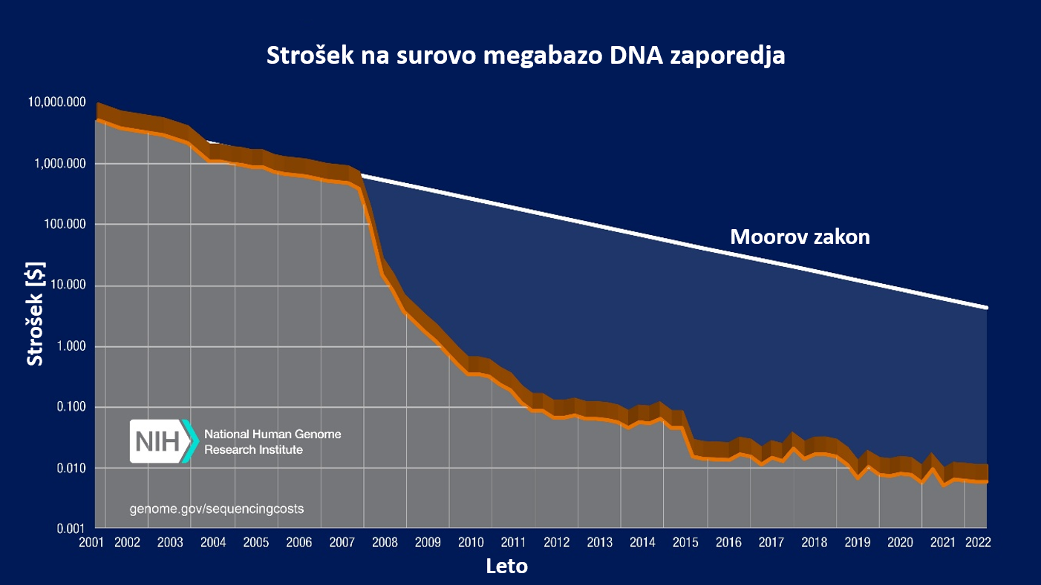
Slika 1: Prikaz stroškov (v ameriških dolarjih) DNA sekvenciranja na surovo megabazo (angl. raw megabase) v letih od 2001 do 2022, ocenjeno s strani Nacionalnega inštituta za zdravje (NIH, ZDA) (Wetterstrand, 2023).

Platforme
Leta 2000 je ameriško podjetje MPSS Lynx Therapeutics razvilo prvo NGS platformo (Barba in sod., 2014). Kmalu so se na trgu pojavile različne izvedbe tehnologij HTS, ki so vodile v razvoj zmogljivejših HTS in posledično v uporabo številnih platform (preglednica 1) (Barba in sod., 2014; Mehetre in sod., 2021; Wu in sod l., 2015). Nekatere med njimi so postopoma propadle oz. jih je kupilo podjetje Illumina, ki na trgu prevladuje še danes (Barba in sod., 2014; Mehetre in sod., 2021).
HTS pristopi se razlikujejo v biokemiji, pripravi vzorca, načinu sekvenciranja, zajemanja rezultatov in analizi podatkov. Komercialno dostopnih platform je veliko (preglednica 1), med drugimi platforma GS FLX+ (454 Life Sciences/Roche), platforma SOLiD (ABI), platforma Ion Torrent/Ion S5 (Life Technologies), platforme podjetja Illumina (HiSeq, MiSeq, NextSeq, GAIIx, NovaSeq, MiniSeq, iSeq), platforme podjetja Pacific Biosciences (PacBio; PacBioRS/RSII, Sequel), platforme podjetja Oxford Nanopore Technologies (ONT; MinION, PromethION, GridION) ter številne druge (Barba in sod., 2014; Berry in sod., 2020; Kutnjak in sod., 2021; Mehetre in sod., 2021; Wu in sod., 2015).
Obstajata dve glavni skupini sekvenčnih platform: metoda določanja kratkih odčitkov (angl. short-read sequencing, SRS), ki ustvarja odčitke dolžine do več sto nukleotidov, in metoda določanja dolgih odčitkov (angl. long-read sequencing, LRS; tudi imenovana sekvenciranje posameznih molekul, SMS), ki ustvarja odčitke dolžine do sto kilobaz (kb) (Kutnjak in sod., 2021).
Preglednica 1: Tehnologije sekvenciranja glede na obdobje uporabe. Podane so glavne tehnologije, tip branja, ključne platforme, dolžine branja in natančnost (Illumina, 2025; Tamang, 2024; Wu in sod., 2015)
Obdobje | Glavna tehnologija | Tip branja* | Ključne platforme | Dolžina branja | Natančnost
~1977–danes | Sanger (dideoksinukleotidi, kapilarna elektroforeza) | Posamezna branja | ABI 3730 / 3730xl, Beckman CEQ, MegaBACE | do 1 kb | >99,99%
~2000–2015 | Masovno vzporedno kratko branje (amplifikacija + sinteza) | SRS | Roche 454 GS FLX+, Illumina GAIIx / HiSeq / NovaSeq, ABI SOLiD, TFS Ion Torrent, BGI DNBSEQ | 50–700 bp | 98–99,9%
~2011–2020 | Analiza posamezne molekule (brez PCR amplifikacije) | LRS | PacBio RS II / Sequel / Revio, ONT MinION / PromethION | 10–100 kb (ONT>1 Mb) | 90–99,9%
~2020–danes | Integrirane platforme z AI analitiko, v realnem času in več-modalnimi podatki | LRS / kombinirano | PacBio Revio, ONT Q20+, Illumina Infinity, Ultima Genomics UG100, Element AVITI | 20–100 kb | >99,9%
*SRS= metoda določanja nukleotidnega zaporedja kratkih odčitkov (Short-Read Sequencing); LRS= metoda določanja nukleotidnega zaporedja dolgih odčitkov (Long-Read Sequencing); kb, kilobaza
Trenutno je za SRS najbolj pogosto uporabljena sekvenčna platforma Illumina, za LRS pa Pacific Biosciences (PacBio) in Oxford Nanopore Technologies (ONT) (Berry in sod., 2020; Kutnjak in sod., 2021). SRS platformi, kot sta Illumina in Ion Torrent, ponujata visoko zmogljivost, kar omogoča obsežne raziskave rastlinskih virusov in viroidov. Vendar takšna visoka zmogljivost ni vedno potrebna, zlasti pri analizi manjšega števila vzorcev v rutinski diagnostiki (Pecman in sod., 2022). Platforma Ion Torrent/Ion S5 je kljub večjemu pojavljanju napak glede na Illumino, široko uporabljena, saj je cenovno ugodna in enostavna za uporabo (Berry in sod., 2020).
Platforma podjetja PacBio podobno kot Illumina temelji na sekvenciranju s sintezo, glavna razlika je v tem, da pri slednji detekcija temelji na signalu pomnoženih fragmentov DNA, PacBio pa deluje na osnovi SMRT tehnologije (angl. Single Molecule Real-Time). PacBio omogoča LRS in posledično zelo dolge odčitke dolžine do 10 kb, vendar pa je imela platforma v preteklosti poleg visoke zmogljivosti tudi veliko stopnjo napak (do 14 %) (Berry in sod., 2020; Wu in sod., 2015), ki se lahko zmanjša z uporabo načina HiFi (angl. High Fidelity) (>99.9%) (CD Genomics, 2025). Platforma ONT (Slika 2) (Tamang, 2024) je LRS in omogoča prilagodljive rešitve z različnimi pretočnimi celicami, od manjših (2,8 Gb na sekvenciranje, s Flongle adapterjem), do večjih, kot so MinION (do 50 Gb na sekvenciranje), GridION (do 250 Gb) in PromethION (do 14 Tb) (Tamang, 2024). Ena ključnih prednosti sekvenciranja z napravo MinION je možnost analize podatkov v realnem času in krajši čas do rezultata (24–48 ur) (Maina in sod., 2024; Pecman in sod., 2022).
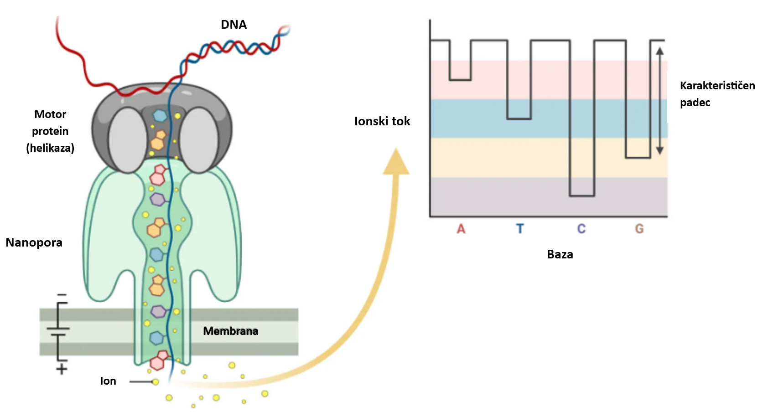
Slika 2: Osnovni princip delovanja sekvenčne tehnologije ONT. Motorni protein (helikaza) odvije DNA tako, da v nanoporo proti pozitivni strani membrane vstopa enoverižna DNA. Vsaka baza povzroči značilno zmanjšanje ionskega toka, kar omogoča določitev nukleotidnega zaporedja DNA (povzeto po (Tamang, 2024)).
Tehnologija ONT temelji na spremljanju prehoda molekul DNA ali RNA skozi proteinsko poro, kar privede do spremembe električne napetosti, ki jo lahko izmerimo (slika 2) (Tamang, 2024). Z ONT lahko sekvenciramo izjemno dolga zaporedja DNA ali RNA. Vendar pa sta v preteklosti potreba po visoki začetni količini RNA (500 ng) in visoka stopnja napake (do 15 %, odvisno od uporabljene pretočne celice) omejila njeno uporabnost (Berry in sod., 2020; Maina in sod., 2024; Pecman in sod., 2022). Z razvojem ONT tehnologije se je zmanjšala tudi stopnja napake (do 5 %), ki se lahko z dodatnimi korekcijami zniža na 99.996% (CD Genomics, 2025). Prednost ONT je, da je MinION prenosna naprava, ki se priključi prek USB-ja, kar omogoča uporabo v različnih laboratorijskih okoljih (Maina in sod., 2024). Uporaba MinION-a za detekcijo virusov je v porastu, saj se uporablja v epidemiološkem spremljanju, identifikaciji mikrobioma in diagnostiki na terenu (Mehetre in sod., 2021). Sekvenciranje z ONT se hitro razvija in pričakuje se, da bo v prihodnosti bolj široko uporabljano (Kutnjak in sod., 2021).

HTS postopek
Za identifikacijo rastlinskih patogenov lahko uporabimo dve vrsti HTS: ciljno (angl. amplicon/targeted sequencing/metabarcoding) in naključno sekvenciranje (angl. shotgun/random sequencing) (EPPO, 2022). Pri ciljnem sekenciranju gre za uporabo specifičnih barkod oz. amplikonov, ki nastanejo s PCR ali sorodnimi protokoli. Začetni oligonukleotidi (ZO) so navadno načrtovani tako, da specifično pomnožijo ohranjeno regijo več različnih tarčnih organizmov (bakterije, glive, rastline, virusi, insekti, nematode) in lahko generirajo nukleotidna zaporedja čim večjega števila vrst. Pri »shotgun« načinu pa naključno sekvenciramo katero koli DNA ali RNA prisotno v vzorcu (ne glede na njen izvor) in pridobimo celoten genom vseh prisotnih patogenov (EPPO, 2022; Lebas in sod., 2022).
Ne glede na uporabljen postopek lahko HTS razdelimo na osem korakov (slika 3), ki obsegajo vzorčenje, laboratorijski in bioinformacijski del in na koncu potrditev in interpretacijo rezultatov (Lebas in sod., 2022). Za vsak korak obstajajo različni protokoli, ki se z razvojem tehnologije redno spreminjajo in jih je posledično potrebno redno posodabljati (EPPO, 2022; Lebas in sod., 2022).
1. korak: vzorčenje. Zahteve za HTS vzorec so podobne kot za ostale diagnostične teste (EPPO, 2021), le da lahko v tem primeru vzorec vsebuje več različnih patogenov (Lebas in sod., 2022).
2. korak: ekstrakcija nukleinskih kislin. Izbira metode ekstrakcije je odvisna od tipa nukleinske kisline (DNA ali RNA), zahtev platforme glede velikosti fragmentov in matriksa (npr. semena, listi, steblo, zemlja, …). V večini primerov zadostujejo protokoli, ki se uporabljajo za PCR in PCR v realnem času (qPCR), v nekaterih primerih pa so podane še dodatne zahteve z višjo integriteto nukleinskih kislin in nižjo koncentracijo (EPPO, 2022). Večina razpoložljivih protokolov priporoča oceno kakovosti in količine nukleinskih kislin pred pripravo knjižnice. Pri nekaterih pristopih obogatitve (npr. VANA [angl. Virion-Associated Nucleic Acids], ekstrakcija dsRNA) so koncentracije pridobljenih nukleinskih kislin lahko nižje od zahtevane količine za pripravo knjižnice, zato je lahko pred gradnjo knjižnice potreben korak naključne amplifikacije (Kutnjak in sod., 2021).
3. korak: priprava knjižnice. Cilj priprave je izolirati in pogosto tudi namnožiti zadostno količino nukleinskih kislin ustrezne velikosti, ki so na obeh koncih obdane z adapterji in indeksi (oligonukleotidnimi zaporedji) potrebnimi za sekvenciranje. Adapterji so kratka nukleotidna zaporedja, ki se razlikujejo med platformami, in omogočajo pritrditev na sekvencer in s tem začetek sekvenciranja. Indeksi se uporabljajo pri sočasnem sekvenciranju več tarč (angl. multiplexing) za povezovanje posameznih fragmentov nukleinske kisline z izvornim vzorcem. Protokol se razlikuje glede na uporabljen HTS test (EPPO, 2022; Lebas in sod., 2022).
Za ciljno sekvenciranje je zelo pomembna izbira ustreznih ZO, ki omogočajo pomnožitev tarčne regije na 3`-koncu in zaporedja adapterja na 5`-koncu (indeksi so opcijski). Priporočljiva je uporaba polimeraze, ki naredi manj napak (angl. high-fidelity), da ne pride do napačnega zaporedja nukleotidov. Pomembno je tudi število ciklov PCR reakcije, ker se mora reakcija ohraniti v eksponentni fazi (EPPO, 2022).
Pri »shotgun« sekvenciranju je na voljo več protokolov, ki so komercialno dostopni. Izbira protokola je odvisna od tehnologije sekvenciranja, tehničnih kriterijev, časa, osebja ter stroškov reagentov in potrošnega materiala. V primeru RNA se najprej izvede korak reverzne transkripcije, pri nekaterih platformah pa se lahko uporabi direktno sekvenciranje RNA (ONT; PacBio) (Lebas in sod., 2022).
Opcijsko v 3. koraku:
- obogatitev (angl. enrichment/ target selection) je neobvezni korak, ki pri »shotgun« sekvenciranju predstavlja odstranitev ne-tarčnih zaporedji (rastlinska ribosomska RNA, rRNA- ribodeplecija), ultracentrifugacija pred ekstrakcijo, obogatitev dvoverižne RNA (dsRNA) ali zajem sonde (angl. probe capture, uporaba tarčno specifičnih oligonukleotidov) (EPPO, 2022; Liefting in sod., 2021).
- združevanje vzorcev (angl. pooling of samples/ multiplexing) je prav tako lahko del priprave knjižnice, ker zmanjša stroške sekvenciranja. Vzorec se označi z indeksom (angl. index/ barcode/ tag /MID), ki je kratko oligonukleotidno zaporedje obdano (ali ne) z adapterjem, in se uporablja za označevanje vzorcev. Indeks je lahko dodan na en ali oba konca fragmenta nukleinske kisline in se sekvencira sočasno s tarčo ali v ločeni regiji, kar omogoča da vsako zaporedje lahko povežemo z originalnim vzorcem (po koraku »razzdruževanja«) (Lebas in sod., 2022). Zaradi združevanja se poveča verjetnost napak in kontaminacije, prav tako pa morajo biti vzorci prej normalizirani, da se zmanjša pristranskost zaradi združevanja (EPPO, 2022).
4. korak: sekvenciranje. Vsak laboratorij naj bi uporabljal optimalno platformo in dolžino odčitkov glede na namen uporabe HTS testa. Obstajajo številne platforme, ki so komercialno dostopne in se zelo pogosto posodabljajo, kar ima lahko vpliv na rezultate. Poleg kvalitete sekvenciranja (število odčitkov, dolžina odčitkov, število napak, globina pokritosti,…) je pomemben tudi strošek sekvenciranja in sod., 2022).
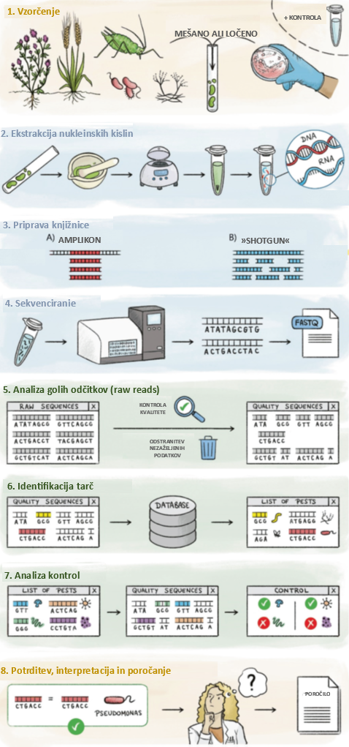
Slika 3: Postopek izvedbe HTS pri rastlinski diagnostiki (povzeto po (Lebas in sod., 2022)).
5. korak: analiza surovih odčitkov (angl. raw reads). Ta korak obsega bioinformacijsko analizo, vključno s kontrolo kakovosti generiranih zaporedij in odstranitvijo adapterjev (neobvezno), indeksov in začetnih oligonukleotidov. V primeru združenih vzorcev, korak »razzdruževanja« (angl. demultiplexing) omogoča dodelitev generiranih zaporedji ustreznim vzorcev. Dodatno se lahko izvede tudi analize, ki zmanjšajo količino podatkov in izboljšajo kakovost analize, kot je na primer združevanje smernih in protismernih odčitkov na osnovi prekrivajočih se regij ali odstranjevanjem podvojenih odčitkov (Kutnjak in sod., 2021; Lebas in sod., 2022).
6. korak: Identifikacija tarč. Bioinformacijska analiza je namenjena povezovanju zaporedji s specifičnimi organizmi. Glede na namen HTS testiranja je lahko anotacija zaporedij taksonomska (vrsta, rod, družina, …) ali funkcijska (določitev ali odčitek pripada kodiranem območju, intronu, promotorju, microRNA,…). Identifikacija se lahko izvede na posameznih odčitkih, po »de novo« sestavljanju, po mapiranju odčitkov na referenčno zaporedje ali z uporabo kombinacije vseh pristopov (Lebas in sod., 2022).
7. korak: analiza kontrol. Ta analiza omogoča preverjanje ali so vse kontrole, vključno s HTS-analizo, dale pričakovane rezultate, z namenom, da se odpravijo lažno pozitivni in/ali lažno negativni rezultati. Za preverjanje morebitne kontaminacije, ki se lahko pojavi med HTS-analizo, se lahko v različnih korakih uporabi pozitivne, negativne in tuje (angl. alien) kontrole. Tuja kontrola vsebuje tarčo (škodljivec ali ne), ki spada v isto skupino kot tarčni organizmi, vendar se v testnem vzorcu ne more pojaviti (EPPO, 2022; Lebas in sod., 2022; Massart in sod., 2022).
8. korak: potrditev tarče, interpretacija in poročanje. Zadnji korak obsega potrditev identitete tarč zaznanih v vzorcu, razlago biološkega in fitosanitarnega pomena identifikacije tarč (zlasti pri novih odkritjih) in poročanje rezultatov HTS-testa (Lebas in sod., 2022).

Bioinformatika
Medtem ko so postopki v laboratoriju in sekvenciranje (angl. wet lab) postali široko dostopni in uporabnikom prijazni, analiza in interpretacija podatkov (angl. dry lab), še vedno zahteva specializirano znanje bioinformatike in ustrezno računalniško infrastrukturo (Berry in sod., 2020). Bioinformacijski del obsega uporabo različnih programov, ki omogočajo analizo surovih podatkov. Rezultati, ki jih generira bioinformacijski analizni postopek (angl. pipeline) so odvisni od uporabljene programske opreme (verzije), nastavitev parametrov in pragov ter natančnosti in popolnosti podatkovnih baz zaporedij, uporabljenih za referenco (EPPO, 2022). Razvitih je bilo veliko bioinformacijskih analiznih postopkov, ki lahko delujejo v okolju Linux, prek spletnih vmesnikov, kot komercialni paketi ali odprtokodna programska oprema. Razvoj gre v smeri poenostavljenih rešitev na »en klik«, ki pa potrebujejo ustrezno usposobljeno osebje, ki razume njihovo delovanje, da jih lahko pravilno uporabi glede na podatke in cilje analize (EPPO, 2022; Ren in sod., 2017).
Na splošno, ne glede na izbiro programske opreme ali analiznega postopka za detekcijo in identifikacijo patogenov v vzorcu, obstajajo skupni koraki, ki jih je mogoče upoštevati za uspešno analizo (Berry in sod., 2020). Najprej se preveri kakovost sekvenčnih podatkov, kot tudi kakovost surovih odčitkov. Surovi podatki platforme se običajno očistijo, obrežejo in filtrirajo, da se odstranijo nizkokakovostni in podvojeni odčitki (Berry in sod., 2020; EPPO, 2022). Odstranitev odčitkov genomov/ transkriptomov gostitelja se izvaja zato, da se zmanjša šum ozadja (npr. odčitki gostitelja in okolja) in poveča frekvenca odčitkov patogenov. Ta korak prav tako zmanjša čas nadaljnje analize. Nadaljnje odstranjevanje šuma ozadja se doseže z mapiranjem odčitkov vzorca na odčitke negativne kontrole, da se zagotovi odstranitev morebitnih kontaminacij, kot so odčitki povezani z reagenti. Preostali odčitki se običajno sestavijo »de novo«, tako da se ustvarijo dolgi segmenti zaporedij (angl. contig). Pri platformah, ki proizvajajo kratke odčitke, ta korak zagotavlja zanesljivost rezultatov in večjo natančnost nadaljnje identifikacije patogenov (Berry in sod., 2020; Lebas in sod., 2022; Massart in sod., 2022).
Taksonomska identifikacija dobljenih segmentov zaporedij se izvede z ujemanjem z geni in zaporedji v nukleotidnih ali proteinskih bazah podatkov, za to se najpogosteje uporabljajo različice programa BLAST (BLASTx, BLASTn, MegaBLAST, BLASTp; NCBI, ZDA). Pogosto se te baze podatkov prenesejo lokalno, da se skrajša čas obdelave. Eden izmed bolj zahtevnih korakov metagenomskih analiz in odkrivanja patogenov je interpretacija rezultatov. Manj izkušeni laboratoriji se lahko soočijo s težavami pri prepoznavanju lažno negativnih in lažno pozitivnih rezultatov, vključno z razlikovanjem med ozadjem, kontaminacijo in resnično prisotnimi patogeni. To je še posebej zahtevno, kadar je koncentracija patogena v vzorcu nizka (Berry in sod., 2020; Kutnjak in sod., 2021).
Eden glavnih dejavnikov, ki vplivajo na natančnost in popolnost sestave genoma, je kakovost sekvenciranih odčitkov (angl. reads) in globina pokritosti (angl. read depth). Ti vidiki se razlikujejo med platformami in pristopi kratkih in dolgih odčitkov. Če zahteve glede kakovosti odčitkov in globine pokritosti niso izpolnjene, konsenznega zaporedja ni mogoče upoštevati. Običajno se takšni nepopolni/genomi z vrzelmi dopolnijo z dodatnim sekvenciranjem. Kakovost sestave bo prav tako odvisna od uporabljenega algoritma za sestavljanje. Obstaja veliko algoritmov za sestavljanje genomov in določanje konsenza, ki se močno razlikujejo po zapletenosti, natančnosti, hitrosti in prilagodljivosti. Na splošno obstajata dva glavna pristopa k sestavljanju genomov: sestavljanje na osnovi referenčnega genoma (angl. reference-based/mapping-based) in »de novo« sestavljanje (Berry in sod., 2020; EPPO, 2022).
Sestavljanje na osnovi referenčnega genoma je zelo uporabno orodje za sestavljanje znanih genomov, saj odčitke vzorca poravnamo na referenčni genom na podlagi najboljše poravnave z referenco. V tem primeru je ključna izbira reference, ki se ne sme preveč razlikovati od vzorca, da se lahko večina odčitkov ustrezno nalega. Analiza na osnovi referenčnega genoma je mogoča z uporabo programov osnovanih na ukazni vrstici (BWA MEM, Bowtie2) oziroma komercialno dostopnih orodji, kot sta Geneious in CLC Genomics Workbench, kot tudi odprtokodnih orodji, kot so Galaxy Platform, Pathosphere, EDGE in številni drugi (Berry in sod., 2020).
»De novo« sestavljanje genomov temelji na povezovanju odčitkov vzorca med seboj z uporabo prekrivajočih se zaporedij, da se ustvarijo daljši segmenti zaporedij. Uporablja se kadar je patogen nov, neznan, referenčni genom ne obstaja ali pa se predvideva, da so prisotne insercije, delecije in ponovitve. Najpogosteje se uporablja orodja kot so SPAdes, Velvet, Minia, ABySS, IDBA-UI, ALLPATHS-LG in SOAPdenovo, ki so lahko del komercialno dostopnih orodji kot sta Geneious in CLC Genomics Workbench (Berry in sod., 2020; Kutnjak in sod., 2021). Če v genomu nastanejo vrzeli, jih lahko zapolnimo in silico z uporabo orodji kot so Bandage, Mauve, CLC Genomics Workbench in EDGE. Za povečanje natančnosti sestavljanje genomov je najboljša uporaba kombinacije obeh načinov sestavljanja (Berry in sod., 2020; EPPO, 2022).
Detekcijo patogenov si lahko olajšamo tudi z uporabo orodji, kot je diagnostična analiza nukleinskih kislin z e-sondami (angl. E-probe Diagnostic Nucleic Acid Analysis; EDNA) (Pasha in sod., 2024). Z uporabo nadgradnje sistema EDNA, ki se imenuje Microbe Finder (MiFi), lahko načrtujemo e-sonde, ki omogočajo neposredno detekcijo tarčnih patogenov v surovih bazah HTS podatkov. Na ta način se lahko izognemo dolgotrajnemu koraku bioinformacijske analize. Platforma MiFi vsebuje dve ključni orodji, MiProbe za načrtovanje e-sond in MiDetect za detekcijo patogenov. Omogoča detekcijo genomov virusov, viroidov, gliv, oomicet in bakterij v rastlinah in drugih organizmih (Pasha in sod., 2024).
Vse platforme in algoritmi za sestavljanje imajo omejitve zato se pričakuje, da bodo v rezultatih prisotne napake. Kontrola kakovosti in pregled sestavljenega zaporedja je zato zelo pomemben korak analize. Zaradi napak namreč lahko prihaja do nepričakovanih insercij ali delecij, premikov bralnih okvirjev ali stop kodonov (Berry in sod., 2020; Jia in sod., 2012). Bioinformatika tako predstavlja ključen del analize, pri katerem so za ustrezno interpretacijo rezultatov zelo pomembne izkušnje in ustrezna usposobljenost osebja.

Prednosti in slabosti HTS za sodobno diagnostiko patogenov
Tehnologija HTS postaja nepogrešljivo orodje za sodobno diagnostiko virusov in viroidov v rastlinah, tako kot ostale diagnostične metode pa ima seveda številne prednosti in slabosti (preglednica 2). Njegova glavna prednost je nepristranska detekcija, ki omogoča odkrivanje znanih in novih patogenov brez predhodnega znanja o njihovi prisotnosti, hkrati pa iz enega vzorca razkrije celoten spekter okužb (Lebas in sod., 2022; Massart in sod., 2022; Pecman in sod., 2022; Rong in sod., 2023). HTS se odlikuje po visoki občutljivosti, sposobnosti prepoznavanja genetskih različic in možnosti ponovne analize podatkov. Kljub temu njegova rutinska uporaba ostaja omejena zaradi visokih stroškov, zahtevne bioinformacijske obdelave, pomanjkanja standardizacije, ker se protokoli za delo v laboratoriju in analizo podatkov zelo razlikujejo (Berry in sod., 2020; EPPO, 2022; Lebas in sod., 2022; Pecman in sod., 2022; Rivarez in sod., 2023; Rong in sod., 2023). Kljub padcu cen HTS analiz, ki omogoča lažjo dostopnost, velik izziv še vedno predstavlja dejstvo kako določiti optimalno količino podatkov (število odčitkov), ki so potrebni za natančno in zanesljivo detekcijo patogenov (Visser in sod., 2016).

Preglednica 2: Prednosti in slabosti HTS (Berry in sod., 2020; Lebas in sod., 2022; Massart in sod., 2022; Pecman in sod., 2022; Visser in sod., 2016).
Vidik | Prednosti HTS | Slabosti HTS
Detekcija patogenov | Nepristranska detekcija – ni potrebe po predhodnem znanju o patogenu; omogoča odkrivanje znanih, divergentnih in novih virusov ter viroidov v enem postopku. | Prisotnost sekvence patogena ne pomeni nujno aktivne okužbe; težave pri ločevanju med dejansko infekcijo in kontaminacijo.
Število tarč  v analizi | Sočasna detekcija več patogenov v enem vzorcu (virusi, viroidi, bakterije, glive). | Različni protokoli in metode lahko dajejo različne rezultate – omejena primerljivost med laboratoriji.
Občutljivost in natančnost | Zazna patogene v zelo nizkih koncentracijah, tudi v latentnih okužbah; visoka ponovljivost rezultatov. | Visoka občutljivost poveča tveganje zaznavanja kontaminacij (npr. iz laboratorija ali okolja).
Genetske informacije | Omogoča identifikacijo sevov, mutacij, rekombinacij in analizo genetske raznolikosti patogenov. | Interpretacija genetskih razlik zahteva poglobljeno bioinformacijsko znanje in kakovostne referenčne baze, ki so pogosto nepopolne.
Uporabnost v diagnostiki | Primerna za odkrivanje kompleksnih mešanih okužb in spremljanje evolucije patogenov. | V številnih državah še ni uradno priznana diagnostična metoda – zahteva dodatno potrditev (npr. PCR).
Dolgoročna uporabnost podatkov | Možnost ponovnih analiz, ko se razširijo baze podatkov ali pojavijo nova vprašanja. | Shranjevanje in obdelava velikih količin podatkov zahtevata močno računalniško infrastrukturo.
Ekonomika in izvedba | Omogoča hiter vpogled v celoten virom rastline v enem postopku. Velika ponudba zunanjih izvajalcev storitev. | Visoki stroški opreme, reagentov in analize; zahteva strokovno usposobljeno osebje.
Standardizacija | Postopki se hitro razvijajo in postajajo dostopnejši. | Pomanjkanje enotnih protokolov za vzorčenje, pripravo knjižnic in analizo podatkov.
Ena glavnih ovir za uvedbo tehnologij HTS v laboratorijih za varstvo rastlin je pomanjkanje mednarodnih smernic, ki bi zajemale tako laboratorijske kot bioinformacijske postopke in obsegale usposabljanje in preverjanje usposobljenosti osebja, ustrezno infrastrukturo in opremo, ter zagotavljanje kakovosti v skladu z nacionalnimi in mednarodnimi (npr. ISO) standardi. Poleg tega je treba v rutinski uporabi upoštevati tudi različne dejavnike, kot so določitev mejnih vrednosti meril kakovosti in njihov sprejemljiv razpon, da se zagotovi zanesljivost rezultatov (Lebas in sod., 2022).

VIROIDI
Viroidi so najmanjši doslej opisani patogeni, sestavljeni zgolj iz 246–401 nukleotidov nekodirajoče krožne RNA (circRNA) (Flores, 2001; Katsarou in sod., 2022; Navarro in sod., 2012) z neznanim evolucijskim izvorom (Rueda in sod., 2025). Odkar so jih leta 1971 odkrili v krompirju (Diener, 1971), so viroide obravnavali kot redke biološke entitete, saj so v zadnje pol stoletja o njih poročali le pri 45 vrstah kritosemenk. Nedavne HTS študije pa so ta pogled postavile pod vprašaj, saj so razkrile na tisoče novih viroidom podobnih entitet, razširjenih po najrazličnejših ekoloških nišah. Presenetljivo je, da večina teh na novo odkritih krožnih RNA kaže znake razmnoževanja v bistveno enostavnejših organizmih, vključno z evkarionti in prokarionti, ne pa samo v rastlinah (Rueda in sod., 2025).
Viroidi imajo pomemben negativen gospodarski vpliv pri kokosovih palmah (700.000 okuženih palm na Filipinih zaradi CCCVd [angl. coconut cadang-cadang viroid; Cocadviroid cadangi]), pri sadnem drevju (do 95 % izgube pridelka avokada zaradi ASBVd [angl. avocado sunblotch viroid; Avsunviroid albamaculaperseae]), pri okrasnih rastlinah (do 65 % zmanjšanje rasti krizantem zaradi CSVd [angl. chrysanthemum stunt viroid; Pospiviroid impedichrysanthemi]), pri vrtninah (do 64 % izgube pridelka krompirja zaradi PSTVd [angl. potato spindle tuber viroid; Pospiviroid fusituberis]), kot tudi pri pridelavi hmelja (do 70 % nižja vsebnost α-kislin zaradi CBCVd [angl. citrus bark cracking viroid; Cocadviroid rimocitri]) (Guček, 2020; Hammond, 2017; Rodriguez in sod., 2017; Verhoeven in sod., 2017).
Diagnostika viroidov je zapletena, da bi bila metoda detekcije učinkovita, mora izpolnjevati kriterije “ASSURED”: cenovno dostopna (angl. affordable), občutljiva (angl. sensitive), selektivna (angl. selective), enostavna za uporabo (angl. user-friendly), hitra in robustna (angl. rapid and robust), brez potrebe po opremi (angl. equipment-free) in dostopna končnim uporabnikom (angl. deliverable to end users). Vendar pa ne obstaja “popolna” metoda zaznavanja ali ena zlata standardna metoda, saj ima vsaka tehnologija svoje prednosti in slabosti (Katsarou in sod., 2019).
Tradicionalno se za zaznavanje viroidov uporabljajo molekularni testi, kot so RT-PCR in RT-qPCR (Guček in sod., 2017). Vendar pa HTS kot ne-tarčna metoda omogoča zaznavo katerega koli viroida, tudi nepričakovanih oziroma neznanih (Rollin, 2023). Z uporabo HTS so na podlagi analiz sRNA, total RNA in dsRNA odkrili nove gostitelje in identificirali številne viroide, kot so PSTVd, CEVd (angl. citrus exocortis viroid; Pospiviroid exocortiscitri), ADFVd (angl. apple dimple fruit viroid; Apscaviroid fossulamali), PLMVd (angl. peach latent mosaic viroid; Pelamoviroid latenspruni), HSVd (angl. hop stunt viroid; Hostuviroid impedihumuli) in GYSVd (angl. grapevine yellow speckle viroid 1 in 2; Apsaviroid alphaflavivitis/ betaflavivitis) (Hadidi in sod., 2016). Med drugim so na tak način v hmelju odkrili tudi CBCVd (Jakse in sod., 2015).
HTS je omogočil tudi odkritje novih ali prej neznanih viroidov (preglednica 3) (Ito in sod., 2013; Ortega-Acosta in sod., 2024; Rueda in sod., 2025; Wu in sod., 2015; Zhang in sod., 2014). Za odkrivanje novih viroidov je bil razvit poseben računalniški algoritem PFOR (angl. progressive filtering of overlapping small RNAs), ki deluje na principu siRNA (malih interferenčnih RNA) (Wu in sod., 2012). V rastlini namreč okužba z viroidi sproži nastanek viroidnih siRNA, ki lahko z visoko gostoto prekrijejo celoten genom viroida. Vendar pa zaradi velike heterogenosti populacij viroidov teh siRNA ni mogoče sestaviti v celotne genome viroidov s konvencionalnimi algoritmi, kot je npr. Velvet. PFOR omogoča postopno odstranjevanje malih RNA, ki se ne prekrivajo oz. tistih, ki jih ni mogoče sestaviti in posledično identifikacijo viroidov iz obeh znanih družin (Wu in sod., 2012, 2015). S posodobitvijo algoritma na PFOR2 se je še povečala učinkovitost filtriranja viroidov (Zhang in sod., 2014). Na ta način so bili odkriti novi viroidi, med drugim GLVd (angl. grapevine latent viroid; Apscaviroid latensvitis), ki so ga uvrstili kot novo vrsto rodu Apscaviroid (Zhang in sod., 2014). Uporaba algoritmov PFOR/PFOR2 je omogočila tudi odkritje dveh viroidom podobnih RNA: GHVd RNA (angl. grapevine hammerhead viroid-like RNA) in AHVd RNA (angl. apple hammerhead viroid-like RNA) (preglednica 3) (Wu in sod., 2012, 2015; Zhang in sod., 2014).
Preglednica 3: Seznam novih viroidov odkritih s HTS.
Viroid (angleško ime) | Družina/Rod | Referenca
persimmon viroid 2 (PVd2) | Apscaviroid | (Ito in sod., 2013)
grapevine hammerhead viroid-like RNA (GHVd RNA) | Avsunviroidae | (Wu in sod., 2012)
apple hammerhead viroid-like RNA (AHVd-like RNA) | Avsunviroidae | (Zhang in sod., 2014)
grapevine latent viroid (GLVd) | Apscaviroid | (Zhang in sod., 2014)
mexican opuntia viroid (MOVd) | Pospiviroidae | (Ortega-Acosta in sod., 2024)
opuntia viroid 2 (OVd-2) | Apscaviroid | (Ortega-Acosta in sod., 2024)
Iskanje novih viroidov na osnovi že obstoječih podatkov HTS je mogoče tudi z uporabo drugih orodji. V svoji raziskavi so Rueda in sod. (2025) izvedli celovito bioinformacijsko iskanje klasičnih rastlinskih viroidov (družina Pospiviroidae, 40 znanih vrst) z uporabo genetske baze podatkov Logan (Chikhi in sod., 2025). S strukturno analizo so identificirali 13.000 genomov, ki izpolnjujejo značilnosti družine Pospiviroidae: majhno krožno RNA zaporedje, paličasto sekundarno strukturo ter prisotnost osrednjih in terminalnih domen, ohranjenih pri vseh viroidih. Med temi so odkrili 20 genomov, ki verjetno predstavljajo nove vrste rastlinskih viroidov. Ti rezultati nakazujejo širši spekter rastlinskih gostiteljev, kot je bilo prej znano. Viroide je tako mogoče zaznati pri novih vrstah kritosemenk, od zeliščnih, kot je črni poper (angl. piper nigrum viroid, PnVd), indigo (angl. strobilanthes cusia viroid, ScVd), do lesnatih rastlin, kot so topoli (angl. populus viroid, PVd) ali magnolije (angl. magnolia viroid, MVd). Novi viroidi so bili prav tako odkriti v okoljskih vzorcih (angl. MAG-X Vd), od sedimentov, do vzorcev blata goveda. Hkrati so v omenjeni raziskavi potrdili tudi veliko novih gostiteljev, med drugim so viroid PSTVd našli v godži jagodah. Uporaba HTS metod v kombinaciji z obsežnimi bazami podatkov tako pripomore k boljšemu razumevanju biologije viroidov, hkrati pa poudarja tudi bolj omejeno genetsko raznolikost in številčnost tipičnih rastlinskih viroidov v primerjavi z drugimi krožnimi RNA molekulami, kot so obeliski in viroidom podobne RNA z ribocimi (Rueda in sod., 2025).

Rutinska diagnostika viroidov s HTS
Tehnologije HTS se nenehno izboljšujejo, da postanejo hitrejše, učinkovitejše in cenejše. Leta 2009 so se HTS tehnologije začele uporabljati tudi na več področjih rastlinske virologije, vključno s sekvenciranjem genomov virusov in viroidov, odkrivanjem in zaznavanjem patogenov, ekologijo in epidemiologijo ter replikacijo in transkripcijo. Identifikacija in karakterizacija znanih in neznanih virusov in viroidov v okuženih rastlinah sta med najuspešnejšimi uporabami teh tehnologij (Barba in sod., 2014). Uporaba HTS tehnologij se je povečala zaradi možnosti prepoznavanja mešanih patogenih okužb v enem samem testu, za katere bi sicer potrebovali več različnih testov. Viroidi se navadno analizirajo v kombinaciji z virusi, saj se s HTS najpogosteje raziskuje celoten virom (vsi virusi in viroidi) gostitelja. Zgodovinsko gledano se je HTS manj uporabljal zaradi svoje zahtevnosti in višje cene (Rollin, 2023). Vendar pa se je z razvojem tehnologij to spremenilo in HTS se zdaj že več kot desetletje uporablja za odkrivanje novih virusov in viroidov ter postaja standardno orodje v raziskavah in diagnostiki rastlinske virologije (Massart in sod., 2022; Rivarez in sod., 2021).
Različni pristopi RNA sekvenciranja (RNA-Seq) so bili obsežno uporabljeni za odkrivanje in karakterizacijo rastlinskih virusov in viroidov, pri čemer se uporabljajo različni vhodni tipi nukleinskih kislin, metode priprave knjižnic in sekvenčne platforme. Ribosomske RNA (rRNA) so izjemno pogoste in predstavljajo 80–90 % celotne RNA, pri čemer je ribodeplecija ključna za obogatitev patogenov v vzorcu (Liefting in sod., 2021). HTS pristopi vključujejo uporabo celotne RNA (totRNA), rRNA-depletirane celotne RNA (rRNA-depleted totRNA), dvoverižne RNA (dsRNA), majhnih RNA (sRNA), poliadeniliranih RNA (polyA RNA) ali z virusom povezanih nukleinskih kislin (VANA) (Javaran in sod., 2023; Maina in sod., 2024; Pecman in sod., 2017; Rivarez in sod., 2021). Za široko detekcijo virusov in viroidov v posameznih vzorcih ali relativno majhnemu številu združenih vzorcev (Pecman in sod., 2017; Rivarez in sod., 2021) se najpogosteje uporabljata sekvenciranje rRNA-depletirane totRNA (Visser in sod., 2016) ali sRNA, medtem ko sta dsRNA in VANA primernejša za obogatitev v večjih skupinah vzorcev (Rivarez in sod., 2021).
Število odčitkov, potrebnih za detekcijo virusov in viroidov, je odvisno od števila virusnih/viroidnih odčitkov v podatkih, velikosti virusnega/viroidnega genoma in kompleksnosti viroma. Nekateri virusi ali viroidi so lahko v podatkih bolj zastopani, odvisno od stopnje okužbe, ki je lahko odvisna od gostitelja in/ali virusa/viroida, odziva rastline na okužbo v primeru majhnih RNA (sRNA) ter narave genoma pri različnih tipih knjižnic (npr. DNA, poli(A)-izbrane RNA, RNA knjižnice z odstranjenimi ribosomi) (Visser in sod., 2016).
Veliko težavo pri vpeljavi HTS v rutinske analize predstavlja vprašanje kontaminacije, saj so ti testi enako ali celo bolj občutljivi na kontaminirane vzorce kot PCR metode. Zaradi številnih korakov priprave in uporabe velikega števila reagentov obstaja povečano tveganje vnosa tuje nukleinske kisline, ki jo HTS zaradi širokega spektra detekcije in visoke občutljivosti zlahka zazna. Kontaminacija se lahko pojavi v katerikoli fazi laboratorijskega postopka, od vzorčenja in izolacije nukleinskih kislin do priprave knjižnic in samega sekvenciranja (Massart in sod., 2022). Viri kontaminacije vključujejo nepravilno rokovanje z vzorci, onesnažene površine, opremo, reagente ali prenos ostankov iz prejšnjih analiz, pogosta pa je tudi navzkrižna kontaminacija med več zaporednimi sekvenciranji. Pri združevanju vzorcev se lahko pojavi navzkrižna kontaminacija na primer zaradi preskakovanja indeksov. Določeni laboratorijski reagenti, kot so kompleti za izolacijo DNA in molekularno čista voda, lahko dodatno vplivajo na rezultate. Zato je nujno dosledno upoštevati dobre laboratorijske prakse, kot so uporaba čistih reagentov, redno čiščenje opreme in fizična ločitev vzorcev z visoko koncentracijo tarčnih organizmov. Kljub temu do popolne odprave kontaminacije ni mogoče priti, zato je njeno spremljanje skozi celoten HTS-postopek ključnega pomena. Prav tako lahko uporaba ustreznih kontrol precej pripomore k lažjemu spremljanju vpliva kontaminacije (EPPO, 2022; Massart in sod., 2022).
V rutinski diagnostiki tehnologije HTS odpirajo nove možnosti za razumevanje statusa patogena v določeni regiji preko programov monitoringa, za certifikacijo sadilnega materiala, za karantensko testiranje (po vnosu) za preprečevanje vnosa patogenov v državo, kot tudi monitoring uvoženega rastlinskega blaga, ki bi lahko predstavljal nova tveganja (EPPO, 2022; Lebas in sod., 2022). Pri HTS je lahko tarča eden ali več različic, vrst, rodov, družin ali skupin organizmov (bakterije, glive, virusi, viroidi), ki se testirajo kot posamezni vzorci ali izolati ali pa v različnih matriksih (rastline, zemlja, voda). Obseg HTS-testa mora biti opredeljen v skladu s standardoma EPPO PM 7/98 (EPPO, 2021) in EPPO PM 7/151 (EPPO, 2022). Slednji opisuje posebne izzive povezane z laboratorijskimi postopki in bioinformacijskimi analizami, validacijo ter nadzorom kakovosti pri HTS testih.
Za učinkovito vključitev HTS v rutinske analize viroidov bo ključnega pomena vzpostavitev referenčnih baz, standardnih protokolov in postopkov validacije (EPPO, 2022; Lebas in sod., 2022). V študiji Bester in sod. (2022) so dokazali, da je z dobro validacijo celotnega HTS postopka možna zanesljiva rutinska analiza viroidov kot so HSVd, CEVd in CDVd (angl. citrus dwarfing viroid; Apscaviroid nanocitri) v agrumih.

ZaključkI
Razvoj tehnologij HTS napreduje izjemno hitro, postopki sekvenciranja se nenehno izboljšujejo, kar zmanjšuje napake, znižuje stroške in povečuje zanesljivost rezultatov. Takšna dinamika pa hkrati otežuje vzpostavljanje stabilnih in primerljivih diagnostičnih protokolov za rutinsko spremljanje in odkrivanje patogenov. Čeprav novi pristopi odpirajo številne raziskovalne priložnosti, pogosto mine več let, preden so ustrezno validirani in uvedeni v redno diagnostično prakso. Zato je nujno, da se načrtovanje na področju zdravja rastlin, tako finančno kot kadrovsko, usmerja dolgoročno (Berry in sod., 2020; EPPO, 2022).
Ob laboratorijskih izboljšavah je v zadnjem desetletju izjemen napredek dosegla tudi bioinformatika, predvsem zaradi povečane računalniške moči in dostopnosti storitev v oblaku. Razvitih je bilo veliko bioinformacijskih orodij, kar dodatno otežuje standardizacijo analiznih postopkov. Kljub tej raznolikosti je pričakovati, da bodo z nadaljnjim razvojem področja in z mednarodnim sodelovanjem raziskovalcev standardizirane prakse postopoma postale samoumevne. Čeprav začetne investicije v HTS lahko delujejo visoke, se pri dovolj velikem obsegu testiranja pogosto povrnejo že v nekaj letih, obenem pa laboratorijem omogočajo bistveno hitrejši in učinkovitejši odziv na pojave in širjenje patogenov (Berry in sod., 2020; EPPO, 2022).
V zadnjih letih se HTS vse pogosteje uporablja tudi pri diagnostiki viroidov, saj omogoča hkratno zaznavanje znanih in novih viroidnih zaporedij brez potrebe po predhodnem poznavanju njihovega genoma. Ta pristop bistveno povečuje zanesljivost diagnostike, zlasti pri gostiteljih, kjer so viroidne okužbe pogoste ali ekonomsko pomembne. Z poenostavitvijo računalniških algoritmov, standardizacijo in validacijo postopkov se bodo lahko HTS tehnologije v bližnji prihodnosti uporabljale za rutinske analize viroidov.
Zahvala
Avtorja se za finančno podporo zahvaljujeta Javni agenciji za znanstvenoraziskovalno in investicijsko dejavnost Republike Slovenije (ARIS, raziskovalni program P4-0077).

VIRI
Barba, M., Czosnek, H., & Hadidi, A. (2014). Historical perspective, development and applications of next-generation sequencing in plant virology. Viruses, 6(1), 106–136. https://doi.org/10.3390/v6010106
Berry, I. M., Melendrez, M. C., Bishop-lilly, K. A., Rutvisuttinunt, W., Pollett, S., Talundzic, E., Morton, L., & Jarman, R. G. (2020). Next Generation Sequencing and Bioinformatics Methodologies for Infectious Disease Research and Public Health : Approaches, Applications, and Considerations for Development of Laboratory Capacity. 221(Suppl 3). https://doi.org/10.1093/infdis/jiz286
Bester, R., Steyn, C., Breytenbach, J. H. J., de Bruyn, R., Cook, G., & Maree, H. J. (2022). Reproducibility and Sensitivity of High-Throughput Sequencing (HTS)-Based Detection of Citrus Tristeza Virus and Three Citrus Viroids. Plants, 11(15). https://doi.org/10.3390/plants11151939
CD Genomics. (2025). Error Rate of PacBio vs Nanopore: How Accurate Are Long-Read Sequencing Technologies. https://www.cd-genomics.com/blog/pacbio-nanopore-error-rate-correction-strategies/
Chikhi, R., Camargo, A. P., Miller, C. J., Fiamenghi, M. B., Agustinho, P., Majidian, S., Autric, G., Hugues, M., Lee, J., Medvedev, P., Gupta, P., Shen, J., Morales-tapia, A., & Sihuta, K. (2025). Logan: Planetary-Scale Genome Assembly Surveys Life’ s Diversity.
Diener, T. O. (1971). Potato spindle tuber “virus”. IV. A replicating, low molecular weight RNA. Virology, 45(2), 411–428. http://www.ncbi.nlm.nih.gov/pubmed/5095900
EPPO. (2021). PM 7/98 (5) Specific requirements for laboratories preparing accreditation for a plant pest diagnostic activity. EPPO Bulletin, 51(3), 468–498. https://doi.org/10.1111/epp.12780
EPPO. (2022a). PM 7/151 (1) Considerations for the use of high throughput sequencing in plant health diagnostics. EPPO Bulletin, 52(3), 619–642. https://doi.org/10.1111/epp.12884
EPPO. (2022b). PM 7/151 (1) Considerations for the use of high throughput sequencing in plant health diagnostics1. EPPO Bulletin, 52(3), 619–642. https://doi.org/10.1111/epp.12884
Flores, R. (2001). A naked plant-specific RNA ten-fold smaller than the smallest known viral RNA: the viroid. Comptes Rendus de l’Académie Des Sciences - Series III, 324(10), 943–952. http://www.ncbi.nlm.nih.gov/pubmed/11570283
Guček, T. (2020). Biologija viroida razpokanosti skorje agrumov ( CBCVd ) in razvoj metod za določanje viroidov v hmelju. In Univerza v Ljubljani, Biotehniška fakulteta.
Guček, T., Trdan, S., Jakše, J., Javornik, B., Matoušek, J., & Radišek, S. (2017). Diagnostic techniques for viroids. Plant Pathology, 66, 339–358.
Hadidi, A., Flores, R., Candresse, T., & Barba, M. (2016). Next-Generation Sequencing and Genome Editing in Plant Virology. Frontiers in Microbiology, 7, 1325. https://doi.org/10.3389/fmicb.2016.01325
Hammond, R. W. (2017). Economic significance of viroids in vegetable and field crops. In A. Hadidi, R. Flores, J. W. Randles, & P. Palukaitis (Eds.), Viroids and Satellites (pp. 5–14). Academic Press, Elsevier.
Illumina. (2025). Sequencing platforms. https://emea.illumina.com/systems/sequencing-platforms.html
Ito, T., Suzaki, K., Nakano, M., & Sato, A. (2013). Characterization of a new apscaviroid from American persimmon. Archives of Virology, 158(12), 2629–2631. https://doi.org/10.1007/s00705-013-1772-x
Jakse, J., Radisek, S., Pokorn, T., Matousek, J., & Javornik, B. (2015). Deep-sequencing revealed Citrus bark cracking viroid (CBCVd) as a highly aggressive pathogen on hop. Plant Pathology, 64(4), 831–842. https://doi.org/10.1111/ppa.12325
Javaran, V. J., Poursalavati, A., Lemoyne, P., Ste-Croix, D. T., Moffett, P., & Fall, M. L. (2023). NanoViromics: long-read sequencing of dsRNA for plant virus and viroid rapid detection. Frontiers in Microbiology, 14(June). https://doi.org/10.3389/fmicb.2023.1192781
Jia, P., Li, F., Xia, J., Chen, H., Ji, H., Pao, W., & Zhao, Z. (2012). Consensus Rules in Variant Detection from Next- Generation Sequencing Data. 7(6). https://doi.org/10.1371/journal.pone.0038470
Katsarou, K., Adkar-Purushothama, C. R., Tassios, E., Samiotaki, M., Andronis, C., Lisón, P., Nikolaou, C., Perreault, J. P., & Kalantidis, K. (2022). Revisiting the Non-Coding Nature of Pospiviroids. Cells, 11(2). https://doi.org/10.3390/cells11020265
Katsarou, K., Bardani, E., Kallemi, P., & Kalantidis, K. (2019). Viral Detection: Past, Present, and Future. BioEssays, 41(10). https://doi.org/10.1002/bies.201900049
Kutnjak, D., Tamisier, L., Adams, I., Boonham, N., Candresse, T., Chiumenti, M., Jonghe, K. De, Kreuze, J. F., Lefebvre, M., Silva, G., Malapi-wight, M., Margaria, P., Mavriˇ, I., Mcgreig, S., Miozzi, L., Remenant, B., Reynard, J., Rollin, J., Rott, M., & Schumpp, O. (2021). A Primer on the Analysis of High-Throughput Sequencing Data for Detection of Plant Viruses.
Lebas, B., Adams, I., Al Rwahnih, M., Baeyen, S., Bilodeau, G. J., Blouin, A. G., Boonham, N., Candresse, T., Chandelier, A., De Jonghe, K., Fox, A., Gaafar, Y. Z. A., Gentit, P., Haegeman, A., Ho, W., Hurtado-Gonzales, O., Jonkers, W., Kreuze, J., Kutjnak, D., … Massart, S. (2022). Facilitating the adoption of high-throughput sequencing technologies as a plant pest diagnostic test in laboratories: A step-by-step description. EPPO Bulletin, 52(2), 394–418. https://doi.org/10.1111/epp.12863
Liefting, L. W., Waite, D. W., & Thompson, J. R. (2021). Application of oxford nanopore technology to plant virus detection. Viruses, 13(8). https://doi.org/10.3390/v13081424
Maina, S., Donovan, N. J., Plett, K., Bogema, D., & Rodoni, B. C. (2024). High-throughput sequencing for plant virology diagnostics and its potential in plant health certification. Frontiers in Horticulture, 3(May), 1–20. https://doi.org/10.3389/fhort.2024.1388028
Massart, S., Adams, I., Al Rwahnih, M., Baeyen, S., Bilodeau, G. J., Blouin, A. G., Boonham, N., Candresse, T., Chandelier, A., De Jonghe, K., Fox, A., & Al., E. (2022). High-throughput sequencing for the diagnostic of plant pathologies and identification of pests: recommendations and challenges. Peer Community Journal, 2(article e62). https://doi.org/10.24072/pci.infections.100002
Mehetre, G. T., Leo, V. V., Singh, G., Sorokan, A., Maksimov, I., Yadav, M. K., Upadhyaya, K., Hashem, A., Alsaleh, A. N., Dawoud, T. M., Almaary, K. S., & Singh, B. P. (2021). Current developments and challenges in plant viral diagnostics: A systematic review. Viruses, 13(3), 1–31. https://doi.org/10.3390/v13030412
Navarro, B., Gisel, A., Rodio, M. E., Delgado, S., Flores, R., & Di Serio, F. (2012). Viroids: How to infect a host and cause disease without encoding proteins. Biochimie, 94(7), 1474–1480. https://doi.org/10.1016/j.biochi.2012.02.020
Ortega-Acosta, C., Ochoa-Martínez, D. L., & Rodríguez-Leyva, E. (2024). High-Throughput Sequencing Reveals New Viroid Species in Opuntia in Mexico. Viruses, 16(8). https://doi.org/10.3390/v16081177
Pasha, A., Espindola, A. S., Ziebell, H., & Ochoa-Corona, F. M. (2024). Highly curated and reliable e-probes for detection of viral pathogens in unassembled HTS datasets from hops. PhytoFrontiers. https://doi.org/10.1094/PHYTOFR-09-24-0106-FI
Pecman, A., Adams, I., Gutiérrez-Aguirre, I., Fox, A., Boonham, N., Ravnikar, M., & Kutnjak, D. (2022). Systematic Comparison of Nanopore and Illumina Sequencing for the Detection of Plant Viruses and Viroids Using Total RNA Sequencing Approach. Frontiers in Microbiology, 13(May), 1–14. https://doi.org/10.3389/fmicb.2022.883921
Pecman, A., Kutnjak, D., Gutiérrez-Aguirre, I., Adams, I., Fox, A., Boonham, N., & Ravnikar, M. (2017). Next generation sequencing for detection and discovery of plant viruses and viroids: Comparison of two approaches. Frontiers in Microbiology, 8(OCT), 1–10. https://doi.org/10.3389/fmicb.2017.01998
Ren, J., Ahlgren, N. A., Lu, Y. Y., Fuhrman, J. A., & Sun, F. (2017). VirFinder: a novel k-mer based tool for identifying viral sequences from assembled metagenomic data. Microbiome, 5(1), 69. https://doi.org/10.1186/s40168-017-0283-5
Rivarez, M. P. S., Pecman, A., Bačnik, K., Maksimović, O., Vučurović, A., Seljak, G., Mehle, N., Gutiérrez-Aguirre, I., Ravnikar, M., & Kutnjak, D. (2023). In-depth study of tomato and weed viromes reveals undiscovered plant virus diversity in an agroecosystem. Microbiome, 11(1), 1–24. https://doi.org/10.1186/s40168-023-01500-6
Rivarez, M. P. S., Vučurović, A., Mehle, N., Ravnikar, M., & Kutnjak, D. (2021). Global Advances in Tomato Virome Research: Current Status and the Impact of High-Throughput Sequencing. Frontiers in Microbiology, 12(May). https://doi.org/10.3389/fmicb.2021.671925
Rodriguez, M. J. B., Vadamalai, G., & Randles, J. W. (2017). Economic significance of palm tree viroids. In A. Hadidi, R. Flores, J. W. Randles, & P. Palukaitis (Eds.), Viroids and Satellites (pp. 39–49). Academic Press, Elsevier.
Rollin, J. (2023). Development and validation of innovative sequencing tools for the fast and efficient detection of plant virus [Universite de Liege – Gembloux AGRO-BIO TECH Development]. https://orbi.uliege.be/handle/2268/304496
Rong, W., Rollin, J., Hanafi, M., Roux, N., & Massart, S. (2023). Validation of High-Throughput Sequencing as Virus Indexing Test for Musa Germplasm: Performance Criteria Evaluation and Contamination Monitoring Using an Alien Control . PhytoFrontiersTM, 3(1), 91–102. https://doi.org/10.1094/phytofr-03-22-0030-fi
Rueda, O., Cervera, A., Babaian, A., Chikhi, R., & de la Pena, M. (2025). Discovery of novel plant viroids (Pospiviroidae family) and viroid-host associations through planetary data mining. In B. Navarro & K. Kalantidis (Eds.), Viroids and Viroid-like RNAs, Book of abstracts (Issue September, p. 14).
Tamang, S. (2024). Oxford Nanopore Sequencing: Principle, Protocol, Uses, Diagram. Microbe Notes. https://microbenotes.com/oxford-nanopore-sequencing/
Verhoeven, J. T. J., Hammond, R. W., & Stancanelli, G. (2017). Economic significance of viroids in ornamental crops. In A. Hadidi, R. Flores, J. W. Randles, & P. Palukaitis (Eds.), Viroids and Satellites (pp. 27–38). Academic Press, Elsevier.
Visser, M., Bester, R., Burger, J. T., & Maree, H. J. (2016). Next-generation sequencing for virus detection: Covering all the bases. Virology Journal, 13(1), 4–9. https://doi.org/10.1186/s12985-016-0539-x
Wetterstrand, M. S. (2023). DNA Sequencing Costs: Data. National Human Research Institute. https://www.genome.gov/about-genomics/fact-sheets/DNA-Sequencing-Costs-Data
Wu, Q., Ding, S. W., Zhang, Y., & Zhu, S. (2015). Identification of Viruses and Viroids by Next-Generation Sequencing and Homology-Dependent and Homology-Independent Algorithms. Annual Review of Phytopathology, 53, 425–444. https://doi.org/10.1146/annurev-phyto-080614-120030
Wu, Q., Wang, Y., Cao, M., Pantaleo, V., Burgyan, J., Li, W. X., & Ding, S. W. (2012). Homology-independent discovery of replicating pathogenic circular RNAs by deep sequencing and a new computational algorithm. Proceedings of the National Academy of Sciences of the Unated States of America, 109(10), 3938–3943. https://doi.org/10.1073/pnas.1117815109
Zhang, Z., Qi, S., Tang, N., Zhang, X., Chen, S., Zhu, P., Ma, L., Cheng, J., Xu, Y., Lu, M., Wang, H., Ding, S. W., Li, S., & Wu, Q. (2014). Discovery of Replicating Circular RNAs by RNA-Seq and Computational Algorithms. PLOS Pathogens, 10(12), e1004553. https://doi.org/10.1371/journal.ppat.1004553

Ta članek je objavljen pod licenco Creative Commons Priznanje avtorstva-Deljenje pod enakimi pogoji 4.0 Mednarodna.

Uporaba georadarja za neinvazivno določanje globine tal, deleža skeleta in prostorske variabilnosti
Jure FERLIN, Matej KNAPIČ, Vesna ZUPANC in Marjana ZAJC
Tipologija / Article type: Pregledni članek / Review article
Prispelo / Arrived: 24. 10. 2025
Sprejeto / Accepted: 11. 12. 205
Objavljeno / Published: December 2025
Izvleček
Produktivnost zemljišča je močno odvisna od globine tal. Ta podatek je nujno potreben pri izračunu količine hranil in vodo-zadrževalnih lastnosti tal. Za natančno oceno volumna tal, ki lahko zadrži hranila in vodo, potrebujemo tudi podatek o deležu skeleta v tleh. Ta dva podatka (globina in delež skeleta) sicer lahko pridobimo z uveljavljenimi metodami vzorčenja tal, a sta zaradi heterogenosti zemljišč pravilna le v točki vzorčenja. Za pridobitev bolj reprezentativnih podatkov bi morali na heterogenem zemljišču točkovno vzorčenje večkrat ponoviti, kar pa je drago, časovno zamudno in obenem tudi destruktivno. Alternativo predstavlja georadar, s katerim lahko hitro, neprekinjeno, neinvazivno in ponovljivo zaznavamo večje površine in znotraj njih opredelimo območja z različnimi talnimi značilnostmi. Princip georadarske metode temelji na zakonih prodiranja elektromagnetnih valov, ki jih v impulzih pošiljamo z oddajno anteno v tla. Ko elektromagnetno valovanje doseže mejo med različnimi materiali, se del vpadnega valovanja odbije in ga na površju zazna sprejemna antena. V članku smo poleg principov delovanja georadarja predstavili problematiko skeletnih tal in uveljavljenih metod vzorčenja. V pregledu literature smo navedli raziskave, s katerimi so avtorji uspešno določili globino (skeletnih) tal, prepoznali mejo med horizonti tal, napovedali delež skeleta in gline. V članku je predstavljen naš vidik, da se lahko georadar uspešno vključi v ustaljene metode dela in nam poleg bolj natančnih podatkov tudi prihrani nekaj časa. Vseeno je na tem področju, v primerjavi z uporabo georadarja na drugih področjih, še veliko neraziskanega.
Ključne besede: pedologija, georadar, skeletna tla, delež skeleta.
USE OF GROUND-PENETRATING RADAR FOR NON-INVASIVE DETERMINATION OF SOIL DEPTH, SKELETON CONTENT, AND SPATIAL VARIABILITY
Abstract
Site productivity is often regulated by soil depth, which is essential for calculating nutrient quantities and soil water-holding capacity. To accurately estimate soil volume, information on the proportion of coarse fragments is also required. Traditional soil-sampling methods, are destructive, time-consuming, expensive, and provide only point data. Due to soil heterogeneity, such data are accurate only at the sampling point and cannot be considered representative of the entire site. Ground-penetrating radar (GPR) is an on-site, non-destructive, easily replicable measurement technique. It enables the identification of zones with different production characteristics across large areas. The principle of the GPR method is based on the penetration of electromagnetic waves, which are transmitted into the soil in pulses by the transmitting antenna. When the electromagnetic waves encounter a boundary between different materials, part of the wave is reflected and detected at the surface by the receiving antenna. The literature contains several studies that have successfully determined the depth of (skeletal) soils, identified boundaries between soil horizons, and predicted the proportion of coarse material and clay. Nevertheless, compared with the use of GPR for determining other properties, there is still considerable room for further development in this area.
Key words: soil science, ground-penetrating radar, skeletal soils, skeleton content.

UVOD
Uveljavljene metode za pridobivanje podatkov o lastnostih tal so običajno invazivne, časovno zamudne in drage (Schoenholtz in sod., 2000; Smith in sod., 2022). Zaradi heterogenosti zemljišč, zlasti pri skeletnih tleh, so rezultati pravilni le na mestu meritve, za realno oceno posamezne talne lastnosti na večji površini pa je potrebno veliko število meritev. Velik delež skeleta v tleh (delci večji od 2 mm) povzroča precejšnje težave pri natančnem določanju fizikalnih lastnosti tal, kot sta globina in volumen. Produktivnost kmetijskega zemljišča je odvisna od globine tal, ki je nujen podatek za izračun količine hranil in vodozadrževalnih sposobnosti tal (Sucre in sod., 2011). Za pravilno oceno volumna tal, ki lahko zadrži hranila in vodo, moramo oceniti tudi delež skeleta po posameznih globinah tal. Zato smo se nekoliko bolj posvetili skeletnim tlom in v članku predstavili problematiko uveljavljenih metod pri vzorčenju takih tal.
Za premagovanje omejitve točkovnih podatkov, kot so podatki iz pedoloških profilov tal, sond za merjenje vsebnosti vode v tleh, piezometrov, ipd., ter za pripravo podatkov o območjih s podobnimi lastnostmi znotraj obravnavanih površin oziroma za mapiranje območij znotraj njiv, trajnih nasadov, travinja ipd., je na voljo več senzorjev in tehnologij. Izbira senzorja ali tehnologije je odvisna predvsem od talnih lastnosti, ki jih želimo določiti, ter od velikosti obravnavanega območja. Čeprav se uporaba georadarja v agronomskih raziskavah v zadnjem času vse bolj uveljavlja, je na voljo sorazmerno malo rezultatov raziskav in zato s člankom želimo predvsem osvetliti glavne možnosti uporabe georadarja pri raziskavah tal. Ker georadar (GPR) na primer omogoča hitro, neprekinjeno ter neinvazivno zaznavanje hidrogeološke in pedološke pestrosti raziskovanega območja, smo v članku predstavili osnovne principe georadarske metode. Ta omogoča digitalizacijo kmetijskih zemljišč in opredelitev območij z različnimi pridelovalnimi značilnostmi znotraj posameznega zemljišča (vsebnost vode, hidravlične lastnosti, globina, tekstura, struktura, zbitost ...). Skupaj s podatki daljinskega zaznavanja predstavljajo osnovo za optimizacijo agrotehničnih ukrepov (gnojenje, setev, namakanje …) glede na dejanske potrebe rastlin (Lombardi in sod., 2022). Poleg večje stroškovne in časovne učinkovitosti georadarska metoda zaradi neinvazivnosti omogoča tudi ponovljivost meritev (Zajícová in Chuman, 2019).
V članku smo želeli s pregledom literature poročati, katere lastnosti tal so drugi avtorji že določali z georadarjem in kje je še potreba po nadaljnjih raziskavah.

problematika skeletnih tal
Skeletnost tal izražamo kot relativni volumski delež proda, kamenja in/ali skal v tleh oziroma delcev, večjih od 2 mm, kar je zgornja meja velikosti teksturnih delcev (peska, melja in gline) v tleh. Prisotnost skeleta ter njegova oblika, velikost, delež in mineralna sestava močno spreminjajo premikanje vode in snovi v tleh. Ker se skelet med seboj ne prilega dovolj tesno, se v talnem matriksu oblikujejo makropore, s čimer se poveča dreniranost tal in posledično zmanjša količina rastlinam razpoložljive vode. Skelet povzroči, da se premikanje vode preusmeri na vmesni finejši material, kar vodi do hitrejšega preperevanja in spremembe kemičnih procesov v tleh. Skelet vpliva tudi na temperaturo tal (Eriksson in Holmgren, 1996; Lal in Shukla, 2004; Wu in sod., 2021).
Predvidevamo, da bo določanje globine tal v neskeletnih tleh dokaj enostavno, saj je kontrast med matično podlago in tlemi velik. V skeletnih tleh je meja med tlemi in matično podlago zabrisana, saj so delci matične podlage pomešani s tlemi. Določitev skeleta predstavlja precejšni izziv in je njegova določitev najbrž odvisna tudi od vrste matične podlage. Na sliki 1 sta prikazana dva pedološka profila tal, ki prikazujeta dve različni obliki skeleta.

Vzorčenje in meritve skeletnih tal
Hranila v rezultatih analiz tal so običajno podana v masnih koncentracijah fine frakcije tal. Mnoge raziskave pa želijo oceniti količino hranil do določene globine tal na območju znane površine. Za pretvorbo koncentracij v količino moramo poznati volumsko gostoto tal in relativni volumski delež fine frakcije (torej odšteti relativni volumski delež skeleta). Te talne lastnosti so prav tako zelo pomembne pri različnih raziskavah onesnažil v okolju in ocenjevanju usode fitofarmacevtskih sredstev v okolju.

Volumska gostota skeletnih tal
V skeletnih tleh je skupna volumska gostota odvisna od mase oziroma volumna skeleta in fine frakcije tal v skupnem volumnu tal. Za meritve gostote se vzorči z zabijanjem kovinskih valjev znanega volumna v tla, kar je v skeletnih tleh skoraj vedno težava ali celo nemogoče. Valji se namreč ob stiku s skeletom ukrivijo ali pa skelet v vzorcu povzroči zračne žepe, kar vodi do napačnih meritev. V tleh brez skeleta je običajno 100 cm3 dovolj velik volumen za oceno volumske gostote tal (ISO 11272, 2017).
V skeletnih tleh lahko volumsko gostoto določamo z metodo izkopa in določanjem izkopanega volumna tal z nasipanjem peska ali dolivanja vode v izkopano jamo ter merjenjem dodanega volumna peska ali vode. Izkopani vzorec (talna frakcija in skelet) sušimo 24 ur pri 105 °C. Maso posušenega vzorca delimo z volumnom izkopanega vzorca, ki je enak volumnu peska ali vode. Tako dobimo volumsko gostoto tal (ISO 11272, 2017).
Zaradi velike heterogenosti tal, ki je zaradi neenakomerne porazdelitve skeleta še izrazitejša, je pomembno, da merjenje določene lastnosti opravimo v dovolj velikem volumnu tal, v osnovnem reprezentativnem volumnu tal (REV). REV je pravilno določen, ko volumen tal ne povzroča dodatne variabilnosti merjene lastnosti. V skeletnih tleh to lahko pomeni volumen, večji od 2000 cm3, odvisno od velikosti skeleta (Buchter in sod., 1994).
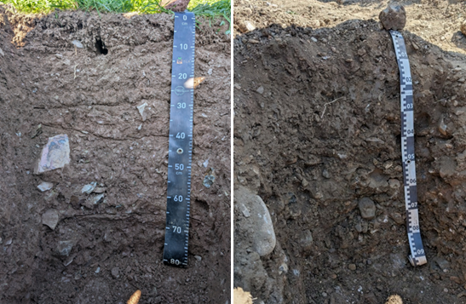
Slika 1: Dva primera skeletnih tal. Na levi je prevladujoča ploščata oblika skeleta, na desni pa zaobljena (Foto: J. Ferlin).

Volumski delež skeleta v tleh
Ker so se objektivne in natančne meritve deleža skeleta ter heterogenosti tal izkazale za zelo zahtevne, se za določanje volumskega deleža skeleta v tleh običajno uporablja subjektivna ocena na terenu, kar povzroči manjšo napako, kot če deleža skeleta sploh ne upoštevamo. Vendar subjektivna ocena pomeni neprecizne izračune količin hranil ali vode v tleh. V literaturi priporočajo, da znaša REV vzorca za merjenje volumskega deleža skeleta v tleh 2100 cm3 za rendzino (Buchter in sod., 1994), do 4000 cm3 za skeletna tla s 35 % do 40 % skeleta oziroma tudi več kot 5000 cm3 za tla z več kot 54 % skeleta (Vincent in Chadwick, 1994), pri čemer so REV povezani z velikostjo skeleta.
Vzorec tal za določanje volumskega deleža skeleta najprej mokro presejemo čez 2 mm sito, s čimer od skeleta odstranimo delce, manjše od 2 mm, ki predstavljajo fino frakcijo tal. Skelet nato potopimo v merilni valj ali čašo z vodo, pri čemer mora biti vode dovolj, da se skelet v celoti potopi. Dvig nivoja vode predstavlja volumen skeleta, saj ta izpodrine enak volumen vode. Metoda je povzeta po Knapič (2014). Za pridobitev reprezentativnih vzorcev potrebujemo večje število pedoloških profilov tal. V primeru večjih skal je potreben tudi večji izkop profila tal. Poleg tega moramo za to metodo v celotni globini profila tal določiti horizonte z različnimi deleži skeleta in iz vsakega odvzeti vzorec. Ta metoda izkopa je sicer zanesljiva, vendar časovno zelo potratna, fizično zahtevna in destruktivna. Ker je skeletnost praviloma zelo variabilna lastnost, je zaželeno, da za večje površine te lastnosti opredelimo z uporabo senzorja na neinvaziven način.

Georadarska metoda
Princip georadarja temelji na zakonih širjenja elektromagnetnih valov, ki jih v kratkih časovnih presledkih (impulzih) pošiljamo z oddajno anteno v tla. Elektromagnetno valovanje se od oddajne antene širi v obliki konusnega stožca z vrhom v središču oddajne antene. Amplituda se zaradi sferičnega razširjanja z oddaljevanjem od antene zmanjšuje (Reynolds, 2011), zato se ločljivost z globino spreminja. Ko elektromagnetno valovanje doseže mejo med različnimi materiali, se zaradi različnih električnih lastnosti del vpadnega valovanja odbije in ga na površju zazna sprejemna antena. Pri tem se meri dvojni čas potovanja valov, torej od oddajne antene do meje med različnimi materiali in od meje do sprejemne antene. Preostali del elektromagnetnega valovanja se na mestu odboja lomi in potuje naprej v globino (Knödel in sod., 2007).
Najpomembnejši lastnosti, ki vplivata na odbojnost na meji med različnimi materiali in na globinski doseg elektromagnetnega valovanja, sta dielektričnost (ε) in električna prevodnost (σ) (Kirsch, 2009). Kontrast dielektričnih lastnosti med različnimi snovmi in s tem sprememba hitrosti elektromagnetnega valovanja, povzročita odboj na meji, kar omogoča razlikovanje med različnimi objekti ali plastmi. Večji kot je kontrast med dielektričnimi lastnostmi mejnih materialov, večji delež vpadnega valovanja se odbije, večja in jasnejša je amplituda odboja. Če je kontrast v dielektričnih lastnostih premajhen, so odboji šibki. Na električne lastnosti tal v največji meri vpliva volumska vsebnost vode. Večji kot je delež vode v preučevanem mediju, večji je odboj vpadnega elektromagnetnega valovanja. Razlike v električnih lastnostih materialov vplivajo tudi na hitrost in dušenje elektromagnetnega valovanja (Knödel in sod., 2007).

Širjenje in dušenje elektromagnetnega valovanja ter dielektričnost in ločljivost georadarskih podatkov
Lastnosti širjenja elektromagnetnega valovanja so odvisne od električnih lastnosti snovi, frekvence in jakosti valovanja. Najpomembnejša dejavnika, s katerima opisujemo širjenje valovanja, sta hitrost in dušenje elektromagnetnih valov. Med najpomembnejšimi dejavniki, ki vplivajo na elektromagnetne lastnosti snovi, so kemična in mineralna sestava, poroznost, prevodnost tekočin v porah, vsebnost vode, temperatura in delež gline (Reynolds, 2011). Vsebnost vode in prisotnost glinenih mineralov vplivata na višjo električno prevodnost snovi ter posledično na večje dušenje elektromagnetnega valovanja. To se z globino hitro zmanjšuje zaradi sferičnega razširjanja in absorpcije, ki je odvisna od prevodnosti preiskanega materiala in frekvence radarskega valovanja (Jol, 2009; Reynolds, 2011).
Hitrost valovanja je odvisna predvsem od dielektrične konstante. Dielektričnost (ε) je sposobnost snovi za skladiščenje električnega naboja. Dielektrične snovi omogočajo širjenje elektromagnetnega valovanja brez znatnega dušenja. Večja kot je dielektričnost, nižja je hitrost valovanja. Na dielektrične lastnosti vplivata tudi poroznost tal in vsebnost vode. Večji kot je delež por, zapolnjenih z zrakom, višja je hitrost valovanja. Višja kot je vsebnost vode v tleh, nižja je hitrost valovanja. Iz preglednice 1 je razvidno, da je relativna dielektričnost vode veliko večja kot pri suhi kamnini, zato lahko že majhna vsebnost vode v snoveh zmanjša hitrost širjenja elektromagnetnega valovanja (Jol, 2009; Reynolds, 2011).
S poznavanjem hitrosti potovanja v materialu ali njegove dielektrične lastnosti lahko časovno skalo potovanja signala pretvorimo v globinsko.
Preglednica 1: Vrednosti relativne dielektrične konstante, hitrosti elektromagnetnega valovanja in električne prevodnosti za različne snovi (Jol, 2009; Lombardi in sod., 2022; Zajícová in Chuman, 2019)
Snov | Relativna dielektričnost  εr [-] | Hitrost elektromagnetnega valovanja [mm/ns] | Električna prevodnost  σ [mS/m]
Zrak | 1,00054 | 300 | 0
Voda (pri 18°C) | 81,1 | 33 | 0,1 – 10 (sladka voda)
Pesek (suh) | 3 – 6 | 120 – 170 | 0,0001 – 1
Pesek (moker) | 25 – 30 | 55 – 60 | 0,1 – 10
Melj (moker) | 10 | 95 | /
Glina (mokra) | 15 (možno tudi do 40) | 86 – 110 | 100 – 1000
Prod | 5 | 134 | /
Hitrost širjenja elektromagnetnega valovanja se zmanjšuje z večanjem vsebnosti vode v snovi. Posledično je ločljivost georadarskih podatkov boljša v mokrih kot v suhih snoveh. Vendar je v mokrih snoveh z dobro električno prevodnostjo, dušenje večje, zato je globinski doseg georadarja manjši. Elektromagnetno valovanje se ugodno širi v snoveh z visoko relativno dielektrično konstanto in nizko električno prevodnostjo (Jol, 2009).
Ločljivost je mera sposobnosti razločevanja med dvema signaloma od dveh blizu ležečih objektov in je odvisna od frekvence georadarskega sistema (središčne frekvence in razpona sosednjih mej frekvenc), kontrasta električnih lastnosti materiala ter geometrijskih značilnosti (oblika, velikost, orientacija) ciljne tarče (Kirsch, 2009). Poznamo horizontalno in vertikalno ločljivost. Pomemben dejavnik horizontalne ločljivosti je širina georadarskega snopa, saj vpliva na hitrost signala in s tem na globinski doseg georadarskih meritev. Vertikalna ločljivost je mera sposobnosti ločevanja dveh georadarskih signalov v času in je predvsem odvisna od frekvence. Višja kot je frekvenca radarskega sistema, večje je dušenje in manjši globinski doseg (Kirsch, 2009).

Delovanje georadarja v tleh
V heterogenem in kompleksnem mediju, kot so tla, je pomembno razumeti posamezne komponente tal (sediment ali preperina, voda, kamnina, zrak), ki vplivajo na georadarsko valovanje in njegov globinski doseg. Bolj kot je medij heterogen, več energije se razprši na objektih pod površjem. V heterogenem okolju, kjer so prisotni različni elementi manjših dimenzij (fragmenti kamnin, razpoke, manjše praznine), prihaja do sipanja elektromagnetnega valovanja, pri čemer prvotno oddani signal izgubi precej energije, saj se razprši na vse strani. Objekti manjših velikosti navadno ne povzročajo močnejših refleksov, kljub temu pa vplivajo na signal, ki potuje skozi tak medij (Jol, 2009).
V tleh ne smemo zanemariti prisotnosti večjih debelin sedimentov, ki povzročajo povečano dušenje signala. Tla imajo kompleksno sestavo in v naravi variirajo ne le v bioloških, kemijskih, fizikalnih in mineraloških značilnostih, temveč tudi v elektromagnetnih. Vse te lastnosti vplivajo na hitrost elektromagnetnega valovanja, dušenje in globinski doseg. Osnovni dejavniki, ki vplivajo na prevodnost tal, so poroznost in delež vode, količina in vrsta soli v raztopini, količina in vrsta glinenih mineralov ter sipanje energije. V tleh so največje izgube energije posledica ionskega izmenjevalnega transporta v raztopini in elektrokemijskih procesov kationov v glinenih mineralih (Doolittle in Collins, 1995).
Na trgu obstaja veliko število različnih dobaviteljev georadarskih naprav. Za lažjo predstavo, kako izgleda, je georadar prikazan na sliki 2.
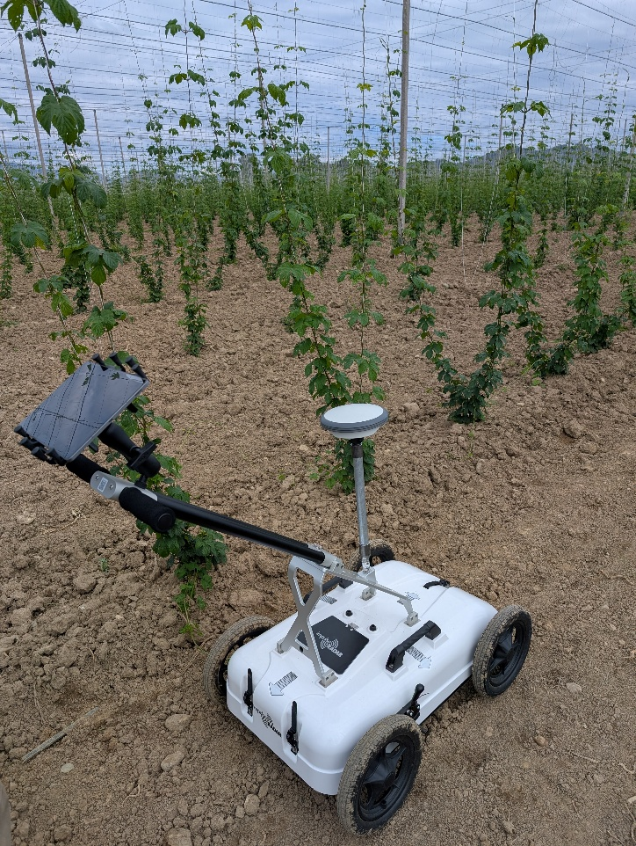
Slika 2: Georadarska naprava v hmeljišču (Foto: J. Ferlin)

določanje lastnosti tal z georadarjem
Pomembne prednosti georadarja, ki so pripomogle k uveljavitvi metode na različnih področjih, so (Lombardi in sod., 2022):
- neinvazivnost (meritve se izvajajo brez posega v preiskovani medij), kar omogoča relativno hitro preiskavo večjih območij;
- visoka ločljivost in natančen vpogled pod površje;
- zvezno zajemanje podatkov (merski podatki so dvodimenzionalni časovni profili poljubne dolžine), kar omogoča, da z mrežo vzporednih in prečnih profilov ter nadaljnjo obdelavo dobimo preglednejše tridimenzionalne modele,
- ponovljivost meritev, saj jih je mogoče večkrat izvesti na istem območju in s časovnim ponavljanjem opazovati spremembe lastnosti materiala;
- cenovno ugodna metoda.

Določanje globine tal
Z georadarjem lahko načeloma zaznamo mejo med tlemi in matično podlago, če je ta meja nenadna in dovolj kontrastna. Običajno je prepoznavna kot visokoamplitudni reflektor, ki je zvezen (Jol, 2009). V študiji so Sucre in sod. (2011) želeli oceniti globino tal do trde matične podlage z georadarsko metodo ter rezultate primerjati z uveljavljeno metodo – vrtanjem z ročnim Edelmanovim svedrom. Raziskava je potekala na različnih tleh ilovnate teksture, delež skeleta je znašal od 15 % do 60 %. Na vseh tipih tal so izvedli kalibracijo georadarja (na znano globino so zakopali kovinsko ploščo). Z georadarjem (200 in 400 MHz anteni) so na vsakem obravnavanju izvedli dve 20-meterski liniji v smeri sever - jug in vzhod - zahod. Na posameznih točkah teh linij so opravili številne izkope pedoloških profilov tal, da so preverili nekatera dvoumna opažanja na radargramih in validirali globino do matične podlage. Podatke so obdelali s programsko opremo. S svedrom so na vsakem obravnavanju opravili pet meritev globine tal. Posamezno vrtanje so zaključili, ko so naleteli na oviro – trdo matično podlago ali večji skelet. Za primerjavo rezultatov obeh metod so uporabili t-test. Med antenama ni bilo razlik. Na vseh obravnavanjih so bile ocenjene globine tal s svedrom (povprečje 53 cm) plitvejše kot pri georadarskih meritvah (povprečje 88 cm). To pomeni, da metoda s svedrom podceni globino tal za 40 %, kar znaša približno 3500 m3 neupoštevanih tal na hektar (večinoma gre za B in BC horizont) in posledično slabšo oceno zemljišča. Metoda določanja globine skeletnih tal z georadarjem se je izkazala za zelo učinkovito. Podobno so ugotovili tudi Smith in sod. (2022), razen v zelo mokrih ali glinenih tleh.

Prepoznavanje meje med horizonti tal
Zhang in sod. (2014) so v študiji želeli raziskati vpliv sezonske dinamike vode v tleh na spremembe v georadarskem signalu ter določiti optimalen čas uporabe georadarja za določanje meje med horizonti. Raziskavo so izvedli na pobočju, na dveh tipih tal. Globoka tla (2 m), MI-MGI teksture, so bila na nagibu 15 %, plitva tla (0,5 m), MI teksture, pa na nagibu 30 %. Pravokotno na smer pobočja so v linijah opravili GPR meritve z anteno 400 MHz. Obe mreži georadarskih meritev sta bili v neposredni bližini vgrajenih senzorjev za vsebnost vode v tleh. Meritve so izvajali dvakrat jeseni in dvakrat spomladi. Na radargramih so poiskali »vrhove« odbojev, da so identificirali meje med sloji. Iz vsebnosti vode v tleh so izračunali dielektrično konstanto tal in ocenili hitrost širjenja elektromagnetnega valovanja, iz česar so določili globino do meje med dvema slojema. To so primerjali in validirali z izkopi profilov tal. Ugotovili so, da je v globokih tleh več odbojev na radargramu ob večji vsebnosti vode v tleh, vendar ne takoj po padavinah, saj korenine dreves in nepravilna oblika skeleta povzročata manjši preferenčni tok. Jasno se vidi meja med B in BC ter med BC in C horizontom. To pripisujejo predvsem neprepustnemu sloju BC, ki zadržuje vodo nad njim, povečanju vode v C horizontu zaradi podpovršinskega lateralnega toka po pobočju. V plitvih tleh so bili jasni odboji na radargramu ob manjši vsebnosti vode v tleh. Infiltrirana voda med koreninami in močno skeletnimi tlemi lahko povzroči uklon georadarskega vala. Najbolj jasna je bila meja z matično podlago.
Ryazantsev in sod. (2022) opozarjajo, da je za uspešno razlikovanje med horizonti z georadarjem potrebno:
- kontrast v elektro-fizikalnih lastnostih med horizonti,
- dovolj velika debelina horizontov zaradi vertikalne ločljivosti georadarja,
- razmeroma majhno slabljenje signala.

Napovedovanje deleža skeleta in gline v tleh
Smith in sod. (2022) so v študiji želeli ugotoviti povezavo med amplitudo georadarskih podatkov in lastnostmi tal ter možnosti za njihovo napovedovanje. Na terenu so izvedli šest linij georadarskih posnetkov z anteno 200 MHz v tleh s teksturo meljaste ilovice. Za preverjanje podatkov so izkopali šest profilov tal in opravili sondiranje na 24 točkah. Podatke so obdelali v programski opremi R, z uporabo paketa »RGPR« jih kalibrirali z merjenjem dvojnega potovalnega časa do kovinske plošče in pretvorili čas v razdaljo. Z analizo surovih amplitudnih atributov so pripravili GPR podatke za napovedno modeliranje ter iz njih izračunali teksturne atribute z uporabo paketa »glcm«. Ti so bili nato uporabljeni za učenje regresijskega modela »random forest« (paket »caret«) za napoved deleža skeleta in gline na podlagi podatkov iz profilov tal. Ugotovili so, da je model precenjeval nižje vrednosti in podcenjeval višje vrednosti deleža skeleta. RMSE vrednosti (koren povprečne kvadratne napake) so bile v zadovoljivih mejah, R2 vrednosti (v kolikšni meri regresijski model ustreza dejanskim podatkom) pa so bile razmeroma visoke, kar nakazuje na dobro napovedovanje in da je regresija »random forest« primerna metoda za raziskovanje povezav med GPR signalom in fizikalnimi lastnostmi tal. Predlagajo uporabo višje frekvence, na primer 400 MHz.

Hidravlične lastnosti tal
Status in dinamika vode v nenasičeni coni tal sta odvisna od vsebnosti vode in hidravličnih lastnosti tal. Uporaba georadarja za spremljanje in oceno vsebnosti vode v tleh je v zadnjih letih pritegnila veliko pozornosti, medtem ko so hidravlične lastnosti tal deležne precej manjše pozornosti. Fizikalne lastnosti tal (tekstura, struktura, volumska gostota, poroznost in razporeditev agregatov) neposredno vplivajo na procese, kot so infiltracija, pronicanje in površinski odtok. Posledično to vpliva na zalogo, tok in drenažo vode v tleh (Li in sod., 2019).
Hidravlične lastnosti tal (nasičena in nenasičena hidravlična prevodnost, vodozadrževalne lastnosti in kapaciteta razpoložljive vode ter infiltracijska sposobnost) omogočajo vpogled v trenutne razmere in dinamiko vode v tleh. Tesno so povezane z zgoraj navedenimi fizikalnimi lastnostmi ter zaskorjenostjo in vsebnostjo organske snovi v tleh (Indoria in sod., 2020).
Konvencionalne metode za določanje hidravličnih lastnosti tal (npr. infiltrometer, Guelph permeameter, tension infiltrometer) imajo alternativo v georadarski metodi, ki sicer ni neposredno povezana s hidravličnimi lastnostmi tal, temveč se zanaša na spremembe vsebnosti vode oziroma spremembe dielektrične konstante medija (Rossi idr., 2015).
Dahunsi in sod. (2023) so pripravili pregled študij, ki obravnavajo določanje hidravličnih lastnosti z georadarjem. Navajajo več raziskav, v katerih so avtorji primerjali georadarske rezultate z uveljavljenimi laboratorijskimi in terenskimi meritvami. Med rezultati ni bilo bistvenih razlik. Z uporabo časovno zaporednih georadarskih posnetkov, modelov ter inverznimi metodami so v raziskavah sledili globini omočenosti tal ter iz tega izpeljati nenasičeno hidravlično prevodnost, infiltracijo in parametre vodozadrževalne krivulje. Z georadarjem so tudi zaznali preferenčne tokove in histerezo (sušenje in navlaževanje tal ne potekata po isti krivulji).

ZAKLJUČKI
Natančna opredelitev časovnih ali prostorskih sprememb lastnosti tal je ključna za precizno kmetijstvo. Čeprav se je področje v zadnjih letih bistveno razvilo, ostaja temeljni izziv, ki še vedno ovira polno izkoriščenost interpretacije georadarskih podatkov, heterogenost tal v naravi ter omejitev, da se lahko vsak podpovršinski sloj odzove na več kot eno spremembo lastnosti tal.
V literaturi je precej objav s področja uporabe georadarske metode za določanje vsebnosti vode v tleh in koreninske biomase rastlin. Kljub nekaterim študijam o uporabi georadarske metode v pedologiji menimo, da je njena uporabna vrednost še veliko večja ter da je možen napredek in razvoj metode za uporabo v skeletnih tleh in z njimi povezanih talnih značilnostih. Pri pregledu podatkov v literaturi smo ugotovili, da so raziskave na temo določanja deleža skeleta v tleh redke, saj smo našli le eno raziskavo, ki je uporabljala georadar za določanje skeleta. Ker je uveljavljena metoda za ugotavljanje skeletnosti, ki je ključen podatek za oceno volumna tal in posledično kakovosti zemljišča, izredno fizično zahtevna in časovno potratna, načrtujemo, da bo ta tema v ospredju naših nadaljnjih raziskav.
Dostopnost raziskovalnih podatkov
Podatki so na voljo pri odgovornem avtorju na utemeljeno zahtevo.

VIRI
Buchter, B., Hinz, C., Flühler, H., 1994. Sample size for determination of coarse fragment content in a stony soil. Geoderma, 63(3–4), 265–275. https://doi.org/10.1016/0016-7061(94)90068-X
Dahunsi, J., Pathirana S., Cheema, M., Krishnapillai, M., Galagedara, L., 2023. Advances in Ground Penetrating Radar application for estimating soil hydraulic properties: A mini review. Canadian Biosystems Engineering, 65(1), 1.17-1.27. https://doi.org/10.7451/CBE.2023.65.1.17
Doolittle, J. A., & Collins, M. E., 1995. Use of soil information to determine application of ground penetrating radar. Journal of Applied Geophysics, 33(1995), 101-108. https://doi.org/10.1016/0926-9851(95)90033-0
Eriksson, C. P., & Holmgren, P., 1996. Estimating stone and boulder content in forest soils—Evaluating the potential of surface penetration methods. CATENA, 28(1–2), 121–134. https://doi.org/10.1016/S0341-8162(96)00031-8
Indoria, A. K., Sharma, K. L., Reddy, K. S. 2020. Hydraulic properties of soil under warming climate. In Climate Change and Soil Interactions 473–508. Elsevier. https://doi.org/10.1016/B978-0-12-8180327.00018-7
ISO 11272:2017. Soil quality - Determination of dry bulk density. 2017
Jol, H. M. (ur.), 2009. Ground penetrating radar: Theory and applications, 1st ed. Elsevier Science.
Kirsch, R. (ur.), 2009. Groundwater Geophysics: A Tool for Hydrogeology, 2nd ed. Springer Berlin Heidelberg. https://doi.org/10.1007/978-3-540-88405-7
Knapič, M., 2014. Opredelitev hidravličnih lastnosti izbranih aluvialnih skeletnih tal v Savinjski dolini. Magistrsko delo. Univerza v Ljubljani, Biotehniška fakulteta.
Knödel, K., Voigt, H.-J., Lange, G., (ur.), 2007. Environmental geology: Handbook of field methods and case studies, 1st ed. Springer.
Lal, R., & Shukla, M. K. (ur.), 2004. Principles of Soil Physics, 1st ed. MARCEL DEKKER, INC.
Li, H., Liao, X., Zhu, H., Wei, X., Shao, M., 2019. Soil physical and hydraulic properties under different land uses in the black soil region of Northeast China. Canadian Journal of Soil Science, 99(4), 406–419. https://doi.org/10.1139/cjss-2019-0039
Lombardi, F., Ortuani, B., Facchi, A., & Lualdi, M., 2022. Assessing the Perspectives of Ground Penetrating Radar for Precision Farming. Remote Sensing, 14(23), 6066. https://doi.org/10.3390/rs14236066
Reynolds, J. M. (ur.), 2011. An Introduction to Applied and Environmental Geophysics, 2nd ed. Wiley-Blackwell.
Rossi, M., Manoli, G., Pasetto, D., Deiana, R., Ferraris, S., Strobbia, C., Putti, M., Cassiani, G., 2015. Coupled inverse modeling of a controlled irrigation experiment using multiple hydro-geophysical data. Advances in Water Resources, 82, 150–165. https://doi.org/10.1016/j.advwatres.2015.03.008
Ryazantsev, P. A., Hartemink, A. E., Bakhmet, O. N., 2022. Delineation and description of soil horizons using ground-penetrating radar for soils under boreal forest in Central Karelia (Russia). CATENA, 214, 106285. https://doi.org/10.1016/j.catena.2022.106285
Schoenholtz, S. H., Miegroet, H. V., Burger, J. A., 2000. A review of chemical and physical properties as indicators of forest soil quality: Challenges and opportunities. Forest Ecology and Management, 138(1–3), 335–356. https://doi.org/10.1016/S0378-1127(00)00423-0
Smith, H. W., Owens, P. R., Ashworth, A. J., 2022. Applications and Analytical Methods of Ground Penetrating Radar for Soil Characterization in a Silvopastoral System. Journal of Environmental and Engineering Geophysics, 27(4), 167–179. https://doi.org/10.32389/JEEG22-001
Sucre, E. B., Tuttle, J. W., Fox, T. R., 2011. The Use of Ground-Penetrating Radar to Accurately Estimate Soil Depth in Rocky Forest Soils. Forest Science, 57(1), 59–66. https://doi.org/10.1093/forestscience/57.1.59
Vincent, K. R., & Chadwick, O. A, 2004. Synthesizing Bulk Density for Soils with Abundant Rock Fragments. Soil Science Society of America Journal, 58(2), 455-464. https://doi.org/10.2136/sssaj1994.03615995005800020030x
Wu, X., Meng, Z., Dang, X., Wang, J., 2021. Effects of rock fragments on the water infiltration and hydraulic conductivity in the soils of the desert steppes of Inner Mongolia, China. Soil and Water Research, 16(3), 151–163. https://doi.org/10.17221/107/2020-SWR
Zajícová, K., & Chuman, T., 2019. Application of ground penetrating radar methods in soil studies: A review. Geoderma, 343, 116–129. https://doi.org/10.1016/j.geoderma.2019.02.024
Zhang, J., Lin, H., & Doolittle, J., 2014. Soil layering and preferential flow impacts on seasonal changes of GPR signals in two contrasting soils. Geoderma, 213, 560–569. https://doi.org/10.1016/j.geoderma.2013.08.035

Ta članek je objavljen pod licenco Creative Commons Priznanje avtorstva-Deljenje pod enakimi pogoji 4.0 Mednarodna.

Usmerjeno vzorčenje podtalnih in pitnih voda na aktivne snovi pesticidov in njihovih razgradnih produktov v letu 2024
Primož BUKOVEC, Tanja FATUR in Žan TROŠT
Tipologija / Article type: Strokovni članek / Professional article
Prispelo / Arrived: 25. 10. 2025
Sprejeto / Accepted: 22. 11. 2025
Objavljeno / Published: December 2025
Izvleček
V okviru strokovne naloge smo spremljali vsebnost aktivnih snovi v FFS in njihovih razgradnih produktov v podzemnih vodah Slovenije. Na ostanke aktivnih snovi je bilo pregledanih 34 vzorcev podtalne vode in 7 vzorcev pitne vode, odvzetih na več lokacijah na treh območjih, in sicer v Savinjski kotlini (sedem odvzemnih mest), Dravski kotlini (sedem odvzemnih mest) in Murski kotlini (deset odvzemnih mest). Izbrana mesta za vzorčenje podtalnice so bila določena na podlagi hidrogeoloških in pedoloških značilnosti ter kmetijskih praks na posameznem območju. Ta mesta predstavljajo najbolj kritične točke za spiranje pesticidov v podzemno vodo, saj izpolnjujejo ključne kriterije, ki povečujejo tveganje za kontaminacijo. Vsak vzorec vode je bil analiziran na več kot 500 komponent fitofarmacevtskih sredstev (aktivne snovi in metaboliti). V vseh analiziranih vzorcih podtalne vode je bilo zaznanih 20 različnih aktivnih snovi oz. njihovih metabolitov, kar predstavlja okoli 3 % vseh analiziranih komponent. V vseh analiziranih vzorcih pitne vode pa je bilo zaznanih le 6 različnih komponent aktivnih snovi oz. njihovih metabolitov, kar predstavlja manj kot 1 % od vseh analiziranih komponent. Vzorčenje in analiza izbranih podtalnih in pitnih voda v delih Slovenije, kjer se izvaja najintenzivnejša kmetijska pridelava na najranljivejših tleh za spiranje v podtalnico, sta pokazala, da imamo na teh območjih kmetijske dejavnosti relativno malo ostankov aktivnih snovi. Raziskave na področju podzemnih voda se bodo nadaljevale in po potrebi bomo dodali v program še nove aktivne snovi in metabolite FFS.
Ključne besede: monitoring podzemnih voda, pesticidi, metaboliti, pitna voda, aktivne snovi v FFS
TARGETED SAMPLING OF GROUNDWATER AND DRINKING WATER FOR ACTIVE SUBSTANCES OF PESTICIDES AND THEIR DEGRADATION PRODUCTS IN 2024
Abstract
As part of the professional assignment, we monitored the content of active substances in PPP and their degradation products in the groundwater of Slovenia. 34 groundwater samples and 7 drinking water samples were examined for active substances residues, taken at several locations in three areas, namely the Savinja Basin (seven sampling points), the Drava Basin (seven sampling points) and the Mura Basin (ten sampling points). The selected groundwater sampling sites were determined based on the hydrogeological and pedological characteristics and agricultural practices in the individual area. These sites represent the most critical points for pesticide leaching into groundwater, as they meet key criteria that increase the risk of contamination. Each water sample was analyzed for more than 500 components of plant protection products (active substances and metabolites). In all analyzed groundwater samples, 20 different active substances or their metabolites were detected, which represents around 3% of all analyzed components. In all analyzed drinking water samples, only 6 different components of active substances or their metabolites were detected, which represents less than 1% of all analyzed components. Sampling and analysis of selected groundwater and drinking water in parts of Slovenia where the most intensive agricultural production is carried out on soils most vulnerable to leaching into groundwater have shown that these areas of agricultural activity have relatively few active substances residues. Research in the field of groundwater will continue and, if necessary, new active substances and metabolites of PPP will be added to the program.
Key words: groundwater monitoring, pesticides, metabolites, drinking water, active substances in PPP

UVOD
Slovenija ima precejšnje zaloge podzemnih voda, iz katerih se oskrbuje okoli 97 % prebivalcev. Podzemne vode so pomembne za namakanje v kmetijstvu, kot tehnološke vode za potrebe industrije, vode iz globljih vodonosnikov pa za zdraviliški turizem in kot mineralne vode. V Sloveniji imamo tri pomembnejše tipe vodonosnikov: vodonosnike z medzrnsko poroznostjo v ravninskih delih rečnih dolin, razpoklinske vodonosnike pretežno v dolomitnih plasteh in kraške vodonosnike v plasteh apnenca na Krasu, Notranjskem, Julijskih in Kamniško-Savinjskih Alpah (ARSO, 2011). V študiji smo se osredotočili na vodonosnike v ravninskih delih rečnih dolin, kjer prevladuje kmetijstvo, ter je tam povečana raba fitofarmacevtskih sredstev. Registracijo fitofarmacevtskih sredstev na območju Republike Slovenije izvaja Uprava RS za varno hrano, veterinarstvo in varstvo rastlin, ki je organ v sestavi Ministrstva za kmetijstvo gozdarstvo in prehrano. Ker fitofarmacevtska sredstva lahko predstavljajo onesnaževala za vire podzemne vode (predvsem v primeru, ko se jih uporablja v nasprotju z dovoljenjem ali se uporablja fitofarmacevtska sredstva, ki niso registrirana), je v postopku ocenjevanja FFS, vpliv na podzemno vodo eno od ključnih tveganj, ki se jih ocenjuje in ovrednoti njihovo sprejemljivost ali nesprejemljivost. V postopku ocenjevanja tveganja za podzemno vodo se tveganje ovrednoti na podlagi matematičnega modela, ki vključuje lastnosti posameznega FFS, vplive okolja ter same predlagane rabe. Pri višjih stopnjah tveganja za podzemne vode pa obstaja možnost uporabe rezultatov monitoringa podzemnih voda.

MATERIAL IN METODE
V tem usmerjenem programu monitoringa podzemnih voda smo preučili le vir onesnaženja s področja rabe fitofarmacevtskih sredstev v kmetijstvu. V študiji smo uporabili že obstoječo mrežo merilnih mest, ki jo upravlja Agencija Republike Slovenije za okolje (ARSO). Načrtovana je tako, da omogoča pregled kemijskega stanja podzemne vode in da zazna pojav dolgoročnih trendov za parametre, na katere vpliva človekova dejavnost oziroma so posledica človekove dejavnosti. Omenjena mreža merilnih mest za oceno kemijskega stanja podzemnih voda je bila zasnovana na podlagi konceptualnih modelov vodnih teles podzemnih voda, to pomeni, da temelji na hidrogeoloških značilnostih vodonosnikov in na problematiki onesnaženja. Merilna mreža vključuje črpališča pitne vode, črpališča za tehnološko vodo, privatne vodnjake ter avtomatske merilne postaje. Mesta za vzorčenje so bila zato izbrana na podlagi celovite analize zgoraj omenjenih dejavnikov, kar omogoča natančno spremljanje najbolj kritičnih točk za spiranje pesticidov v podzemno vodo. Za analizo podtalne vode je bilo odvzetih 17 vzorcev v mesecu juniju in novembru 2024, ter 7 vzorcev pitne vode v mesecu novembru. Vzorčenje je v vseh primerih opravila pooblaščena organizacija, ki že izvaja nacionalni monitoring podtalnih voda (Nacionalni laboratorij za zdravje, okolje in hrano - NLZOH). Vzorci za analizo so bili odvzeti v enakem hidrološkem stanju, kot ga pri nacionalnem monitoringu podtalnice določi Agencija RS za okolje in v skladu s standardom SIST ISO 5667-11 (SIST ISO, 2025). Kemijsko analizo pobranih vzorcev podtalnice je opravil nemški laboratorij Eurofins SOFIA Berlin. Vsak posamezni vzorec podzemne vode je bil analiziran na 632 aktivnih snovi fitofarmacevtskih sredstev in njihovih razgradnih produktov. Uporabljenih je bilo 5 multirezidualnih metod in tri analitske metode za določanje posameznih metabolitov (DMS (N,N-dimethylsulfamide), DMSA (N,N-dimethylsulfamic acid) in TFA (trifluoroacetic acid). Meja kvantifikacije (LOQ) se je glede na komponento, ki so jo analizirali, razlikovala. Njena vrednost je bila med 0,01 µg/L in 0,1 µg/L. Lokacije vzorčnih mest za pitno in podzemno vodo so navedene v preglednicah 1 in 2, vizualno pa so prikazana na slikah 1, 2 in 3.
Preglednica 1: Lokacije vzorčnih mest za pitno vodo
Ime lokacije
Vrtina Vrbje 5
Črpališče Podvin 1
Črpališče Letuš
Kmetija Plečko, Podova, Rače
Vrtec Apače
Vrtec Gančani
Vrtec Ljutomer

Preglednica 2: Lokacije vzorčnih mest za podtalno vodo
Ime lokacije | Koordinata X | Koordinata Y | Globina do gladine podzemne vode (m)
ŽALEC Žal 1/14 | 122795 | 512748 | 1-2
MEDLOG, vodnjak A | 121358 | 517757 | 2
LATKOVA VAS Lvas-1/14 | 122467 | 507307 | 5
TRNAVA Trn-1/14 | 123755 | 505547 | 4
SOBETINCI Sob-1/14 | 140794 | 574744 | 5
PODOVA Pod-1/10 | 144526 | 555552 | /
SPODNJA HAJDINA SHaj-1/14 | 141564 | 564525 | 8
DORNAVA (Do-1/09) | 143579 | 573030 | 4-5
ŠIKOLE 1581 | 141130 | 555386 | /
KIDRIČEVO 2571 | 140528 | 560725 | /
MALI SEGOVCI MSeg-1/14 | 172015 | 570589 | 3-4
RAKIČAN (Ra-1/09) | 168250 | 591544 | 3-4
GANČANI Gan-1/14 | 165800 | 595041 | 3
ODRANCI (Od-1/09) | 161730 | 598458 | 1-2
LUKAVCI V3 | 156022 | 587601 | /
VEŠČICA (Ve-1/09) | 154572 | 596759 | 2
BENICA Ben-1/14 | 152572 | 616225 | 2-3
Na slikah 1, 2 in 3 so označena vsa mesta vzorčenja glede na lokacijo. Mesta odvzema podzemne vode so označena z rdečo, mesta odvzema pitne vode pa z zeleno barvo.
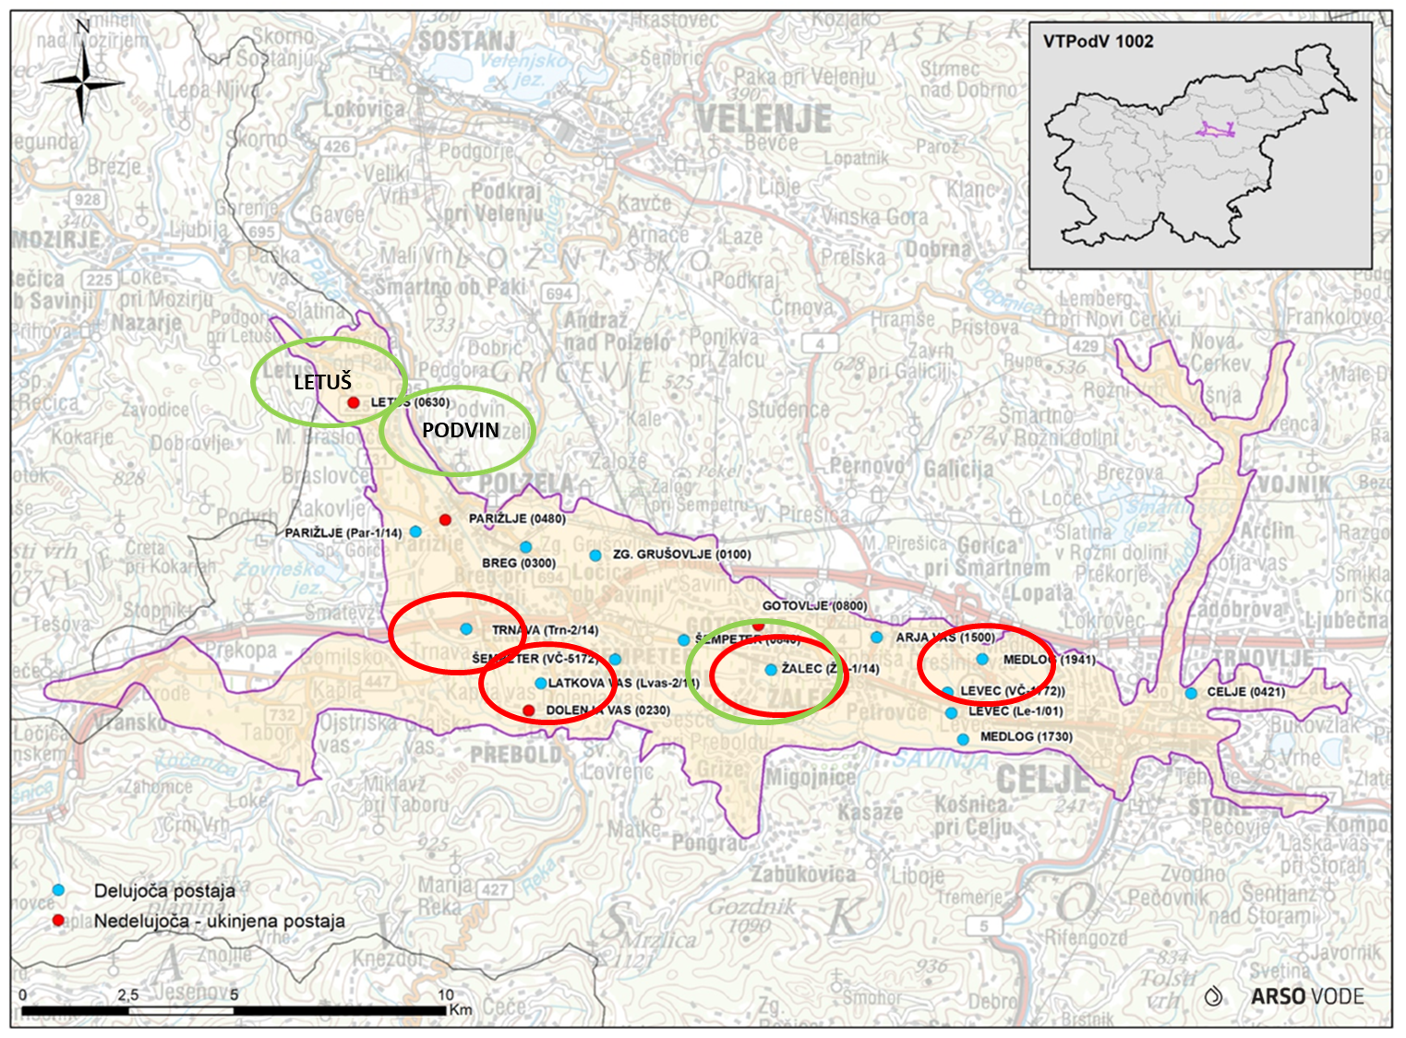
Slika 1: Merilna mesta v Savinjski kotlini
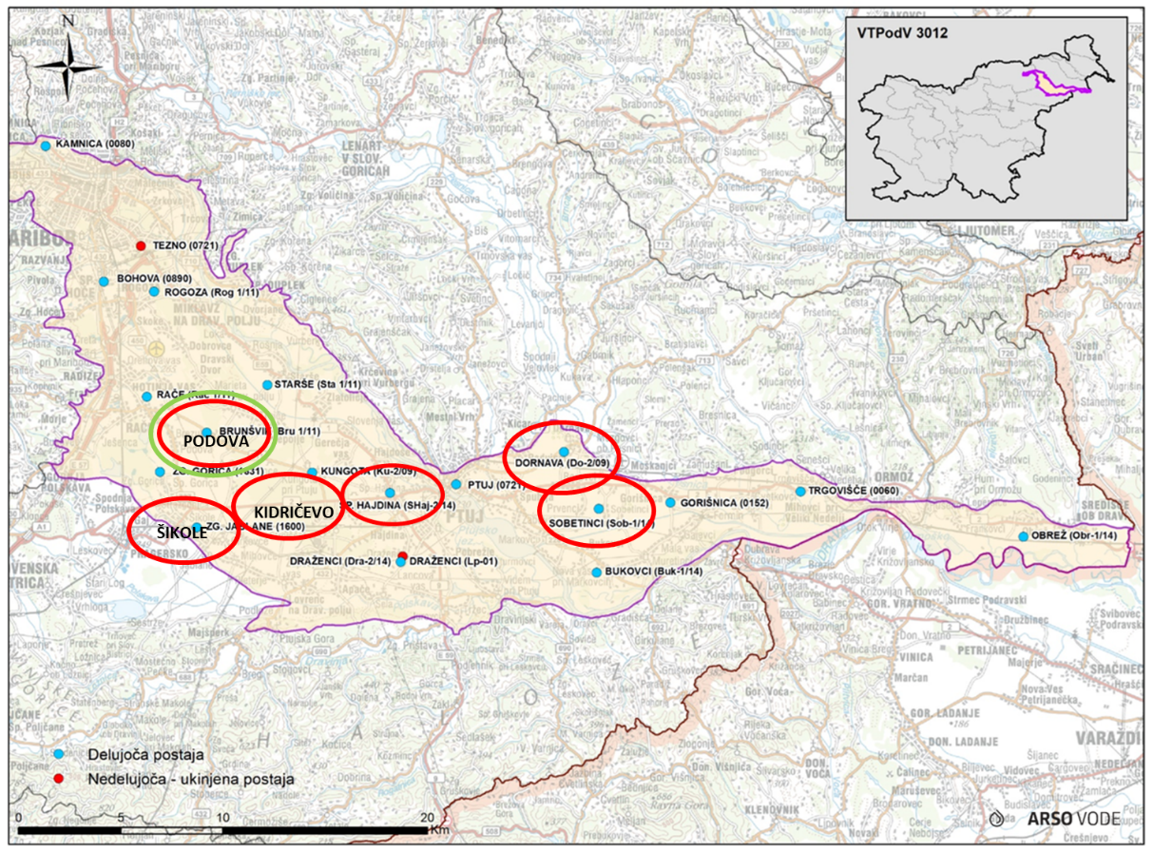
Slika 2: Merilna mesta v Dravski kotlini
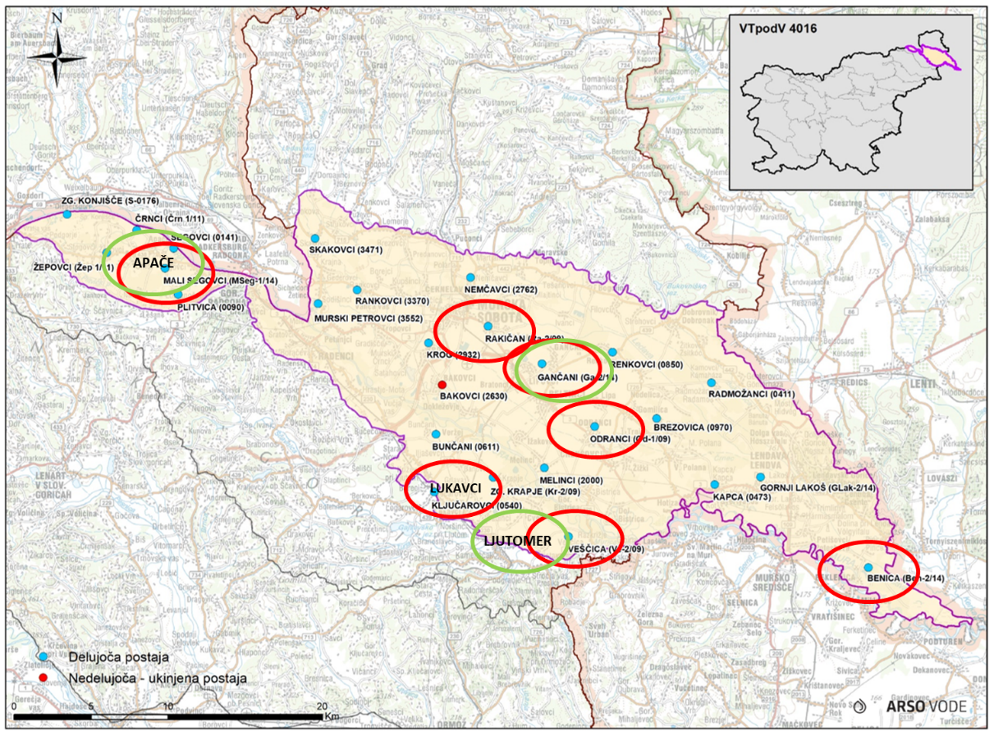
Slika 3: Merilna mesta v Murski kotlini

REZULTATI IN RAZPRAVA
Rezultati analiz so predstavljeni v naslednjih preglednicah 3 in 4, ločeno glede na čas odvzema vzorca (junij in november). V obeh terminih je bilo odvzetih 17 vzorcev podzemne vode (skupaj 34), vzorci pitne vode pa so bili odvzeti v novembru, skupaj 7 vzorcev.
Preglednica 3: Pregled rezultatov analiz podzemne vode, vzorčene v juniju in novembru 2024
Komponenta* | Meja kvantifikacije (LOQ) [µg/L] | Število vzorcev, kjer je bila snov zaznana (Junij 2024) | Število vzorcev s preseganjem 0,1 µg/L ***  (Junij 2024) | Število vzorcev, kjer je bila snov zaznana  (November 2024) | Število vzorcev s preseganjem 0,1 µg/L***  (November 2024) | Najvišja izmerjena koncentracija** [µg/L]
Atrazine | 0,03 - 0,05 | 9 | 2 | 6 | 1 | 0,220
Atrazin, desethyl | 0,05 | 7 | 4 | 7 | 3 | 0,140
Atrazine desethyl desisopropyl | 0,05 | 1 | 1 | 4 | 1 | 0,180
Dimethachlor CGA 369873 | 0,02 | 4 | 0 | 3 | 0 | 0,045
Dimethachlor CGA 373464 | 0,02 | 0 | 0 | 1 | 0 | 0,029
Dimethachlor ethane sulfonic acid | 0,02 | 1 | 0 | 1 | 0 | 0,025
Metolachlor CGA 368208 | 0,02 | 7 | 2 | 5 | 1 | 0,150
Metolachlor ethanesulfonic acid (ESA) | 0,02 | 14 | 13 | 14 | 13 | 2,300
Metolachlor NOA 413173 | 0,02 | 11 | 6 | 10 | 8 | 0,510
Chloridazon. methyl desphenyl- | 0,01 | 16 | 9 | 14 | 9 | 1,900
Chloridazon desphenyl | 0,02 | 14 | 13 | 14 | 13 | 4,700
Metazachlor ethanesulfonic acid | 0,02 | 3 | 1 | 3 | 1 | 0,330
Metazachlor oxanilic acid | 0,02 | 1 | 0 | 1 | 0 | 0,044
Dimethylsulfamide (DMS) | 0,10 | 2 | 0 | 1 | 1 | 0,390
Metribuzin | 0,03 | 1 | 0 | 0 | 0 | 0,080
Prometryn | 0,05 | 1 | 0 | 1 | 0 | 0,140
Nicosulfuron | 0,05 | 1 | 1 | 2 | 1 | 0,240
Trifluoroacetic acid (TFA) | 0,05 | - | - | 17 | 17 | 2,500
* v preglednici so prikazane samo tiste aktivne snovi in metaboliti fitofarmacevtskih sredstev, ki so jih izvedene kemijske analize zaznale v vzorcih vode. Imena aktivnih snovi in metabolitov so zaradi izogibanja napak pri prevajanju zapisana v angleškem jeziku
** najvišja zaznana koncentracija v juniju ali novembru 2024
*** mejna vrednost 0.1 µg/L, predstavlja standard kakovosti in vrednosti praga po Uredbi o stanju podzemnih voda (Uradni list RS, št.25/09, 68/12 in 66/16), ki razmejuje dobro oziroma slabo kemijsko stanje podzemne vode
V analiziranih vzorcih podzemne in vode, so bile ugotovljene naslednje komponente:
Atrazine, Desethyl atrazine, Atrazine-desethyl-desisopropyl, Metalaxyl CGA 108906, Dimetachlor CGA 369873, Dimethachlor ethane sulfonic acid, Dimetachlor CGA 373464, Metolachlor CGA 368208, Metolachlor Ethanesulfonic acid (ESA), Metolachlor NOA 413173, Chloridazon methyl-desphenyl, Chloridazon-desphenyl, Metazachlor ethanesulfonic acid, N,N-Dimethylsulfamide (DMS), Metribuzin, Prometryn, Nicosulfuron, in Trifluoroacetic acid (TFA).
Preglednica 4: Pregled analiz pitne vode, vzorčene v novembru 2024
Komponenta* | Meja kvantifikacije (LOQ) [µg/L] | Število vzorcev, kjer je bila snov zaznana | Število vzorcev s preseganjem 0,1µg/L*** | Najvišja izmerjena koncentracija** [µg/L]
Atrazine | 0,03 - 0,05 | 1 | 0 | 0,071
Metolachlor ethanesulfonic acid (ESA) | 0,02 | 3 | 3 | 0,390
Metolachlor NOA 413173 | 0,02 | 1 | 0 | 0,033
Chloridazon, methyl-desphenyl- | 0,01 | 2 | 1 | 0,160
Chloridazon-desphenyl | 0,02 | 3 | 1 | 0,430
Trifluoroacetic acid (TFA) | 0,05 | 7 | 7 | 1,800
* V preglednici so prikazane samo tiste aktivne snovi in metaboliti fitofarmacevtskih sredstev, ki so jih izvedene kemijske analize zaznale v vzorcih vode. Imena aktivnih snovi in metabolitov so zaradi izogibanja napak pri prevajanju zapisana v angleškem jeziku.
** Najvišja zaznana koncentracija.
*** mejna vrednost 0.1 µg/L, predstavlja standard kakovosti in vrednosti praga po Uredbi o stanju podzemnih voda (Uradni list RS, št.25/09, 68/12 in 66/16), ki razmejuje dobro oziroma slabo kemijsko stanje podzemne vode
V analiziranih vzorcih pitne vode so bile ugotovljene naslednje aktivne snovi in metaboliti:
Atrazine, Metolachlor Ethanesulfonic acid (ESA), Metolachlor NOA 413173, Chloridazon methyl-desphenyl, Chloridazon-desphenyl in Trifluoroacetic acid (TFA).
Atrazine je v Sloveniji prepovedan od leta 2003, vendar se na določenih točkah, predvsem v Dravski kotlini in Murski kotlini še vedno pojavlja tako atrazin, kot desethyl atrazine in atrazine-desethyl-desisopropyl. Ocenjujemo, da je to še vedno posledica rabe iz preteklosti. Atrazine je razvrščen kot alergen v stiku s kožo in škodljiv za posamezne organe po ponavljajoči izpostavljenosti (Uredba 1272/2008, 2008). Za atrazine in njegove kloro-S-triazinske metabolite, kamor sodita tudi desethyl atrazine in atrazine-desethyl-desisopropyl, so po pregledu vseh razpoložljivih študij, s poudarkom na študijah rakotvornosti, strupenosti za razvoj in razmnoževanje teh študijah lastnosti kemičnih motilcev hormonskega sistema, določili skupno vrednost ADI (sprejemljiv dnevni odmerek) 0,02 mg/kg tm/dan (Atrazine 37–138 JMPR 2007, vključeno v Guidelines for drinking-water quality: Fourth edition, WHO/HSE/WSH/10.01/11/Rev/1, 2011). Najvišja izmerjena koncentracija atrazina v podtalnici je bila 0,22 µg/L, desethyl atrazina 0,14 µg/L in atrazine-desethyl-desisopropyla 0,11 µg/L. Ocena tveganja je pokazala, da atrazin in njegovi metaboliti v podzemni vodi predstavljajo le nizek delež sprejemljivega dnevnega vnosa. Ocenjena izpostavljenost je bila pri najvišji koncentraciji atrazina manj kot 0,3 % ADI.
V primeru aktivne snovi S-metolachlor, ki od leta 2024 ni več registriran v Sloveniji in je bil registriran kot herbicid v koruzi, so bili ugotovljeni v vzorcih podzemne vode 3 metaboliti in sicer CGA 368208, Ethanesulfonic acid (ESA) in NOA413173. Metabolit CGA 368208 je bil ugotovljen v 12 od 34 vzorcev, preseganje mejne vrednosti 0,1 µg/L je bilo ugotovljeno v treh vzorcih, najvišja izmerjena koncentracija je bila 0,15 µg/L. Metabolit Ethanesulfonic acid (ESA), je bil ugotovljen v 14 vzorcih podtalne vode junija in istih vzorcih tudi novembra. Junija je bila najvišja izmerjena koncentracija 2,3 µg/L, novembra 1,9 µg/L. V vzorcih odvzetih v obeh merilnih obdobjih je v 13 vzorcih koncentracija presegla 0,1 µg/L. Skupno je bil ugotovljen v 28 od 34 vzorcev podzemne vode, od tega je bilo preseganje mejne vrednosti 0,1 µg/L ugotovljeno v 26 vzorcih, najvišja izmerjena koncentracija je bila 2,3 µg/L. Metabolit ESA je bil ugotovljen tudi v vzorcih pitne vode, in sicer na 3 mestih od 7. Ugotovljen je bil na lokacijah Podova (0,39 µg/L), Apače (0,14 µg/L) in Gančani (0,14 µg/L). Za metabolit ESA, je značilno, da se razgrajuje počasneje od aktivne snovi, zato je značilno, da je v okolju precej dlje prisoten kot aktivna snov (je perzistentna v okolju) (EFSA, 2023a). Metabolit NOA413173, je bil ugotovljen v 21 od 34 vzorcev podzemne vode, od tega je bilo preseganje mejne vrednosti 0,1 µg/L bilo ugotovljeno v 14 vzorcih, najvišja izmerjena koncentracija je bila 0,51 µg/L. S potekom dovoljenja rabe v Sloveniji, računamo, da bodo koncentracije metabolitov upadle, kar rahlo nakazujejo tudi rezultati novembrskih analiz, kjer je bila koncentracija metabolita ESA jeseni v 8 primerih nižja in v 5 primerih višja kot izmerjena koncentracija spomladi. Podoben trend, upamo, da bo veljal tudi za oba preostala metabolita (CGA 368208 in NOA413173).
S-metolachlor je razvrščan kot rakotvoren 2. kategorije in alergen v stiku s kožo (EFSA, 2023b).
Skladno s smernico SANCO/221/2000 –rev.11 za določanje relevantnosti metabolitov v podtalnici so vsi metaboliti S-metolachlora relevantni, saj niso bili predloženi dokazi, da ne delujejo rakotvorno kot izhodna aktivna snov. Visok potencial spiranja metabolitov S-metolachlora v podtalnico in toksikološka relevantnost metabolitov sta botrovali sklepu Evropske komisije, da ne obnovi odobritve S-metolachlor v EU. Metabolit ESA ni genotoksičen. Za metabolit ESA genotoksičnega potenciala v okviru evropske presoje ni bilo moč ovreči, a je Francija v okviru nacionalne presoje ocenila dodatne študije, ki kažejo, da ESA ne deluje genotoksično. Z ESA so bile izvedene tudi dlje časa trajajoče študije na podganah in psih, ter študija razvojne toksičnosti pri podganah. Na podlagi rezultatov študij je bil za ESA predlagan sprejemljiv dnevni odmerek 0,2 mg/kg tm/dan. Pri oceni tveganja bomo uporabili bolj konzervativen pristop in upoštevali referenčno vrednost določeno za S-metolachlor, ki je nižja in sicer 0,03 mg/kg tm/dan in temelji na več študijah.
Tveganje za potrošnike zaradi prisotnosti metabolita ESA v podtalnici smo ocenili za več starostnih skupin po metodologiji, ki jo uporablja Svetovna zdravstvena organizacija (SZO), za dojenčke, mlajše otroke in odrasle upoštevajoč predpostavke v smernicah SZO o kakovosti pitne vode. Predpostavili smo, da dojenčki, ki jih ne dojijo, popijejo 0,75 L vode na dan, mlajši otroci 1 L in odrasle osebe 2 L vode na dan, pri čemer smo upoštevali telesno maso dojenčkov 5 kg, manjših otrok 10 kg in odraslih 60 kg. Tveganje smo ocenili za najvišjo izmerjeno koncentracijo metabolita v podtalnici, to je 2,3 µg/L. Ker smo v oceni upoštevali referenčno vrednost za aktivno snov S-metolachlor, smo upoštevali razliko v molski masi metabolita in aktivne snovi, ter tako določili ekvivalentno koncentracijo aktivne snovi. Molekulska masa S-metolachlora je 283,8 g/mol, ESA 329,4 g/mol. Iz tega sledi, da je ekvivalentna koncentracija aktivne snovi 1,3 µg/L ((2,3 μg/L × 283,8 g/mol) / 329,4 g/mol).
Metabolita CGA368208 in NOA413173 sta relevantna, ker izhajata iz aktivne snovi, ki je rakotvorna in nimamo dokazov, da ne delujeta rakotvorno. Ocenjena izpostavljenost metabolitoma je bila manj kot 1 % ADI. Iz tega je razvidno, da metabolita ne predstavljata upoštevanja vrednega tveganja za zdravje potrošnikov.
Chloridazon od leta 2010 ni več registriran v Sloveniji in od 2018 niti v EU, registriran pa je bil za rabo v sladkorni pesi, kot herbicid. Aktivna snov chloridazon ni bila ugotovljena v nobenem vzorcu podzemne vode. Sta pa bila ugotovljena 2 metabolita in sicer methyl desphenyl chloridazon, ter desphenyl chloridazon. Nobena od teh komponent ni toksikološko relevantna.
Metabolit methyl desphenyl chloridazon je bil ugotovljen v 30 od 34 vzorcev podzemne vode, od tega je bilo preseganje mejne vrednosti 0,1 µg/L ugotovljeno v 18 vzorcih, najvišja izmerjena koncentracija je bila 1,9 µg/L.
Metabolit desphenyl chloridazon, je bil ugotovljen v 28 od 34 vzorcev podzemne vode, od tega je bilo preseganje mejne vrednosti 0,1 µg/L ugotovljeno v 26 vzorcih, najvišja izmerjena koncentracija je bila 4,7 µg/L. Izvor metabolitov Chloridazona ni znan, saj je bila prepoved rabe v Sloveniji v veljavi že 14 let. Vzrok pojavljanja metabolitov v podtalni vodi je lahko v tem, da je obnašanje Chloridazona v okolju podobno obnašanju Atrazina (dolgotrajni proces razgradnje iz okolja), ali pa da se pojavlja nedovoljena raba sredstev na osnovi Chloridazona. Menimo, da je druga varianta manj verjetna. Sledi tudi nadaljnja analiza podatkov usode in obnašanja Chloridazona iz dosegljivih virov na EU nivoju, da se ugotovi, od kod ugotovljene koncentracije.
Tretja možnost pojavljanja Chloridazonovih metabolitov v podtalnih vodah pa bi lahko bilo tudi posledica nekmetijske rabe, za kar pa trenutno še nimamo podatkov in zadevo raziskujemo.
Trifluoroacetic acid (TFA), je del skupine sintetičnih kemikalij, ki se obširno pojavljajo v industriji in potrošniških izdelkih (PFAS-per in poli fluorirane alkilne snovi). PFAS-i vsebujejo ogljik-fluoridne vezi, ki so med najmočnejšimi kemijskimi vezmi. Zaradi tega so odporne na razgradnjo v okolju in živih organizmih, kar vodi v njihovo kopičenje v okolju in živih tkivih. Glavni viri TFA so v kemični industriji, farmaciji, hladilni tehniki na vseh nivojih (industrija, kot hlajenje domov in avtomobilov), fitofarmaciji, veterini itd. TFA nastaja tudi pri razgradnji nekaterih aktivnih snovi fitofarmacevtskih sredstvih in biocidnih proizvodov. Nedavne študije so zaznale prisotnost TFA v podtalnici po različnih evropskih državah, s koncentracijami v razponu od 0,37 µg/L do 3,3 µg/L, povprečno pa 1,18 µg/L. (EurEau, 2024). V Švici je pilotna študija, izvedena v letih 2022 in 2023, potrdila prisotnost TFA v podtalnici po celotni državi. Ugotovljene koncentracije so se zelo razlikovale, pri čemer so bile v kmetijskih območjih zaznane višje vrednosti, ki so dosegle do 5 µg/L. Izjemno visoke vrednosti, presežne 10 µg/L, so bile zabeležene v bližini območij čistilnih naprav, kjer se odvaja prečiščena industrijska odpadna voda (BAFU, 2025). V Franciji so bile koncentracije TFA v pitni vodi zabeležene do 2 µg/L, kar presega regulativno mejo 0,1 µg/L za aktivne snovi v FFS in njihove metabolite. To je povzročilo precejšnjo zaskrbljenost glede skladnosti kakovosti pitne vode (Le monde, 2024). V Nemčiji so dokazali prisotnost TFA v večini vodnih teles (German Environment Agency, 2023).
Za Slovenijo podatkov o koncentracijah TFA v podtalnih in pitnih vodah nismo imeli, zato smo ga vključili v nabor. Rezultati analiz so pokazali, da je bil TFA izmerjen v vseh vzorcih podtalne in pitne vode. Ugotovljene koncentracije v podtalnih vodah so se gibale od 0,28 µg/L do maksimalno 2,5 µg/L, v vzorcih pitne vode pa med 0,69 in 1,8 µg/L.
Zaenkrat na EU nivoju še ni harmoniziranega pristopa pri določitvi maksimalne dopustne koncentracije TFA v podtalni in pitni vodi. Na podlagi novih ugotovitev o vplivu TFA na razvoj in razmnoževanje je Evropska komisija zadolžila EFSA, da preuči, ali je trenutno določena vrednost ADI (0,05 mg/kg tm na dan) še vedno primerna za oceno tveganja za potrošnike.

ZAKLJUČKI
Glede na to, da je bilo analiziranih komponent v podzemni in pitni vodi 632, je bilo zaznanih le malo različnih aktivnih snovi oz. njihovih metabolitov. V vseh analiziranih vzorcih podtalne vode je bilo zaznanih le 20 različnih aktivnih snovi oz. njihovih metabolitov, oz. okoli 3 % vseh analiziranih komponent, v pitni vodi pa je bilo zaznanih 6 različnih komponent, oz. manj kot 1 % vseh analiziranih komponent.
V vseh analiziranih vzorcih podtalne vode, je bilo nad mejno vrednostjo 0,1 µg/L ugotovljeno le 11 komponent aktivnih snovi in njihovih metabolitov, kar predstavlja manj kot 2 % od vseh analiziranih komponent, v pitni vodi pa so bile nad mejno vrednostjo 0,1 µg/L ugotovljene le 4 komponente aktivnih snovi in njihovih metabolitov, kar predstavlja okoli 0,5 % od vseh analiziranih komponent.
Preseneča sicer prisotnost nekaterih aktivnih snovi, kot npr. chloridazon in njegovi metaboliti, katerega uporaba že dolgo ni več dovoljena v Sloveniji oz. EU, razlog pojavljanja le teh sicer še ni znan, verjetno pa gre za dolgotrajni proces razgradnje iz okolja.
Na podlagi teh rezultatov lahko zaključimo, da večjih težav z aktivnimi snovmi iz FFS v podzemni in pitni vodi na preučevanih območjih nimamo, kljub vsemu pa se bo v prihodnosti mreža vzorčevalnih mest razširila še na druga mesta po Sloveniji. Po potrebi bomo dodali v program še nove aktivne snovi in metabolite fitofarmacevtskih sredstev.
Zahvala
Zahvaljujemo se UVHVVR za financiranje strokovne naloge.
Dostopnost raziskovalnih podatkov
Podatki so na voljo pri odgovornem avtorju na utemeljeno zahtevo.

VIRI
ARSO. 2011. Program monitoringa stanja voda za obdobje 2010–2015, Agencija RS za okolje, Ljubljana.
BAFU. 2025. TFA in groundwater (https://www.bafu.admin.ch/bafu/en/home/topics/water/groundwater/groundwater-quality/tfa-im-grundwasser.html). Dostopano: 14.10.2025
EFSA. 2023a. Peer review of the pesticide risk assessment of the active substance S-metolachlor excluding the assessment of the endocrine disrupting properties (https://efsa.onlinelibrary.wiley.com/doi/full/10.2903/j.efsa.2023.7852) Dostopano: 17.10.2025
EFSA, 2023b. Peer review of the pesticide risk assessment of the active substance S‐metolachlor excluding the assessment of the endocrine disrupting properties (https://pmc.ncbi.nlm.nih.gov/articles/PMC9972551/). Dostopano: 17.10.2025
EurEau. 2024. New study reveals alarming forever Chemical TFA concentrations in Europe’s water (https://www.eureau.org/news/905-new-study-reveals- alarming-forever-chemical-tfa-concentrations-in-europes-water?). Dostopano:14.10.2025
German Environment Agency. 2023.
Le Monde. 2024. Drinking water in France threatened with non-compliance due to 'forever chemical'. (https://www.lemonde.fr/en/environment/article/2024/11/12/drinking-water-in-france-threatened-with-non-compliance-due-to-forever-chemical_6732547_114.html?). Dostopano:11.10.2025
SIST ISO, 2025, (https://cdn.standards.iteh.ai/samples/42990/0e5936fc8c7f474c87ec1ec3d22330cf/SIST-ISO-5667-11-2010.pdf) Dostopano:17.10.2025
Uredba 1272/2008. 2008. Uredba (ES) št. 1272/2008 Evropskega parlamenta in Sveta z dne 16. decembra 2008 o razvrščanju, označevanju in pakiranju snovi ter zmesi, o spremembi in razveljavitvi direktiv 67/548/EGS in 1999/45/ES ter spremembi Uredbe (ES) št. 1907/2006 (Besedilo velja za EGP). (https://eur-lex.europa.eu/legal-content/SL/TXT/?uri=celex:32008R1272) Dostopano: 17.10.2025

Ta članek je objavljen pod licenco Creative Commons Priznanje avtorstva-Deljenje pod enakimi pogoji 4.0 Mednarodna.

Climate change impacts on plant diseases and crop protection
Octave LACROIX in Sebastjan RADIŠEK
Tipologija / Article type: Pregledni članek / Review article
Prispelo / Arrived: 25. 10. 2025
Sprejeto / Accepted: 10. 12. 2025
Objavljeno / Published: December 2025
Abstract
Climate change is considered one of the greatest threats to agriculture, resulting in significant yield losses and the loss of arable land due to various factors, ranging from unfavorable climate conditions to soil fertility issues. One significant aspect of climate change affecting crops is the development of diseases. The main factors of climate change affecting agriculture are the increase in temperature and CO2 levels, as well as the alteration of precipitation regimes, which can lead to extreme weather events such as droughts and floods. These factors considerably affect pathogens' expression of disease in hosts, as well as their spatial and temporal distribution and life cycle limiting factors, which are now changing. Early studies show an increase in the severity and occurrence of diseases caused by pathogens in crops, a reduction in plant defense mechanisms, the emergence of new, adapted, and more aggressive pathogen strains, and a wider and faster expansion of pathogens. However, the efficacy of plant protection products is also reduced. However, each pathosystem is affected differently by climate change, and mitigating effects must be studied independently.
Key words: global warming; food security, plant pathogens, plant pathology
VPLIV PODNEBNIH SPREMEMB NA RASTLINSKE BOLEZNI IN VARSTVO RASTLIN
Izvleček
Podnebne spremembe veljajo za eno največjih groženj kmetijstvu, saj povzročajo znatne izgube pridelka in izgubo obdelovalnih zemljišč zaradi različnih dejavnikov, od neugodnih podnebnih razmer do vpliva na zmanjšanje rodovitnosti tal. Eden od pomembnih vidikov podnebnih sprememb, ki vplivajo na kmetijske rastline, je razvoj bolezni. Glavni dejavniki podnebnih sprememb, ki vplivajo na kmetijstvo, so povišanje temperature in ravni CO2 ter sprememba režimov padavin, kar lahko privede do ekstremnih vremenskih pojavov, kot so suše in poplave. Ti dejavniki znatno vplivajo na izražanje bolezni patogenov pri gostiteljih, pa tudi na njihovo prostorsko in časovno porazdelitev ter dejavnike, ki omejujejo življenjski krog, ki se zdaj spreminjajo. Zgodnje študije kažejo povečanje resnosti in pojava bolezni, ki jih povzročajo rastlinski patogeni, zmanjšanje obrambnih mehanizmov rastlin, pojav novih, prilagojenih in agresivnejših sevov patogenov ter širše in hitrejše širjenje patogenov. Vendar pa se zaradi podnebnih sprememb zmanjša tudi učinkovitost fitofarmacevtskih sredstev. Podnebne spremembe različno vplivajo na patosisteme, blažilne učinke pa je treba preučiti neodvisno.
Ključne besede: globalno segrevanje, prehranska varnost, rastlinski patogeni, fitopatologija

Introduction
Over the past 40 years, each decade has seen a greater increase in temperature than that observed since 1850. From 2011 to 2020, the average temperature rose by 1.09°C compared to the period 1850-1900, of which 1.07°C is attributable to human activity, with the remainder due to natural factors and internal variability. Projections indicate an expected increase of 1 to 5°C over the next 75 years (Intergovernmental Panel on Climate Change (IPCC), 2021). Precipitation has increased since 1950, with an acceleration since 1980. Humans are responsible for 65 to 100% of this increase and the change in ocean surface salinity. The intensity of storms in high latitudes in both hemispheres has also increased. According to various temperature increase models, the intensity of extreme precipitation will increase by 6.7 to 30.2% and will be 1.3 to 2.7 times more frequent than in the last ten years. On the other hand, droughts in agriculture are expected to be 1.7 to 4.1 times more frequent than in the last ten years (Dunn et al., 2020; Intergovernmental Panel on Climate Change (IPCC), 2021). Levels of carbon dioxide (CO2) and nitrous oxide (N2O) have been rising steadily since 1750 due to human activities, with increases of 47 and 23% respectively. Annual averages for CO2 and N2O rose from 391 ppm and 324 ppb in 2011 to 410 ppm and 332 ppb in 2019 (Intergovernmental Panel on Climate Change (IPCC), 2013, 2021). Various climate change scenarios show an accumulation of 1,000 to 4,000 GtCO2 in the atmosphere between 2024 and 2100, due to less efficient carbon storage in the oceans and soils (Intergovernmental Panel on Climate Change (IPCC), 2022) . Due to climate change, the frequency of extreme weather events such as heat waves, heavy rainfall, droughts, and cyclones is increasing every year. Heat waves are more intense than in 1950, while extreme cold spells have become less frequent and less severe. Climate change has contributed to increased drought in agriculture in some regions, caused by increased evapotranspiration.
Today, climate change is considered one of the main threats to agricultural systems, particularly to food security, with potential yield losses (Pérez-Lucas et al., 2024). Despite the positive effect of increased CO2 and higher rainfall on plant growth and yield, the adverse effects of extreme weather events such as heat waves, floods, or droughts far outweigh the “fertilization” effect of CO2. As temperature, CO2, and precipitation are the main factors influencing crop establishment and growth, pathogens and their host-parasite relationships are also profoundly affected by any climate change, positive or negative, and will determine the horizon for pathogen management in the coming decades. In recent decades, the frequency and impact of pathogens have increased significantly (Wood et al., 2018), but the mechanisms of pathogen pathogenicity, spread, and survival are not sufficient to explain the growing threat they pose. Since pathogens are closely linked to their hosts, it is necessary to study the impact of climate change on their host-parasite relationship and disease management.

Climate change impacts on pathogens

Pathogenicity
High temperatures generally promote the proliferation of plant pathogens (Tab. 1; Fig. 1), particularly fungi and bacteria, leading to more aggressive disease development (Lahlali et al., 2024). Rising temperatures can promote hyphal growth and disease severity, although there is an optimal temperature range that favours pathogen development and evolutionary adaptation (M. Wu et al., 2019; Sbeiti et al., 2023). Rising temperatures and elevated CO2 levels (ECO2) exacerbate the threat of late blight in potatoes (Phytophthora infestans (Montagne) de Bary), as well as serious rice diseases such as rice blast (Pyricularia oryzae Cavara) and sheath blight (Rhizoctonia solani Kühn) (Lahlali et al., 2024). Furthermore, the combination of increased CO2 and temperature has been shown to increase the incidence of several plant diseases, including powdery mildew on zucchini (Golovinomyces cichoracearum (de Candolle) Heluta), Alternaria spp. leaf spot on arugula, black spot and downy mildew on basil (Peronospora belbahrii Thines), Allophoma tropica (R. Schneider & Boerema) Q. Chen & L. Cai on lettuce, and Neocamarosporium betae (Berlese) Ariyawansa & K.D. Hyde leaf spot on beets (Lahlali et al., 2024).
In the case of rice sheath blight (R. solani), inoculation of different cultivars, such as Lemont and YSBR1, revealed that increasing the temperature significantly increased the vertical length of lesions in Lemont (from 21 to 38%), while the effect on YSBR1 was minimal (from -1 to 6%). Interestingly, while ECO2 had no effect on lesion length for either cultivar, the combination of high temperature and ECO2 was associated with increased membrane lipid peroxidation, further exacerbating lesion severity. Despite the presence of ECO2, which promotes biomass production by the plant, the negative impact of pathogens on plant yields was not mitigated. In the case of rice, for example, yield and biomass decreased by 2.0–2.5% and 2.9–4.2%, respectively, due to increased sheath blight under future climate conditions (Shen et al., 2023). In addition, high CO2 levels have been associated with higher viral titers in plants, often leading to increased susceptibility to viral infections and a consequent increase in disease severity (Macháčová et al., 2024; Scandolera et al., 2024).
Precipitation is a key environmental factor that influences plant diseases by determining water and nutrient availability, soil moisture, pH levels, pesticide leaching, runoff, and inoculum formation and dispersal (Markovska et al., 2020; Lahlali et al., 2024). For example, increased precipitation can increase the frequency and severity of soil- and leaf-borne diseases such as root rot, damping-off, leaf spot, and downy mildew; the risk of flooding and waterlogging can create anaerobic conditions and promote the development of certain pathogens, such as Pythium spp. and Phytophthora spp. (Lahlali et al., 2024). Increased precipitation leads to higher humidity levels, which can have a significant impact on the occurrence and severity of leaf and fruit diseases caused by fungi and bacteria, such as anthracnose (Colletotrichum spp.), potato scab (Streptomyces scabiei (Thaxter) Lambert & Loria) and gray mold (Botrytis cinerea Persoon), as well as brown rust of winter wheat (Puccinia recondita Desmazières) (Markovska et al., 2020; Lahlali et al., 2024). Post-harvest diseases such as gray mold and soft rot (Pectobacterium carotovorum subsp. carotovorum (Jones) Hauben et al. of Pandanus conoideus Lam. fruits), which can cause significant losses during storage and transport, are promoted by increased humidity (Lahlali et al., 2024). In cases of low rainfall and drought, ear rot caused by Aspergillus flavus Link and Fusarium spp. are significant threats in maize fields (Lahlali et al., 2024). However, for certain diseases, such as Sclerotinia rot caused by Sclerotinia sclerotiorum (Libert) de Bary in kiwifruit and red needle cast in Radiata pine, drought may lead to a reduction in disease severity (Wakelin et al., 2018).
Moderate drought can increase disease severity in the host, while water replenishment after drought maintains pathogen severity in the host, particularly in stomatal conductance (Teshome et al., 2024).

Infectivity and propagation
Climate warming could also promote the overwintering and persistence of pathogens and insect vectors (Kobori & Hanboonsong, 2017; Lahlali et al., 2024; Mohanapriya et al., 2025). With higher winter temperatures, higher annual survival rates are predicted for pathogens such as Phytophthora cinnamomi Rands, whose survival rate has already increased in recent warmer years (Lahlali et al., 2024). Rising winter temperatures also alter the dispersal of pathogens across a territory, directly affecting their survival in new areas. Some pathogens have spread hundreds of kilometers over the past century, particularly near the Atlantic coast (Lahlali et al., 2024). However, high temperatures can reduce the performance of insect vectors in transmitting pathogens (Mohanapriya et al., 2025), as in the example of the transmission of cucumber mosaic virus in tobacco plants by aphids, which cannot be explained by the survival rate of the vector, but by its reduced transmission efficiency in high temperatures (Balagalla et al., 2025).
Precipitation plays a key role in leaf wetness duration, a crucial factor influencing infection and sporulation of many leaf pathogens. Increased precipitation tends to favour the development and spread of plant diseases, particularly those caused by oomycetes, while other diseases such as rusts, smuts, and powdery mildews are less common and spread under low humidity conditions (Lamichhane et al., 2024).
However, decreased rainfall may increase the use of irrigation, which can create favourable conditions (e.g., saturated soils) for certain diseases, such as bacterial wilt caused by Erwinia tracheiphila (Smith) Bergey et al. and root-knot nematodes caused by Meloidogyne spp. (Lahlali et al., 2024). Pathogens that thrive in drought conditions, such as causal agents of charcoal rot or fusarium wilt, which can affect various crops, including corn, sorghum, soybeans, sunflowers, and dry beans, can survive for years in dry soil and only a few weeks in moist, saturated soil (Lahlali et al., 2024; Teshome et al., 2024; Haddoudi et al., 2025).

Table 1: Impacts of climate change on pathogens. "+" indicates a positive impact for the pathogen, "-" indicates a negative impact for the pathogen, and "=" indicates no impact.
Climate change factor | Impact | Direction | Description | References
Increase of temperature | Pathogenicity | + | Higher growth and severity of disease; emergence of aggressive pathogen strains | (E. J. Wu et al., 2019; Sbeiti et al., 2023; Shen et al., 2023; Lahlali et al., 2024)
Increase of temperature | Outbreak | + | Higher survival rates for pathogens and their insect vectors during the winter allow for dispersal into new, suitable areas | (Kobori & Hanboonsong, 2017; Lahlali et al., 2024; Mohanapriya et al., 2025)
Increase of temperature | Outbreak | - | Insect vector's performance reduced | (Balagalla et al., 2025; Mohanapriya et al., 2025)
Increase of CO2 | Pathogenicity | + | Higher growth, occurrence and severity of disease | (Lahlali et al., 2024; Scandolera et al., 2024)
Increase of precipitation | Pathogenicity | + | Increased frequency and severity of disease; anaerobic soil conditions; post-harvest disease. | (Markovska et al., 2020; Lahlali et al., 2024)
Increase of precipitation | Outbreak | + | Inoculum formation and dispersal. Floods can spread pathogens over longer distances. | (Castroverde et al., 2015; Alcayna et al., 2022; Lahlali et al., 2024)
Decrease of precipitation | Pathogenicity | =/+ | Drought increases the incidence and intensity of certain diseases | (Wakelin et al., 2018; Lahlali et al., 2024; Teshome et al., 2024)
Decrease of precipitation | Outbreak | + | An irrigation system can favor the dispersal of pathogens and their survival in dry soil conditions | (Krauthausen et al., 2011; Alcayna et al., 2022; Lahlali et al., 2024)
Decrease of precipitation | Outbreak | - | Reduced sporulation | (Lahlali et al., 2024)

Climate change impacts on host-Pathogen INTERACTIONS

Dispersal of host
Not only do temperature changes alter agroclimatic zones, influencing host migration (Osland et al., 2023), but they may also promote the emergence of new pathogen complexes (Argüelles-Moyao & Galicia, 2024; Lahlali et al., 2024). The emergence of new strains is influenced by rising temperatures and increasing levels of CO2 in the atmosphere (Pérez-Lucas et al., 2024), leading to rapid evolution of pathogenic strains. New strains create the possibility of new secondary hosts and are also better adapted to climate change, with even more aggressive strains (Sbeiti et al., 2023). The underlying mechanism for this rapid evolution is the increase in pathogen population and infection cycles, exposing more individuals to new climatic conditions in various hosts and growing areas (Lahlali et al., 2024).
The decrease in precipitation is expected to completely alter plant migration. As reduced precipitation and drought create unfavourable conditions for plants, humid and arid regions will change, leading to a decline in biodiversity in these areas (Fitzpatrick et al., 2008). The loss of biodiversity, as well as the low reproduction of host plants, will have a lasting impact on the spread of pathogens and their reservoirs for new strains. Decreased humidity can affect the quality and quantity of pollen and nectar, which can impact pollination and reproduction of host plants, with a change in the geographic distribution of host pathogens (Lahlali et al., 2024). However, waterborne diseases are expected to spread much more than vector-borne diseases, as extreme weather events such as floods become more frequent (Alcayna et al., 2022). Irrigation as a solution to drought can lead to the broad dissemination of pathogens in fields or greenhouses, particularly sprinkler irrigation, which increases water splashing among crops (Krauthausen et al., 2011). Meta-analysis revealed that pathogen will follow their hosts (especially wild plants), which are predicted to migrate around 6 km per decade on average (Chakraborty, 2013). Strong wind are part of extreme weather events that may reshape the migration of host and pathogen in the following years. Wind can for example disperse fungal spores such as wheat stem rust (Puccinia graminis Persoon) over thousands of kilometers (Castroverde et al., 2015).

Host defense mechanisms
Temperature is a key environmental factor that influences plant growth, development, and physiological processes. In addition, climate-induced changes in the phenology and physiology of host plants can make them more susceptible or more resistant to certain pathogens (Lahlali et al., 2024). Despite the potential gains in crop yields resulting from climate change, plant diseases may offset these gains. Heat and cold waves can induce thermal and oxidative stress in plants, compromising their photosynthesis and respiration and making them more susceptible to pathogens such as powdery mildew on grapevine (Erysiphe necator Schweinitz) and powdery mildew on zucchini (Podosphaera xanthii (Castagne) Braun & Shishkoff) (Gullino et al., 2018).
The role of temperature increase on phytohormone signaling pathways, particularly salicylic acid, has been demonstrated, reducing the accumulation of salicylic acid and other phenolic compounds in plants (Huot et al., 2017; Sivadasan et al., 2018; Rossi & Castroverde, 2024), while increasing the accumulation of jasmonic acid (Zhao et al., 2016). This response to heat is independent of pathogens and can lead to the suppression of callose deposition in plants.
Plants placed in an ECO2 environment generally show greater growth in their aerial parts and a higher C/N ratio, linked to increased photosynthesis and instantaneous water use efficiency due to CO2 “fertilization.” These effects can often compensate for the loss of biomass due to pathogens (Scandolera et al., 2024). Under ECO2 conditions, plants show increased resistance or greater sensitivity to pathogens depending on the pathosystem in question and various defense mechanisms. For example, the necrotrophic leaf pathogen B. cinerea induces resistance in its hosts when exposed to ECO2, while a reduction in resistance to the hemibiotrophic leaf pathogen Pseudomonas syringae pv. tomato (Okabe) Young, Dye & Wilkie has been observed (Lahlali et al., 2024). Other host-pathogen relationships remain unchanged when exposed to ECO2, as is the case with the soil pathogens Fusarium oxysporum f. sp. raphani Kendrick & Snyder and R. solani, which remained similar under all CO2 conditions tested. The adaptation of defense mechanisms to ECO2 can be observed in plant phenotypes, phytohormone signaling pathways, or the silencing of pathogenic RNAs. Increased CO2 can induce higher or equal stomatal density, but reduce their conduction, which reduces the potential for infection by pathogens (McElrone et al., 2005). Any change in stomatal structure and function induced by increased CO2 can affect the infection process. A loss of resistance to pathogens can also be observed with a significant increase in the level of membrane lipid peroxidation, associated with greater severity of fruit and leaf diseases, such as that caused by sheath blight (R. solani) on rice in ECO2 (Lahlali et al., 2024). The results obtained on host defense signaling pathways highlight that CO2 levels influence the accumulation of phytohormones, particularly the balance between salicylic acid- and jasmonic acid-dependent defenses, thereby affecting resistance against hemibiotrophic and necrotrophic leaf pathogens (Lahlali et al., 2024). ECO2 appears to enhance the salicylic acid signaling pathway while decreasing that of jasmonic acid (Scandolera et al., 2024; Mohanapriya et al., 2025). The ABA phytohormones level does not seem to be altered in ECO2 conditions in pathosystems. RNAi pathway on the defense response against virus under ECO2 seems to be triggered as lower titer of virus RNA is found, however genes involved in the production of key cellular proteins used in the degradation of viral-derived dsRNA (Dicer-like, RNA-dependent RNA polymerase and Argonaute proteins) were downregulated in ECO2.
In most pathosystems, one of the expected consequences of increased drought is an increase in disease expression. Increased precipitation and humidity appear to affect plant defense mechanisms, particularly secondary metabolites, with lower expression levels mainly in roots, which could lead to weakened phytohormone signaling, with JA accumulation being affected (Kharel et al., 2023). It is important to note that some diseases can benefit from drought conditions, as stressed plants become far less responsive to specific pathogens, leading to eased pathogen infestation. Decreased rainfall can also increase the susceptibility of host plants to water stress and other pathogens, such as Fusarium spp. and Verticillium spp., whose incidence and severity are increased (Manici et al., 2014; Lahlali et al., 2024; Haddoudi et al., 2025). Extreme weather events causing physical damage, physiological stress, and biochemical alterations in host plants, such as hail, can damage protective structures such as the cuticle and epidermis, making plants more vulnerable to diseases like downy mildew, bacterial spot, fire blight and crown gall pathogens (Lahlali et al., 2024).

Table 2: Impacts of climate change on host-pathogen interactions. "+" indicates a positive impact for the pathogen, "-" indicates a negative impact for the pathogen, and "=" indicates no impact.
Climate change factor | Impact | Direction | Description | References
Increase of temperature | Host dispersal | + | Host plant migration | (Chakraborty, 2013; Argüelles-Moyao & Galicia, 2024; Lahlali et al., 2024)
Increase of temperature | Secondary host | + | Emergence of novel disease complexes and pathogenic strains | (Osland et al., 2023; Lahlali et al., 2024)
Increase of temperature | Host defense | + | Physiological stress, oxidative stress, increased membrane lipid peroxidation levels, reduced salicylic acid accumulation, and increased jasmonic acid accumulation | (Zhao et al., 2016; Huot et al., 2017; Gullino et al., 2018; Lahlali et al., 2024; Rossi & Castroverde, 2024)
Increase of CO2 | Secondary host | + | Emergence of novel disease complexes and pathogenic strains | (Lahlali et al., 2024)
Increase of CO2 | Host defense | + | Physiological stress increases the level of membrane lipid peroxidation and disrupts the balance between salicylic acid- and jasmonic acid-dependent defense | (Gullino et al., 2018; Lahlali et al., 2024; Scandolera et al., 2024; Mohanapriya et al., 2025)
Increase of CO2 | Host defense | - / = | Increase in biomass and C/N ratio. Pathogen silencing RNA. Reduction in stomatal conduction | (McElrone et al., 2005; Scandolera et al., 2024)
Increase of precipitation | Host defense | - | Hailstorms can cause injuries that serve as entry points for pathogens | (Lahlali et al., 2024)
Increase of precipitation | Host defense | + | Impact on jasmonic acid accumulation | (Kharel et al., 2023)
Decrease of precipitation | Host dispersal | - | Drought affects the pollen and nectar of the host plant, which reduces its migration | (Fitzpatrick et al., 2008; Lahlali et al., 2024)
Decrease of precipitation | Secondary host | - | Loss of biodiversity in wet and arid regions | (Fitzpatrick et al., 2008)
Decrease of precipitation | Host defense | + | Drought stress increases disease severity because plants use resources for defense against abiotic factors | (Manici et al., 2014; Lahlali et al., 2024; Haddoudi et al., 2025)

Climate change impacts on plant protection
Rainfall and high humidity can reduce the effectiveness of chemical treatments by decreasing their lifespan on sprayed leaves, and accelerate their degradation and leaching in soil (Ganchev & Ivanov, 2023; Lahlali et al., 2024). In case of increasing occurrence of extreme weather events such as infrequent heavy rainfall, decomposition of pesticides in soil will be impaired and will lead to an increase of leaching in ground waters (Aslam et al., 2015). However, biological control agents (e.g., Beauveria peruviensis D.E. Bustam., M.S. Calderon, M. Oliva & S. Leiva and Metarhizium sp.) are also enhanced and provide good pest control under conditions of high rainfall (Juarez-Contreras et al., 2025).

Table 3: Impacts of climate change on plant protection. "+" indicates a positive impact for the pathogen, "-" indicates a negative impact for the pathogen, and "=" indicates no impact.
Climate change factor | Impact | Direction | Description | References
Increase of temperature | Control measures efficacy | -/= | Biocontrol agents more active and efficient | (Gilardi et al., 2024; Lahlali et al., 2024; Evans et al., 2025)
Increase of CO2 | Control measures efficacy | - / = | Biocontrol agents more active and efficient | (Gilardi et al., 2024; Lahlali et al., 2024; Evans et al., 2025)
Increase of precipitation | Control measures efficacy | + | Chemical and biological control methods are less efficient. Faster degradation of products | (Aslam et al., 2015; Ganchev & Ivanov, 2023; Lahlali et al., 2024)
Increase of precipitation | Control measures efficacy | - | Higher pathogenicity of biocontrol agents | (Juarez-Contreras et al., 2025)
Decrease of precipitation | Control measures efficacy | = | Drought stress does not affect control agents | (Haddoudi et al., 2025)
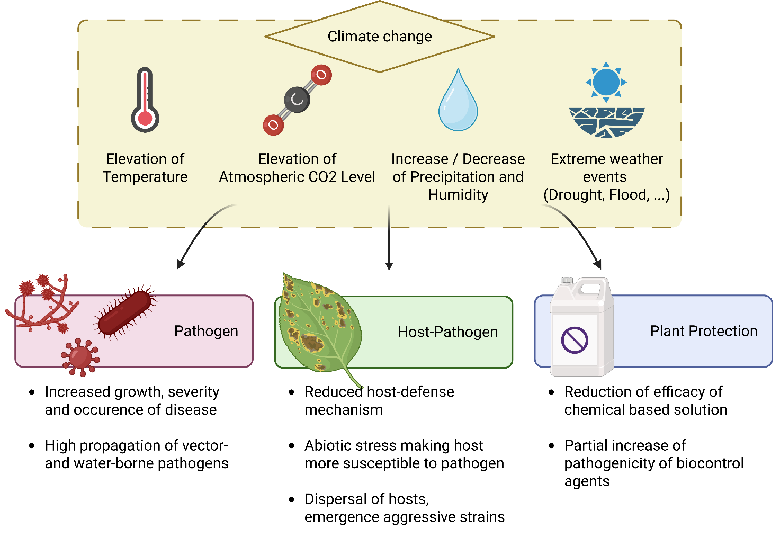Figure 1: Main climate change factors affecting plant diseases and crop protection.
With regard to the application of biological control agents and resistance inducers, their effectiveness appears to be enhanced in most of the pathosystems studied in a scenario of global warming and increased CO2 concentration (Evans et al., 2025). The effectiveness of Ampelomyces quisqualis Cesati against powdery mildew in zucchini has been shown to be enhanced under conditions of high temperature and ECO2 (Lahlali et al., 2024). These results have been corroborated by the use of various biological control agents (i.e., Streptomyces griseoviridis Anderson, Ehrlich, Sun & Burkholder, Trichoderma asperellum Samuels, Lieckfeldt & Nirenberg, Beauveria bassiana (Balsamo) Vuillemin, and resistance inducers based on potassium phosphite and calcium oxide) on the lettuce-fusarium wilt pathosystem, with equal or improved control of the pathogen at high temperatures and CO2 concentrations, up to 28°C, where biological control agents were ineffective (Gilardi et al., 2024).
The emergence of new, more aggressive strains is expected to be driven by rising temperatures and CO2 levels. To combat these new strains, the focus should be on breeding new varieties that are resistant or more tolerant to them. These new varieties should also exhibit acute resistance to unfavorable abiotic conditions. On the other hand, forecasting and modeling pathogen migration and outbreaks need to be developed to better assess and mitigate risks. Some attempts have been made, such as with the pathogen Xylella fastidiosa Wells, Raju, Hung, Weisburg, Parl & Beemer, which was famously involved in the grapevine crisis in Europe. In conjunction with mapping and climate change scenario modeling, these attempts have identified high-risk areas that require close observation and integration into intensive plant protection programs (Alqahtani et al., 2025).

Discussion
Studies on climate change affecting pathogens and pathosystems are already showing adverse effects on various crops, as well as beneficial effects on others. The impact of climate change appears uncertain for many pathogens, and each host-pathogen relationship must be assessed and rethought in order to cope with the new climatic conditions ahead. As agriculture gradually shifts toward less chemical-based plant protection, it is essential to include studies on biological control agents and the increasing complexity of crop diversity in the study of pathosystems. Crop models, which provide useful information on the ecosystem services provided by crops based on crop characteristics and climatic conditions, can be used as screening tools in the analysis of climate change impacts (Vercambre et al., 2024). When crop and pest models are coupled (i.e., pest density and severity are added to the crop model and interact with crop process functions), the impacts of climate change can be studied directly on pathogens within a specific crop (Lacroix et al., 2024). Models of soil-borne pathogen growth show that climate change will shift regions susceptible to certain plant fungal pathogens, particularly in northern Europe, while susceptibility to these pathogens will remain unchanged in Mediterranean countries (Manici et al., 2014). Studies on the local climate forecast for the coming years are needed to reshape agriculture in the context of climate change.
Therefore, breeding programs must incorporate climate-resilient resistance genes that are effective across a wide range of environmental conditions, particularly with regard to heat resistance and elevated CO₂. Additionally, these programs should consider epigenetic and physiological traits that facilitate stress adaptation because crops will face unfavorable abiotic conditions. To ensure effective plant protection in the future, agricultural practices must adopt climate-smart approaches. These approaches should include real-time monitoring systems, advanced forecasting models, and precision agriculture technologies. Decision support systems integrating weather data, pathogen modeling, and remote sensing could improve early warning capabilities and optimize intervention timing. Strengthening extension services, regional diagnostic networks, and international cooperation is essential for the proactive management of international pest and disease threats.
Data Availability
This article is a review and does not contain any original data. All data discussed in this review are available in the cited literature.

REFERENCES
Alcayna, T., Fletcher, I., Gibb, R., Tremblay, L., Funk, S., Rao, B., & Lowe, R. (2022). Climate-sensitive disease outbreaks in the aftermath of extreme climatic events: A scoping review. One Earth, 5(4), 336–350. https://doi.org/10.1016/j.oneear.2022.03.011
Alqahtani, M. S. M., Elshahawi, A. k., & Khalaf, S. M. H. (2025). Projecting the global spread of Xylella fastidiosa under climate change using maxent modeling. Scientific Reports, 15(1), 1–11. https://doi.org/10.1038/s41598-025-18286-2
Argüelles-Moyao, A., & Galicia, L. (2024). Assisted migration and plant invasion: importance of belowground ecology in conifer forest tree ecosystems. Canadian Journal of Forest Research, 54(1), 110–121. https://doi.org/10.1139/cjfr-2023-0016
Aslam, S., Iqbal, A., Deschamps, M., Recous, S., Garnier, P., & Benoit, P. (2015). Effect of rainfall regimes and mulch decomposition on the dissipation and leaching of S-metolachlor and glyphosate: A soil column experiment. Pest Management Science, 71(2), 278–291. https://doi.org/10.1002/ps.3803
Balagalla, D. N., Jayasinghe, W. H., Gefei, H., Kandegama, W. M. W. W., Kim, J., & Kim, H. (2025). Elevated Temperature Can Reduce Cucumber Mosaic Virus Transmission in Tobacco Plants by Altering the Insect Vector’s Performance. Plant Pathology Journal, 41(4), 498–506. https://doi.org/10.5423/PPJ.OA.02.2025.0016
Castroverde, C. D. M., He, S. Y., Lansing, E., Lansing, E., Lansing, E., & Lansing, E. (2015). Plant and pathogen warfare under changing climate conditions. 344(6188), 1173–1178. https://doi.org/10.1016/j.cub.2018.03.054.
Chakraborty, S. (2013). Migrate or evolve: Options for plant pathogens under climate change. Global Change Biology, 19(7), 1985–2000. https://doi.org/10.1111/gcb.12205
Dunn, R. J. H., Alexander, L. V., Donat, M. G., Zhang, X., Bador, M., Herold, N., Lippmann, T., Allan, R., Aguilar, E., Barry, A. A., Brunet, M., Caesar, J., Chagnaud, G., Cheng, V., Cinco, T., Durre, I., de Guzman, R., Htay, T. M., Wan Ibadullah, W. M., … Bin Hj Yussof, M. N. A. (2020). Development of an Updated Global Land In Situ-Based Data Set of Temperature and Precipitation Extremes: HadEX3. Journal of Geophysical Research: Atmospheres, 125(16), 1–37. https://doi.org/10.1029/2019JD032263
Evans, A. E., Pfadenhauer, W. G., Buonaiuto, D. M., Fertakos, M. E., Brown-Lima, C. J., & Morelli, T. L. (2025). The future of biocontrol in the Anthropocene: A review of climate change impacts on biocontrol agents and their targets. Ecological Applications, 35(6), 1–14. https://doi.org/10.1002/eap.70088
Fitzpatrick, M. C., Gove, A. D., Sanders, N. J., & Dunn, R. R. (2008). Climate change, plant migration, and range collapse in a global biodiversity hotspot: The Banksia (Proteaceae) of Western Australia. Global Change Biology, 14(6), 1337–1352. https://doi.org/10.1111/j.1365-2486.2008.01559.x
Ganchev, D., & Ivanov, A. (2023). Evaluation of stickiness of plants protection products. Scientific Papers. Series A. Agronomy, 66(2), 487–491.
Gilardi, G., Tabone, G., Gullino, M. L., & Garibaldi, A. (2024). Effect of the use of biocontrol agents and resistance inducers against race 1 of Fusarium oxysporum f. sp. lactucae on lettuce in a simulated climate change scenario. Journal of Plant Pathology, 106(1), 23–30. https://doi.org/10.1007/s42161-023-01555-2
Gullino, M. L., Pugliese, M., Gilardi, G., & Garibaldi, A. (2018). Effect of increased CO2 and temperature on plant diseases: a critical appraisal of results obtained in studies carried out under controlled environment facilities. Journal of Plant Pathology, 100(3), 371–389. https://doi.org/10.1007/s42161-018-0125-8
Haddoudi, I., Mrabet, M., & Mora, I. (2025). Investigating Bacillus amyloliquefaciens VFS2 for Vicia faba - fusarium wilt biocontrol and plant growth promotion under osmotic stress. July. https://doi.org/10.1002/ps.70078
Huot, B., Castroverde, C. D. M., Velásquez, A. C., Hubbard, E., Pulman, J. A., Yao, J., Childs, K. L., Tsuda, K., Montgomery, B. L., & He, S. Y. (2017). Dual impact of elevated temperature on plant defence and bacterial virulence in Arabidopsis. Nature Communications, 8(1808), 1–11. https://doi.org/10.1038/s41467-017-01674-2
Intergovernmental Panel on Climate Change (IPCC). (2013). Changements climatiques 2013: Les éléments scientifiques.
Intergovernmental Panel on Climate Change (IPCC). (2021). Changement climatique 2021 Les bases scientifiques physiques. In Contribution du Groupe de travail I au sixième Rapport d’évaluation du Groupe d’experts intergouvernemental sur l’évolution du climat. www.ipcc.ch
Intergovernmental Panel on Climate Change (IPCC). (2022). Sixth Assessment Report (AR6) Climate Change 2022: Mitigation of Climate Change. In Working Group III contribution to the Sixth Assessment Report of the Intergovernmental Panel on Climate Change (Issue 1).
Juarez-Contreras, L., Rascón, J., Oliva-Cruz, C., Vigo, C. N., Santa Cruz, C., Culqui, L., & Oliva-Cruz, M. (2025). Pathogenicity of biological formulations based on Beauveria peruviensis and Metarhizium sp. under controlled conditions and their efficacy in the field for the control of coffee berry borer in Peru. Journal of Agriculture and Food Research, 22(January). https://doi.org/10.1016/j.jafr.2025.102049
Kharel, B., Rusalepp, L., Bhattarai, B., Kaasik, A., Kupper, P., Lutter, R., & Mänd, P. (2023). Effects of air humidity and soil moisture on secondary metabolites in the leaves and roots of Betula pendula of different competitive status. Oecologia, 202(2), 193–210. https://doi.org/10.1007/s00442-023-05388-9
Kobori, Y., & Hanboonsong, Y. (2017). Effect of temperature on the development and reproduction of the sugarcane white leaf insect vector, Matsumuratettix hiroglyphicus (Matsumura) (Hemiptera: Cicadellidae). Journal of Asia-Pacific Entomology, 20(1), 281–284. https://doi.org/10.1016/j.aspen.2017.01.011
Krauthausen, H. J., Laun, N., & Wohanka, W. (2011). Methods to reduce the spread of the black rot pathogen, Xanthomonas campestris pv. campestris, in brassica transplants. Journal of Plant Diseases and Protection, 118(1), 7–16. https://doi.org/10.1007/BF03356375
Lacroix, O., Lescourret, F., Génard, M., Memah, M. M., Vercambre, G., Valsesia, P., Bevacqua, D., & Grechi, I. (2024). Modeling the effect of multiple pests on ecosystem services provided by fruit crops: Application to apple. Agricultural Systems, 213. https://doi.org/10.1016/j.agsy.2023.103808
Lahlali, R., Taoussi, M., Laasli, S. E., Gachara, G., Ezzouggari, R., Belabess, Z., Aberkani, K., Assouguem, A., Meddich, A., El Jarroudi, M., & Barka, E. A. (2024). Effects of climate change on plant pathogens and host-pathogen interactions. Crop and Environment, 3(3), 159–170. https://doi.org/10.1016/j.crope.2024.05.003
Lamichhane, J. R., Barbetti, M. J., Chilvers, M. I., Pandey, A. K., & Steinberg, C. (2024). Exploiting root exudates to manage soil-borne disease complexes in a changing climate. Trends in Microbiology, 32(1), 27–37. https://doi.org/10.1016/j.tim.2023.07.011
Macháčová, M., Tomášková, I., Corcobado, T., Nagy, Z., Milanović, S., Janoušek, J., Pešková, V., Čepl, J., Gezan, S., Nakládal, O., Zumr, V., Kalyniukova, A., Milenković, I., & Jung, T. (2024). Response of Alnus glutinosa to Phytophthora bark infections at ambient and elevated CO2 levels. Frontiers in Forests and Global Change, 7. https://doi.org/10.3389/ffgc.2024.1379791
Manici, L. M., Bregaglio, S., Fumagalli, D., & Donatelli, M. (2014). Modelling soil borne fungal pathogens of arable crops under climate change. 2071–2083. https://doi.org/10.1007/s00484-014-0808-6
Markovska, O., Dudchenko, V., & Grechishkina, T. (2020). Prevalence and harmfulness of winter wheat brown leaf rust (Puccinia recondita Rob. ex desm. f. sp. tritici) in the Southern Steppe of Ukraine. Ukrainian Journal of Ecology, 10(6), 69–74. https://doi.org/10.15421/2020_260
McElrone, A., Reid, C. D., Hoye, K. A., Hart, E., & Jackson, R. B. (2005). Elevated CO 2 reduces disease incidence and severity of a red maple fungal pathogen via changes in host physiology and leaf chemistry. Global Change Biology, 11, 1828–1836. https://doi.org/10.1111/j.1365-2486.2005.01015.x
Mohanapriya, S., Vanitha, S., Geethalakshmi, V., Pazhanivelan, S., Ragunath, K. P., Sendhilvel, V., & Vanitha, G. (2025). Plant health dynamics in accordance with climate change. Physiological and Molecular Plant Pathology, 138(March). https://doi.org/10.1016/j.pmpp.2025.102655
Osland, M. J., Chivoiu, B., Feher, L. C., Dale, L. L., Lieurance, D., Daniel, W. M., & Spencer, J. E. (2023). Plant migration due to winter climate change: range expansion of tropical invasive plants in response to warming winters. Biological Invasions, 25(9), 2813–2830. https://doi.org/10.1007/s10530-023-03075-7
Pérez-Lucas, G., Navarro, G., & Navarro, S. (2024). Adapting agriculture and pesticide use in Mediterranean regions under climate change scenarios: A comprehensive review. European Journal of Agronomy, 161(September). https://doi.org/10.1016/j.eja.2024.127337
Rossi, C. A. M., & Castroverde, C. D. M. (2024). Distinct profiles of plant immune resilience revealed by natural variation in warm temperature ‐ modulated disease resistance among Arabidopsis accessions. February, 5115–5125. https://doi.org/10.1111/pce.15098
Sbeiti, A. A. L., Mazurier, M., Ben, C., Rickauer, M., & Gentzbittel, L. (2023). Temperature increase modifies susceptibility to Verticillium wilt in Medicago spp and may contribute to the emergence of more aggressive pathogenic strains. Frontiers in Plant Science, 14(February), 1–15. https://doi.org/10.3389/fpls.2023.1109154
Scandolera, T., Teano, G., Naderpour, M., Geffroy, V., & Pflieger, S. (2024). Insights into the effects of elevated atmospheric carbon dioxide on plant-virus interactions: A literature review. Environmental and Experimental Botany, 221(August 2023). https://doi.org/10.1016/j.envexpbot.2024.105737
Shen, M., Cai, C., Song, L., Qiu, J., Ma, C., Wang, D., Gu, X., Yang, X., Wei, W., Tao, Y., Zhang, J., Liu, G., & Zhu, C. (2023). Elevated CO2 and temperature under future climate change increase severity of rice sheath blight. Frontiers in Plant Science, 14(January), 1–14. https://doi.org/10.3389/fpls.2023.1115614
Sivadasan, U., Chenhao, C., Nissinen, K., & Randriamanana, T. R. (2018). Growth and defence of aspen (Populus tremula) after three seasons under elevated temperature and ultraviolet-B radiation. February. https://doi.org/10.1139/cjfr-2017-0380
Teshome, D. T., Zharare, G. E., Ployet, R., & Naidoo, S. (2024). Molecular mechanisms underlying tree host-pathogen interactions under drought stress and subsequent rewatering in Eucalyptus grandis. Plant Stress, 14(June), 100697. https://doi.org/10.1016/j.stress.2024.100697
Vercambre, G., Mirás-Avalos, J. M., Juillion, P., Moradzadeh, M., Plenet, D., Valsesia, P., Memah, M. M., Launay, M., Lesniak, V., Cheviron, B., Genard, M., & Lescourret, F. (2024). Analyzing the impacts of climate change on ecosystem services provided by apple orchards in Southeast France using a process-based model. Journal of Environmental Management, 370(September). https://doi.org/10.1016/j.jenvman.2024.122470
Wakelin, S. A., Gomez-Gallego, M., Jones, E., Smaill, S., Lear, G., & Lambie, S. (2018). Climate change induced drought impacts on plant diseases in New Zealand. Australasian Plant Pathology, 47(1), 101–114. https://doi.org/10.1007/s13313-018-0541-4
Wood, J. R., Díaz, F. P., Latorre, C., Wilmshurst, J. M., Burge, O. R., & Gutiérrez, R. A. (2018). Plant pathogen responses to Late Pleistocene and Holocene climate change in the central Atacama Desert, Chile. Scientific Reports, 8(1), 1–8. https://doi.org/10.1038/s41598-018-35299-2
Wu, E. J., Wang, Y. P., Yahuza, L., He, M. H., Sun, D. L., Huang, Y. M., Liu, Y. C., Yang, L. N., Zhu, W., & Zhan, J. (2019). Rapid adaptation of the Irish potato famine pathogen Phytophthora infestans to changing temperature. Evolutionary Applications, 13(4), 768–780. https://doi.org/10.1111/eva.12899
Wu, M., Adesanya, A. W., Morales, M. A., Walsh, D. B., Lavine, L. C., Lavine, M. D., & Zhu, F. (2019). Multiple acaricide resistance and underlying mechanisms in Tetranychus urticae on hops. Journal of Pest Science, 92(2), 543–555. https://doi.org/10.1007/s10340-018-1050-5
Zhao, F., Li, Y., Chen, L., Zhu, L., Ren, H., Lin, H., & Xi, D. (2016). Temperature Dependent Defence of Nicotiana tabacum Against Cucumber mosaic virus and Recovery Occurs with the Formation of Dark Green Islands. 293–301. https://doi.org/10.1007/s12374-016-0035-2

Ta članek je objavljen pod licenco Creative Commons Priznanje avtorstva-Deljenje pod enakimi pogoji 4.0 Mednarodna.

Corrigendum: Validacija metode duplex RT-qPCR za določanje viroida razpokanosti skorje agrumov (CBCVd) na hmelju z uporabo mRNA1192 interne kontrole
Tanja GUČEK in Sebastjan RADIŠEK
Tipologija / Article type: Corrigendum
Prispelo / Arrived: 22. 10. 2025
Sprejeto / Accepted: 23. 10. 2025
Objavljeno / Published: December 2025
Corrigendum odpravlja napako v članku Guček in Radišek (2023), objavljenem v Hmeljarskem biltenu letnik 30, str. 26-39.
V članku na strani 34 v besedilu in preglednici 8 je navedena mejna vrednost (Cq cut-off) za CBCVd pri uporabi SensiFast kompleta reagentov kot 31,2. Na podlagi rezultatov analiz, izvedenih v Diagnostičnem laboratoriju za varstvo rastlin (DL) v letih 2024 in 2025, smo ugotovili, da je bila je mejna vrednost za CBCVd postavljena previsoko. Izračun je temeljil na rezultatih gBlocks (umetno sintetiziran CBCVd), kar ne ustreza realnim vzorcem hmelja okuženega s CBCVd.
Leta 2025 smo izvedli dodatno validacijo metode duplex RT-qPCR za hkratno detekcijo CBCVd in notranje kontrole mRNA1192. V ta namen smo testirali serijo redčitev (od 10⁰ do 10⁻⁷) večjega števila CBCVd pozitivnih in negativnih vzorcev hmelja ter izračunali nove Cq cut-off vrednosti po metodi Mehle in sod. (2013). Izračune smo izvedli ločeno za CBCVd in mRNA1192 ter za vsak komplet reagentov (SensiFast in AgPath). Mejno vrednost (Cq cut-off) smo določili na podlagi zadnjih pozitivnih vrednosti v seriji redčitev. Izračunali smo povprečje teh vrednosti, ga zaokrožili navzgor za pol enote in prišteli 0,5. Na tej osnovi smo določili vrednosti: CBCVd, SensiFast (27 vzorcev)= 28,0; CBCVd, AgPath (12 vzorcev)= 34,0; mRNA1192, SensiFast (25 vzorcev)= 31,0; mRNA1192, AgPath (12 vzorcev)= 35,5 (preglednica 1).
Preglednica 1: Mejne vrednosti za CBCVd in mRNA1192 za komplet reagentov SensiFast in AgPath
Komplet reagentov* | Število vzorcev testiranih na CBCVd | Cq cut-off CBCVd | Število vzorcev testiranih na mRNA1192 | Cq cut-off mRNA1192
SensiFast | 27 | 28,0 | 25 | 31,0
AgPath | 12 | 34,0 | 12 | 35,5
* SensiFAST Probe No-ROX Kit (Bioline) + MultiScribe Reverse Transcriptase (TFS)
AgPath-IDTM One Step RT-PCR, Thermo Fisher Scientific
Za dodatno zanesljivost rezultatov smo uvedli interval nezaupanja – vse vzorce z rezultati ±1 Cq glede na določene Cq cut-off vrednosti ponovno analiziramo.
Poleg tega smo med validacijo analizirali vpliv različnih redčitev vzorcev. Ugotovili smo, da je zaradi prisotnosti nespecifičnih signalov najbolj ustrezna 100-kratna redčitev vzorca, ki jo zdaj rutinsko uporabljamo v kombinaciji z novimi Cq cut-off vrednostmi.
Poudarjamo, da so te mejne vrednosti specifične za našo kombinacijo reagentov, instrumentov in pogojev dela. Vsak laboratorij mora zato na podlagi lastne validacije določiti svoje ustrezne Cq cut-off vrednosti.

CORRIGENDUM: VALIDATION OF THE RT-qPCR METHOD FOR THE DETECTION OF CITRUS BARKCRACKING VIROID (CBCVd) ON HOPS INCLUDING mRNA1192 AS INTERNAL CONTROL
Corrigendum corrects an error in the article by Guček and Radišek (2023), published in Hop Bulletin, Volume 30, pages 26–39.
On page 34 of the article, in both text and Table 8, the Cq cut-off value for CBCVd when using SensiFast kit is stated as 31.2. Based on the results of analyses conducted at the Plant Health Diagnostic Laboratory (DL) in 2024 and 2025, we determined that the Cq cut-off value for CBCVd had been set too high. The original calculation was based on gBlocks (artificially synthesized CBCVd), which does not fully reflect the performance of real hop samples infected with CBCVd.
In 2025, we performed an additional validation of the duplex RT-qPCR method for the simultaneous detection of CBCVd and the internal control mRNA1192. For this purpose, we tested a dilution series (from 10⁰ to 10⁻⁷) using a larger number of CBCVd-positive and -negative hop samples and calculated new Cq cut-off values following the method described by Mehle et al. (2013). Calculations were carried out separately for CBCVd and mRNA1192, as well as for each kit (SensiFast and AgPath). The cut-off value was determined based on the last consistently positive values in the dilution series. The average of these values was calculated, rounded up to the nearest half Cq, and then 0.5 was added. Based on this method, the following cut-off values were determined: CBCVd, SensiFast (27 samples): 28.0; CBCVd, AgPath (12 samples): 34.0; mRNA1192, SensiFast (25 samples): 31.0; mRNA1192, AgPath (12 samples): 35.5 (Table 1).
Table 1: The Cq cut-off value for CBCVd and mRNA1192 for SensiFast in AgPath kits.
Kit* | Number of samples tested for CBCVd | Cq cut-off CBCVd | Number of samples tested for mRNA1192 | Cq cut-off mRNA1192
SensiFast | 27 | 28.0 | 25 | 31.0
AgPath | 12 | 34.0 | 12 | 35.5
* SensiFAST Probe No-ROX Kit (Bioline) + MultiScribe Reverse Transcriptase (TFS)
AgPath-IDTM One Step RT-PCR, Thermo Fisher Scientific
To further ensure the reliability of results, we established a confidence interval around the cut-off – all samples with results within ±1 Cq of the Cq cut-off are reanalyzed. Additionally, during validation we examined the effect of different sample dilutions and determined that a 100-fold dilution was optimal due to the occurrence of nonspecific signals. This dilution is now used routinely in combination with the newly established Cq cut-off values.
We emphasize that these cut-off values are specific to our particular combination of reagents, instruments, and working conditions. Therefore, each laboratory must establish its own Cq cut-off values based on its own validation data.

VIRI
Chandelier, A. et al. 2006. Validation of a real-time PCR method for the detection of Phytophthora ramorum. Bull. OEPP/EPPO Bull. 36, 409–414.
Guček T, Radišek S. 2023. Validacija metode duRT-qPCR za določanje viroida razpokanosti skorje agrumov (CBCVd) na hmelju z uporabo mRNA1192 interne kontrole. Hmeljarski bilten. 30:26–39.
Mehle N, Prezelj N, Hren M, Boben J, Gruden K, Ravnikar M, Dermastia M. 2013 A real-time PCR detection system for the bois noir and flavescence dorée phytoplasmas and quantification of the target DNA. Methods Mol Biol. 2013; 938:253-68. doi: 10.1007/978-1-62703-089-2_22. PMID: 22987422.

Biotehniška fakulteta Univerze v Ljubljani (BF UL), Oddelek za agronomijo, e- mail: mt26732@student.uni-lj.si
Mag. biotehol., Inštitut za hmeljarstvo in pivovarstvo Slovenije (IHPS), e- mail: lucija.luskar@ihps.si
Izr. prof. dr., IHPS, e-mail: andreja.cerenak@ihps.si
Dr., BF UL, Oddelek za agronomijo, e- mail: jernej.jakse@bf.uni-lj.si
Dr., BF UL, Oddelek za agronomijo, e- mail: helena.volk@bf.uni-lj.si
Dr., Inštitut za hmeljarstvo in pivovarstvo Slovenije (IHPS), e-pošta: barbara.ceh@ihps.si
Mag. biotehnol., IHPS, e-pošta: ana.karnicnik@ihps.si
Dr., Inštitut za hmeljarstvo in pivovarstvo Slovenije (IHPS), e-pošta: ksenija.obrovnik@ihps.si
Univ. dipl. inž. kmet, IHPS, e-pošta: monika.oset-luskar@ihps.si
Izr. prof. dr., Inštitut za hmeljarstvo in pivovarstvo Slovenije, e-pošta: iztok.kosir@ihps.si
Prof. dr., Oregon State University (OSU), e-pošta: tom.shellhammer@oregonstate.edu
Študentka Biotehniške fakultete Univerze v Ljubljani (BF UL), e-pošta: anakocevarbaloh@gmail.com
Dr., Inštitut za hmeljarstvo in pivovarstvo Slovenije (IHPS), e-pošta: ksenija.obrovnik@ihps.si
3 Dr., IHPS, e-pošta: miha.ocvirk@ihps.si
4 Izr. prof. dr., IHPS in BF UL, e-pošta: iztok.kosir@ihps.si
Mag., inž. hort., Inštitut za hmeljarstvo in pivovarstvo Slovenije (IHPS), e-pošta: zan.trost@ihps.si
Univ. dipl. inž. agr., IHPS, e-pošta: josko.livk@ihps.si
Prof. dr., Inštitut za hmeljarstvo in pivovarstvo Slovenije and Fakulteta za kmetijstvo in biosistemske vede Univerze v Mariboru, e-mail: martin.pavlovic@ihps.si
Dr., Biotehniška fakulteta Univerze v Ljubljani (BF UL), Oddelek za agronomijo, e-pošta: marjeta.erzen@bf.uni-lj.si
Doc. dr., BF UL, Oddelek za agronomijo, e-pošta: marko.flajsman@bf.uni-lj.si
Dr., Inštitut za hmeljarstvo in pivovarstvo Slovenije (IHPS), e-pošta: tanja.gucek@ihps.si
Dr., IHPS, e-pošta: sebastjan.radisek@ihps.si
Mag. inž. agr., Inštitut za hmeljarstvo in pivovarstvo Slovenije (IHPS), e-pošta: jure.ferlin@ihps.si
Mag., IHPS, e-pošta: matej.knapic@ihps.si
Doc. dr., Biotehniška fakulteta, Oddelek za agronomijo (BF UL), e-pošta: vesna.zupanc@bf.uni-lj.si
Doc. dr., Geološki zavod Slovenije, e-pošta: Marjana.Zajc@GEO-ZS.SI
Univ. dipl. inž. kmet., Inštitut za hmeljarstvo in pivovarstvo Slovenije (IHPS), e-pošta: primoz.bukovec@ihps.si
Dr., Nacionalni inštitut za javno zdravje (NIJZ), e-pošta: tan.fatur@nijz.si
Mag.inž.hort., IHPS, e-pošta: zan.trost@ihps.si
Mag. inž. hort., Inštitut za hmeljarstvo in pivovarstvo Slovenije (IHPS), e-mail: octave.lacroix@ihps.si
Dr., IHPS, e-mail: sebastjan.radisek@ihps.si
Dr., Inštitut za hmeljarstvo in pivovarstvo Slovenije (IHPS), e-pošta: tanja.gucek@ihps.si
Dr., IHPS, e-pošta: sebastjan.radisek@ihps.si

