Guidelines for organic hop production – EIP EKOHMELJ
(Project Summary)
In the project of the European Innovative Partnership EKOHMELJ, the Slovenian Institute of Hop Research and Brewing (IHPS) with its partners, published guidelines for organic hop production - in accordance with the content of the European Green Deal and the EU Farm-to-Fork strategy.
IHPS carried out various technological experiments and field trials in hop production technologies, composting of hops, fertilization and plant protection as well as irrigation of hop fields at 6 locations in 3 regions (5 hop farms, IHPS). In addition, on workshops they assessed economics of hop production at farm level. They spread project experiences and results among other hop growers and the wider professional public - with demonstrations, on workshops, on technological meetings, on a seminar and in various publications.
The key result of the project is the document Guidelines for Organic Hop Production. Furthermore, project deliverables embrace several documents aiming to contribute in reduction of pesticides and mineral fertilizers use in agriculture, to protect the environment and to increase the export competitiveness of hop farms within organic hop industry.
The two-year project (06/2023-05/2025) EKOHMELJ is financed by: the European Agricultural Fund for Rural Development and the Republic of Slovenia. More about the project on: https://www.ihps.si/hmeljarstvo/eip-ekohmelj/.
Prof. Dr. M. Pavlovič, project leader

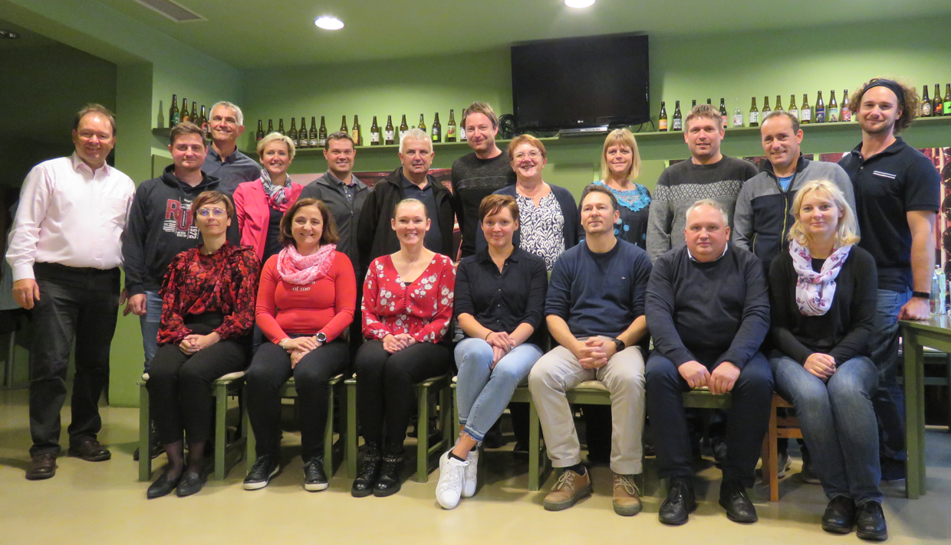
EKOHMELJ project team


